QQQ – Decision 1 – Chapter 6 – Linear Programming (Version 2)
Total Marks: 24
(24 = Platinum, 22 = Gold, 19 = Silver, 16 = Bronze)
1. A manufacturer of frozen yoghurt is going to exhibit at a trade fair. He will take two types of frozen yoghurt, Banana Blast and Strawberry Scream.
He will take a total of at least 1000 litres of yoghurt.
He wants at least 25% of the yoghurt to be Banana Blast. He also wants there to be at most half as much Banana Blast as Strawberry Scream.
Each litre of Banana Blast costs £3 to produce and each litre of Strawberry Scream costs £2 to produce. The manufacturer wants to minimise his costs.
Let $x$ represent the number of litres of Banana Blast and $y$ represent the number of litres of Strawberry Scream.
Formulate this as a linear programming problem, stating the objective and listing the constraints as simplified inequalities with integer coefficients.
You should not attempt to solve the problem. (6)
(Total 6 marks)
Edexcel D1 June 2014 (R) Q8
2.
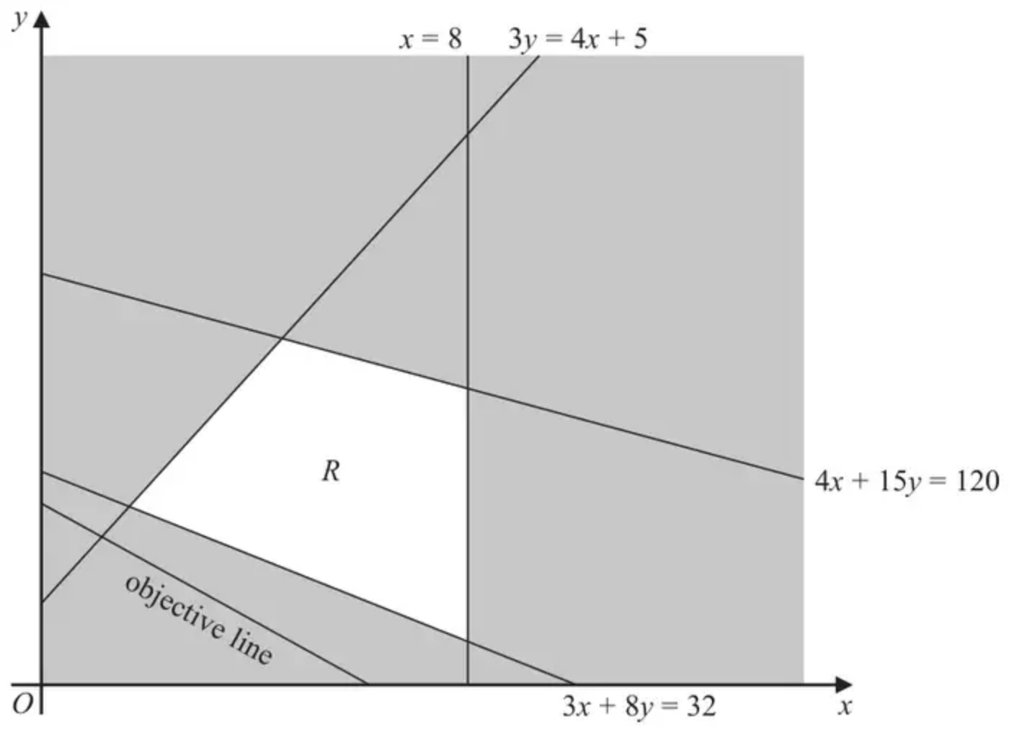
Figure 3
Figure 3 shows the constraints of a linear programming problem in $x$ and $y$.
The unshaded area, including its boundaries, forms the feasible region, $R$.
An objective line has been drawn and labelled on the graph.
(a) State the inequalities that define the feasible region. (2)
The maximum value of the objective function is $\frac{160}{3}$
The minimum value of the objective function is $\frac{883}{41}$
(b) Determine the objective function, showing your working clearly. (5)
(Total 7 marks)
Edexcel AS June 2023 Q4
3. The manager of a factory is planning the production schedule for the next three weeks for a range of cabinets. The following constraints apply to the production schedule.
• The total number of cabinets produced in week 3 cannot be fewer than the total number produced in weeks 1 and 2
• At most twice as many cabinets must be produced in week 3 as in week 2
• The number of cabinets produced in weeks 2 and 3 must, in total, be at most 125
The production cost for each cabinet produced in weeks 1, 2 and 3 is £250, £275 and £200 respectively.
The factory manager decides to formulate a linear programming problem to find a production schedule that minimises the total cost of production.
The objective is to minimise $250x+275y+200z$
(a) Explain what the variables $x$, $y$ and $z$ represent. (1)
(b) Write down the constraints of the linear programming problem in terms of $x$, $y$ and $z$. (2)
Due to demand, exactly 150 cabinets must be produced during these three weeks. This reduces the constraints to
$$\begin{matrix}x+y⩽75 \\ x+3y⩾150 \\ x⩾25 \\ y⩾0\end{matrix}$$
which are shown in Diagram 1 in the answer book.
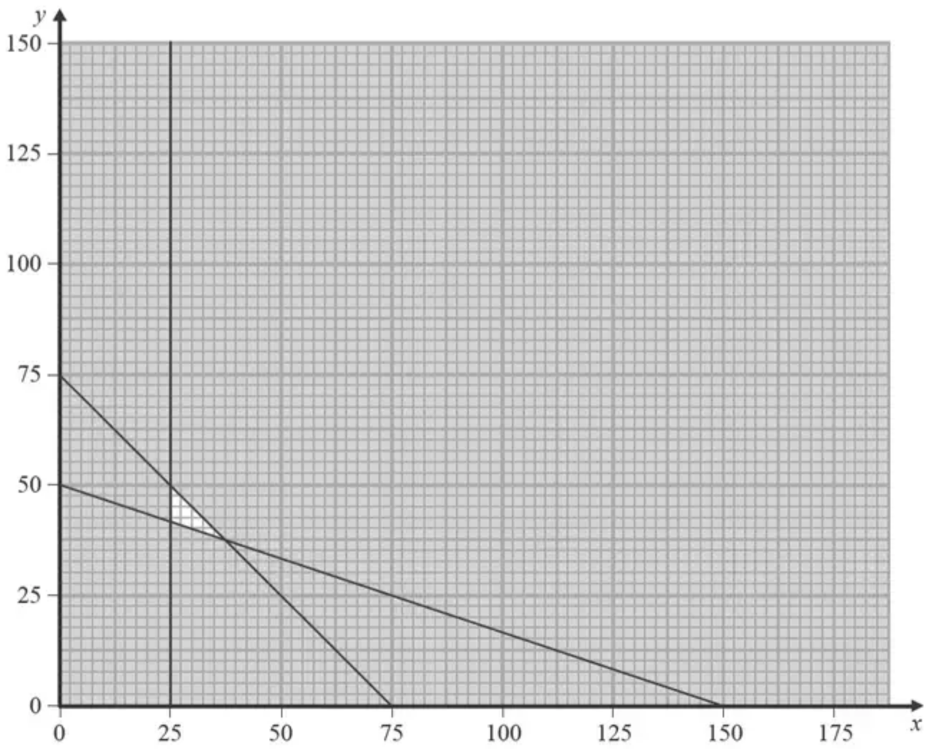
Diagram 1
Given that the manager does not want any cabinets left unfinished at the end of a week,
(c)
(i) use a graphical approach to solve the linear programming problem and hence determine the production schedule which minimises the cost of production. You should make your method and working clear.
(ii) Find the minimum total cost of the production schedule. (8)
(Total 11 marks)
Edexcel AS June 2018 Q4
Solutions
1.
Scheme | Marks
Minimise $C=3x+2y$ | B1
Subject to:
$x+y⩾1000$ | B1
$\frac{1}{4}(x+y)⩽x,$ simplifies to $y⩽3x$ | M1 A1
$2x⩽y$ | M1 A1
$(x,y⩾0)$
 | (6 marks)

Notes
1B1: CAO – expression correct and ‘minimise’.
2B1: CAO
1M1: Correct method – must see $\frac{1}{4}(x+y)\text{■}x$ where $\text{■}$ is any inequality or =. The bracket must be present or implied by later working.
1A1: CAO – simplified – answer must have integer coefficients.
2M1: Correct method – one of $2x\text{■}y$ or $x\text{■}2y$ where $\text{■}$ is any inequality or =.
2A1: CAO – answer must have integer coefficient.
2.
Mark scheme (a)
Scheme | Marks | AO
$x⩽8, 3x+8y⩾32, 3y⩽4x+5, 4x+15y⩽120$ | B2, 1, 0 | 3.3  1.1b
 | (2)

Notes
B1: Any two correct inequalities. Condone strict inequalities
B1: All four correct inequalities (not strict)
Mark scheme (b)
Scheme | Marks | AO
Attempt to solve correct two equations to find either optimal vertex  Coordinates of ‘minimum’ point is $(\frac{56}{41},\frac{143}{41})$  Coordinates of ‘maximum’ point is $(8,\frac{88}{15})$ | M1  A1  A1 | 3.4  1.1b  1.1b
Setting up a pair of simultaneous equations using their two points and an objective function of the form $ax+by$  (If correct $\begin{matrix}56a+143b & =883 \\ 15a+11b & =100\end{matrix}$ oe) | dM1 | 3.1a
Objective function is $(P=)3x+5y$ | A1 | 2.2a
 | (5)
 | (7 marks)

Notes
M1: Considering either of the following pairs of simultaneous equations:
$3y=4x+5,3x+8y=32$ or $x=8,4x+15y=120$
Must find at least one pair of coordinates from either of these two pairs (condone poor algebra in the solving of these equations)
A1: cao $(\frac{56}{41},\frac{143}{41})$ - must be seen exact at some point. They do not have to associate this with being the ‘minimum’
A1: cao $(8,\frac{88}{15})$ - must be seen exact at some point. They do not have to associate this with being the ‘maximum’
dM1: Setting up a pair of linear simultaneous equations using their two points. For this mark they must be using their solution of $3y=4x+5,3x+8y=32$ together with $\frac{883}{41}$ and their solution of $x=8,4x+15y=120$ together with $\frac{160}{3}$. Allow use of any two different variables for their pair of linear simultaneous equations. Look out for $\frac{56}{41}x+\frac{143}{41}y=\frac{883}{41}$ and $8x+\frac{88}{15}y=\frac{160}{3}$ which implies the first four marks
A1: cao – allow just the expression $3x+5y$ but not any multiple or factor of this (but isw if correct expression is seen first). Allow equal to any other letter but not equal to a value, for example, $3x+5y=0$ is A0
3.
Mark scheme (a)
Scheme | Marks | AO
$x$ is the number of cabinets produced in week 1, $y$ is the number of cabinets produced in week 2 and $z$ is the number of cabinets produced in week 3 | B1 | 2.5
 | (1)

Notes
B1: Cao - must contain ‘number of…’ (oe e.g. ‘amount of’, ‘quantity of’,…) at least once
Mark scheme (b)
Scheme | Marks | AO
$x+y⩽z$  $z⩽2y$  $y+z⩽125$  $(x,y,z⩾0)$ | B1  B1 | 3.3  3.3
 | (2)

Notes
B1: Any one correct (accept strict inequalities)
B1: All three correct
Mark scheme (c)
Scheme | Marks | AO
(i) Objective is $P=250x+275y+200(150−x−y)$ | M1 | 3.1a
$P=50x+75y(+30000)$ | A1 | 1.1b
Objective line drawn or at least two vertices tested | M1 | 3.1a
Optimal point $(25,\frac{125}{3})$ | A1 | 1.1b
Consideration of integer coordinates around the optimal vertex | M1 | 1.1b
Correct integer coordinate (25, 42) | A1 | 1.1b
The production schedule is 25 cabinets in week 1, 42 cabinets in week 2 and 83 cabinets in week 3 | B1 | 3.2a
(ii) Total cost of production is £34 400 | B1 | 1.1b
 | (8)
 | (11 marks)

Notes
Note that the vertices of the FR are $(25,\frac{125}{3}),(25,50),(\frac{75}{2},\frac{75}{2})$
(c)(i) M1: Attempt to derive new objective function in terms of $x$ and $y$ only by using $x+y+z=150$ or attempt to calculate all three values of $z$ using $x+y+z=150$
A1: Cao for objective in terms of $x$ and $y$ only or all three correct $z$ values $(\frac{250}{3},75,75)$
M1: Objective line drawn consistent with their objective function (or its reciprocal) or testing two of the correct vertices (to at least 1 decimal place where applicable) in their objective function involving $x$ and $y$ only or testing two of the correct vertices (to at least 1 decimal place where applicable) in $250x+275y+200z$
A1: Correct optimal point $(25,\frac{125}{3})$ or $(25,\frac{125}{3},\frac{250}{3})$ - accept 41.6 or 41.7 (or better) – so at least 1 decimal place (truncated or rounded) if not given exact
M1: Consideration of integer point(s) (e.g. (25, 41) etc.) around the optimal vertex – must have attempted point testing of the vertices of the feasible region or objective line
A1: Correct integer coordinate (25, 42) stated and either clear rejection of (26, 41) - by checking in $x+3y⩾150$ or testing of (27, 41) in a correct objective function
B1: Cao (in context – so not in terms of $x$, $y$ and $z$)
(c)(ii) B1: Cao (£34,400) – condone lack of units

