QQQ – Decision 1 – Chapter 6 – Linear Programming (Version 1)
Total Marks: 25
(25 = Platinum, 23 = Gold, 20 = Silver, 17 = Bronze)
1. A firm is planning to produce two types of radio, type A and type B.
Market research suggests that, each week:
• At least 50 type A radios should be produced.
• The number of type A radios should be between 20% and 40% of the total number of radios produced.
Each type A radio requires 3 switches and each type B radio requires 2 switches. The firm can only buy 200 switches each week.
The profit on each type A radio is £15.
The profit on each type B radio is £12.
The firm wishes to maximise its weekly profit.
Formulate this situation as a linear programming problem, defining your variables.
(Total 7 marks)
Edexcel D1 June 2011 Q8
2.
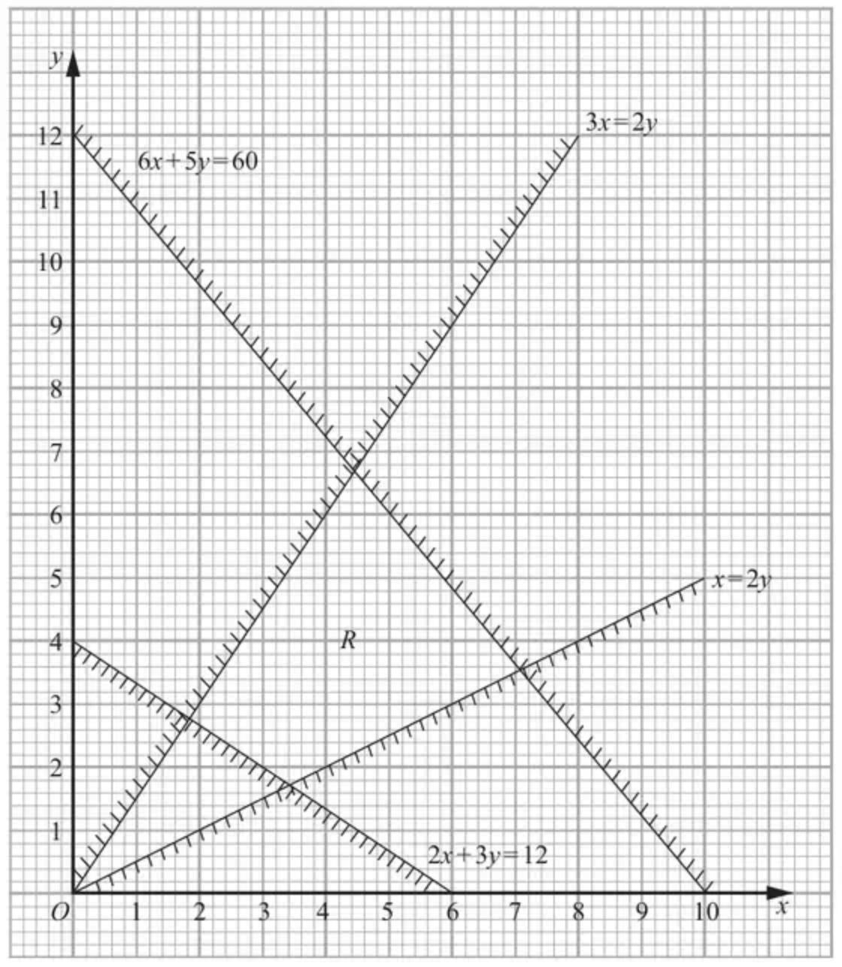
Figure 2
Figure 2 shows the constraints of a linear programming problem in $x$ and $y$, where $R$ is the feasible region.
(a) Write down the inequalities that form region $R$. (2)
The objective is to maximise $3x+y$.
(b) Find the optimal values of $x$ and $y$. You must make your method clear. (4)
(c) Obtain the optimal value of the objective function. (1)
Given that integer values of $x$ and $y$ are now required,
(d) write down the optimal values of $x$ and $y$. (1)
(Total 8 marks)
Edexcel D1 June 2011 Q3
3.
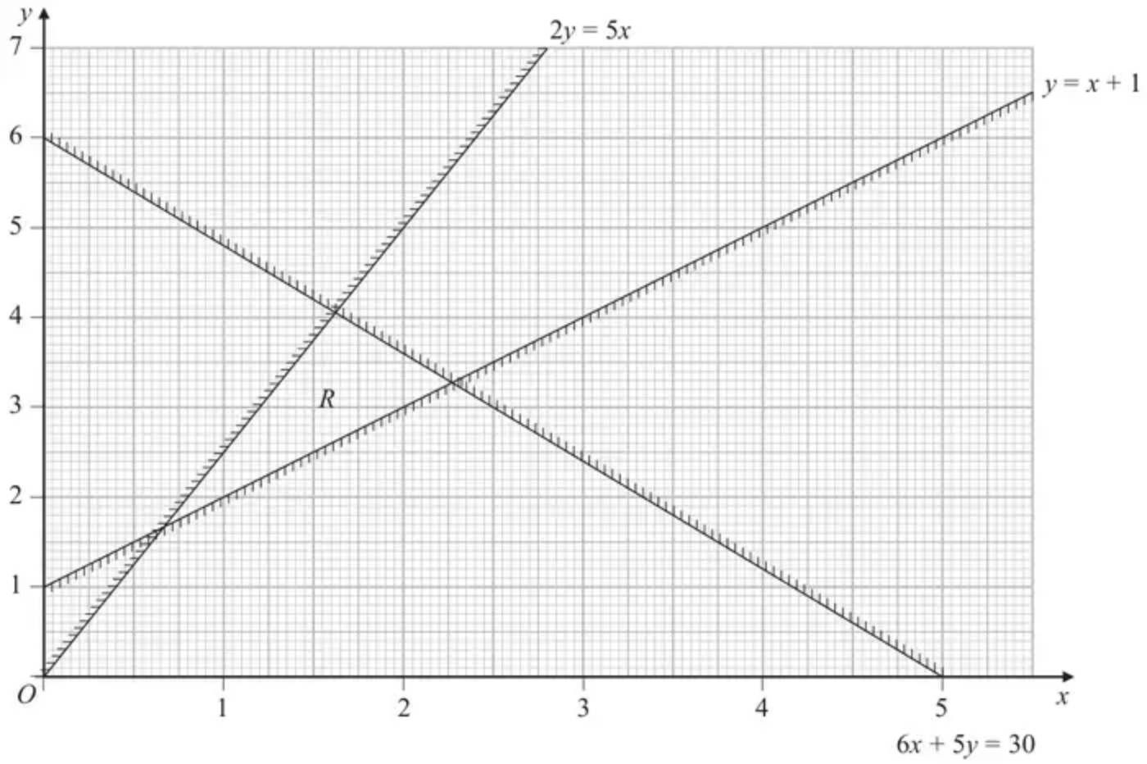
Figure 3
Figure 3 shows the constraints of a linear programming problem in $x$ and $y$, where $R$ is the feasible region.
(a) Write down the inequalities that define $R$. (2)
The objective is to maximise $P$, where $P=3x+y$
(b) Obtain the exact value of $P$ at each of the three vertices of $R$ and hence find the optimal vertex, $V$. (4)
The objective is changed to maximise $Q$, where $Q=3x+ay$. Given that $a$ is a constant and the optimal vertex is still $V$,
(c) find the range of possible values of $a$. (4)
(Total 10 marks)
Edexcel A2 October 2020 Q4
Solutions
1.
Scheme | Marks
Let $x$ be the number of type A radios and y be the number of type B radios. | B1
(Maximise P =) $15x+12y$ | B1
Subject to  $x⩾50$ | B1
$\frac{1}{5}(x+y)<x (\text{accept}⩽)[y<4x]$ | B1
$\frac{2}{5}(x+y)>x (\text{accept}⩾)[2y>3x]$ | B1
$3x+2y⩽200$ | B1
$y⩾0$ | B1
 | (7 marks)

Notes
1B1 Defining $x$ and $y$; Must see ‘number of’
2B1 CAO objective function $15x+12y$
3B1 CAO $x⩾50$
4B1 CAO o.e $\frac{1}{5}(x+y)<x⇒y<4x$
5B1 CAO o.e $\frac{2}{5}(x+y)>x⇒2y>3x$ (corrected from the printed mark scheme: the notes print $\frac{2}{3}(x+y)$; the scheme above has $\frac{2}{5}(x+y)$, i.e. 40%)
6B1 CAO o.e $3x+2y⩽200$
7B1 CAO $y⩾0$
2.
Mark scheme (a)
Scheme | Marks
$6x+5y⩽60$  $2x+3y⩾12$  $3x⩾2y$  $x⩽2y$ | B2,1,0
 | (2)

Notes
(a)1B1 Any two inequalities correct, accept < and > here (but not = of course).
2B1 All four correct. Must be $⩽$ and $⩾$ here
Mark scheme (b)
Scheme | Marks
Drawing objective line{ (0,3) (1,0)} Testing at least 2 points | M1 A1
Calculating optimal point Testing at least 3 points | DM1
$(7\frac{1}{17},3\frac{9}{17})=(\frac{120}{17},\frac{60}{17})≈(7.06,3.53)$ | A1 awrt
 | (4)

Notes
$$\begin{matrix} & (3\frac{3}{7},1\frac{5}{7})=(\frac{24}{7},\frac{12}{7})≈(3.43,1.71)→12 \\ & (1\frac{11}{13},2\frac{10}{13})=(\frac{24}{13},\frac{36}{13})≈(1.85,2.77)→8.307692(8\frac{4}{13}=\frac{108}{13}) \\ & (4\frac{4}{9},6\frac{2}{3})=(\frac{40}{9},\frac{20}{3})≈(4.44,6.67)→20 \\ & (7\frac{1}{17},3\frac{9}{17})=(\frac{120}{17},\frac{60}{17})≈(7.06,3.53)→24.705882(24\frac{12}{17}=\frac{420}{17})\end{matrix}$$
(b)1M1 Drawing objective line or its reciprocal OR testing two vertices in the feasible region (see list above) points correct to 1 dp.
1A1 Correct objective line OR two points correctly tested (1 dp ok)
2DM1 Calculating optimal point either answer to 2 dp or better or using S.E’s (correct 2 equations for their point + attempt to eliminate one variable.); OR Testing three points correctly and optimal one to 2dp.
2A1 CAO 2 dp or better.
Mark scheme (c)
Scheme | Marks
$24\frac{12}{17}=\frac{420}{17}≈24.7$ (awrt) | B1
 | (1)

Notes
(c)B1 CAO
(Corrected from the printed mark scheme: the scheme prints $\frac{240}{17}$; $24\frac{12}{17}=\frac{420}{17}$, as in the list of points above.)
Mark scheme (d)
Scheme | Marks
(6,4) | B1
 | (1)
 | (8 marks)

Notes
(d)B1 CAO not (4,6).
3.
Mark scheme (a)
Scheme | Marks | AO
$2y⩽5x,y⩾x+1,6x+5y⩽30$ | B2,1,0 | 1.1b  2.5
 | (2)

Notes
(a) B1: Any two correct (accept strict inequalities) – accept equivalent inequalities
B1: CAO (accept equivalent inequalities but inequalities must not be strict)
Mark scheme (b)
Scheme | Marks | AO
$(\frac{2}{3},\frac{5}{3}),(\frac{60}{37},\frac{150}{37}),(\frac{25}{11},\frac{36}{11})$ | B1  B1 | 1.1b  1.1b
$(\frac{2}{3},\frac{5}{3})→P=\frac{11}{3}$  $(\frac{60}{37},\frac{150}{37})→P=\frac{330}{37}$  $(\frac{25}{11},\frac{36}{11})→P=\frac{111}{11}$ so optimal vertex is $(\frac{25}{11},\frac{36}{11})$ | M1  A1 | 2.1  2.2a
 | (4)

Notes
(b) B1: One correct vertex (must be exact)
B1: All three correct vertices (must be exact)
M1: Testing all three of their vertices in the correct objective function
A1: Correct three values of $P$ and correct optimal vertex either stated or clearly indicated on the graph
Mark scheme (c)
Scheme | Marks | AO
$Q=3x+ay$
$3(\frac{25}{11})+\frac{36a}{11}>3(\frac{60}{37})+\frac{150a}{37}$ | M1 | 3.1a
$⇒a<\frac{5}{2}$ | A1 | 2.2a
$3(\frac{25}{11})+\frac{36a}{11}>3(\frac{2}{3})+\frac{5a}{3}$ | M1 | 1.1b
$⇒a>−3$ | A1 | 2.2a
 | (4)
 | (10 marks)

Notes
(c) M1: Their optimal point from (b) evaluated in $Q$ compared to their $(\frac{60}{37},\frac{150}{37})$ evaluated in $Q$ (with correct inequality)
A1: $a<\frac{5}{2}$
M1: Their optimal point from (b) evaluated in $Q$ compared to their $(\frac{2}{3},\frac{5}{3})$ evaluated in $Q$ (with correct inequality)
A1: $a>−3$

