QQQ – Decision 1 – Chapter 5 – The Travelling Salesman Problem (Version 2)
Total Marks: 22
(22 = Platinum, 20 = Gold, 18 = Silver, 15 = Bronze)
1.
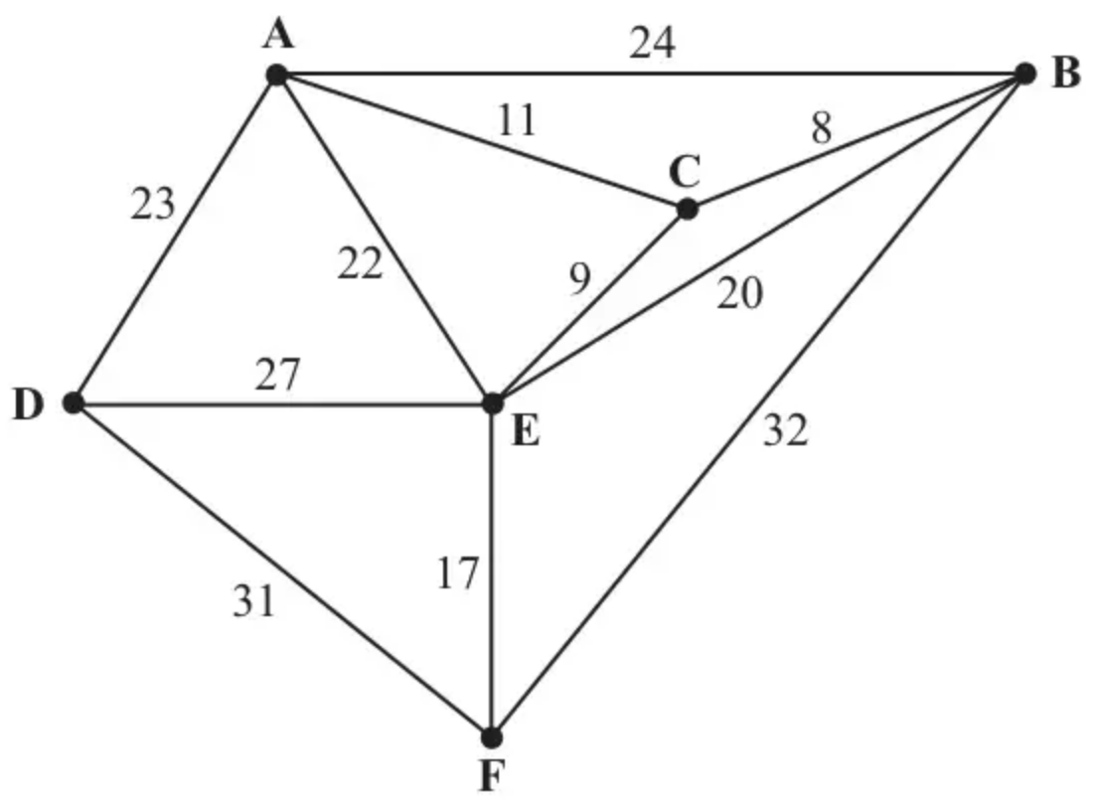
Figure 1
The network in Figure 1 shows the distances, in km, between six towns, A, B, C, D, E and F. Mabintou needs to visit each town. She will start and finish at A and wishes to minimise the total distance travelled.
(a) By inspection, complete the two copies of the table of least distances in your answer book. (3)
(b) Starting at A, use the nearest neighbour algorithm to find an upper bound for the length of Mabintou’s route. Write down the route which gives this upper bound. (3)
(c) Starting by deleting A, and all of its arcs, find a lower bound for the route length. (4)
(Total 10 marks)
Edexcel D2 June 2011 Q1
2.
 | A | B | C | D | E
A | – | 15 | 19 | 25 | 20
B | 15 | – | 15 | 15 | 25
C | 19 | 15 | – | 22 | 11
D | 25 | 15 | 22 | – | 18
E | 20 | 25 | 11 | 18 | –

The table shows the least distances, in km, between five hiding places, A, B, C, D and E.
Agent Goodie has to leave a secret message in each of the hiding places. He will start and finish at A, and wishes to minimise the total distance travelled.
(a) Use Prim’s algorithm to find a minimum spanning tree for this network. Make your order of arc selection clear. (2)
(b) Use your answer to part (a) to determine an initial upper bound for the length of Agent Goodie’s route. (1)
(c) Show that there are two nearest neighbour routes which start from A. State these routes and their lengths. (3)
(d) State the better upper bound from your answers to (b) and (c). (1)
(e) Starting by deleting B, and all of its arcs, find a lower bound for the length of Agent Goodie’s route. (4)
(f) Consider your answers to (d) and (e) and hence state an optimal route. (1)
(Total 12 marks)
Edexcel D2 June 2013 Q1
Solutions
1.
Mark scheme (a)
Scheme | Marks
 | B3, 2, 1, 0
   | A | B | C | D | E | F
  A | - | 19 | 11 | 23 | 20 | 37
  B | 19 | - | 8 | 42 | 17 | 32
  C | 11 | 8 | - | 34 | 9 | 26
  D | 23 | 42 | 34 | - | 27 | 31
  E | 20 | 17 | 9 | 27 | - | 17
  F | 37 | 32 | 26 | 31 | 17 | -
 | (3)

Notes
The entries to be found are shown in bold.
1B1 One double entry correct
2B1 Two double entries correct
3B1 Three double entries correct
Mark scheme (b)
Scheme | Marks
A C B E F D A  11 8 17 17 31 23 = 107 | M1 A1 A1
 | (3)

Notes
M1 NN route, each letter appearing once, condone lack of return vertex
1A1 CAO
2A1 CAO
Mark scheme (c)
Scheme | Marks
Delete A  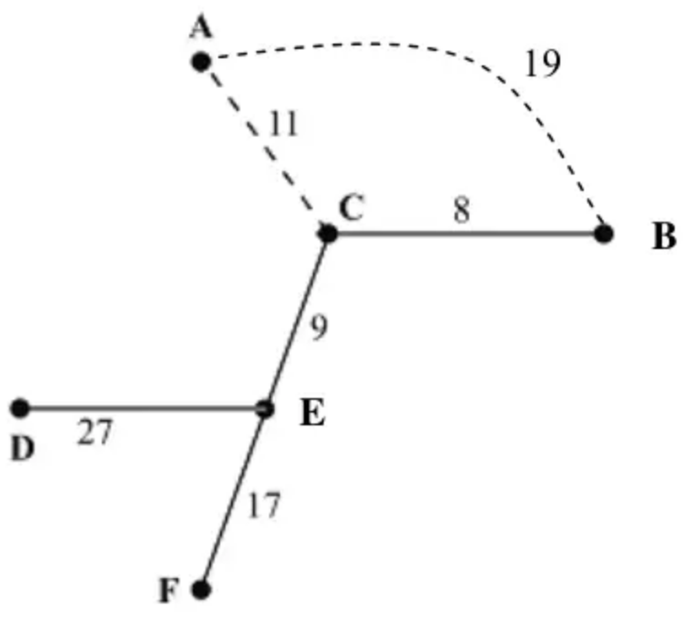 | M1
RMST weight = 61 | A1
Lower bound = 61 + 11 + 19 = 91 km | M1 A1
 | (4)
 | (10 marks)

Notes
1M1 Finding my RMST – accept 61 for both marks
1A1 Either 8 + 9 + 17 + 27 or 61 seen
2M1 Adding on two least arcs, accept 11 and 19 or AC and AB
2A1 91 CAO
2.
Mark scheme (a)
Scheme | Marks
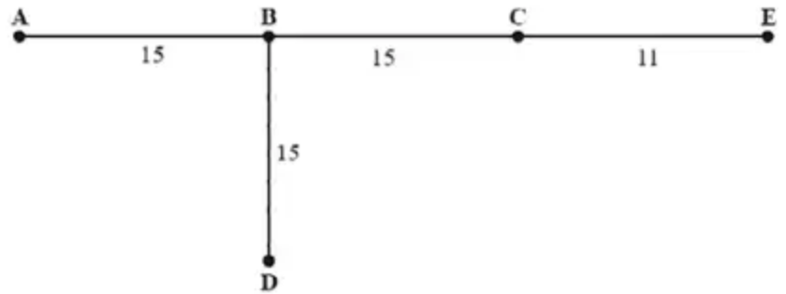  e.g. starting from A: AB, BD, BC, CE or AB, BC, CE, BD | M1 A1
 | (2)

Notes
a1M1 First three arcs (or all 5 nodes / or numbers across the top of the matrix) selected correctly (may start from any node). Award M1 only for a correct tree with no working.
a1A1 CAO (order of arc selection clear)
Mark scheme (b)
Scheme | Marks
2 x 56 = 112 | B1
 | (1)

Notes
b1B1 112 CAO
Mark scheme (c)
Scheme | Marks
A B C E D A  15 15 11 18 25 = 84  and  A B D E C A  15 15 18 11 19 = 78 | M1 A1 A1
 | (3)

Notes
c1M1 Nearest Neighbour either A-B-C-E-D- or A-B-D-E-C- (condone lack of return to start). Accept 12354 or 12534 across the top of the matrix.
c1A1 1 route and length CAO (Do not ISW if route length is doubled)
c2A1 both routes and lengths CAO (Do not ISW if route lengths are doubled)
Mark scheme (d)
Scheme | Marks
78 is the better upper bound | B1ft
 | (1)

Notes
d1B1ft their stated shortest (must be a number)
Mark scheme (e)
Scheme | Marks
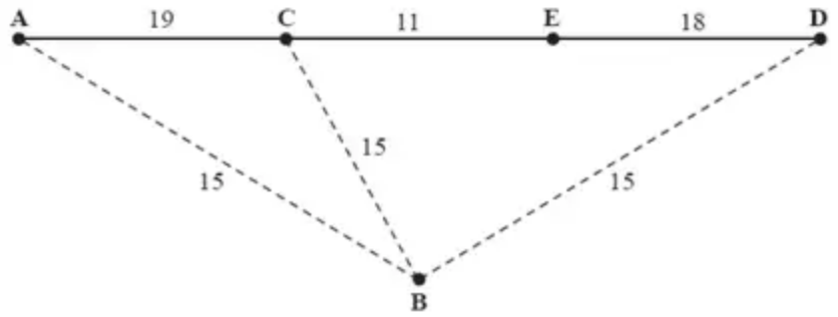 | 1M1 A1
Lower bound = 48 + 15 + 15 = 78 | 2M1 A1
 | (4)

Notes
e1M1 Finding correct RMST (maybe implicit) 48 sufficient, or correct numbers. 3 arcs.
e1A1 CAO; tree or 48 or 11 + 18 + 19 seen.
e2M1 Adding 2 least arcs to B; 15 and 15 or two out of BA, BC or BD or 30 only
e2A1 CAO 78
Mark scheme (f)
Scheme | Marks
The route is ABDECA  (The optimal route length is 78, since upper bound = lower bound) | B1
 | (1)
 | (12 marks)

Notes
f1B1 CAO, accept any start point for the correct tour, but must return to start. Dependent on their answer to part (d) = their answer to part (e).

