QQQ – Decision 1 – Chapter 5 – The Travelling Salesman Problem (Version 1)
Total Marks: 23
(23 = Platinum, 21 = Gold, 18 = Silver, 16 = Bronze)
1.
(a) Explain the difference between the classical travelling salesperson problem and the practical travelling salesperson problem. (2)
 | A | B | C | D | E | F | G
A | – | 31 | 15 | 12 | 24 | 17 | 22
B | 31 | – | 20 | 25 | 14 | 25 | 50
C | 15 | 20 | – | 16 | 24 | 19 | 21
D | 12 | 25 | 16 | – | 21 | 32 | 17
E | 24 | 14 | 24 | 21 | – | 28 | 41
F | 17 | 25 | 19 | 32 | 28 | – | 25
G | 22 | 50 | 21 | 17 | 41 | 25 | –

The table above shows the least direct distances, in miles, between seven towns, A, B, C, D, E, F and G. Yiyi needs to visit each town, starting and finishing at A, and wishes to minimise the total distance she will travel.
(b) Show that there are two nearest neighbour routes that start from A. State these routes and their lengths. (3)
(c) Starting by deleting A, and all of its arcs, find a lower bound for the length of Yiyi’s route. (3)
(d) Use your results to write down the smallest interval which you can be confident contains the optimal length of Yiyi’s route. (2)
(Total 10 marks)
Edexcel D2 June 2016 Q1
2. The table below represents a network of shortest distances, in miles, to travel between nine castles, A, B, C, D, E, F, G, H and J.
 | A | B | C | D | E | F | G | H | J
A | – | 50 | 59 | 26 | 50 | 40 | 87 | 63 | 59
B | 50 | – | 28 | 61 | 79 | 63 | 45 | 64 | 48
C | 59 | 28 | – | 33 | 57 | 35 | 70 | 36 | 45
D | 26 | 61 | 33 | – | 24 | 64 | 71 | 37 | 33
E | 50 | 79 | 57 | 24 | – | 40 | 64 | 30 | 31
F | 40 | 63 | 35 | 64 | 40 | – | 47 | 70 | 71
G | 87 | 45 | 70 | 71 | 64 | 47 | – | 34 | 67
H | 63 | 64 | 36 | 37 | 30 | 70 | 34 | – | 33
J | 59 | 48 | 45 | 33 | 31 | 71 | 67 | 33 | –

(a) Use Prim’s algorithm, starting at D, to find the minimum spanning tree for this network. You must clearly state the order in which you select the arcs of your tree. (3)
(b) State the weight of the minimum spanning tree found in part (a). (1)
(c) Draw the minimum spanning tree using the vertices given in Diagram 1 in the answer book. (1)
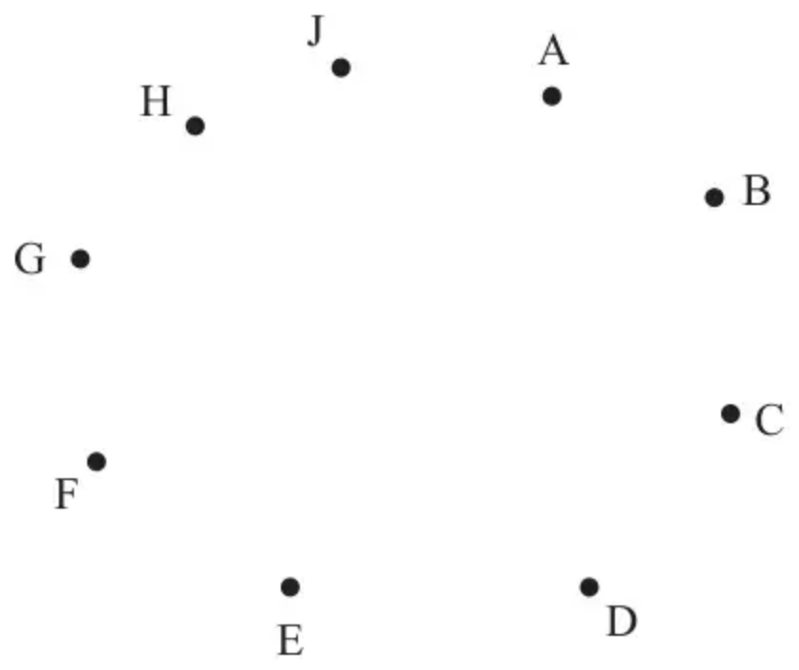
Diagram 1
A historian needs to visit all of the castles, starting and finishing at the same castle, and wishes to minimise the total distance travelled.
(d) Use your answer to part (b) to calculate an initial upper bound for the length of the historian’s route. (1)
(e)
(i) Use the nearest neighbour algorithm, starting at D, to find an upper bound for the length of the historian’s route.
(ii) Write down the route which gives this upper bound. (3)
Using the nearest neighbour algorithm, starting at F, an upper bound of length 352 miles was found.
(f) State the best upper bound that can be obtained by using this information and your answers from parts (d) and (e). Give the reason for your answer. (1)
(g) By deleting A and all of its arcs, find a lower bound for the length of the historian’s route. (2)
By deleting J and all of its arcs, a lower bound of length 274 miles was found.
(h) State the best lower bound that can be obtained by using this information and your answer to part (g). Give the reason for your answer. (1)
(Total 13 marks)
Edexcel A2 June 2024 Q2
Solutions
1.
Mark scheme (a)
Scheme | Marks
e.g. in the practical problem each vertex must be visited at least once. In the classical problem each vertex must be visited just once | B2, 1, 0
 | (2)

Notes
a1B1: Understands the difference is connected to the number of times each vertex may be visited (but maybe incorrectly attributed). Must be an attempt at a difference (so must refer to both the classical and practical problems explicitly). Technical language (vertex/node) must be correct. Need not imply each/every/all (oe) vertices for this first mark
a2B1: Correctly identifies which is classical and which is practical and correctly states the difference. Must imply that each/every/all (oe) vertices are visited, so for example, ‘the practical problem visits a vertex at least once while the classical visits a vertex only once’ is B1B0 (note that B0B1 is not possible in (a))
Mark scheme (b)
Scheme | Marks
A – D – C – F – B – E – G – A  12+16+19+25+14+41+22 = 149 | M1  A1
A – D – C – F – G – E – B – A  12+16+19+25+41+14+31 = 158 | A1
 | (3)

Notes
b1M1: Either one correct route, must return to A, or one correct length stated (do not isw in part (b) if correct lengths seen but are then doubled)
b1A1: One correct route, must return to A and corresponding length correct
b2A1: Both routes correct and their corresponding lengths correct
Mark scheme (c)
Scheme | Marks
RMST weight = 86 (miles) | B1
86 + 12 + 15 = 113 (miles) | M1 A1
 | (3)

Notes
c1B1: CAO for RMST weight (either 86 or 20 + 16 + 14 + 19 + 17) – maybe implied by later working
c1M1: Adding 12 + 15 (the two least weighted arcs) to their RMST length (the length of their RMST must be in the interval $66⩽\text{RMST}⩽106$) – this mark maybe implied by the correct value for the lower bound
c1A1: CAO - if 113 seen without working then award all 3 marks in (c)
Mark scheme (d)
Scheme | Marks
113 $⩽$ optimal distance $⩽$ 149 | B2, 1, 0
 | (2)
 | 10 marks

Notes
d1B1: Their numbers correctly used, accept any inequalities or any indication of interval from their 113 to their 149 (so 113 – 149 can score this mark). This mark is dependent on two totals seen in (b), however, neither of the two totals need to be correct. Please note that UB > LB for this mark
d2B1: CAO (no follow through on their values) including correct inequalities or equivalent set notation (but condone $113<\text{optimal distance}⩽149$)
2.
Mark scheme (a)
Scheme | Marks | AO
Prim’s starting at D: DE, AD, EH; EJ, CD, BC; GH, CF | M1  A1  A1 | 1.1b  1.1b  1.1b
 | (3)

Notes
M1: First three arcs correctly chosen in order {DE, AD, EH, …} or first four nodes correctly chosen in order{D, E, A, H,…}. If any rejections seen at any point then M1 (max) only. Order of nodes may be seen at the top of the matrix {3, -, -, 1, 2, -, -, 4, -} so please check the top of the matrix carefully. If they start at any other vertex M1 only for the first three arcs in order (Starting at A AD DE EH).
A1: First six arcs correctly chosen in order {DE, AD, EH, EJ, CD, BC, …} or all nine nodes correctly chosen in order{D, E, A, H, J, C, B, G, F}. Order of nodes may be seen at the top of the matrix so for the first two marks accept {3, 7, 6, 1, 2, 9, 8, 4, 5} (do not condone any missing numbers e.g. the number 9 must be above F)
A1: CSO – all arcs correctly stated and chosen in the correct order. Candidates must be considering arcs for this final mark (do not accept a list of nodes or numbers across the top of the matrix unless the correct list of arcs (in the correct order) is also seen)
Mark scheme (b)
Scheme | Marks | AO
Weight of MST is 241 (miles) | B1 | 1.1b
 | (1)

Notes
B1: CAO (241) – no units required (in this or any of the subsequent parts)
Mark scheme (c)
Scheme | Marks | AO
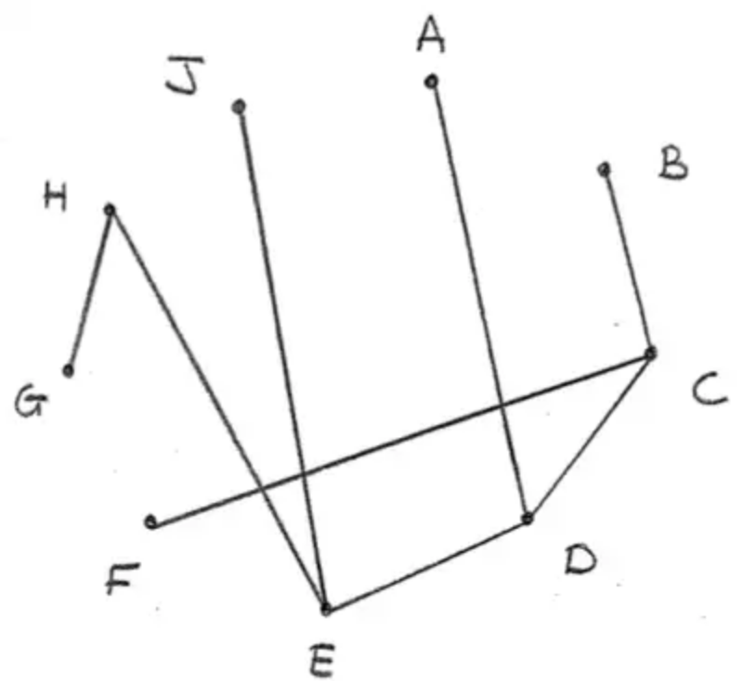 | B1 | 1.1b
 | (1)

Notes
B1: Correct MST (If multiple attempts not rejected check all and award mark if any one is correct)
Mark scheme (d)
Scheme | Marks | AO
482 (miles) | B1ft | 1.1b
 | (1)

Notes
B1ft: Follow through double their answer to (b)
Mark scheme (e)
Scheme | Marks | AO
NNA starting at D: D – E – H – J – C – B – G – F – A – D  24 + 30 + 33 + 45 + 28 + 45 + 47 + 40 + 26 = 318 (miles) | M1  A1  A1 | 1.1b  1.1b  1.1b
 | (3)

Notes
M1: Nearest neighbour route starting at D – must have at least D – E – H – J – C – B – … allow if stated in terms of arcs (DE EH HJ JC CB) but not for just numbering across the matrix
A1: CAO route (must return to D and can be stated as arcs DE EH HJ JC CB BG GF FA AD)
A1: CAO length (318)
Mark scheme (f)
Scheme | Marks | AO
The best upper bound is the one found in (e) as 318 is less than both 352 and 482 | dB1ft | 2.2a
 | (1)

Notes
dB1ft: Follow through their value from (e) (must include reason e.g. 318 is the lowest of the values found, but they do not need to mention the other values) Must score at least M1 in (e)
Mark scheme (g)
Scheme | Marks | AO
(241 – 26) + 26 + 40 = 281 (miles) | M1  A1 | 3.1b  2.2a
 | (2)

Notes
M1: (weight of their MST from (b) or 241 only) – 26 + 26(AD) + 40(AF) (oe so may not see the – 26 + 26). A correct answer of 281 can imply this (and the next) mark. Alternatively may delete A and find RMST (215) and add AD (26) and AF (40)
A1: 281
Mark scheme (h)
Scheme | Marks | AO
The best lower bound is the one found in (g) as 281 is greater than 274 | dB1ft | 2.2a
 | (1)
 | (13 marks)

Notes
dB1ft: Follow through their “281” with 274 and makes conclusion (e.g. 281 is the bigger value, but they do not need to mention 274). Must be a smaller value than their answer to (f) and must score at least M1 in (g)

