QQQ – Decision 1 – Chapter 4 – Route Inspection (Version 1)
Total Marks: 24
(24 = Platinum, 22 = Gold, 19 = Silver, 16 = Bronze)
1.
(a) Explain why a network cannot have an odd number of vertices of odd degree. (2)
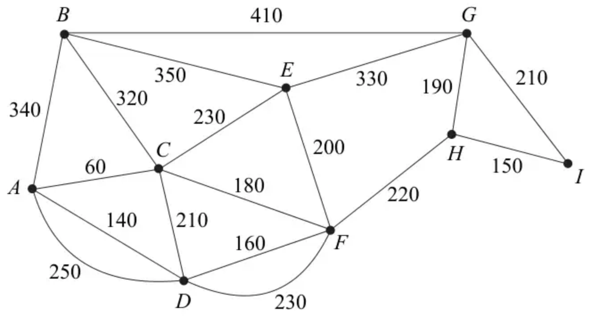
Figure 4
Figure 4 shows a network of paths in a public park. The number on each arc represents the length of that path in metres. Hamish needs to walk along each path at least once to check the paths for frost damage starting and finishing at $A$. He wishes to minimise the total distance he walks.
(b) Use the route inspection algorithm to find which paths, if any, need to be traversed twice. (4)
(c) Find the length of Hamish’s route.
[The total weight of the network in Figure 4 is 4180 m.] (1)
(Total 7 marks)
Edexcel D1 January 2007 Q5
2.
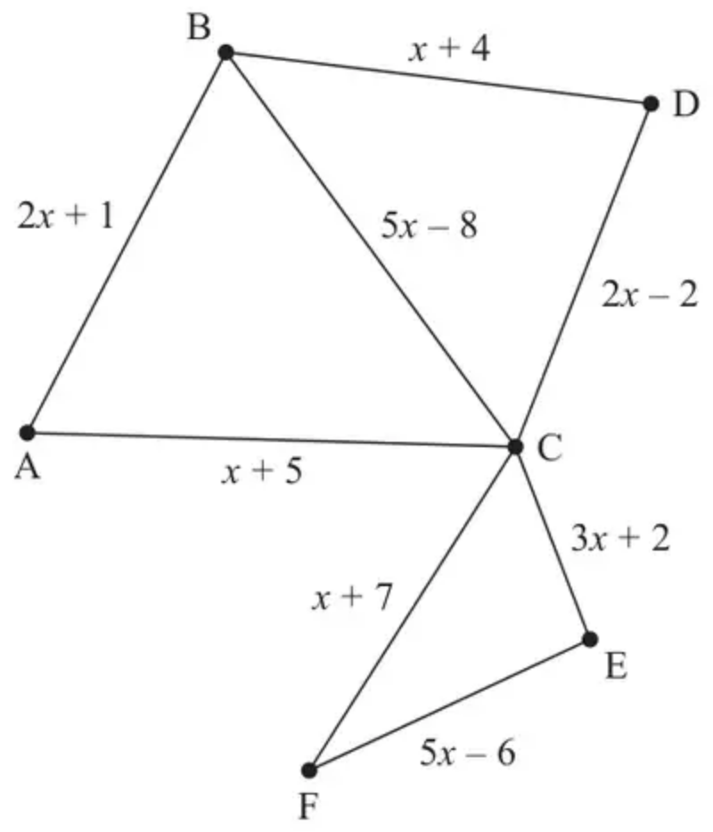
Figure 4
[The weight of the network is $20x+3$]
Figure 4 shows a graph G that contains 8 arcs and 6 vertices.
(a) State the minimum number of arcs that would need to be added to make G into an Eulerian graph. (1)
(b) Explain whether or not the route A – C – F – E – C – D – B is an example of a path on G. (1)
Figure 4 represents a network of 8 roads in a city. The expression on each arc gives the time, in minutes, to travel along the corresponding road.
You are given that $x>1.6$
A route is required that
• starts and finishes at the same vertex
• traverses each road at least once
• minimises the total time taken
The route inspection algorithm is applied to the network in Figure 4 and the time taken for the route is found to be at most 189 minutes.
Given that the inspection route contains two roads that need to be traversed twice,
(c) determine the range of possible values of $x$, making your reasoning clear. (6)
(Total 8 marks)
Edexcel AS June 2023 Q5
3.
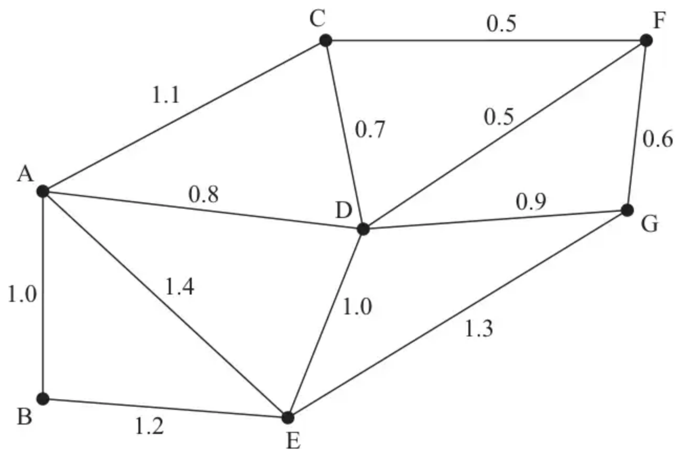
Figure 4
Figure 4 models a network of roads in a housing estate. The number on each arc represents the length, in km, of the road.
The total weight of the network is 11 km.
A council worker needs to travel along each road once to inspect the road surface. He will start and finish at A and wishes to minimise the length of his route.
(a) Use an appropriate algorithm to find a route for the council worker. You should make your method and working clear. State your route and its length. (6)
A postal worker needs to walk along each road twice, once on each side of the road. She must start and finish at A. The length of her route is to be minimised. You should ignore the width of the road.
(b)
(i) Explain how this differs from the standard route inspection problem. (1)
(ii) Find the length of the shortest route for the postal worker. (2)
(Total 9 marks)
Edexcel D1 January 2008 Q3
Solutions
1.
Mark scheme (a)
Scheme | Marks
e.g. Each edge contributes 2 to the sum of degrees, hence this sum must be even.  Therefore there must be an even (or zero) number of vertices of odd degree  Hence there cannot be an odd number of vertices of odd degree | B2,1,0
 | (2)

Mark scheme (b)
Scheme | Marks
$CD+FH=200+220=420∗$ | M1 A1
$CF+DH=180+380=560$ | A1
$CH+DF=400+160=560$
repeat $CA,AD$ and $FH$ | A1
 | (4)

Mark scheme (c)
Scheme | Marks
length $=4180+420$ft $=4600$ m | B1ft
 | (1)
 | (7 marks)

2.
Mark scheme (a)
Scheme | Marks | AO
1 | B1 | 1.2
 | (1)

Notes
(a) B1: cao
Mark scheme (b)
Scheme | Marks | AO
The route is not an example of a path as vertex C appears twice | B1 | 2.4
 | (1)

Notes
(b) B1: No + correct reason – no bod – must refer to C appearing twice (not just that a vertex is repeated) or that it contains the cycle C – F – E – C (not just that it contains a cycle). All technical language must be correct if used for this mark and do not isw any incorrect reasoning (for example if they imply that a path must pass through every vertex)
Mark scheme (c)
Scheme | Marks | AO
As the route contains two roads that need to be traversed twice this means that either the pairing AB, AC or BD, CD needs to be repeated | B1 | 2.1
AB + AC = $3x+6$ and BD + CD = $3x+2$ and as $3x+6>3x+2$ (for all values of $x$) this means that BD + CD are repeated | B1 | 2.2a
Because two roads are repeated in the shortest inspection route this means that $5x−8>3x+2$ | M1 | 3.1b
$x>5$ | A1 | 1.1b
$(20x+3)+(3x+2)⩽189$ | M1 | 3.4
$x⩽8$ | A1 | 2.2a
 | (6)
 | (8 marks)

Notes
(c) B1: Recognising that one of the two pairings between B and C containing two arcs will need to be repeated. For example, might state BAC or BDC or BA, AC or BD, DC (as an indication of considering the two odd nodes B and C together with one of the two paths via A and D) or one of the expressions $3x+6$ or $3x+2$ (or correct but unsimplified) seen would score this mark. Condone for this mark those candidates who consider the direct arc BC (provided at least one of the pairings via A or D is considered too)
B1: Correct deduction that BD + CD needs to be repeated (or that AB + AC is not repeated). Allow stating that $3x+2$ is ‘better’ than $3x+6$ or simply stating both expressions and selecting $3x+2$ (but we must see both simplified expressions for this mark). This selection of $3x+2$ (after seeing both expressions) could be implied by forming an equation/inequality with only this expression. This mark cannot be awarded if either of the other two inequalities/equations e.g. $(20x+3)+(3x+6)⩽189$ or $(20x+3)+(5x−8)⩽189$ are formed, unless they are explicitly rejected with the correct reason (that is because $3x+6>3x+2$ and because the route contains two roads). Obtaining $x⩽7.826…$ and/or $x⩽7.76$ and simply rejecting these without the valid reasons as stated above does not score this mark
M1: Considers explicitly the direct route between B and C ($5x−8$) and compares this (in the form of a linear equation or inequality) with either of the two pairings AB + AC or BD + CD
A1: cao ($x>5$)
M1: ($20x+3$) + (either their $3x+6$ or their $3x+2$) together with 189 (allow equals or any inequality)
A1: cao ($x⩽8$)
If full marks would have been awarded in (c) but any other inequalities apart from $x>5$ and $x⩽8$ are found, then withhold the second B mark
3.
Mark scheme (a)
Scheme | Marks
CD + FG = 0.7 + 0.6 = 1.3 * | M1 A1
CF + DG = 0.5 + 0.9 = 1.4 | A1
CG + DF = 1.1 + 0.5 = 1.6 | A1
repeat CD and FG
A possible route e.g.  A C D C F G F D G E D A E B A | A1
length: 11 + 1.3 = 12.3 km | A1ft
 | (6)

Notes
Q3(a) 1M1 3 distinct pairings of their 4 odd nodes
1A1 one line correct (condone missing total)
2A1 2 lines correct including totals
3A1 All three lines correct including totals
4A1 15 letters, repeat CD and FG, start/finish A, A to G there.
5A1ft 11+ thier minimum
Mark scheme (b)
Scheme | Marks
(i) Each arc has to be traversed twice | B1
 | (1)
(ii) $2×11=22$ km | B2, 0
 | (2)
 | (9 marks)

Notes
(b)i 1B1 cao ‘twice’ probably the trigger
ii 2B1 22
3B1 22km

