QQQ – Decision 1 – Chapter 3 – Algorithms on Graphs (Version 2)
Total Marks: 24
(24 = Platinum, 22 = Gold, 19 = Silver, 16 = Bronze)
1.
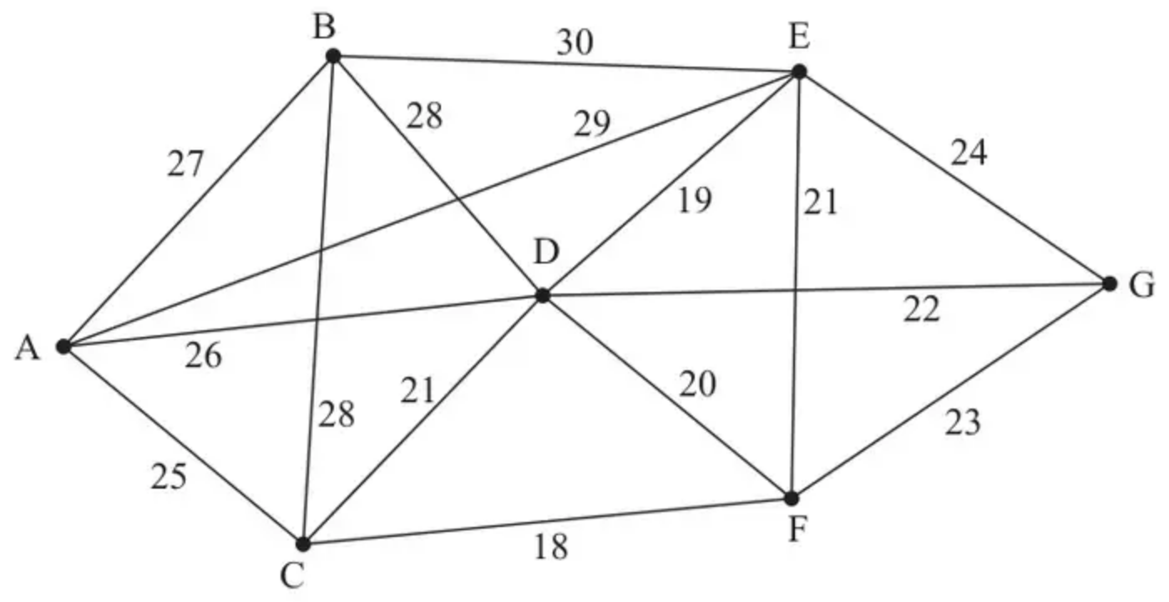
Figure 4
(a) State two differences between Kruskal’s algorithm and Prim’s algorithm for finding a minimum spanning tree. (2)
(b) Listing the arcs in the order that you consider them, find a minimum spanning tree for the network in Figure 4, using
(i) Prim’s algorithm,
(ii) Kruskal’s algorithm. (6)
(Total 8 marks)
Edexcel D1 June 2008 Q4
2.
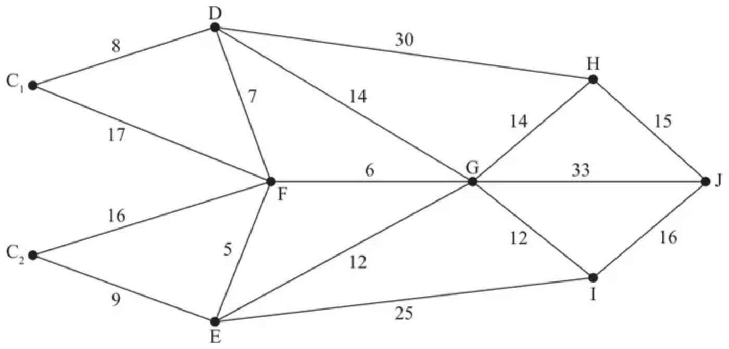
Figure 5
Figure 5 represents a network of roads. The number on each arc represents the length, in miles, of the corresponding road. A large crane is required at J and it may be transported from either C₁ or C₂. A route of minimum length is required.
It is decided to use Dijkstra’s algorithm to find the shortest routes between C₁ and J and between C₂ and J.
(a) Explain why J, rather than C₁ or C₂, should be chosen as the starting vertex. (1)
(b) Use Dijkstra’s algorithm to find the shortest route needed to transport the crane. State your route and its length. (6)
(Total 7 marks)
Edexcel D1 June 2013 (R) Q7
3.
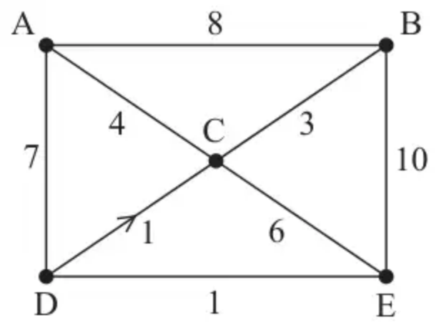
Figure 2
Direct roads between five villages, A, B, C, D and E, are shown in Figure 2. The weight on each arc is the time, in minutes, it takes to travel along the corresponding road. The road from D to C is one-way as indicated by the arrow on the corresponding arc.
Floyd’s algorithm is to be used to find the complete network of shortest times between the five villages.
(a) Set up initial time and route matrices. (2)
The matrices after two iterations of Floyd’s algorithm are shown below.
Time matrix
 | A | B | C | D | E
A | – | 8 | 4 | 7 | 18
B | 8 | – | 3 | 15 | 10
C | 4 | 3 | – | 11 | 6
D | 7 | 15 | 1 | – | 1
E | 18 | 10 | 6 | 1 | –

Route matrix
 | A | B | C | D | E
A | A | B | C | D | B
B | A | B | C | A | E
C | A | B | C | A | E
D | A | A | C | D | E
E | B | B | C | D | E

(b) Perform the next two iterations of Floyd’s algorithm that follow from the tables above. You should show the time and route matrices after each iteration. (4)
The final time matrix after completion of Floyd’s algorithm is shown below.
Final time matrix
 | A | B | C | D | E
A | – | 7 | 4 | 7 | 8
B | 7 | – | 3 | 10 | 9
C | 4 | 3 | – | 7 | 6
D | 5 | 4 | 1 | – | 1
E | 6 | 5 | 2 | 1 | –

(c)
(i) Use the nearest neighbour algorithm, starting at A, to find a Hamiltonian cycle in the complete network of shortest times.
(ii) Find the time taken for this cycle.
(iii) Interpret the cycle in terms of the actual villages visited. (3)
(Total 9 marks)
Edexcel A2 October 2020 Q3
Solutions
1.
Mark scheme (a)
Scheme | Marks
e.g.  • Prims starts with any vertex, Kruskal starts with the shortest arc.  • It is not necessary to check for cycles when using Prim.  • Prims adds nodes to the growing tree, Kruskal adds arcs.  • The tree ‘grows’ in a connected fashion when using Prim.  • Prim can be used when data in a matrix form.  Other correct statements also get credit. | B2, 1, 0
 | (2)

Notes
(a) 1B1: Generous one correct difference. If bod give B1
2B1: Generous two distinct, correct differences.
Mark scheme (b)
Scheme | Marks
(i) e.g. AC, CF, FD, DE, DG, AB. | M1, A1, A1
 | (3)
(ii) CF, DE, DF, not CD, not EF, DG, not FG, not EG, AC, not AD, AB.  [18, 19, 20, not 21, not 21 , 22 , not 23, not 24, 25, not 26, 27] | M1, A1, A1
 | (3)
 | (8 marks)

Notes
(b) 1M1: Prim’s algorithm – first three arcs chosen correctly, in order, or first four nodes chosen correctly, in order.
1A1: First five arcs chosen correctly; all 7 nodes chosen correctly, in order.
2A1: All correct and arcs chosen in correct order.
2M1: Kruskal’s algorithm – first 4 arcs selected chosen correctly.
1A1: All six non-rejected arcs chosen correctly.
2A1: All rejections correct and in correct order and at correct time.
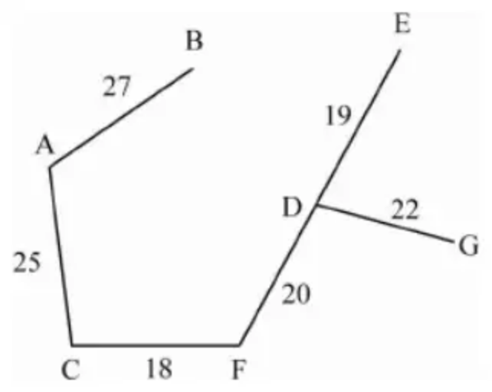
2.
Mark scheme (a)
Scheme | Marks
E.g. We would be able to find the shortest distance from J to every other vertex.  E.g. We would only need to apply Dijkstra’s algorithm once. | B1
 | (1)

Notes
a1B1 CAO
Mark scheme (b)
Scheme | Marks
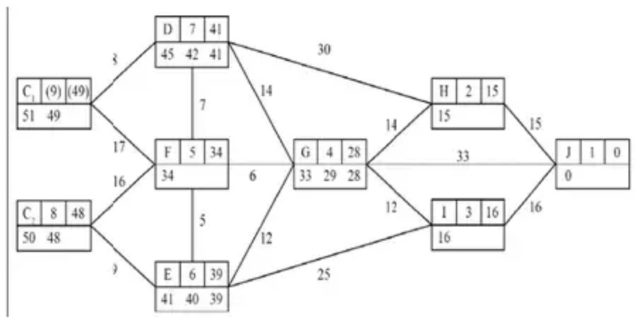 | M1  A1 (G, H, I J)  A1(D, E, F)  A1ft (C₁, C₂)
Shortest route is C₂EFGIJ  length 48 (miles) | A1  A1ft
 | (6)
 | (7 marks)

Notes
b1M1 A larger value replaced by a smaller value at least once in the working values at either G, E, D, C₁ or C₂.
b1A1 All values in G, H, I and J correct. The working values at G must be in the correct order. Condone lack of 0 in the working value at J.
b2A1 All values in D, E and F correct and the working values in the correct order. Penalise order of labelling only once per question. (F, E and D labelled in that order with G, H, I and J labelled before F).
b3A1ft All values in C₁ and C₂ ft correct and the working values in the correct order. Penalise order of labelling only once per question. (C₂ labelled after all other nodes (D to J) – condone lack of final value or order of labelling for C₁)
b4A1 Route CAO
b5A1ft Their final value ft (if answer is not 48 ft their final value at either C₁ or C₂ dependent on their route)
If the candidate uses either C₁ or C₂ as the starting vertex then this is not a misread. They can score a maximum of M1A0A0A0A1A1ft. If starting at:
C₁ – M1 for a larger value replaced by a smaller value at either C₂, F, G, H, I or J , then A0 A0 A0 then A1 for the route (C₁DFGIJ) and then A1 for 49 (or ft their final value at J).
C₂ – M1 for a larger value replaced by a smaller value at either C₁, F, G, H, I or J, then A0 A0 A0 then A1 for the route (C₂ EFGIJ) and then A1 for 48 (or ft their final value at J).
If the candidate uses both C₁ and C₂ as the starting vertices then award M1 for a larger value replaced by a smaller value at either F, G, H, I or J, then A0 A0 A0 then A1 for the correct route only (C₂ EFGIJ) and A1 for 48 (no ft).
3.
Mark scheme (a)
Scheme | Marks | AO
Time matrix  Route matrix | B1  B1 | 1.1b  1.1b
   | A | B | C | D | E
  A | – | 8 | 4 | 7 | ∞
  B | 8 | – | 3 | ∞ | 10
  C | 4 | 3 | – | ∞ | 6
  D | 7 | ∞ | 1 | – | 1
  E | ∞ | 10 | 6 | 1 | –
   | A | B | C | D | E
  A | A | B | C | D | E
  B | A | B | C | D | E
  C | A | B | C | D | E
  D | A | B | C | D | E
  E | A | B | C | D | E
 | (2)

Notes
(a) B1: Correct time matrix
B1: Correct route matrix
Mark scheme (b)
Scheme | Marks | AO
Time matrix  Route matrix  Time matrix  Route matrix | M1  A1  M1  A1 | 1.1b  1.1b  1.1b  1.1b
   | A | B | C | D | E
  A | – | 7 | 4 | 7 | 10
  B | 7 | – | 3 | 14 | 9
  C | 4 | 3 | – | 11 | 6
  D | 5 | 4 | 1 | – | 1
  E | 10 | 9 | 6 | 1 | –
   | A | B | C | D | E
  A | A | C | C | D | C
  B | C | B | C | C | C
  C | A | B | C | A | E
  D | C | C | C | D | E
  E | C | C | C | D | E
   | A | B | C | D | E
  A | – | 7 | 4 | 7 | 8
  B | 7 | – | 3 | 14 | 9
  C | 4 | 3 | – | 11 | 6
  D | 5 | 4 | 1 | – | 1
  E | 6 | 5 | 2 | 1 | –
   | A | B | C | D | E
  A | A | C | C | D | D
  B | C | B | C | C | C
  C | A | B | C | A | E
  D | C | C | C | D | E
  E | D | D | D | D | E
 | (4)

Notes
(b) M1: No change in the third row and third column of both matrices with at least one value in the time matrix reduced correctly and one value in the route matrix changed to C
A1: CAO
M1: No change in the fourth row and fourth column of both matrices with at least one value in the time matrix reduced correctly (follow through their first iteration) and one value in the route matrix changed to D
A1: CAO
Mark scheme (c)
Scheme | Marks | AO
(i) NNA: A – C – B – E – D – A | B1 | 1.1b
(ii) 4 + 3 + 9 + 1 + 5 = 22 minutes | dB1 | 1.1b
(iii) A – C – B – C – E – D – C – A | B1 | 3.2a
 | (3)
 | (9 marks)

Notes
(c)(i) B1: CAO
(c)(ii) dB1: CAO – not from A – C – D – E – B – A
(c)(iii) B1: CAO

