QQQ – Decision 1 – Chapter 3 – Algorithms on Graphs (Version 1)
Total Marks: 25
(25 = Platinum, 23 = Gold, 20 = Silver, 17 = Bronze)
1.
 | A | B | C | D | E | F
A | - | 135 | 180 | 70 | 95 | 225
B | 135 | - | 215 | 125 | 205 | 240
C | 180 | 215 | - | 150 | 165 | 155
D | 70 | 125 | 150 | - | 100 | 195
E | 95 | 205 | 165 | 100 | - | 215
F | 225 | 240 | 155 | 195 | 215 | -

The table shows the lengths, in km, of potential rail routes between six towns, A, B, C, D, E and F.
(a) Use Prim’s algorithm, starting from A, to find a minimum spanning tree for this table. You must list the arcs that form your tree in the order that they are selected. (3)
(b) Draw your tree using the vertices given in Diagram 1 in the answer book. (1)
(c) State the total weight of your tree. (1)
(Total 5 marks)
Edexcel D1 June 2009 Q1
2. The table below shows the lengths, in km, of the roads in a network connecting seven towns, A, B, C, D, E, F and G.
 | A | B | C | D | E | F | G
A | – | 24 | – | 22 | 35 | – | –
B | 24 | – | 25 | 27 | – | – | –
C | – | 25 | – | 33 | 31 | 36 | 26
D | 22 | 27 | 33 | – | – | 42 | –
E | 35 | – | 31 | – | – | 37 | 29
F | – | – | 36 | 42 | 37 | – | 40
G | – | – | 26 | – | 29 | 40 | –

(a) By adding the arcs from vertex D along with their weights, complete the drawing of the network on Diagram 1 in the answer book. (2)
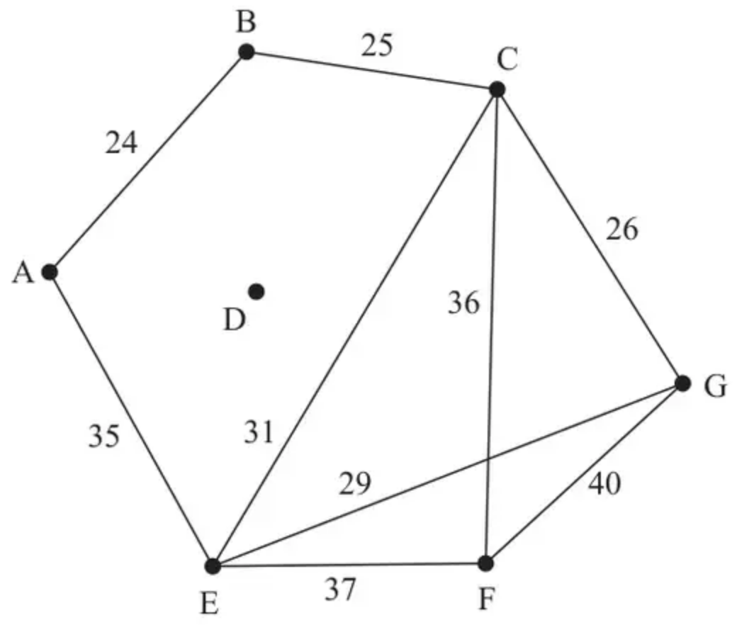
Diagram 1
(b) Use Kruskal’s algorithm to find a minimum spanning tree for the network. You should list the arcs in the order that you consider them. In each case, state whether you are adding the arc to your minimum spanning tree. (3)
(c) State the weight of the minimum spanning tree. (1)
(Total 6 marks)
Edexcel A2 October 2020 Q1
3.
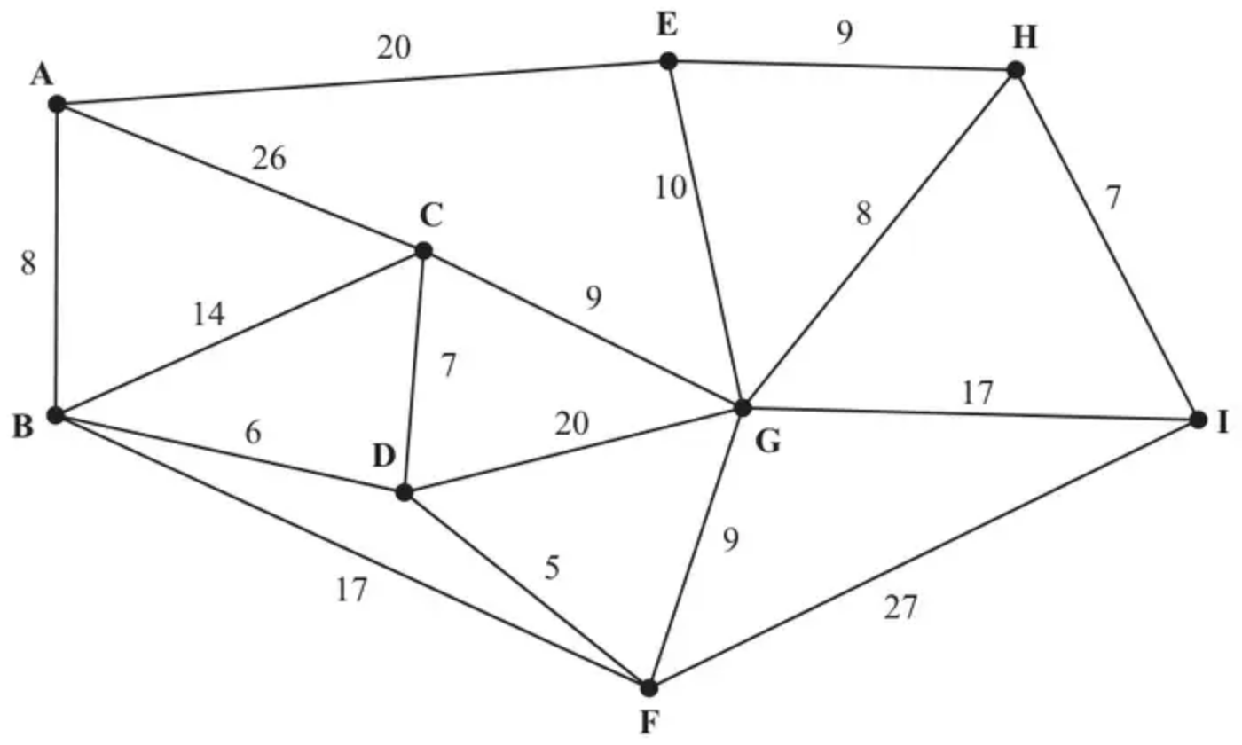
Figure 4
Figure 4 represents a network of roads. The number on each arc gives the length, in km, of that road.
(a) Use Dijkstra’s algorithm to find the shortest distance from A to I. State your shortest route. (6)
(b) State the shortest distance from A to G. (1)
(Total 7 marks)
Edexcel D1 June 2009 Q6
4.
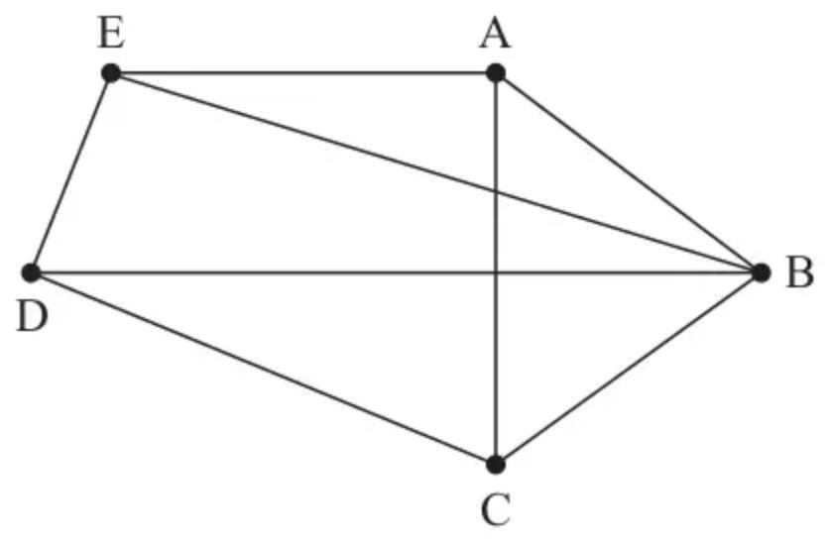
Figure 1
Figure 1 shows the graph G.
(a) State whether G is Eulerian, semi-Eulerian, or neither, giving a reason for your answer. (1)
(b) Write down an example of a Hamiltonian cycle on G. (1)
(c) State whether or not G is planar, justifying your answer. (1)
(d) State the number of arcs that would need to be added to G to make the graph $K_{5}$ (1)
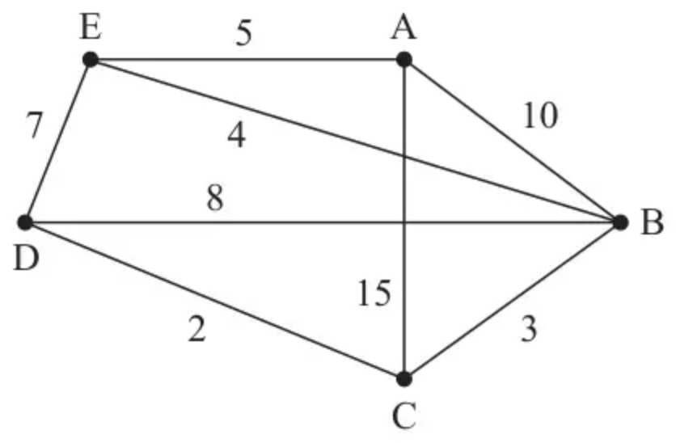
Figure 2
Direct roads between five villages, A, B, C, D and E, are represented in Figure 2. The weight on each arc is the time, in minutes, required to travel along the corresponding road. Floyd’s algorithm is to be used to find the complete network of shortest times between the five villages.
(e) For the network represented in Figure 2, complete the initial time matrix in the answer book. (1)
Initial time matrix (answer book)
 | A | B | C | D | E
A | –
B |  | –
C |  |  | –
D |  |  |  | –
E |  |  |  |  | –

The time matrix after four iterations of Floyd’s algorithm is shown in Table 1.
 | A | B | C | D | E
A | – | 10 | 13 | 15 | 5
B | 10 | – | 3 | 5 | 4
C | 13 | 3 | – | 2 | 7
D | 15 | 5 | 2 | – | 7
E | 5 | 4 | 7 | 7 | –

Table 1
(f) Perform the final iteration of Floyd’s algorithm that follows from Table 1, showing the time matrix for this iteration. (2)
(Total 7 marks)
Edexcel A2 June 2023 Q1
Solutions
1.
Mark scheme (a)
Scheme | Marks
AD, AE, DB; DC, CF | M1 A1;  A1
 | (3)

Notes
(a) 1M1: Using Prim – first 2 arcs probably but condone starting from another vertex.
1A1: first three arcs correct
2A1: all correct.
Apply the misread rule, if not listing arcs or not starting at A.
So for M1 (only)
Accept numbers across the top (condoning absence of 6)
Accept full vertex listing
Accept full arc listing starting from vertex other than A
[AD AE DB DC CF] | {1 4 5 2 3 6} | ADEBCF
BD AD AE CD CF | {3 1 5 2 4 6} | BDAECF
CD AD AE BD CF | {3 5 1 2 4 6} | CDAEBF
DA AE DB CD CF | {2 4 5 1 3 6} | DAEBCF
EA AD DB DC CF | {2 4 5 3 1 6} | EADBCF
FC CD AD AE BD | {4 6 2 3 5 1} | FCDAEB

Mark scheme (b)
Scheme | Marks
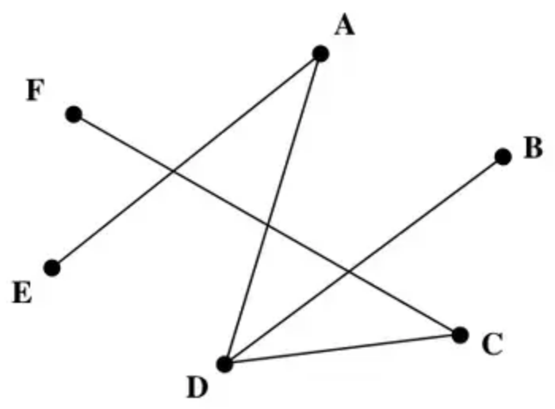 | B1
 | (1)

Notes
(b) 1B1: CAO
Mark scheme (c)
Scheme | Marks
Weight 595 (km) | B1
 | (1)
 | (5 marks)

Notes
(c) 1B1: CAO condone lack of km.
2.
Mark scheme (a)
Scheme | Marks | AO
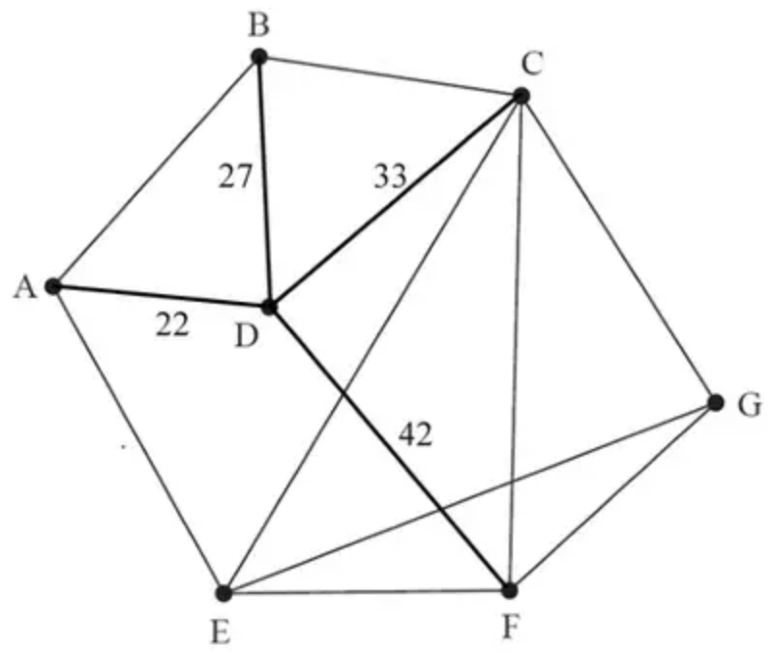 | M1  A1 | 1.1b  1.1b
 | (2)

Notes
(a) M1: Either all arcs correct (ignore weights) or two arcs correct (including correct weights)
A1: CAO
Mark scheme (b)
Scheme | Marks | AO
Kruskal’s algorithm: AD, AB, BC, CG, reject BD, EG, reject CE, reject CD, reject AE, CF (reject EF, reject FG, reject DF) | M1  A1  A1 | 1.1b  1.1b  1.1b
 | (3)

Notes
(b) M1: Kruskal’s algorithm – first three arcs correctly chosen and at least one rejection seen at some point
A1: All six arcs selected correctly AD, AB, BC, CG, EG, CF only
A1: CSO – all selections and rejections correct (in correct order and at the correct time)
Mark scheme (c)
Scheme | Marks | AO
Weight of MST: 162 (km) | B1 | 1.1b
 | (1)
 | (6 marks)

Notes
(c) B1: CAO (condone lack of units)
3.
Mark scheme (a)
Scheme | Marks
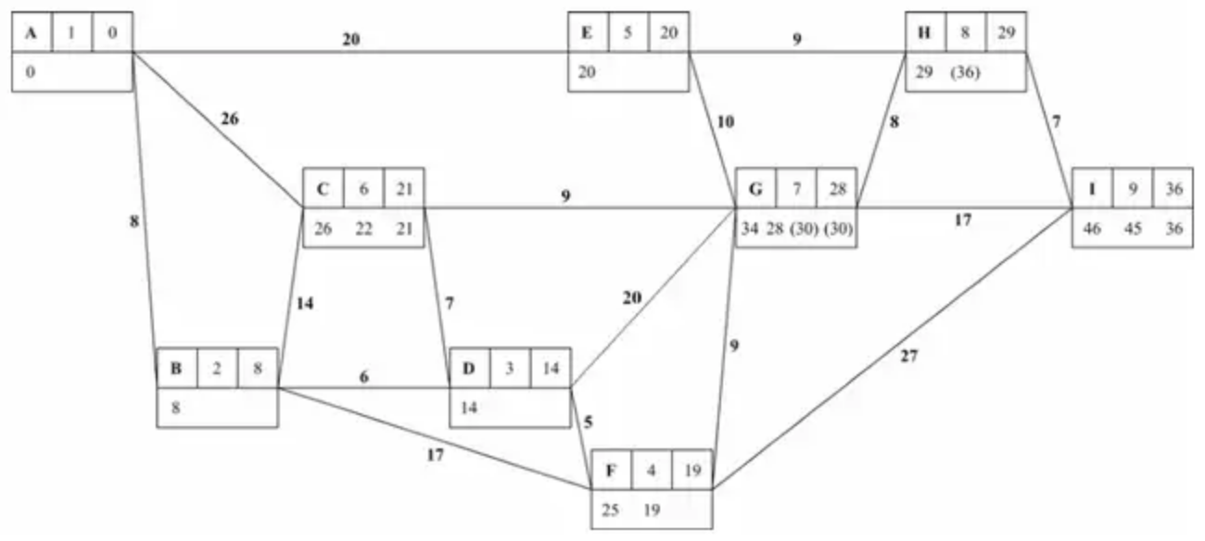 | M1  1A1  2A1ft  3A1ft  4A1ft
Route: A E H I | 5A1
 | (6)

Notes
(a) 1M1: Small replacing big in the working values at C or F or G or I
1A1: Everything correct in boxes at A, B, D and F
2A1ft: ft boxes at E and C handled correctly but penalise order of labelling only once
3A1ft: ft boxes at G and H handled correctly but penalise order of labelling only once
4A1ft: ft boxes at I handled correctly but penalise order of labelling only once
5A1: route cao A E H I
Mark scheme (b)
Scheme | Marks
Shortest distance from A to G is 28 km | B1ft
 | (1)
 | (7 marks)

Notes
(b) 1B1ft: ft their final label at G condone lack of km
4.
Mark scheme (a)
Scheme | Marks | AO
Graph G is neither as there are more than two vertices of odd degree | B1 | 2.4
 | (1)

Notes
B1: ‘Neither’ together with a correct reason (ignore irrelevant statements but do not isw incorrect statements)
Examples of B1:
• G contains more than 2 odd nodes
• G contains 4 odd nodes (or stating that A, C, D and E are odd)
• G contains (only) 1 even node
• The number of odd degree nodes in G is not 0 or 2
Examples of B0
• G contains odd nodes
• G contains at least 2 odd nodes
• G contains 4 nodes of degree 3 (not linking this to ‘odd’)
Mark scheme (b)
Scheme | Marks | AO
e.g. A – B – C – D – E – A | B1 | 1.1b
 | (1)

Notes
B1: CAO - must begin and end at the same node and include every other node in the graph exactly once. Accept if given in terms of arcs e.g. AC, CB, BD, DE, EA
Mark scheme (c)
Scheme | Marks | AO
G is planar as it can be drawn with no arcs intersecting/crossing each other  e.g.  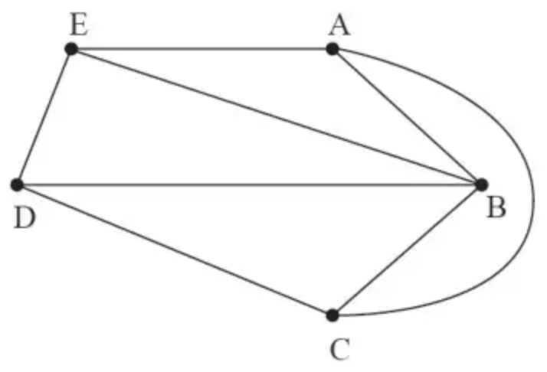 | B1 | 2.4
 | (1)

Notes
B1: Correct answer of planar + justification
Examples of correct justification:
• AC can be moved outside or EB, DB can be moved outside
• AC(O), BE(I), BD(I) (or vice-versa) accept just AC(O) or BE(O) and BD(O)
• A correct drawing of the graph as planar (condone nodes not being labelled)
Examples of insufficient justification:
• Move arc BE (or BD) outside (need to mention both)
• Move arcs outside so that no arcs cross each other (must give specific examples of which arc(s) are being moved outside)
• Comments about moving nodes
Mark scheme (d)
Scheme | Marks | AO
2 | B1 | 1.1b
 | (1)

Notes
B1: CAO (2 only)
Mark scheme (e)
Scheme | Marks | AO
 | B1 | 1.1b
   | A | B | C | D | E
  A | - | 10 | 15 | ∞ | 5
  B | 10 | - | 3 | 8 | 4
  C | 15 | 3 | - | 2 | ∞
  D | ∞ | 8 | 2 | - | 7
  E | 5 | 4 | ∞ | 7 | -
 | (1)

Notes
B1: CAO - no blanks entries (apart from the lead diagonal) and must include $\text{∞}$ in cells AD, CE, DA, EC)
Mark scheme (f)
Scheme | Marks | AO
 | M1  A1 | 1.1b  1.1b
   | A | B | C | D | E
  A | - | [9] | [12] | [12] | 5
  B | [9] | - | 3 | 5 | 4
  C | [12] | 3 | - | 2 | 7
  D | [12] | 5 | 2 | - | 7
  E | 5 | 4 | 7 | 7 | -
 | (2)
 | (7 marks)

Notes
M1: No change in the fifth row and fifth column with at least two values reduced correctly (no blank entries – apart from the lead diagonal)
A1: CAO for the final iteration

