QQQ – Decision 1 – Chapter 2 – Graphs and Networks (Version 2)
Total Marks: 22
(22 = Platinum, 20 = Gold, 18 = Silver, 15 = Bronze)
1. Explain what is meant by a planar graph. (2)
(Total 2 marks)
Edexcel D1 June 2007 Q1
2.
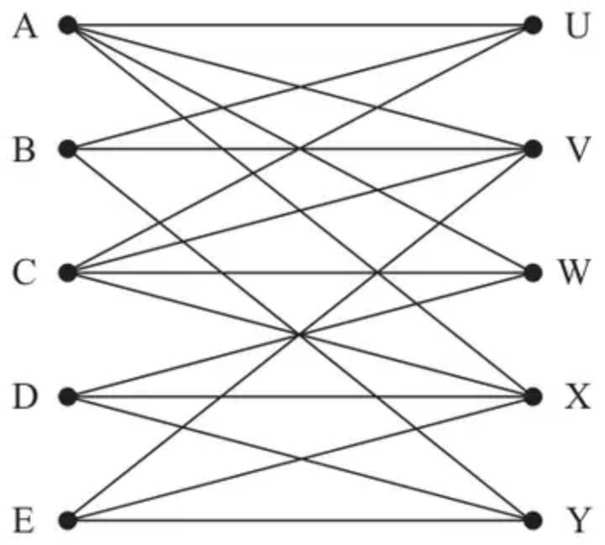
Figure 1
A Hamiltonian cycle for the graph in Figure 1 begins C, V, E, X, A, W, ….
(a) Complete the Hamiltonian cycle. (1)
(b) Hence use the planarity algorithm to determine whether the graph shown in Figure 1 is planar. You must make your working clear and justify your answer. (3)
(Total 4 marks)
Edexcel A2 October 2021 Q1
3.
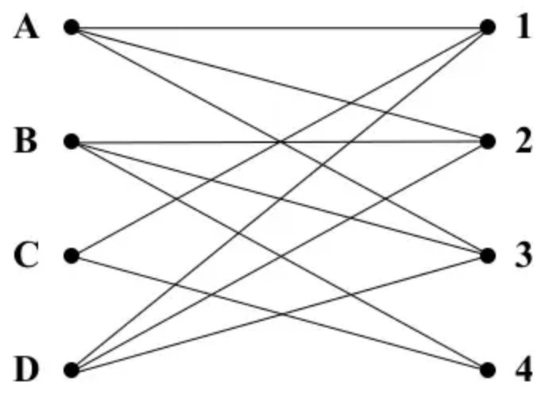
Figure 3
(a) Write down the name given to the type of graph drawn in Figure 3. (1)
A Hamiltonian cycle for the graph in Figure 3 begins A, 3, B, … .
(b) Complete this Hamiltonian cycle. (2)
(c) Starting with the Hamiltonian cycle found in (b), use the planarity algorithm to determine if the graph is planar. (3)
(Total 6 marks)
Edexcel D1 January 2007 Q3
4. A simply connected graph is a connected graph in which any two vertices are directly connected by at most one arc and no vertex is directly connected to itself.
(a) Given that a simply connected graph has exactly four vertices,
(i) write down the minimum number of arcs it can have,
(ii) write down the maximum number of arcs it can have. (2)
(b)
(i) Draw a simply connected graph that has exactly four vertices and exactly five arcs.
(ii) State, with justification, whether your graph is Eulerian, semi-Eulerian or neither. (3)
(c) By considering the orders of the vertices, explain why there is only one simply connected graph with exactly four vertices and exactly five arcs. (5)
(Total 10 marks)
Edexcel AS June 2018 Q2
Solutions
1.
Scheme | Marks
A graph is planar if it can be drawn in a plane in such a way that no two edges meet each other, except at a vertex to which they are both incident | B2, 1, 0
 | (2 marks)

2.
Mark scheme (a)
Scheme | Marks | AO
…, D, Y, B, U, C | B1 | 1.1b
 | (1)

Notes
(a) B1: CAO (CVEXAWDYBUC) – must return to C
Mark scheme (b)
Scheme | Marks | AO
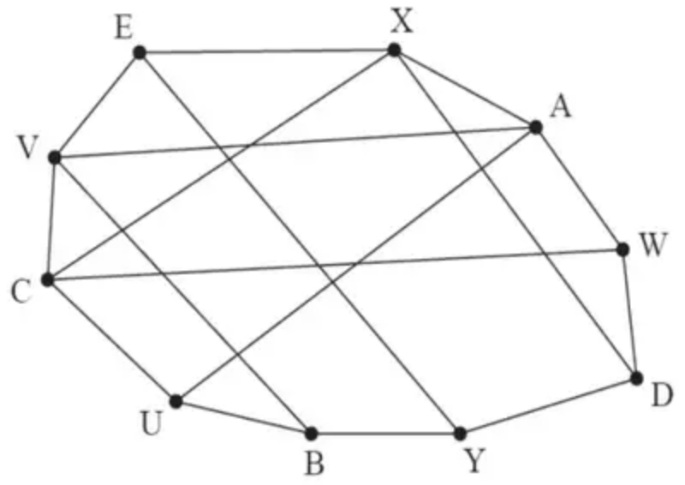  Or list of arcs: AU, AV, BV, CW, CX, DX, EY | M1 | 2.1
e.g., select (and label) AU (as I) and the arcs that intersect AU are BV, EY, CW and DX (so label them O so AU(I), AV, BV(O), CW(O), CX, DX(O), EY(O)) | A1 | 1.1b
Edges BV and CW intersect and so the graph is not planar (oe) | A1 | 2.2a
 | (3)
 | (4 marks)

Notes
(b) M1: Either draws their Hamiltonian cycle from part (a) as the edges of a polygon and shows the remaining arcs intersecting inside OR lists the arcs that are not part of the Hamiltonian cycle
A1: Selects any arc (that is not part of the Hamiltonian cycle) and lists/references the correct arcs that intersect with this selected arc – dependent on any correct Hamiltonian cycle and correct arcs that are not part of this cycle
A1: cao – based on their initial arc selection, states the two arcs that are unlabelled (or that are labelled with the same label) which intersect each other (e.g., if CX chosen as the initial selection then this arc intersects with BV, EY and AV but EY and AV intersect) and concludes that the graph is not planar. This mark is dependent on the correct Hamiltonian cycle stated in either (a) or (b)
3.
Mark scheme (a)
Scheme | Marks
A bipartite graph | B1
 | (1)

Mark scheme (b)
Scheme | Marks
A, 3, B, 4, C, 1, D, 2, A | B2,1,0
 | (2)

Mark scheme (c)
Scheme | Marks
Redrawing  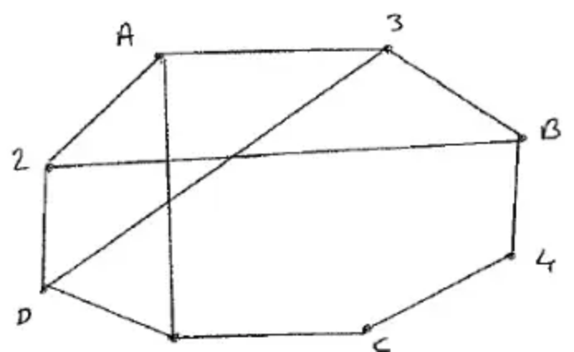 | M1  A1
Identifying that it is not planar | A1ft
 | (3)
 | (6 marks)

4.
Mark scheme (a)
Scheme | Marks | AO
Minimum number of arcs is 3 | B1 | 2.2a
Maximum number of arcs is 6 | B1 | 2.2a
 | (2)

Notes
B1: Cao
B1: Cao
Mark scheme (b)
Scheme | Marks | AO
(i) e.g.  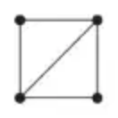 | B1 | 1.1b
(ii) The graph has exactly two odd nodes and so the graph is semi-Eulerian | B1  DB1 | 2.4  2.2a
 | (3)

Notes
(b)(i) B1: Cao oe (vertices must be clear)
(b)(ii) B1: Explanation which consists of the graph having two odd nodes (or consistent explanation with their graph in (b)(i))
DB1: Exactly (or only) two odd nodes together with the deduction that therefore the graph is semi-Eulerian (from a correct graph only in (b)(i))
Mark scheme (c)
Scheme | Marks | AO
The sum of the orders of the vertices = 2(number of arcs) = 10 | B1 | 1.2
One possibility is that the orders are 1, 3, 3 and 3 | M1 | 2.1
In a simply connected graph with four vertices each of the vertices of order 3 must connect to the three other vertices therefore it is not possible to have three vertices all with order 3 | A1 | 2.4
The second possibility is that the orders are 2, 2, 3 and 3 | M1 | 2.1
There is only one way to make a graph with vertices of orders 2, 2, 3 and 3 as the two vertices of order 2 cannot be connected to each other (note that as the graph is connected no vertex can have order 0). There are no other possible graphs as the maximum order of a vertex is 3 (due to the condition that the graph must be simple) | A1 | 2.2a
 | (5)
 | (10 marks)

Notes
B1: 10 seen – this mark can be implied if two or more lists of four numbers which sum to 10 are seen
M1: States that the vertex orders could be 1, 3, 3, 3 or that no vertex can have an order greater than 3
A1: Convincing argument that 1, 3, 3, 3 is not possible
M1: Considers the possibility of the orders being 2, 2, 3, 3
A1: Convincing argument that there is only one way of making a graph with vertex orders of 2, 2, 3, 3 (e.g. mention of the fact that the two vertices of order 2 cannot be connected to each other)
For full marks in (c) – there must be some mention of the fact that there cannot be a vertex with order greater than 3 (withhold last A mark if this point is not considered)

