QQQ – Decision 1 – Chapter 2 – Graphs and Networks (Version 1)
Total Marks: 25
(25 = Platinum, 23 = Gold, 20 = Silver, 17 = Bronze)
1. Explain what is meant, in a network, by
(a) a walk, (2)
(b) a tour. (2)
(Total 4 marks)
Edexcel D2 June 2008 Q2
2.
(a) Draw the graph ${\text{K}}_{5}$ (1)
(b)
(i) In the context of graph theory explain what is meant by ‘semi-Eulerian’.
(ii) Draw two semi-Eulerian subgraphs of ${\text{K}}_{5}$, each having five vertices but with a different number of edges. (3)
(c) Explain why a graph with exactly five vertices with vertex orders 1, 2, 2, 3 and 4 cannot be a tree. (2)
(Total 6 marks)
Edexcel AS June 2019 Q1
3.
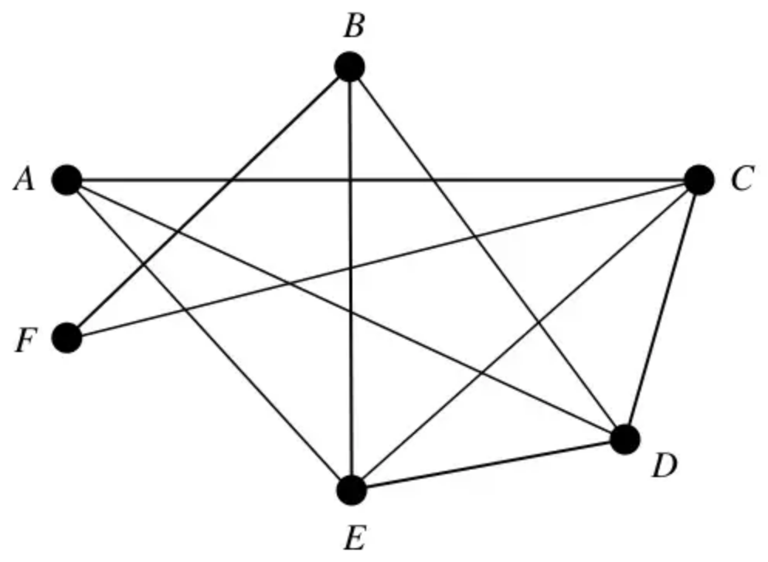
Figure 1
(a) Starting from $A$; write down a Hamiltonian cycle for the graph in Figure 1. (2)
(b) Use the planarity algorithm to show that the graph in Figure 1 is planar. (3)
Arcs $AF$ and $EF$ are now added to the graph.
(c) Explain why the new graph is not planar. (2)
(Total 7 marks)
Edexcel D1 June 2005 Q2
4.
(a) Explain why it is not possible to draw a graph with exactly six nodes with degrees 1, 2, 3, 4, 5 and 6 (1)
A tree, T, has exactly six nodes. The degrees of the six nodes of T are
$1 2 (4−x) (2x−5) (4x−11) (3x−5)$
where $x$ is an integer.
(b) Explain how you know that T cannot be Eulerian. (1)
(c)
(i) Determine the value of $x$
(ii) Hence state whether T is semi-Eulerian or not. You must justify your answer. (5)
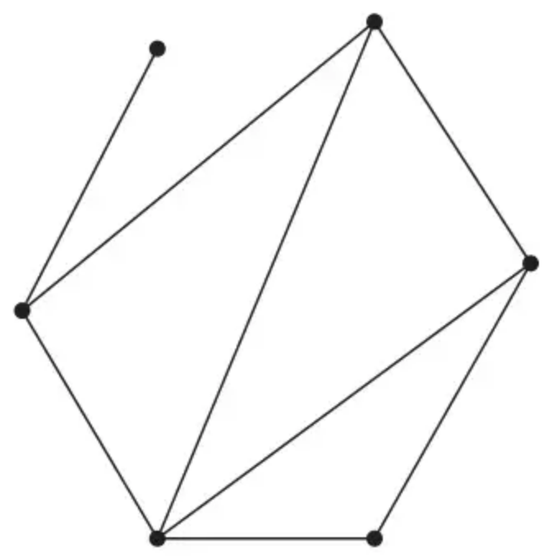
Figure 2
Figure 2 shows a graph, G, with six nodes with degrees 1, 2, 3, 3, 3 and 4
(d) Using the vertices in Diagram 1 in the answer book, draw a graph with exactly six nodes with degrees 1, 2, 3, 3, 3 and 4 that is not isomorphic to G. (1)
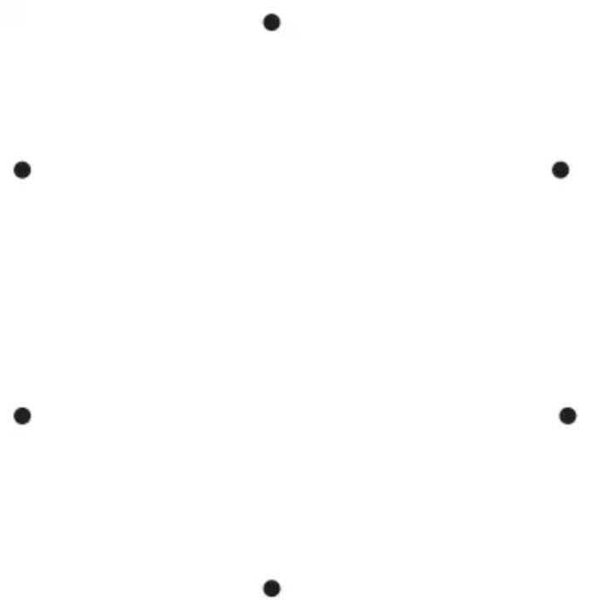
Diagram 1
(Total 8 marks)
Edexcel A2 June 2024 Q4
Solutions
1.
Mark scheme (a)
Scheme | Marks
A walk is a finite sequence of arcs such that the end vertex of one arc is the start vertex of the next. | B2, 1, 0
 | (2)

Notes
1B1: Probably one of the two below but accept correct relevant statement – bod gets B1, generous.
2B1: A good clear complete answer: End vertex = start vertex + finite.
Mark scheme (b)
Scheme | Marks
A tour is a walk that visits every vertex, returning to its starting vertex. | B2, 1, 0
 | (2)
 | (4 marks)

Notes
1B1: Probably one of the two below but accept correct relevant statement – bod gets B1, generous.
2B1: A good clear complete answer: Every vertex + return to start.
From the D1 and D2 glossaries
D1
A path is a finite sequence of edges, such that the end vertex of one edge in the sequence is the start vertex of the next, and in which no vertex appears more than once.
A cycle (circuit) is a closed path, ie the end vertex of the last edge is the start vertex of the first edge.
D2
A walk in a network is a finite sequence of edges such that the end vertex of one edge is the start vertex of the next.
A walk which visits every vertex, returning to its starting vertex, is called a tour.
2.
Mark scheme (a)
Scheme | Marks | AO
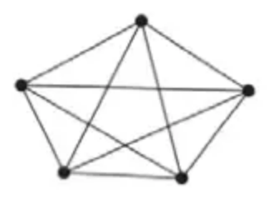 | B1 | 1.2
 | (1)

Notes
B1: CAO (give bod for position of nodes)
Mark scheme (b)
Scheme | Marks | AO
(i) A semi-Eulerian graph contains exactly two nodes of odd order (and any number of nodes of even order) | B1 | 2.5
(ii) e.g. (two semi-Eulerian subgraphs of ${\text{K}}_{5}$ with a different number of edges)  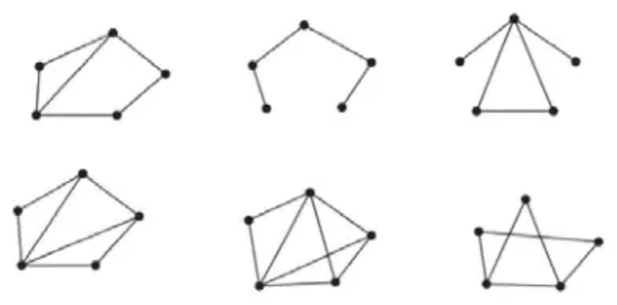 | B1  B1 | 1.1b  1.1b
 | (3)

Notes
(b)(i) B1: CAO (accept ‘there are exactly two odd nodes’ but must contain exact oe (e.g. ‘only two odd nodes’ or ‘all but 2 nodes have an even order’ but not ‘the graph has two odd nodes’))
(b)(ii) B1: One correct semi-Eulerian subgraph of ${\text{K}}_{5}$ with five nodes
B1: Two correct semi-Eulerian subgraphs of ${\text{K}}_{5}$ with five nodes – note that the graphs must have a different number of edges
Mark scheme (c)
Scheme | Marks | AO
e.g. The graph with five vertices has $\frac{1+2+2+3+4}{2}=6$ arcs but a tree on five nodes would contain only 4 arcs | B1  B1dep | 2.2a  2.4
 | (2)
 | (6 marks)

Notes
B1: Deducing that the graph has 6 arcs or a tree on five nodes has 4 arcs or the node of order 4 must be connected to the other 4 nodes or an argument based on the sum of the orders of both the graph and the tree (but must relate the orders to the number of arcs and not the number of nodes) or the node with order 4 and one of the nodes of orders 2 or 3 would create a cycle or a tree must have two nodes of order 1
B1dep: Complete argument – graph has 6 arcs and the tree would only have 4 arcs or the sum of the orders is 12 compared to 8 for the tree or the node of order 4 must be connected to the other 4 nodes therefore all the other vertices would have to have order 1 or the graph has 6 arcs and therefore with 5 vertices there would have to be cycles or the node of order 4 is connected to the other 4 nodes and so together with the node of order 3 (or 2) a cycle would be formed or a tree must have at least two nodes of order 1 as otherwise a cycle would be formed
Note: no marks in (c) for attempts based only on examples of graphs drawn with the vertex orders as stated
3.
Mark scheme (a)
Scheme | Marks
e.g. $AEBFCDA$ | M1 A1
 | (2)

Mark scheme (b)
Scheme | Marks
e.g.  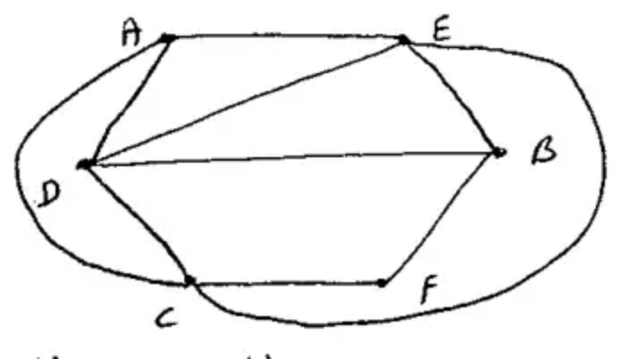 | M1 A1 A1
 | (3)

Mark scheme (c)
Scheme | Marks
State that one of these arcs ($AF$ or $EF$) [Named], crosses at least one arc in each set. [Named arcs] | B2,1,0
 | (2)
 | (7 marks)

4.
Mark scheme (a)
Scheme | Marks | AO
e.g. A graph cannot contain an odd number of odd vertices  e.g. $\frac{1+2+3+4+5+6}{2}=10.5$ which is not an integer and so therefore not possible to have a graph with the given vertex orders | B1 | 1.2
 | (1)

Notes
(a) In a and b condone poor language such as number of odd degrees instead of number of odd nodes
B1: CAO – common examples that score B1:
• Cannot have (a graph with an) odd number of odd vertices
• Cannot have a graph with three odd vertices
• The sum of the degrees/order (of the vertices) is 21 which is not even therefore not possible (but not just for obtaining 21 and saying ‘impossible’). The 21 must be linked either in words to the ‘sum of the degrees/order’ or explicitly showing 1+ 2 + 3 + 4 + 5 + 6 = 21 so just ’21 is not even’ scores B0
• The sum of the degrees/order (of the vertices) is 21 which is odd therefore not possible (with equivalent justification of the 21 as in the previous bullet-point)
• $\frac{1+2+3+4+5+6}{2}=10.5$ which is not an integer so therefore impossible. They do not have to explain that they are using the result that $∑\text{vertex degrees}=2(\text{no of arcs})$ but they must explain why a value of 10.5 leads to the required graph not being possible. A value of 10.5 with no working (or explanation) scores B0
Mark scheme (b)
Scheme | Marks | AO
e.g.  T has at least one node of degree one or one node with odd degree | B1 | 2.4
 | (1)

Notes
(b) B1: CAO – correct reasoning that not all the vertices of T can have an even degree. Allow for this mark a general statement that no tree can be Eulerian as all trees contain at least two nodes of degree 1. Allow as a minimum statement that at least one of the nodes has a degree of 1 or at least one odd node (accept valency instead of degree or order)
Mark scheme (c)
Scheme | Marks | AO
6 nodes in T therefore the tree contains 5 arcs | B1 | 1.2
$1+2+(4−x)+(2x−5)+(4x−11)+(3x−5)=2(5)$  $(8x−14=10)$ | M1 | 3.1a
$x=3$ | A1 | 1.1b
Alternatively
$\begin{matrix}4−x>0 & ⇒x<4 & 4−x⩾1 & ⇒x⩽3 \\ 2x−5>0 & ⇒x>2.5 & 4x−11⩾1 & ⇒x⩾3 \\ 2.5<x<4 & ⇒x=3 & & ⇒x=3\end{matrix}$
Therefore, the degrees of the nodes are 1, 2, 1, 1, 1 and 4 | M1 | 2.1
T is not semi-Eulerian as there are more than two nodes of odd degree | A1 | 2.2a
 | (5)

Notes
B1: correctly using the fact that the number of arcs in T is 5 (possibly implied by later working – e.g. forming an equation for the sum of nodes = 2 x 5) An answer of $x=3$ from correct working implies this mark.
Alternative approach either $4−x>0⇒x<4$ or $2x−5>0⇒x>2.5$
May use $4x−11⩾1⇒x⩾3$
M1: Forming an equation involving the degree of the six nodes and 2(5).
Alternative approach both inequalities stated and combined to obtain range of values for $x$
A1: CAO ($x=3$) – must come from correct working
M1: Calculating the degree of the remaining vertices using their value of $x$. As a minimum we must see correct values for at least two more odd nodes. Must have an integer value for $x$ (this can be implied by sight of 1, 2, 1, 1, 1, 4) Alternatively may clearly use $x=3$ is odd and deduce that there are at least three odd nodes
A1: CAO (not Semi-Eulerian) – with correct reasoning
Mark scheme (d)
Scheme | Marks | AO
e.g.  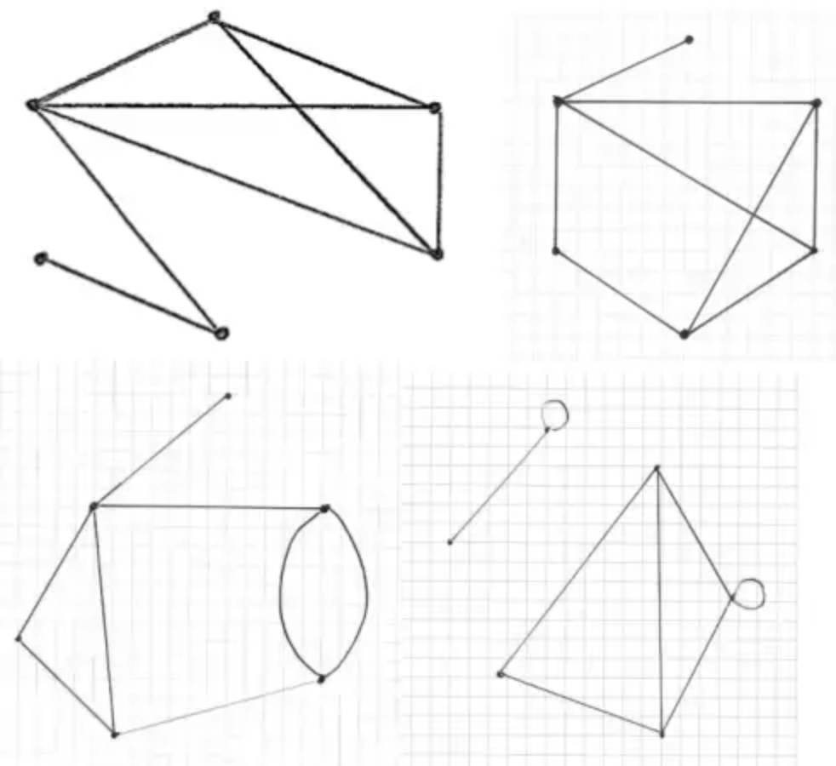 | B1 | 1.1b
 | (1)
 | (8 marks)

Notes
B1: CAO (any graph that is not isomorphic to G – must contain exactly 8 arcs) If a simple, connected graph the vertex with degree 1 must connect to either the vertex of degree 2 or degree 4. Note this does not have to be a simple graph and may not be connected
(Degrees are 1, 2, 3, 3, 3, 4)

