QQQ – Decision 1 – Chapter 1 – Algorithms (Version 2)
Total Marks: 22
(22 = Platinum, 20 = Gold, 18 = Silver, 15 = Bronze)
1.
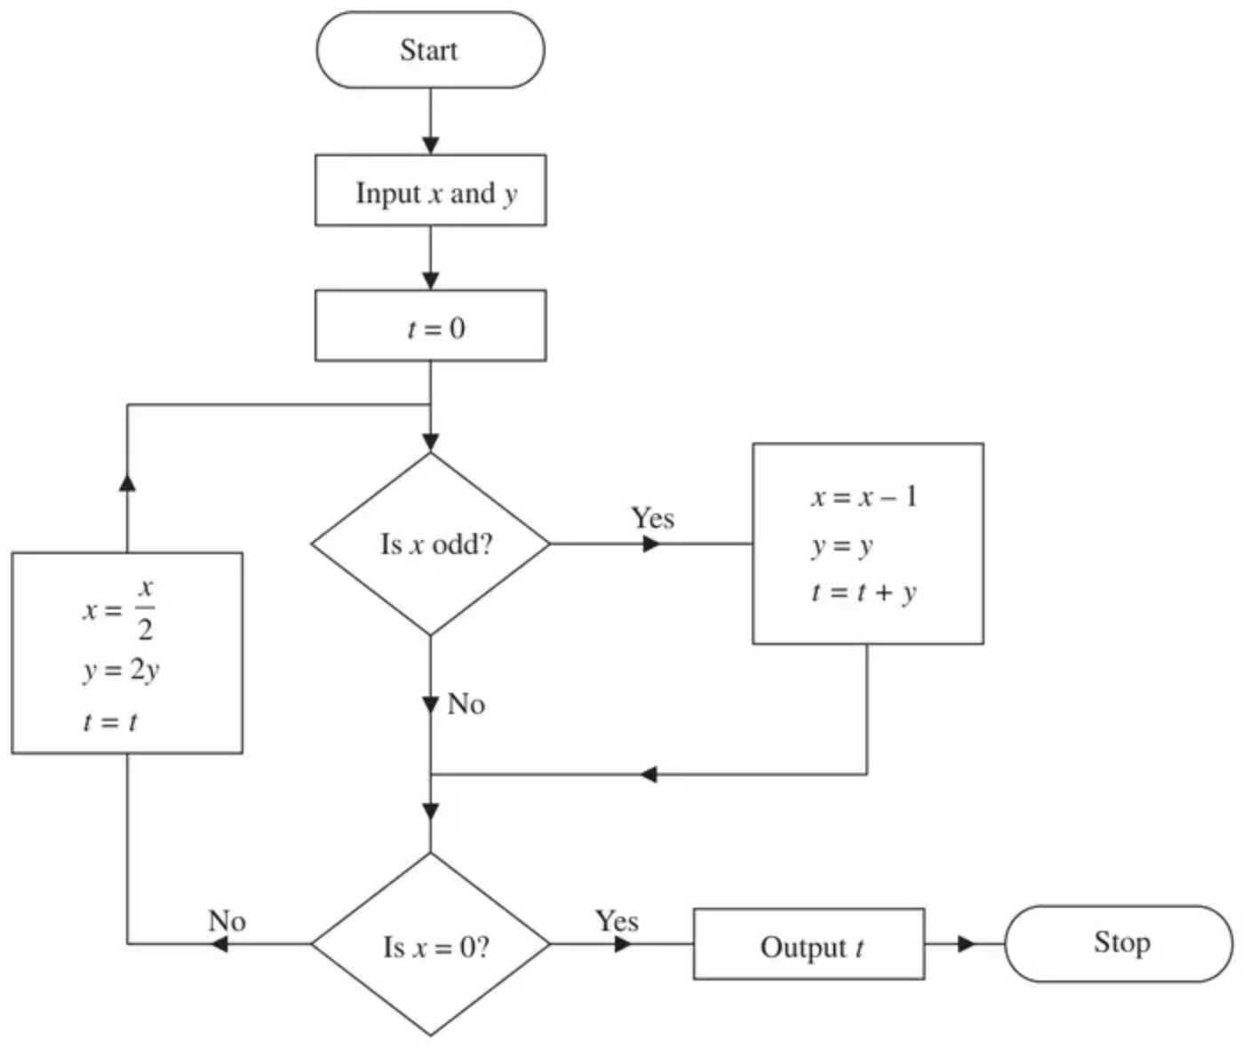
Figure 4
An algorithm is described by the flow chart shown in Figure 4.
Given that $x=27$ and $y=5$,
(a) complete the table in the answer book to show the results obtained at each step when the algorithm is applied. Give the final output. (4)
The numbers 122 and $\frac{1}{2}$ are to be used as inputs for the algorithm described by the flow chart.
(b)
(i) State, giving a reason, which number should be input as $x$.
(ii) State the output. (3)
(Total 7 marks)
Edexcel D1 June 2016 Q5
2. The nine distinct numbers in the following list are to be packed into bins of size 50
23 | 17 | 19 | $x$ | 24 | 8 | 18 | 10 | 21

When the first-fit bin packing algorithm is applied to the numbers in the list it results in the following allocation.
Bin 1: | 23 17 8
Bin 2: | 19 $x$ 10
Bin 3: | 24 18
Bin 4: | 21

(a) Explain why $13<x<21$ (3)
The same list of numbers is to be sorted into descending order. A bubble sort, starting at the left-hand end of the list, is to be used to obtain the sorted list. After the first complete pass the list is
23 | 19 | 17 | 24 | $x$ | 18 | 10 | 21 | 8

(b) Using this information, write down the smallest interval that must contain $x$, giving your answer as an inequality. (2)
When the first-fit decreasing bin packing algorithm is applied to the nine distinct numbers it results in the following allocation.
Bin 1: | 24 23
Bin 2: | 21 19 10
Bin 3: | 18 17 $x$
Bin 4: | 8

Given that only one of the bins is full and that $x$ is an integer,
(c) calculate the value of $x$. You must give reasons for your answer. (2)
(Total 7 marks)
Edexcel A2 October 2020 Q5
3.
2.1 | 1.7 | 3.0 | 1.9 | 3.2 | 1.2 | 3.3 | 1.4 | 1.5 | 0.2

(a) Use the first-fit bin packing algorithm to determine how the numbers listed above can be packed into bins of size 5 (2)
The list of numbers is now to be sorted into descending order.
(b) Perform a quick sort on the original list to obtain the sorted list. You should show the result of each pass and identify your pivots clearly. (4)
For a list of $n$ numbers, the quick sort algorithm has, on average, order $nlog⁡n$.
Given that it takes 2.32 seconds to run the algorithm when $n=450$
(c) calculate approximately how long it will take, to the nearest tenth of a second, to run the algorithm when $n=11250$. You should make your method and working clear. (2)
(Total 8 marks)
Edexcel A2 June 2019 Q1
Solutions
1.
Mark scheme (a)
Scheme | Marks
 | M1 (3 rows + 1st correct)  A1 (2nd and 3rd rows correct)  A1 (4th, 5th and 6th rows correct)
  $x$ | $y$ | $t$ | Is $x$ odd? | Is $x=0$?
  27 | 5 | 0 | Yes
  26 | (5) | 5 |  | No | Row 1
  13 | 10 | (5) | Yes |  | Row 2
  12 | (10) | 15 |  | No | Row 3
  6 | 20 | (15) | No | No | Row 4
  3 | 40 | (15) | Yes |  | Row 5
  2 | (40) | 55 |  | No | Row 6
  1 | 80 | (55) | Yes
  0 | (80) | 135 |  | Yes
   |  | (135)
Output = 135 | A1 (CSO)
 | (4)

Notes
Candidates may write each changed value/statement in a new row which is fine. Assume that each row begins and ends when a value in $x$ is changed. For example, the values in row 1 in the table above consists of the $x$ values going from the 26 to the 13
a1M1: At least three rows of cells in columns $x$, $y$ and $t$ completed with a correct first row (so 26 for $x$ and 5 for $t$)
a1A1: CAO – second and third rows correct (for just the columns in $x$, $y$ and $t$)
a2A1: CAO – fourth, fifth and sixth rows correct (for just the columns in $x$, $y$ and $t$)
a3A1: CSO – including the output of 135 either on the given line in the answer book or clearly stated in the table but it must be absolutely clear that the output is the final $t$ value (no bod). Furthermore, all ‘yes’ and ‘no’ comments must be present in the 4th and 5th columns with no additional/incorrect ‘yes’ or ‘no’
Mark scheme (b)
Scheme | Marks
(i) $x$ must be a (positive) integer and therefore $x=122$ | B1 DB1
(ii) 61 | B1
 | (3)
 | (7 marks)

Notes
bi1B1: $x$ must be 122 and any attempt at a reason
bi2DB1: Dependent on previous B mark (so B0B1 is not possible) – 122 and a correct valid reason – e.g. $x$ must be an integer/whole number or ½ is not odd or even or if you input ½ then you can never get to $x=0$ when halving, etc. Just saying that the algorithm ‘won’t work’ or that the algorithm ‘will get stuck in a loop’ or ‘not terminate’ is not sufficient for this second mark neither is the argument of subtracting 1 from a ½. It must be clear why the algorithm won’t output a value for $t$ with $x=\frac{1}{2}$ - so essentially there needs to be some indication of why $x$ will never become 0. Furthermore, just saying that $x$ will never reach 0 is insufficient – we need an indication of why $x=0$ is not possible with a starting value of $x=\frac{1}{2}$
bii3B1: CAO
2.
Mark scheme (a)
Scheme | Marks | AO
If $x$ has been placed in Bin 2 then $10<x⩽31$ - this is because Bin 1 at this stage only contains 40 and before $x$ had been placed in Bin 2 it only contained 19
As the 18 has been placed in Bin 3 this implies that $x>50−(19+18)$ so $x>13$ | B1 | 3.1a
As the 10 has been placed in Bin 2 after the $x$ then $x⩽50−(19+10)$ so $x⩽21$ | B1 | 2.4
However, the number are all distinct and therefore $13<x<21$ | B1 | 2.2a
 | (3)

Notes
(a) B1: Correct reasoning of why $x>13$ accept $x>50−(19+18)$
B1: Correct explanation of why $x⩽21$ accept $x⩽50−(19+10)$
B1: Correct deduction that $13<x<21$ must mention that the numbers are distinct (oe)
Mark scheme (b)
Scheme | Marks | AO
$13<x<17$ | B1  B1 | 2.2a  2.2a
 | (2)

Notes
(b) B1: Use first complete pass to deduce that $x<17$
B1: Correct lower bound of $x>13$
Mark scheme (c)
Scheme | Marks | AO
If $x$ has been placed in Bin 3 then this implies that $x⩽15$ | M1 | 2.4
So $x$ is either 14 or 15 – but as Bin 2 is full $⇒x=14$ | A1 | 2.2a
 | (2)
 | (7 marks)

Notes
(c) M1: Using first-fit decreasing in an attempt to derive new upper bound for $x$ (so either for stating both $x$ could equal 14 or 15, $x⩽15$ or $x<15$)
A1: Correct deduction that $x=14$ (must clearly state or imply that Bin 2 is full)
3.
Mark scheme (a)
Scheme | Marks | AO
Bin 1: 2.1 1.7 1.2  Bin 2: 3.0 1.9  Bin 3: 3.2 1.4 0.2  Bin 4: 3.3 1.5 | M1  A1 | 1.1b  1.1b
 | (2)

Notes
PLEASE NOTE NO MISREADS IN PARTS (a) and (b) – MARK ACCORDING TO THE SCHEME AND THE SPECIAL CASE FOR ASCENDING ORDER IN (b)
(a) M1: First six items placed correctly and at least eight values placed in bins - condone cumulative totals for M1 only (the underlined values)
A1: CSO – all correct (so no additional/repeated values)
Mark scheme (b)
Scheme | Marks | AO
e.g. middle right | M1  A1  A1ft  A1 | 1.1b  1.1b  1.1b  1.1b
  2.1 | 1.7 | 3.0 | 1.9 | 3.2 | $\boxed{1.2}$ | 3.3 | 1.4 | 1.5 | 0.2 | Pivot: 1.2
  2.1 | 1.7 | 3.0 | 1.9 | $\boxed{3.2}$ | 3.3 | 1.4 | 1.5 | $\overset{‾}{1.2}$ | 0.2 | Pivot(s): 3.2 (0.2)
  3.3 | $\overset{‾}{3.2}$ | 2.1 | 1.7 | 3.0 | $\boxed{1.9}$ | 1.4 | 1.5 | $\overset{‾}{1.2}$ | 0.2 | Pivot(s): (3.3) 1.9
  3.3 | $\overset{‾}{3.2}$ | 2.1 | $\boxed{3.0}$ | $\overset{‾}{1.9}$ | 1.7 | $\boxed{1.4}$ | 1.5 | $\overset{‾}{1.2}$ | 0.2 | Pivots: 3.0 1.4
  3.3 | $\overset{‾}{3.2}$ | $\overset{‾}{3.0}$ | 2.1 | $\overset{‾}{1.9}$ | 1.7 | $\boxed{1.5}$ | $\overset{‾}{1.4}$ | $\overset{‾}{1.2}$ | 0.2 | Pivot(s): (2.1) 1.5
  3.3 | $\overset{‾}{3.2}$ | $\overset{‾}{3.0}$ | 2.1 | $\overset{‾}{1.9}$ | 1.7 | $\overset{‾}{1.5}$ | $\overset{‾}{1.4}$ | $\overset{‾}{1.2}$ | 0.2
 | (4)

Notes
(b) M1: Quick sort, pivot, p, chosen (must be choosing middle left or right – choosing first/last item as the pivot is M0). After the first pass the list must read (values greater than the pivot), pivot, (values less that the pivot). If only choosing one pivot per iteration then max of M1A1 only – Bubble sort is not a MR and scores M0
A1: First pass correct and next pivots chosen correctly for the second pass (but the second pass does not need to be correct) – so they must be choosing (if middle right) a pivot value of 3.2 for the second pass or (if middle left) a pivot value of 1.9
A1ft: Second and third passes correct (follow through from their first pass and choice of pivots). They do not need to be choosing a pivot for the fourth pass for this mark
A1: CSO (correct solution only – all previous marks in this part must have been awarded) including if middle right a fifth pass with the 1.5 used as a pivot or if middle left a fourth pass with the 1.7 used as a pivot
Sorting list into ascending order in (b)
• If the candidate sorts the list into ascending order and reverses the list in this part then this can score full marks in (b)
• If the list is not reversed in (b) then remove the last two A marks earned in (b). If the candidate says that the list needs reversing in (b) but does not actually show the reversed list in (b) then remove the last A mark earned
• Note that if sorting into ascending order then a ‘sort complete’ statement is required – this could be shown by the final list being re-written or ‘sorted’ statement or each item being used as a pivot (which would therefore mean that the final list would have been written twice) BEFORE list is reversed
Middle left
2.1 | 1.7 | 3.0 | 1.9 | $\boxed{3.2}$ | 1.2 | 3.3 | 1.4 | 1.5 | 0.2
3.3 | $\overset{‾}{3.2}$ | 2.1 | 1.7 | 3.0 | $\boxed{1.9}$ | 1.2 | 1.4 | 1.5 | 0.2
3.3 | $\overset{‾}{3.2}$ | $\boxed{2.1}$ | 3.0 | $\overset{‾}{1.9}$ | 1.7 | 1.2 | $\boxed{1.4}$ | 1.5 | 0.2
3.3 | $\overset{‾}{3.2}$ | 3.0 | $\overset{‾}{2.1}$ | $\overset{‾}{1.9}$ | $\boxed{1.7}$ | 1.5 | $\overset{‾}{1.4}$ | $\boxed{1.2}$ | 0.2
3.3 | $\overset{‾}{3.2}$ | 3.0 | $\overset{‾}{2.1}$ | $\overset{‾}{1.9}$ | $\overset{‾}{1.7}$ | 1.5 | $\overset{‾}{1.4}$ | $\overset{‾}{1.2}$ | 0.2

Middle right ascending (which requires a ‘sort complete’ statement – see above)
2.1 | 1.7 | 3.0 | 1.9 | 3.2 | $\boxed{1.2}$ | 3.3 | 1.4 | 1.5 | 0.2
0.2 | $\overset{‾}{1.2}$ | 2.1 | 1.7 | 3.0 | 1.9 | $\boxed{3.2}$ | 3.3 | 1.4 | 1.5
0.2 | $\overset{‾}{1.2}$ | 2.1 | 1.7 | 3.0 | $\boxed{1.9}$ | 1.4 | 1.5 | $\overset{‾}{3.2}$ | 3.3
0.2 | $\overset{‾}{1.2}$ | 1.7 | $\boxed{1.4}$ | 1.5 | $\overset{‾}{1.9}$ | 2.1 | $\boxed{3.0}$ | $\overset{‾}{3.2}$ | 3.3
0.2 | $\overset{‾}{1.2}$ | $\overset{‾}{1.4}$ | 1.7 | $\boxed{1.5}$ | $\overset{‾}{1.9}$ | 2.1 | $\overset{‾}{3.0}$ | $\overset{‾}{3.2}$ | 3.3
0.2 | $\overset{‾}{1.2}$ | $\overset{‾}{1.4}$ | $\overset{‾}{1.5}$ | 1.7 | $\overset{‾}{1.9}$ | 2.1 | $\overset{‾}{3.0}$ | $\overset{‾}{3.2}$ | 3.3

Middle left ascending (which required a ‘sort complete’ statement – see above)
2.1 | 1.7 | 3.0 | 1.9 | $\boxed{3.2}$ | 1.2 | 3.3 | 1.4 | 1.5 | 0.2
2.1 | 1.7 | 3.0 | $\boxed{1.9}$ | 1.2 | 1.4 | 1.5 | 0.2 | $\overset{‾}{3.2}$ | 3.3
1.7 | 1.2 | $\boxed{1.4}$ | 1.5 | 0.2 | $\overset{‾}{1.9}$ | $\boxed{2.1}$ | 3.0 | $\overset{‾}{3.2}$ | 3.3
$\boxed{1.2}$ | 0.2 | $\overset{‾}{1.4}$ | $\boxed{1.7}$ | 1.5 | $\overset{‾}{1.9}$ | $\overset{‾}{2.1}$ | 3.0 | $\overset{‾}{3.2}$ | 3.3
0.2 | $\overset{‾}{1.2}$ | $\overset{‾}{1.4}$ | 1.5 | $\overset{‾}{1.7}$ | $\overset{‾}{1.9}$ | $\overset{‾}{2.1}$ | 3.0 | $\overset{‾}{3.2}$ | 3.3

Mark scheme (c)
Scheme | Marks | AO
$\frac{2.32(11250log⁡11250)}{450log⁡450}$ | M1 | 1.1a
= 88.6 seconds | A1 | 1.1b
 | (2)
 | (8 marks)

Notes
(c) M1: Complete correct method – allow reciprocal – allow slips in values only e.g. 1250 for 11 250
A1: CAO – the exact value of 88.6 must be stated at some point (as question specifically asked for the answer to the nearest tenth of a second) – isw if 90 follows 88.6 seen. 90 with no working scores no marks. An answer of 88.6 with no working scores M1A0 – condone lack of units (but if present must be correct)

