QQQ – Decision 1 – Chapter 1 – Algorithms (Version 1)
Total Marks: 25
(25 = Platinum, 23 = Gold, 20 = Silver, 17 = Bronze)
1.
52 48 50 45 64 47 53
The list of numbers above is to be sorted into descending order. Perform a bubble sort to obtain the sorted list, giving the state of the list after each completed pass. (4)
(Total 4 marks)
Edexcel D1 June 2006 Q1
2.
4.7 | 2.9 | 5.5 | 1.4 | 5.8 | 2.8 | 3.8 | 6.5 | 5.1 | 6.3 | 4.1

(a) Use the first-fit bin packing algorithm to determine how the numbers listed above can be packed into bins of size 13 (3)
(b) Use the first-fit decreasing bin packing algorithm to determine how the numbers listed above can be packed into bins of size 13 (2)
(Total 5 marks)
Edexcel A2 June 2025 Q1
3.
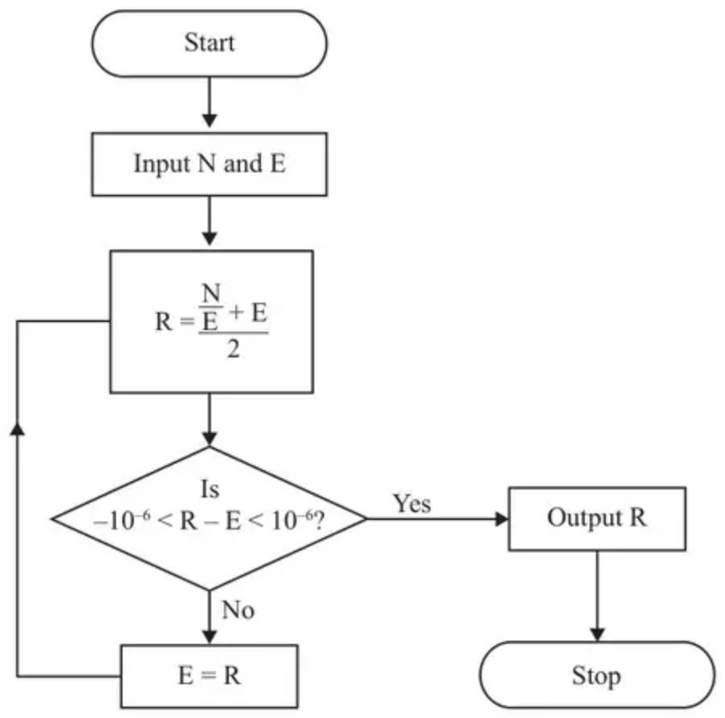
Figure 1
Hero’s algorithm for finding a square root is described by the flow chart shown in Figure 1.
Given that $N=72$ and $E=8$,
(a) use the flow chart to complete the table in the answer book, working to at least seven decimal places when necessary. Give the final output correct to seven decimal places. (4)
The flow chart is used with $N=72$ and $E=−8$,
(b) describe how this would affect the output. (1)
(c) State the value of E which cannot be used when using this flow chart. (1)
(Total 6 marks)
Edexcel D1 January 2013 Q1
4.
271 | 828 | 182 | 845 | 904 | 523 | 536 | 028 | 747 | 135

The list of ten numbers above is to be sorted into descending order.
(a) Perform a quick sort on the list to obtain the sorted list. You should show the result of each pass and identify the pivots clearly. (4)
A list of $n$ numbers is to be sorted into descending order using bubble sort.
(b) Determine, in the worst case, the total number of comparisons required to sort the list. Give your answer as a simplified expression in terms of $n$. (2)
The following algorithm determines an approximation to the value of e
Step 1 | Start
Step 2 | Let $a=1$
Step 3 | Let $b=1$
Step 4 | Let $c=1$
Step 5 | Let $d=a$
Step 6 | Let $c=c×b$
Step 7 | Let $d=d+\frac{1}{c}$
Step 8 | If $b=6$ go to Step 11
Step 9 | Let $b=b+1$
Step 10 | Go to Step 6
Step 11 | Output $d$
Step 12 | Stop

(c) Complete the table in the answer book to show the results obtained at each step of the algorithm. (3)
[The table in the answer book has columns headed $a$, $b$, $c$, $d$. You may not need to use all the rows in this table. It may not be necessary to complete all boxes in each row.]
$a$ | $b$ | $c$ | $d$

(d) Calculate, to 3 significant figures, the percentage error in using the value found in (c) to approximate the value of e (1)
(Total 10 marks)
Edexcel A2 June 2025 Q2
Solutions
1.
Scheme | Marks
e.g.  no further changes – list sorted | M1  A1  A1ft  A1
  52 | 48 | 50 | 45 | 64 | 47 | 53
  52 | 50 | 48 | 64 | 47 | 53 | 45
  52 | 50 | 64 | 48 | 53 | 47 | 45
  52 | 64 | 50 | 53 | 48 | 47 | 45
  64 | 52 | 53 | 50 | 48 | 47 | 45
  64 | 53 | 52 | 50 | 48 | 47 | 45
 | (4 marks)

Notes
M1 Bubble sort – 1st pass complete – end term 45 or 64, consistent L→R or R→L. Shuttle, Quick etc get M0
A1 First 2 passes correct
A1ft Next 2 passes correct (ft if L←R next pass) (condone ‘shrinking’ list)
A1 Final pass + final statement/rewrites list cso – must see whole list
2.
Mark scheme (a)
Scheme | Marks | AO
Bin 1: $\boxed{4.7}$ $\boxed{2.9}$ $\boxed{1.4}$ 2.8  Bin 2: $\boxed{5.5}$ 5.8  Bin 3: 3.8 6.5  Bin 4: 5.1 6.3  Bin 5: 4.1 | M1  A1  A1 | 1.1b  1.1b  1.1b
 | (3)

Notes
a1M1: First four items placed correctly (the boxed values) and at least eight values placed in bins – condone cumulative totals for M1 only
a1A1: First eight items placed correctly (the boxed and bold values)
a2A1: CSO (no additional/repeated values)
Mark scheme (b)
Scheme | Marks | AO
Bin 1: $\overset{‾}{6.5}$ $\overset{‾}{6.3}$  Bin 2: $\overset{‾}{5.8}$ $\overset{‾}{5.5}$ 1.4  Bin 3: $\overset{‾}{5.1}$ $\overset{‾}{4.7}$ 2.9  Bin 4: $\overset{‾}{4.1}$ $\overset{‾}{3.8}$ 2.8 | M1  A1 | 1.1b  1.1b
 | (2)
 | (5 marks)

Notes
b1M1: First eight items placed correctly (the underlined values) and at least ten values placed in bins (no additional/repeated values) - condone cumulative totals for M1 only
b1A1: CSO
3.
Mark scheme (a)
Scheme | Marks
 | M1  A1  A1
  N | E | R | Qn
  72 | 8 | 8.5 | N
   | 8.5 | 8.485 294 118 | N
   | 8.485 294 118 | 8.485 281 374 | N
   | 8.485 281 374 | 8.485 281 374 | Y
Output is R = 8.485 281 4 | A1ft
 | (4)

Notes
a1M1 At least two rows of cells in just E and R completed.
a1A1 CAO first two rows correct giving exact values or awrt 7dp (the exact second value for R is $\frac{577}{68}$).
a2A1 CAO third and fourth rows awrt 7dp
a3A1ft Output for R must follow through from their final value for R awrt 7dp – candidate must have answered ‘yes’ to score this mark. Output either on the answer line (or on the second page) or stated in the table but must be in the column for R below the row which contains ‘yes’.
Condone N = 72 on each row and entries appearing on separate rows throughout for full marks. Allow e.g. ticks/crosses etc. for yes/no.
Mark scheme (b)
Scheme | Marks
We would get a negative output for R/ We would get the negative square root | B1
 | (1)

Notes
b1B1 Mention of ‘negative’ scores B1 however do not accept incorrect statements but bod that ‘negative’ only is implicitly describing the effect on the output. Accept ‘other square root’.
Mark scheme (c)
Scheme | Marks
E cannot be zero | B1
 | (1)
 | (6 marks)

Notes
c1B1 CAO (nothing/null etc. scores B0). Condone E = 0.
4.
Mark scheme (a)
Scheme | Marks | AO
e.g. Middle right | M1  A1  A1ft  A1 | 1.1b  1.1b  1.1b  1.1b
   |  |  |  |  |  |  |  |  |  | Pivots
  271 | 828 | 182 | 845 | 904 | 523 | 536 | 028 | 747 | 135 | 523
  828 | 845 | 904 | 536 | 747 | $\overset{‾}{\text{523}}$ | 271 | 182 | 028 | 135 | 904, 028
  $\overset{‾}{\text{904}}$ | 828 | 845 | 536 | 747 | $\overset{‾}{\text{523}}$ | 271 | 182 | 135 | $\overset{‾}{\text{028}}$ | 536, 182
  $\overset{‾}{\text{904}}$ | 828 | 845 | 747 | $\overset{‾}{\text{536}}$ | $\overset{‾}{\text{523}}$ | 271 | $\overset{‾}{\text{182}}$ | 135 | $\overset{‾}{\text{028}}$ | 845
  $\overset{‾}{\text{904}}$ | $\overset{‾}{\text{845}}$ | 828 | 747 | $\overset{‾}{\text{536}}$ | $\overset{‾}{\text{523}}$ | $\overset{‾}{\text{271}}$ | $\overset{‾}{\text{182}}$ | $\overset{‾}{\text{135}}$ | $\overset{‾}{\text{028}}$ | 747
  $\overset{‾}{\text{904}}$ | $\overset{‾}{\text{845}}$ | 828 | $\overset{‾}{\text{747}}$ | $\overset{‾}{\text{536}}$ | $\overset{‾}{\text{523}}$ | $\overset{‾}{\text{271}}$ | $\overset{‾}{\text{182}}$ | $\overset{‾}{\text{135}}$ | $\overset{‾}{\text{028}}$
Middle left
 |  |  |  |  |  |  |  |  |  | Pivots
271 | 828 | 182 | 845 | 904 | 523 | 536 | 028 | 747 | 135 | 904
$\overset{‾}{\text{904}}$ | 271 | 828 | 182 | 845 | 523 | 536 | 028 | 747 | 135 | 523
$\overset{‾}{\text{904}}$ | 828 | 845 | 536 | 747 | $\overset{‾}{\text{523}}$ | 271 | 182 | 028 | 135 | 845, 182
$\overset{‾}{\text{904}}$ | $\overset{‾}{\text{845}}$ | 828 | 536 | 747 | $\overset{‾}{\text{523}}$ | 271 | $\overset{‾}{\text{182}}$ | 028 | 135 | 536, 028
$\overset{‾}{\text{904}}$ | $\overset{‾}{\text{845}}$ | 828 | 747 | $\overset{‾}{\text{536}}$ | $\overset{‾}{\text{523}}$ | $\overset{‾}{\text{271}}$ | $\overset{‾}{\text{182}}$ | 135 | $\overset{‾}{\text{028}}$ | 828
$\overset{‾}{\text{904}}$ | $\overset{‾}{\text{845}}$ | $\overset{‾}{\text{828}}$ | 747 | $\overset{‾}{\text{536}}$ | $\overset{‾}{\text{523}}$ | $\overset{‾}{\text{271}}$ | $\overset{‾}{\text{182}}$ | $\overset{‾}{\text{135}}$ | $\overset{‾}{\text{028}}$

 | (4)

Notes
a1M1: Quick sort, pivot, p, chosen (must be choosing middle left or right – choosing any other item as the pivot is M0). After the first pass the list must read (values greater than the pivot), pivot, (values less that the pivot). Condone one error or omission in the list.
If only choosing one pivot per iteration then max of M1 only
Bubble sort is not a MR and scores M0.
If the list is sorted into ascending order, they can score M1 A1 A0 A0 for a fully correct sort even if reversed (if any error seen this can score M1 only).
If 028 is written as 28 at any stage this will lose the final CSO mark
The choice of pivots may only be seen once they have been used
a1A1: First pass correct and next pivots chosen correctly for the second pass (but the second pass does not need to be correct)
a2A1ft: Second and third passes correct (follow through from their first pass and choice of pivots). They do not need to be choosing a pivot for the fourth pass for this mark
If they alternate MR and ML pivots for the first and second passes, the pivots for the third pass must be consistent with their second pass
a3A1: CSO – so must have chosen and used 747 (MR) or 828 (ML) as a pivot for the fifth pass
Sort Ascending Max M1 A1 A0 A0 e.g Middle right
 |  |  |  |  |  |  |  |  |  | Pivots
271 | 828 | 182 | 845 | 904 | 523 | 536 | 028 | 747 | 135 | 523
271 | 182 | 028 | 135 | $\overset{‾}{\text{523}}$ | 828 | 845 | 904 | 536 | 747 | 028, 904
$\overset{‾}{\text{028}}$ | 271 | 182 | 135 | $\overset{‾}{\text{523}}$ | 828 | 845 | 536 | 747 | $\overset{‾}{\text{904}}$ | 182, 536
$\overset{‾}{\text{028}}$ | 135 | $\overset{‾}{\text{182}}$ | 271 | $\overset{‾}{\text{523}}$ | $\overset{‾}{\text{536}}$ | 828 | 845 | 747 | $\overset{‾}{\text{904}}$ | 845
$\overset{‾}{\text{028}}$ | $\overset{‾}{\text{135}}$ | $\overset{‾}{\text{182}}$ | $\overset{‾}{\text{271}}$ | $\overset{‾}{\text{523}}$ | $\overset{‾}{\text{536}}$ | 828 | 747 | $\overset{‾}{\text{845}}$ | $\overset{‾}{\text{904}}$ | 747
$\overset{‾}{\text{028}}$ | $\overset{‾}{\text{135}}$ | $\overset{‾}{\text{182}}$ | $\overset{‾}{\text{271}}$ | $\overset{‾}{\text{523}}$ | $\overset{‾}{\text{536}}$ | $\overset{‾}{\text{747}}$ | 828 | $\overset{‾}{\text{845}}$ | $\overset{‾}{\text{904}}$

Middle left
 |  |  |  |  |  |  |  |  |  | Pivots
271 | 828 | 182 | 845 | 904 | 523 | 536 | 028 | 747 | 135 | 904
271 | 828 | 182 | 845 | 523 | 536 | 028 | 747 | 135 | $\overset{‾}{\text{904}}$ | 523
271 | 182 | 028 | 135 | $\overset{‾}{\text{523}}$ | 828 | 845 | 536 | 747 | $\overset{‾}{\text{904}}$ | 182, 845
028 | 135 | $\overset{‾}{\text{182}}$ | 271 | $\overset{‾}{\text{523}}$ | 828 | 536 | 747 | $\overset{‾}{\text{845}}$ | $\overset{‾}{\text{904}}$ | 028, 536
$\overset{‾}{\text{028}}$ | 135 | $\overset{‾}{\text{182}}$ | $\overset{‾}{\text{271}}$ | $\overset{‾}{\text{523}}$ | $\overset{‾}{\text{536}}$ | 828 | 747 | $\overset{‾}{\text{845}}$ | $\overset{‾}{\text{904}}$ | 828
$\overset{‾}{\text{028}}$ | $\overset{‾}{\text{135}}$ | $\overset{‾}{\text{182}}$ | $\overset{‾}{\text{271}}$ | $\overset{‾}{\text{523}}$ | $\overset{‾}{\text{536}}$ | 747 | 828 | $\overset{‾}{\text{845}}$ | $\overset{‾}{\text{904}}$

Mark scheme (b)
Scheme | Marks | AO
In the worst case, the first pass requires $(n−1)$ comparisons, the second $(n−2)$, and so on | M1 | 3.1a
$\sum_{r=1}^{n−1}{r}\frac{1}{2}n(n−1)$ | A1 | 2.2a
 | (2)

Notes
b1M1: Considering the total number of comparisons in the worst case (possibly will see e.g. $(n−1)+(n−2)+…[+2+1]$ which scores this mark (brackets not needed and sufficient terms to make sum clear. Accept a clear list without + signs for this mark)
b1A1: Using the standard series result that $∑r=\frac{1}{2}n(n+1)$ with $n=(n−1)$ to get the correct quadratic expression for the total number of comparisons when sorting $n$ values using bubble sort (allow any letter) Accept $(n−1)+(n−2)+…+2+1=\frac{1}{2}n(n−1)$ for both marks (sight of $\frac{1}{2}n(n−1)$ with no working scores both marks) (ISW if correct expression incorrectly expanded)
Mark scheme (c)
Scheme | Marks | AO
 | M1  A1 | 1.1b  1.1b
  $a$ | $b$ | $c$ | $d$ | decimal | 3 sig fig
  1 | 1 | 1 | 1 | 1 | 1 | Row 1
   |  | 1 | 2 | 2 | 2 | Row 2
   | 2 | 2 | $\frac{5}{2}$ | 2.5 | 2.5 | Row 3
   | 3 | 6 | $\frac{8}{3}$ | 2.666… | 2.67 | Row 4
   | 4 | 24 | $\frac{65}{24}$ | 2.708333… | 2.71 | Row 5
   | 5 | 120 | $\frac{163}{60}$ | 2.71666… | 2.72 | Row 6
   | 6 | 720 | $\frac{1957}{720}$ | 2.7180555… | 2.72 | Row 7
Output is $\frac{1957}{720}$ (accept 2.7180555… or 2.72 if working to 3 s.f.) | A1 | 2.2a
SC Accept
$a$ | $b$ | $c$ | $d$ | decimal | 3 sig fig
1 | 1 | 1 | 1 | 1 | 1
 | 2 | 1 | 2 | 2 | 2
 | 3 | 2 | $\frac{5}{2}$ | 2.5 | 2.5
 | 4 | 6 | $\frac{8}{3}$ | 2.666… | 2.67
 | 5 | 24 | $\frac{65}{24}$ | 2.708333… | 2.71
 | 6 | 120 | $\frac{163}{60}$ | 2.71666… | 2.72
 |  | 720 | $\frac{1957}{720}$ | 2.7180555… | 2.72

 | (3)

Notes
Note: Rows are shown above, and they may be spread across multiple rows in the table. Each row ends when the appropriate value in column d is seen
c1M1: At least four rows of cells completed with a correct first and second row – condone repeated values in all columns or a single value in each row (Note SC accept Column B with 1, 2, 3, 4, 5, 6 with no empty cell between 1 and 2)
c1A1: CAO – the values in the third, fourth and fifth rows correct (accept either full recurring decimals or decimals consistently rounded to 3 significant figures)
c2A1: CAO - correct output following a correct seventh row (their output must be clearly indicated e.g. on the Output line or identified in or near the table) If a value is written on the output line, this takes precedence over the table.
Mark scheme (d)
Scheme | Marks | AO
$\frac{∣\frac{1957}{720}−\text{e}∣}{\text{e}}×100=0.00832(\text{\%})$ If using 2.72 error = 0.0632(%) | B1ft | 3.2b
 | (1)
 | (10 marks)

Notes
d1B1ft: Follow through their answer to (c) provided that % error is < 0.1% (must be given to at least 3 significant figures) (condone missing %) (accept - 0.00832%) (if a numerical approximation to e is used, it must be given to at least 3 d.p. – so 2.718 or better) (accept $8.32×10^{−3}$). If incorrect working is seen, even if followed by a correct answer, this is B0.
Note $\frac{∣\frac{1957}{720}−\text{e}∣}{\frac{1957}{720}}×100=0.00832\text{\%}$ scores B0

