QQQ – Core Pure 2 – Chapter 8 – Modelling with Differential Equations (Version 1)
Total Marks: 25
(25 = Platinum, 23 = Gold, 20 = Silver, 17 = Bronze)
1. The displacement of a door from its equilibrium (closed) position is measured by the angle, $θ$ radians, which the door makes with its closed position. The door can swing either side of the equilibrium position so that $θ$ can take positive and negative values. The door is released from rest from an open position at time $t=0$.
A proposed differential equation to model the motion of the door for $t⩾0$ is
$\frac{{\text{d}}^{2}θ}{\text{d}t^{2}}+λ\frac{\text{d}θ}{\text{d}t}+3θ=0$ where $λ$ is a constant and $λ⩾0$.
(a)
(i) According to the model, for what value of $λ$ will the motion of the door be simple harmonic? [1]
(ii) Explain briefly why modelling the motion of the door as simple harmonic is unlikely to be realistic. [1]
(b) Find the range of values of $λ$ for which the model predicts that the door will never pass through the equilibrium position. [2]
(c) Sketch a possible graph of $θ$ against $t$ when $λ$ lies outside the range found in part (b) but the motion is not simple harmonic. [1]
(Total 5 marks)
OCR A A2 October 2021 Paper 1 Q11
2. A raindrop falls from rest from a cloud. The velocity, $v$ m s${}^{−1}$ vertically downwards, of the raindrop, $t$ seconds after the raindrop starts to fall, is modelled by the differential equation
$$(t+2)\frac{\text{d}v}{\text{d}t}+3v=k(t+2)−3 t⩾0$$
where $k$ is a positive constant.
(a) Solve the differential equation to show that
$$v=\frac{k}{4}(t+2)−1+\frac{4(2−k)}{(t+2)^{3}}$$
(5)
Given that $v=4$ when $t=2$
(b) determine, according to the model, the velocity of the raindrop 5 seconds after it starts to fall. (3)
(c) Comment on the validity of the model for very large values of $t$ (1)
(Total 9 marks)
Edexcel A2 June 2024 Paper 1 Q5
3. Solve the simultaneous differential equations

$$\frac{\text{d}x}{\text{d}t}+2x=4y, \frac{\text{d}y}{\text{d}t}+3x=5y,$$

given that when $t=0$, $x=0$ and $y=1$. [11]
(Total 11 marks)
OCR MEI A2 October 2020 Paper 1 Q14
Solutions
1.
Mark scheme (a)
Scheme | Marks | AO
(i) For SHM $λ=0$ | B1 | 3.3
 | [1]
(ii) The door should close, but in SHM the motion continues indefinitely | B1 | 3.5b
 | [1]

Mark scheme (b)
Scheme | Marks | AO
Over- or critical- damping implies $λ^{2}−12⩾0$  So $λ⩾2\sqrt{3}$ | M1  A1 | 3.3  3.4
 | [2]

Notes
M1: Consider discriminant with $⩾$ or $>$
Ignore $λ⩽−2\sqrt{3}$
Mark scheme (c)
Scheme | Marks | AO
e.g.  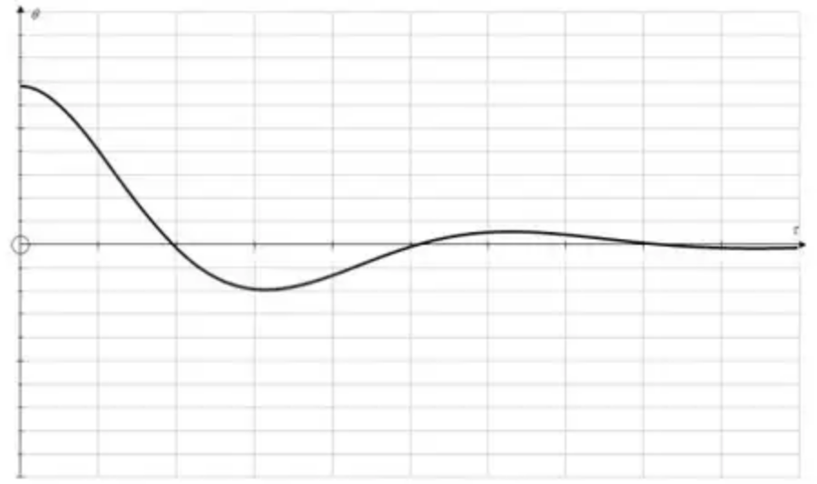 | B1 | 3.4
 | [1]

Notes
B1: Graph of under-damped system.
Start anywhere non-zero on $θ$-axis with zero gradient.
Each peak must be lower than before
At least two peaks (not including start point)
The graph must look as though it is approaching the $t$ axis
2.
Mark scheme (a)
Scheme | Marks | AO
$(t+2)\frac{\text{d}v}{\text{d}t}+3v=k(t+2)−3⇒\frac{\text{d}v}{\text{d}t}+\frac{3v}{t+2}=k−\frac{3}{t+2}$  $I={\text{e}}^{∫\frac{3}{t+2}\text{d}t}=(t+2)^{3}$ | M1 | 3.1b
$⇒v(t+2)^{3}=∫(k(t+2)^{3}−3(t+2)^{2})\text{d}t=…$ | M1 | 1.1b
$v(t+2)^{3}=\frac{k}{4}(t+2)^{4}−(t+2)^{3}(+c)$  $[\text{Alt}(t+2)^{3}v=\frac{kt^{4}}{4}+2kt^{3}−t^{3}+6kt^{2}−6t^{2}+8kt−12t(+c)]$ | A1 | 1.1b
$t=0,v=0⇒c=8−4k$ | M1 | 3.4
$v(t+2)^{3}=\frac{k}{4}(t+2)^{4}−(t+2)^{3}+8−4k$  $⇒v=\frac{k}{4}(t+2)−1+\frac{4(2−k)}{(t+2)^{3}}$ * | A1* | 2.1
 | (5)

Notes
M1: Begins to solve the problem with a correct process to find the integrating factor for the model. Look for an attempt at ${\text{e}}^{∫\frac{A}{t+2}\text{d}t}=…$ where $A$ is a constant (positive or negative). For attempts at IF by recognition they must achieve form $A(t+2)^{3}$
M1: Attempts the solution of the differential equation using a correct method with their integrating factor. The d$t$ may be implied. They must attempt the integration as part of the method, though it need not be correct – any changed function will do. So score for $v×\text{their IF}=\text{their attempt at integrating their IF}×(k−\frac{3}{t+2})$ allowing for errors expanding this bracket.
A1: Correct solution. The $+c$ may be missing for this mark.
M1: Interprets the initial conditions to find the constant of integration – must have a constant of integration for this mark and the correct initial conditions must be clear.
A1*: Obtains the printed answer with no errors and at least one intermediate line between $v(t+2)^{3}=\frac{k}{4}(t+2)^{4}−(t+2)^{3}+c$ and the stated answer. Allow terms in different order, but the $8−4k$ must be factorised.
Mark scheme (b)
Scheme | Marks | AO
$v=4,t=2⇒4=k−1+\frac{4(2−k)}{64}⇒k=…(5.2)$ | M1 | 3.1b
$⇒v=\frac{\text{“}5.2\text{”}}{4}(5+2)−1+\frac{4(2−\text{“}5.2\text{”})}{(5+2)^{3}}=…$ | dM1 | 3.4
Velocity is $8.06$ m s${}^{−1}$ (awrt) | A1 | 3.2a
 | (3)

Notes
M1: Uses the given conditions to establish the value of $k$ in the model
dM1: Uses their value of $k$ and the equation of the model with $t=5$ to find a value for $v$. If a value of $k$ has been found accept “$t=5v=…$” with any value for an attempt.
A1: Correct value including units (allow awrt 8.06 m s${}^{−1}$). Accept exact answer 5531/686
Mark scheme (c)
Scheme | Marks | AO
E.g.  • The model suggests the velocity increases indefinitely which is unlikely  • The raindrop will reach the ground/doesn’t fall forever so not valid  • The raindrop will reach a terminal velocity after a finite time so not good model | B1 | 3.5a
 | (1)
 | (9 marks)

Notes
B1: Evaluates the model by making a suitable comment – see scheme for examples. Accept answers relating to the size of velocity increasing beyond what is reasonable or answers that allude to the situation not being able to continue for ever. Accept if symbols are used, e.g. “as $t→\text{∞},v→\text{∞}$ which cannot happen” but must include a comment on validity, not just a statement about what happens (e.g. $t→\text{∞},v→\text{∞}$ with no comment).
Do not accept e.g. “$v$ does not tend to a value” as this is just a statement about what happens.
If contrary information is given then award B0.
Some examples of borderline answers seen.
• “Not valid as rain is limited to how fast its velocity is therefore can’t be big.” Scores B1
• “Due to gravitational force and not huge height between cloud and ground, the model would be inaccurate for large period of time, because the velocity of raindrops would be a big number, which is unlikely.” B1
• “Not valid for very large value of $t$ as raindrop will not move that fast.” B0
• “Raindrop has very little mass so effect due to gravity is lower. Unlikely to have a 1000 m s${}^{−1}$ raindrop. Not very valid model for large values of $t$” B1
• “The water droplet wouldn’t always follow the model in cases where it hits a surface” B0
• “No valid as raindrop will hit ground soon. Speed can be infinitely big which is not plausible.” B1
• “Would not be valid as the raindrop likely has already hit the ground.” B1
You may need to use your judgement on whether their comments are acceptable.
3.
Scheme | Marks | AO
$\frac{{\text{d}}^{2}x}{\text{d}t^{2}}+2\frac{\text{d}x}{\text{d}t}=4\frac{\text{d}y}{\text{d}t}=20y−12x$ | M1 | 3.1a
$⇒\frac{{\text{d}}^{2}x}{\text{d}t^{2}}+2\frac{\text{d}x}{\text{d}t}=5\frac{\text{d}x}{\text{d}t}+10x−12x$ | M1 | 3.1a
$⇒\frac{{\text{d}}^{2}x}{\text{d}t^{2}}−3\frac{\text{d}x}{\text{d}t}+2x=0$ | A1 | 1.1
AE $λ^{2}−3λ+2=0$  $⇒λ=1$ or $2$  GS $x=A{\text{e}}^{t}+B{\text{e}}^{2t}$ | B1ft | 1.1
$y=\frac{1}{4}(\frac{\text{d}x}{\text{d}t}+2x)=\frac{1}{4}(A{\text{e}}^{t}+2B{\text{e}}^{2t}+2A{\text{e}}^{t}+2B{\text{e}}^{2t})$ | M1 | 2.1
$=\frac{3}{4}A{\text{e}}^{t}+B{\text{e}}^{2t}$ | A1 | 2.2a
when $t=0$, $x=A+B=0$ | M1 | 1.1
$1=\frac{3}{4}A+B$ | A1 | 1.1
 | M1 | 1.1
$⇒A=−4,B=4$  so $x=4{\text{e}}^{2t}−4{\text{e}}^{t}$  $y=4{\text{e}}^{2t}−3{\text{e}}^{t}$ | A1  A1 | 3.2a  3.2a
 | [11]

Notes
M1: diff and subst for $\text{d}y\text{/d}t$ or $\text{d}x\text{/d}t$
M1: subst for $y$ (or $x$)
A1: Must be simplified
B1ft: ft their values of $λ$
M1: subst for $x$, $\text{d}x\text{/d}t$
M1: subst $t=0$ in $x$, $y$ to find eqns in $A$, $B$
A1: both equations correct
M1: solving the equations to find A and B
A1: for both A and B
A1: for correct equations for both $x$ and $y$
Alternative method
Scheme | Marks
$\frac{{\text{d}}^{2}y}{\text{d}t^{2}}+3\frac{\text{d}x}{\text{d}t}=5\frac{\text{d}y}{\text{d}t}$
$\frac{1}{3}(5\frac{\text{d}y}{\text{d}t}−\frac{{\text{d}}^{2}y}{\text{d}t^{2}})+\frac{2}{3}(5y−\frac{\text{d}y}{\text{d}t})=4y$
$\frac{{\text{d}}^{2}y}{\text{d}t^{2}}−3\frac{\text{d}y}{\text{d}t}+2y=0$
AE $λ^{2}−3λ+2=0$
$⇒λ=1$ or $2$
GS $y=C{\text{e}}^{t}+D{\text{e}}^{2t}$
$x=\frac{4}{3}C{\text{e}}^{t}+D{\text{e}}^{2t}$
when $t=0$, $4C+3D=0$
$C+D=1$
$C=−3,D=4$

