QQQ – Core Pure 2 – Chapter 6 – Hyperbolic Functions (Version 1)
Total Marks: 25
(25 = Platinum, 23 = Gold, 20 = Silver, 17 = Bronze)
1.
(a) On the axes below, sketch the graph of
$$y=cosh⁡x$$
Indicate the value of any intercept of the curve with the axes. [2 marks]
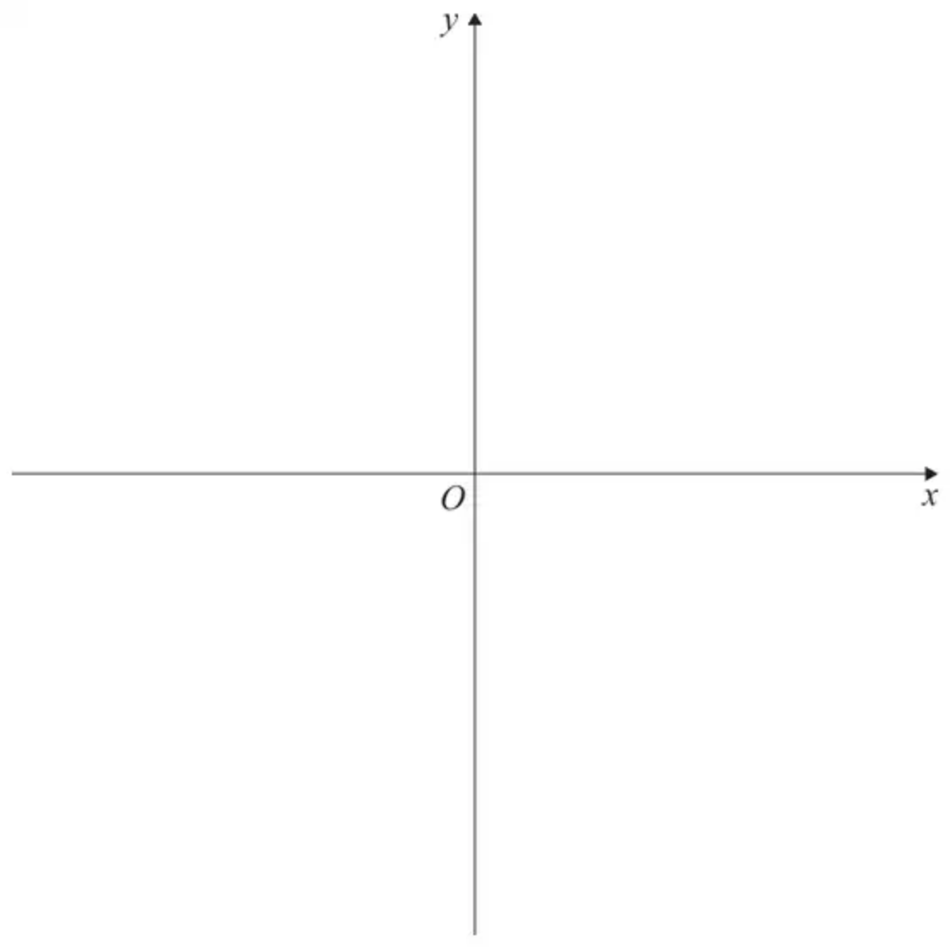
(b) Solve the equation
$$cosh⁡x=2$$
Give your answers to three significant figures. [2 marks]
(Total 4 marks)
AQA AS June 2024 Paper 1 Q6
2.
In this question you must show all stages of your working.
Solutions relying entirely on calculator technology are not acceptable.
Determine the exact values of $x$ for which
$$sinh⁡2x=3sinh⁡x$$
(5)
(Total 5 marks)
Edexcel A2 June 2025 Paper 1 Q2
3.
(a) Given that $y={cosh⁡}^{−1}(\frac{1}{3}x)$, find $\frac{\text{d}y}{\text{d}x}$ in terms of $x$. [1]
(b) Determine an equation of the normal to the curve $y={cosh⁡}^{−1}(\frac{1}{3}x)$ at the point where $x=5$.
Give your answer in the form $ax+by=c+ln⁡d$, where $a$, $b$, $c$ and $d$ are integers. [4]
(Total 5 marks)
OCR A A2 June 2025 Paper 1 Q2
4.
(a) Find
$$∫\frac{1}{\sqrt{(4x^{2}+9)}}\text{d}x$$
(2)
(b) Use your answer to part (a) to find the exact value of
$$\int_{−3}^{3}{}\frac{1}{\sqrt{(4x^{2}+9)}}\text{d}x$$
giving your answer in the form $kln⁡(a+b\sqrt{5})$, where $a$ and $b$ are integers and $k$ is a constant. (3)
(Total 5 marks)
Edexcel FP3 June 2013 Q2
5.
(a) Using the exponential definitions of $sinh⁡x$ and $cosh⁡x$, prove that
$${coth⁡}^{−1}(x)=\frac{1}{2}ln⁡(\frac{x+1}{x−1})$$
[3 marks]
(b) Hence, solve the equation
$${coth⁡}^{−1}(x)=−ln⁡5$$
Give your answer in an exact form. [3 marks]
(Total 6 marks)
AQA A2 June 2025 Paper 1 Q14
Solutions
1.
Mark scheme (a)
Scheme | Marks | AO
Draws the correct shape, approximately symmetrical about the $y$-axis and above the $x$-axis | B1 | 1.1b
Indicates one $y$-axis intercept at $(0,1)$  Accept 1 clearly labelled on the $y$-axis. | B1 | 1.1b
 | (2)

Typical solution
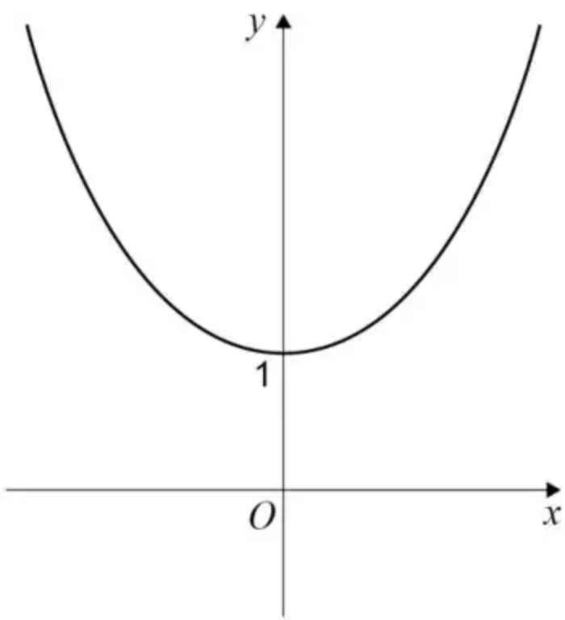
Mark scheme (b)
Scheme | Marks | AO
Obtains at least one correct solution.  Accept $ln⁡(2+\sqrt{3})$ or $ln⁡(2−\sqrt{3})$ or equivalent ln expression.  Accept AWRT 1.32 or $−1.32$  Do not accept ${cosh⁡}^{−1}2$ | M1 | 1.1a
Obtains AWRT $±1.32$ with no other solutions given. | A1 | 1.1b
 | (2)
 | (4 marks)

Typical solution
$$x=±{cosh⁡}^{−1}2$$
$$x=±1.32\text{(3sf)}$$
2.
Scheme | Marks | AO
Uses the identity $sinh⁡2x=2sinh⁡xcosh⁡x$ to find a value for $sinh⁡x$ or $cosh⁡x$  $2sinh⁡xcosh⁡x=3sinh⁡x⇒2sinh⁡xcosh⁡x−3sinh⁡x=0$  $sinh⁡x(2cosh⁡x−3)=0⇒sinh⁡x=…$ or $cosh⁡x=…$ | M1 | 3.1a
$sinh⁡x=0⇒x=0$ | B1 | 1.1b
$cosh⁡x=\text{“}\frac{3}{2}\text{”}⇒x=ln⁡[\text{“}\frac{3}{2}\text{”}+\sqrt{{(\text{“}\frac{3}{2}\text{”})}^{2}−1}]$  Alternatively  $cosh⁡x=\frac{3}{2}⇒\frac{1}{2}({\text{e}}^{x}+{\text{e}}^{−x})⇒{\text{e}}^{2x}−3{\text{e}}^{x}+1=0$  $⇒{\text{e}}^{x}=\frac{3+\sqrt{5}}{2}$ or $\frac{3−\sqrt{5}}{2}⇒x=ln⁡…$ | dM1 | 1.1b
$x=ln⁡[\frac{3}{2}+\sqrt{{(\frac{3}{2})}^{2}−1}]$ | A1 | 1.1b
$x=±ln⁡(\frac{3+\sqrt{5}}{2})$ or $x=ln⁡(\frac{3±\sqrt{5}}{2})$ | A1 | 2.2a
 | (5)
 | (5 marks)

Notes
M1: Uses the identity $sinh⁡2x=2sinh⁡xcosh⁡x$ and proceeds to find a value for $sinh⁡x$ or $cosh⁡x$
B1: $x=0$
dM1: Uses the correct formula for $\text{arcosh}⁡x$ with their value of $cosh⁡x$ to find a value for $x$ as a natural logarithm or alternatively gives awrt to 3sf. e.g. 0.962, $−0.962$. You may need to check their workings.
Alternatively uses the exponential definition for $cosh⁡x$, forms and solves a quadratic for ${\text{e}}^{x}$ leading to find a value for $x$ as a natural logarithm. Usual rules apply for solving a quadratic by any means including using a calculator. You may need to check their workings. If correct answers are given without workings, you may award this mark.
A1: Deduces one correct exact value for $x$. Accept exact unsimplified equivalents.
A1: Deduces both correct exact values for $x$. Accept exact simplified equivalents. isw
Accept, for example $x=±ln⁡(\frac{3}{2}+\frac{\sqrt{5}}{2})$ and $x=±ln⁡(\frac{3}{2}+\sqrt{\frac{5}{4}})$
Also accept equivalent answers which you may need to check; their may be several alternatives.
e.g. Accept $x=ln⁡(\frac{2}{3+\sqrt{5}})$ for $x=ln⁡(\frac{3−\sqrt{5}}{2})$
Alternative method use of exponentials
Scheme | Marks | AO
Uses the identities $sinh⁡x=\frac{{\text{e}}^{x}−{\text{e}}^{−x}}{2}$ and $sinh⁡2x=\frac{{\text{e}}^{2x}−{\text{e}}^{−2x}}{2}$  $\frac{{\text{e}}^{2x}−{\text{e}}^{−2x}}{2}=3(\frac{{\text{e}}^{x}−{\text{e}}^{−x}}{2})$ leading to a quartic equation for ${\text{e}}^{x}$  (Note correct equation is ${\text{e}}^{4x}−3{\text{e}}^{3x}+3{\text{e}}^{x}−1=0$) | M1 | 3.1a
${\text{e}}^{x}=1⇒x=0$ | B1 | 1.1b
Solves quartic to find a value for ${\text{e}}^{x}$ leading to $x=ln⁡…$ | dM1 | 1.1b
$x=ln⁡[\frac{3}{2}+\sqrt{{(\frac{3}{2})}^{2}−1}]$ | A1 | 1.1b
$x=±ln⁡(\frac{3+\sqrt{5}}{2})$ or $x=ln⁡(\frac{3±\sqrt{5}}{2})$ | A1 | 2.2a
 | (5)

M1: Uses correct identities such as $sinh⁡x=\frac{{\text{e}}^{x}−{\text{e}}^{−x}}{2}$ and $sinh⁡2x=\frac{{\text{e}}^{2x}−{\text{e}}^{−2x}}{2}$ to form a quartic equation for ${\text{e}}^{x}$
B1: $x=0$
dM1: Solve their quartic equation to find a value for $x$ (other than $x=0$) via a correct method. If correct answers are given from their quartic equation without workings, you may award this mark. You may need to check their workings.
A1: Deduces one correct exact value for $x$, which may be unsimplified.
A1: Deduces both correct exact values for $x$ isw
Note: Inexact answers for the quartic equation ${\text{e}}^{x}=2.618,0.3819$ leading to awrt 0.962, $−0.962$ scores maximum M1 B1 dM1 A0 A0
3.
Mark scheme (a)
Scheme | Marks | AO
$\frac{\text{d}y}{\text{d}x}=\frac{1}{\sqrt{x^{2}−9}}$ | B1 | 1.1
 | [1]

Notes
B1: Accept any equivalent (un-simplified) forms e.g. $\frac{1}{3}×\frac{1}{\sqrt{{(\frac{x}{3})}^{2}−1}}$ or $\frac{1}{\sqrt{x^{2}−3^{2}}}$. Invisible brackets e.g. $\frac{1}{3}×\frac{1}{\sqrt{{\frac{x}{3}}^{2}−1}}$ is B0 unless correctly recovered. ISW if correct un-simplified form is simplified incorrectly
Mark scheme (b)
Scheme | Marks | AO
$m_{N}=−4$ | B1 | 1.1
$y=ln⁡(\frac{5}{3}+\sqrt{{(\frac{5}{3})}^{2}−1}) (=ln⁡3)$ | B1 | 1.1
$y−ln⁡3=−4(x−5)$ | M1 | 1.1
$4x+y=20+ln⁡3$ | A1 | 1.1
 | [4]

Notes
B1: Correct normal gradient (soi) – possibly BC
B1: For correct un-simplified (or simplified) $y$-coordinate in logarithmic form when $x=5$ – ISW if simplified incorrectly
M1: Any complete correct method for the equation of a straight line with $x=5$, their $y$ coordinate (which must be of the form $ln⁡(a)$ where $a>0$) and any non-zero gradient. If using $y=mx+c$ then must explicitly find $c$ using $x=5$, any non-zero $m$ and their $y$ which must be of the form as stated above (but allow errors in the evaluation of $c$)
A1: oe but must be integer values e.g. $8x+2y=40+ln⁡9$ and must be of the form $ax+by=c+ln⁡d$ e.g. allow $−ln⁡3−20=−y−4x$
4.
Mark scheme (a)
Scheme | Marks
$k\text{arsinh}(\frac{2x}{3})(+c)$ or $kln⁡[px+\sqrt{(p^{2}x^{2}+\frac{9}{4}p^{2})}](+c)$ | M1
$\frac{1}{2}\text{arsinh}(\frac{2x}{3})(+c)$ or $\frac{1}{2}ln⁡[px+\sqrt{(p^{2}x^{2}+\frac{9}{4}p^{2})}](+c)$ | A1
 | (2)

Notes
Alternative for (a)
Scheme | Marks
$x=\frac{3}{2}sinh⁡u⇒∫\frac{1}{\sqrt{9{sinh⁡}^{2}u+9}}⋅\frac{3}{2}cosh⁡u\text{d}u=k\text{arsinh}(\frac{2x}{3})(+c)$ | M1
$\frac{1}{2}\text{arsinh}(\frac{2x}{3})(+c)$ | A1

Mark scheme (b)
Scheme | Marks
So: $\frac{1}{2}ln⁡[6+\sqrt{45}]−\frac{1}{2}ln⁡[−6+\sqrt{45}]=\frac{1}{2}ln⁡[\frac{6+\sqrt{45}}{−6+\sqrt{45}}]$  Uses correct limits and combines logs | M1
$=\frac{1}{2}ln⁡[\frac{6+\sqrt{45}}{−6+\sqrt{45}}][\frac{6+\sqrt{45}}{6+\sqrt{45}}]=\frac{1}{2}ln⁡[\frac{(6+\sqrt{45})^{2}}{9}]$  Correct method to rationalise denominator (may be implied)  Method must be clear if answer does not follow their fraction | M1
$=ln⁡[2+\sqrt{5}]$ (or $\frac{1}{2}ln⁡[9+4\sqrt{5}]$) | A1cso
 | (3)
 | (5 marks)

Notes
Note that the last 3 marks can be scored without the need to rationalise e.g.
$2×\frac{1}{2}{[ln⁡[2x+\sqrt{(4x^{2}+9)}]]}_{0}^{3}=ln⁡(6+\sqrt{45})−ln⁡3=ln⁡(\frac{6+\sqrt{45}}{3})$
M1: Uses the limits 0 and 3 and doubles
M1: Combines Logs
A1: $ln⁡[2+\sqrt{5}]$ oe
Alternative for (b)
Scheme | Marks
${[\frac{1}{2}\text{arsinh}(\frac{2x}{3})]}_{−3}^{3}=\frac{1}{2}\text{arsinh}2−\frac{1}{2}\text{arsinh}−2$
$\frac{1}{2}ln⁡(2+\sqrt{5})−\frac{1}{2}ln⁡(\sqrt{5}−2)=\frac{1}{2}ln⁡(\frac{2+\sqrt{5}}{\sqrt{5}−2})$  Uses correct limits and combines logs | M1
$=\frac{1}{2}ln⁡(\frac{2+\sqrt{5}}{\sqrt{5}−2}⋅\frac{\sqrt{5}+2}{\sqrt{5}+2})=\frac{1}{2}ln⁡(\frac{2\sqrt{5}+4+5+2\sqrt{5}}{5−4})$  Correct method to rationalise denominator (may be implied)  Method must be clear if answer does not follow their fraction | M1
$=\frac{1}{2}ln⁡[9+4\sqrt{5}]$ | A1cso

5.
Mark scheme (a)
Scheme | Marks | AO
Uses definitions of sinh and cosh.  PI $x=\frac{{\text{e}}^{y}+{\text{e}}^{−y}}{{\text{e}}^{y}−{\text{e}}^{−y}}$ or $x=\frac{{\text{e}}^{2y}+1}{{\text{e}}^{2y}−1}$ | M1 | 1.1a
Rearranges to make ${\text{e}}^{2y}$ or ${\text{e}}^{2x}$ the subject.  or  Uses the quadratic equation formula | M1 | 3.1a
Completes a reasoned argument, starting from the full definitions of sinh and cosh, to obtain  ${coth⁡}^{−1}(x)=\frac{1}{2}ln⁡(\frac{x+1}{x−1})$  AG | R1 | 2.1
 | (3)

Typical solution
Let $y={coth⁡}^{−1}(x)$
Then $x=coth⁡y$
$$x=\frac{\frac{1}{2}({\text{e}}^{y}+{\text{e}}^{−y})}{\frac{1}{2}({\text{e}}^{y}−{\text{e}}^{−y})}=\frac{{\text{e}}^{2y}+1}{{\text{e}}^{2y}−1}$$
$$x({\text{e}}^{2y}−1)={\text{e}}^{2y}+1$$
$$x{\text{e}}^{2y}−x={\text{e}}^{2y}+1$$
$${\text{e}}^{2y}(x−1)=x+1$$
$${\text{e}}^{2y}=\frac{x+1}{x−1}$$
$$2y=ln⁡(\frac{x+1}{x−1})$$
$$y=\frac{1}{2}ln⁡(\frac{x+1}{x−1})$$
$${coth⁡}^{−1}(x)=\frac{1}{2}ln⁡(\frac{x+1}{x−1})$$
Mark scheme (b)
Scheme | Marks | AO
Uses the result from part (a) to form an equation and applies at least one law of logs correctly | M1 | 3.1a
Obtains $\frac{x+1}{x−1}=\frac{1}{25}$ OE | A1 | 1.1b
Obtains $−\frac{13}{12}$ OE | A1 | 1.1b
 | (3)
 | (6 marks)

Typical solution
$$\frac{1}{2}ln⁡(\frac{x+1}{x−1})=−ln⁡5=ln⁡\frac{1}{5}$$
$$ln⁡(\frac{x+1}{x−1})=2ln⁡\frac{1}{5}=ln⁡{(\frac{1}{5})}^{2}$$
$$\frac{x+1}{x−1}=\frac{1}{25}$$
$$25(x+1)=x−1$$
$$25x+25=x−1$$
$$x=−\frac{13}{12}$$

