QQQ – Core Pure 2 – Chapter 4 – Volumes of Revolution (Version 2)
Total Marks: 23
(23 = Platinum, 21 = Gold, 18 = Silver, 16 = Bronze)
1.
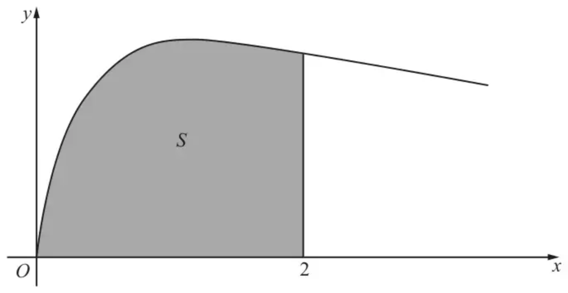
Figure 1
Figure 1 shows the curve with equation
$$y=\sqrt{(\frac{2x}{3x^{2}+4})}, x⩾0$$
The finite region $S$, shown shaded in Figure 1, is bounded by the curve, the $x$-axis and the line $x=2$
The region $S$ is rotated $360^{∘}$ about the $x$-axis.
Use integration to find the exact value of the volume of the solid generated, giving your answer in the form $kln⁡a$, where $k$ and $a$ are constants. (5)
(Total 5 marks)
Edexcel C4 January 2012 Q4
2.
In this question you must show all stages of your working.
Solutions relying entirely on calculator technology are not acceptable.
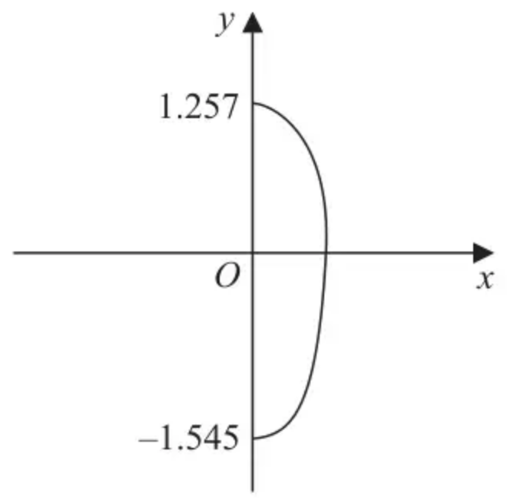
Figure 2
John picked 100 berries from a plant.
The largest berry picked was approximately 2.8 cm long.
The shape of this berry is modelled by rotating the curve with equation
$$16x^{2}+3y^{2}−ycos⁡(\frac{5}{2}y)=6 x⩾0$$
shown in Figure 2, about the $y$-axis through $2π$ radians, where the units are cm.
Given that the $y$ intercepts of the curve are $−1.545$ and $1.257$ to four significant figures,
(a) use algebraic integration to determine, according to the model, the volume of this berry. (6)
Given that the 100 berries John picked were then squeezed for juice,
(b) use your answer to part (a) to decide whether, in reality, there is likely to be enough juice to fill a $200{\text{cm}}^{3}$ cup, giving a reason for your answer. (2)
(Total 8 marks)
Edexcel A2 June 2023 Paper 2 Q7
3.
(a) Using the identity $cos⁡2θ=1−2{sin⁡}^{2}θ$, find $∫{sin⁡}^{2}θ\text{d}θ$. (2)
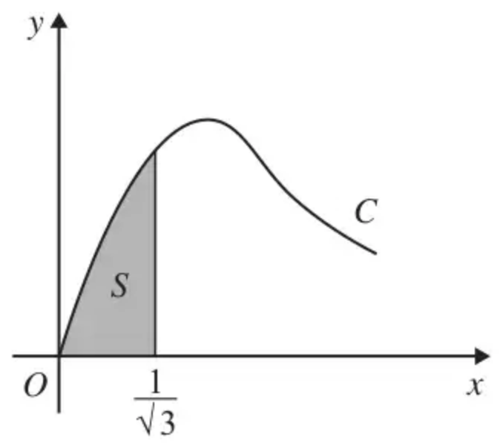
Figure 4
Figure 4 shows part of the curve $C$ with parametric equations
$$x=tan⁡θ, y=2sin⁡2θ, 0⩽θ<\frac{π}{2}$$
The finite shaded region $S$ shown in Figure 4 is bounded by $C$, the line $x=\frac{1}{\sqrt{3}}$ and the $x$-axis. This shaded region is rotated through $2π$ radians about the $x$-axis to form a solid of revolution.
(b) Show that the volume of the solid of revolution formed is given by the integral
$$k\int_{0}^{\frac{π}{6}}{}{sin⁡}^{2}θ\text{d}θ$$
where $k$ is a constant. (5)
(c) Hence find the exact value for this volume, giving your answer in the form $pπ^{2}+qπ\sqrt{3}$, where $p$ and $q$ are constants. (3)
(Total 10 marks)
Edexcel C4 June 2009 Q8
Solutions
1.
Scheme | Marks
$\text{Volume}=\overset{‾}{π\int_{0}^{2}{}{(\sqrt{(\frac{2x}{3x^{2}+4})})}^{2}\text{d}x}$ Use of $V=\overset{‾}{π∫y^{2}}\text{d}x$. | B1
$=(π){[\frac{1}{3}ln⁡(3x^{2}+4)]}_{0}^{2}$ $±kln⁡(3x^{2}+4)$ | M1
$\frac{1}{3}ln⁡(3x^{2}+4)$ | A1
$=(π)[(\frac{1}{3}ln⁡16)−(\frac{1}{3}ln⁡4)]$ Substitutes limits of 2 and 0 and subtracts the correct way round. | dM1
So Volume $=\overset{‾}{\frac{1}{3}πln⁡4}$ $\overset{‾}{\frac{1}{3}πln⁡4}$ or $\overset{‾}{\frac{2}{3}πln⁡2}$ | A1 oe isw
 | (5)
 | (5 marks)

Notes
NOTE: $π$ is required for the B1 mark and the final A1 mark. It is not required for the 3 intermediate marks.
B1: For applying $π∫y^{2}$. Ignore limits and $\text{d}x$. This can be implied by later working, but the pi and $∫\frac{2x}{3x^{2}+4}$ must appear on one line somewhere in the candidate’s working.
B1 can also be implied by a correct final answer. Note: $\backslash pi\backslash left(\backslash displaystyle\backslash int y\backslash right)^2$ would be B0.
Working in x
M1: For $±kln⁡(3x^{2}+4)$ or $±kln⁡(x^{2}+\frac{4}{3})$ where $k$ is a constant and $k$ can be 1.
Note: M0 for $±kxln⁡(3x^{2}+4)$.
Note: M1 can also be given for $±kln⁡(p(3x^{2}+4))$, where $k$ and $p$ are constants and $k$ can be 1.
A1: For $\frac{1}{3}ln⁡(3x^{2}+4)$ or $\frac{1}{3}ln⁡(\frac{1}{3}(3x^{2}+4))$ or $\frac{1}{3}ln⁡(x^{2}+\frac{4}{3})$ or $\frac{1}{3}ln⁡(p(3x^{2}+4))$.
You may allow M1 A1 for $\frac{1}{3}(\frac{x}{x})ln⁡(3x^{2}+4)$ or $\frac{1}{3}(\frac{2x}{6x})ln⁡(3x^{2}+4)$
dM1: Substitutes limits of 2 and 0 and subtracts the correct way round. Working in decimals is fine for dM1.
A1: For either $\frac{1}{3}πln⁡4,\frac{1}{3}ln⁡4^{π},\frac{2}{3}πln⁡2,πln⁡4^{\frac{1}{3}},πln⁡2^{\frac{2}{3}},\frac{1}{3}πln⁡(\frac{16}{4}),2πln⁡(\frac{16^{\frac{1}{6}}}{4^{\frac{1}{6}}})$, etc.
Note: $\frac{1}{3}π(ln⁡16−ln⁡4)$ would be A0.
Working in u: where $u=3x^{2}+4$,
M1: For $±kln⁡u$ where $k$ is a constant and $k$ can be 1.
Note: M1 can also be given for $±kln⁡(pu)$, where $k$ and $p$ are constants and $k$ can be 1.
A1: For $\frac{1}{3}ln⁡u$ or $\frac{1}{3}ln⁡3u$ or $\frac{1}{3}ln⁡pu$.
dM1: Substitutes limits of 16 and 4 in u or limits of 2 and 0 in $x$ and subtracts the correct way round.
A1: As above!
2.
Mark scheme (a)
Scheme | Marks | AO
$\frac{π}{16}\int_{−1.545}^{1.257}{(6−3y^{2}+ycos⁡(\frac{5}{2}y))}\{\text{d}y\}$  $π\int_{−1.545}^{1.257}{(\frac{3}{8}−\frac{3}{16}y^{2}+\frac{1}{16}ycos⁡(\frac{5}{2}y))}\{\text{d}y\}$ | B1 | 1.1a
$∫x^{2}\text{d}y=\frac{1}{16}∫6−3y^{2}+ycos⁡(\frac{5}{2}y)\text{d}y→Ky−Ly^{3}+…$ | M1 | 1.1b
$∫ycos⁡(\frac{5}{2}y)\text{d}y=Aysin⁡(\frac{5}{2}y)+Bcos⁡(\frac{5}{2}y)(+c)$  $\{∫ycos⁡(\frac{5}{2}y)\text{d}y=y\text{.}\frac{2}{5}sin⁡(\frac{5}{2}y)−∫1.\frac{2}{5}sin⁡(\frac{5}{2}y)\text{d}y=\frac{2}{5}ysin⁡(\frac{5}{2}y)+\frac{4}{25}cos⁡(\frac{5}{2}y)(+c)\}$ | M1 | 3.1a
$∫x^{2}\text{d}y=\frac{1}{16}(6y−y^{3}+\frac{2}{5}ysin⁡(\frac{5}{2}y)+\frac{4}{25}cos⁡(\frac{5}{2}y))(+c)$  $∫x^{2}\text{d}y=\frac{3}{8}y−\frac{1}{16}y^{3}+\frac{1}{40}ysin⁡(\frac{5}{2}y)+\frac{1}{100}cos⁡(\frac{5}{2}y)(+c)$ | A1 | 1.1b
$\int_{−1.545}^{1.257}{}x^{2}\text{d}y=\frac{1}{16}{[6y−y^{3}+\frac{2}{5}ysin⁡(\frac{5}{2}y)+\frac{4}{25}cos⁡(\frac{5}{2}y)]}_{−1.545}^{1.257}$  $=\frac{1}{16}(5.3954…−(−6.1101…))=…$  $=(0.3372…)−(−0.3818…)=…$ | M1 | 3.4
Volume $=π×\frac{11.505…}{16}=2.26$ cm³ (2.2591159…) cso | A1 | 3.2a
 | (6)

Notes
B1: Selects the correct volume of revolution formula to use, with correct limits in evidence, could appear later in their working
M1: Attempts to integrate with the correct form for the constant and term in $y^{2}$
M1: Applies integration by parts fully on the $ycos⁡(\frac{5}{2}y)$ term in the correct direction. Allow slips in the coefficients, but the form must be correct.
A1: Correct integration of the $x^{2}$ equation.
M1: Applies the correct limits to their integral provided there was some attempt at integration. No need for the $π$ for this mark. Condone working in degrees (5.74 …) - (-5.38…), award this mark following correct integration. If their integration is incorrect you will need to check the use of limits in radians only if they do not show the substitution.
A1: Correct volume including units. Accept awrt 2.26 cm³. Allow $0.719π$ cm³. Correct solution only
Note: All previous marks must have been scored to award this final accuracy mark
Special case: Use of calculator for all the integration can score a maximum of B1M0M0A0M1A0
Mark scheme (b)
Scheme | Marks | AO
Max volume for 100 berries (as we know volume of the largest) is $100×2.26≃226$ | B1ft | 1.1b
Reason e.g. not all the berries will become juice (e.g. skin, flesh, seeds may not pulp) or not all will be as big as the largest, 150 < 200 or 300 > 200  If their value  • is less than 220 – so not likely to produce $200{\text{cm}}^{3}$ of juice.  • is between 220 and 250 – they can conclude either way  • is greater than 250 – so likely to produce $200{\text{cm}}^{3}$ of juice. | B1ft | 2.2b
 | (2)
 | (8 marks)

Notes
(corrected from the printed mark scheme: the subtotal for (b) is printed as (1); part (b) carries 2 marks, B1ft B1ft)
B1ft: Attempts to estimate the volume of juice produced by 100 berries - look for their (a) multiplied by 100.
B1ft: Draws a suitable conclusion with reason given, see scheme
3.
Mark scheme (a)
Scheme | Marks
$∫{sin⁡}^{2}θ\text{d}θ=\frac{1}{2}∫(1−cos⁡2θ)\text{d}θ=\frac{1}{2}θ−\frac{1}{4}sin⁡2θ (+C)$ | M1 A1
 | (2)

Mark scheme (b)
Scheme | Marks
$x=tan⁡θ⇒\frac{\text{d}x}{\text{d}θ}={sec⁡}^{2}θ$
$π∫y^{2}\text{d}x=π∫y^{2}\frac{\text{d}x}{\text{d}θ}\text{d}θ=π∫(2sin⁡2θ)^{2}{sec⁡}^{2}θ\text{d}θ$ | M1 A1
$=π∫\frac{(2×2sin⁡θcos⁡θ)^{2}}{{cos⁡}^{2}θ}\text{d}θ$ | M1
$=16π∫{sin⁡}^{2}θ\text{d}θ$ $k=16π$ | A1
$x=0⇒tan⁡θ=0⇒θ=0, x=\frac{1}{\sqrt{3}}⇒tan⁡θ=\frac{1}{\sqrt{3}}⇒θ=\frac{π}{6}$ | B1
$(V=16π\int_{0}^{\frac{π}{6}}{}{sin⁡}^{2}θ\text{d}θ)$
 | (5)

Mark scheme (c)
Scheme | Marks
$V=16π{[\frac{1}{2}θ−\frac{sin⁡2θ}{4}]}_{0}^{\frac{π}{6}}$ | M1
$=16π[(\frac{π}{12}−\frac{1}{4}sin⁡\frac{π}{3})−(0−0)]$ Use of correct limits | M1
$=16π(\frac{π}{12}−\frac{\sqrt{3}}{8})=\frac{4}{3}π^{2}−2π\sqrt{3}$ $p=\frac{4}{3},q=−2$ | A1
 | (3)
 | (10 marks)

