QQQ – Core Pure 2 – Chapter 4 – Volumes of Revolution (Version 1)
Total Marks: 23
(23 = Platinum, 21 = Gold, 18 = Silver, 16 = Bronze)
1. In this question you must show detailed reasoning.
Fig. 4 shows the region bounded by the curve $y=sec⁡\frac{1}{2}x$, the $x$-axis, the $y$-axis and the line $x=\frac{1}{2}π$.
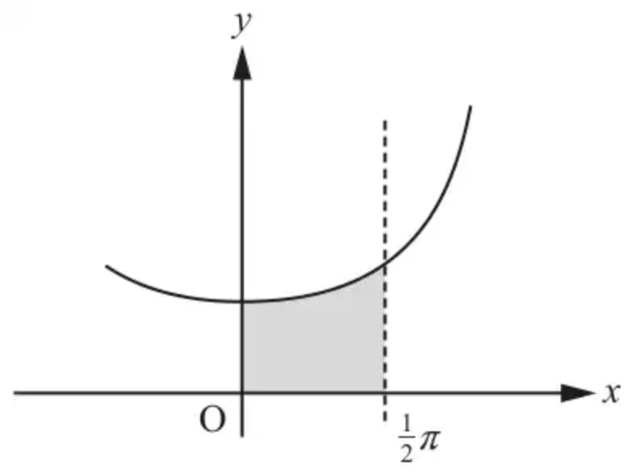
Fig. 4
This region is rotated through $2π$ radians about the $x$-axis.
Find, in exact form, the volume of the solid of revolution generated. [3]
(Total 3 marks)
OCR MEI A2 June 2019 Paper 1 Q4
2. In this question you must show detailed reasoning.
The region $R$ is bounded by the curve with equation $y=\frac{1}{\sqrt{3x^{2}−3x+1}}$, the $x$-axis and the lines with equations $x=\frac{1}{2}$ and $x=1$ (see diagram). The units of the axes are cm.
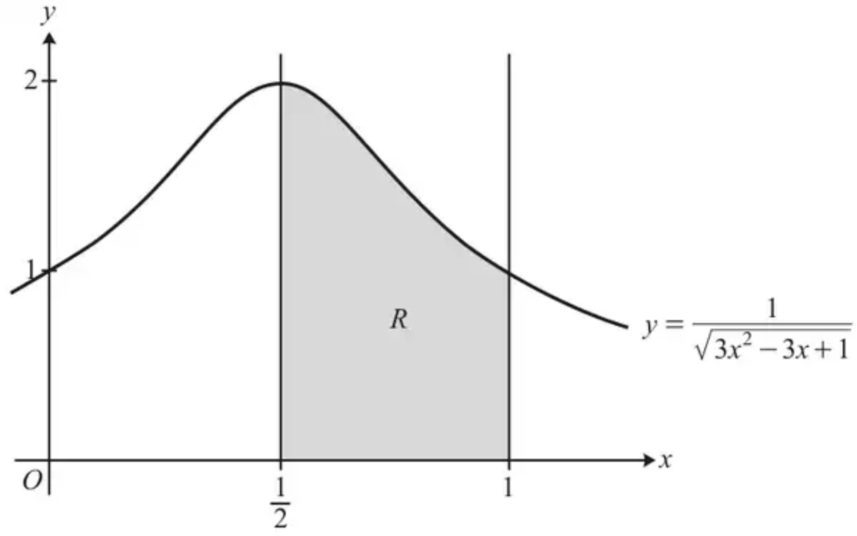
A pendant is to be made out of a precious metal. The shape of the pendant is modelled as the shape formed when $R$ is rotated by $2π$ radians about the $x$-axis.
Find the exact value of the volume of precious metal required to make the pendant, according to the model. [4]
(Total 4 marks)
OCR A A2 June 2023 Paper 2 Q4
3. The region $R_{1}$ is bounded by the curve $y=\frac{80}{\sqrt{25−x^{2}}}$, the line $x=k$ and the coordinate axes, as shown in Fig. 1.
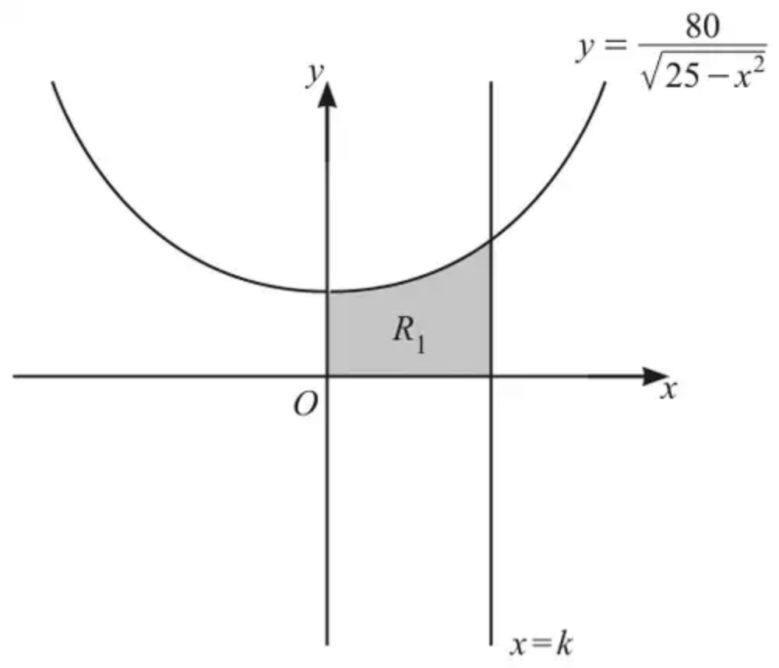
Fig. 1
(a) In this question you must show detailed reasoning.
Given that the area of $R_{1}$ is $\frac{40}{3}π$, determine the value of $k$. [3]
The region $R_{2}$ is bounded by the curve $y=\frac{80}{\sqrt{25−x^{2}}}$, the line $y=20$ and the $y$-axis as shown in Fig. 2.
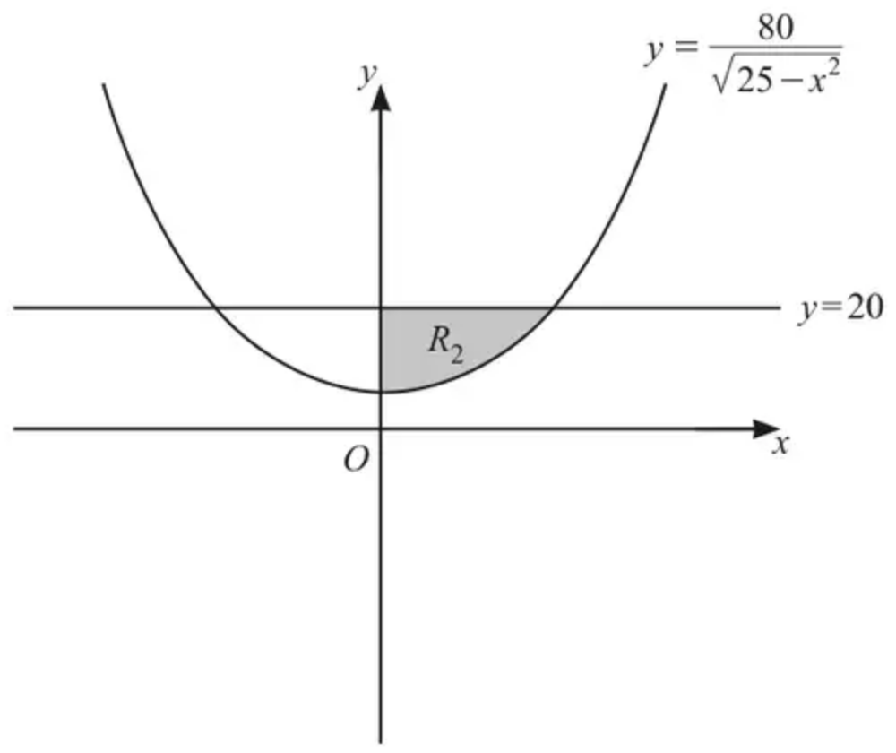
Fig. 2
(b) Find, in an exact form, the volume of the solid formed when $R_{2}$ is rotated by $2π$ radians about the y-axis. [3]
(Total 6 marks)
OCR A A2 June 2025 Paper 1 Q3
4.
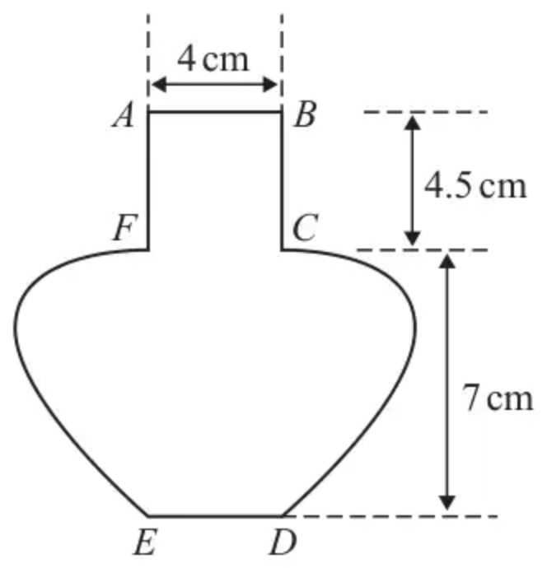
Figure 1
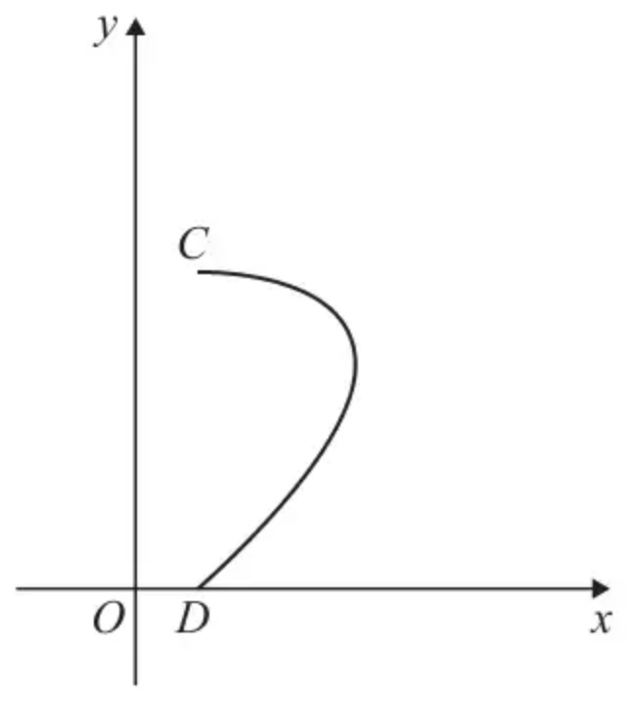
Figure 2
Figure 1 shows the central vertical cross-section $ABCDEFA$ of a vase together with measurements that have been taken from the vase.
The horizontal cross-section between $AB$ and $FC$ is a circle with diameter 4 cm.
The base of the vase $ED$ is horizontal and the point $E$ is vertically below $F$ and the point $D$ is vertically below $C$.
Using these measurements, the curve $CD$ is modelled by the parametric equations
$$x=a+3sin⁡2t y=bcos⁡t 0⩽t⩽\frac{π}{2}$$
where $a$ and $b$ are constants and $O$ is the fixed origin, as shown in Figure 2.
(a) Determine the value of $a$ and the value of $b$ according to the model. (2)
(b) Using algebraic integration and showing all your working, determine, according to the model, the volume of the vase, giving your answer to the nearest cm³ (7)
(c) State a limitation of the model. (1)
(Total 10 marks)
Edexcel A2 June 2024 Paper 2 Q9
Solutions
1.
Scheme | Marks | AO
DR  $V=\int_{0}^{\frac{π}{2}}{π}{sec⁡}^{2}\frac{1}{2}x\text{d}x$ | B1 | 1.1b
$=π{[2tan⁡\frac{1}{2}x]}_{0}^{\frac{π}{2}}$ | B1 | 1.1b
$=π(2tan⁡\frac{1}{4}π−0)=2π$ | B1cao | 1.1b
 | [3]

Notes
B1: correct integral and limits
B1: $2tan⁡\frac{1}{2}x$; condone $π$ missing
B1cao: unsupported B0
2.
Scheme | Marks | AO
DR  $V=π\int_{\frac{1}{2}}^{1}{}{({(3x^{2}−3x+1)}^{−\frac{1}{2}})}^{2}\text{d}x$ | M1 | 3.3
$V=π∫\frac{1}{3x^{2}−3x+1}\text{d}x=\frac{1}{3}π∫\frac{1}{x^{2}−x+\frac{1}{3}}\text{d}x$  $=\frac{1}{3}π∫\frac{1}{{(x−\frac{1}{2})}^{2}−\frac{1}{4}+\frac{1}{3}}\text{d}x=\frac{1}{3}π∫\frac{1}{{(x−\frac{1}{2})}^{2}+\frac{1}{12}}\text{d}x$ | M1 | 2.2a
$∫\frac{1}{{(x−\frac{1}{2})}^{2}+\frac{1}{12}}\text{d}x=[\frac{1}{\sqrt{\frac{1}{12}}}{tan⁡}^{−1}(\frac{x−\frac{1}{2}}{\sqrt{\frac{1}{12}}})]$ | A1 | 1.1
$=\frac{2}{\sqrt{3}}π[{tan⁡}^{−1}(\sqrt{3})−{tan⁡}^{−1}(0)]$  $=\frac{2}{\sqrt{3}}π\frac{π}{3}=\frac{2\sqrt{3}}{9}π^{2}$  so $\frac{2\sqrt{3}}{9}π^{2}{\text{cm}}^{3}$ | A1 | 3.4
 | [4]

Notes
M1: (1st) Using $V=π\int_{a}^{b}{}y^{2}\text{d}x$ with limits. Accept squared out expression. Condone omission of $\text{d}x$
M1: (2nd) Expressing the integral in completed square form, or $π∫\frac{1}{3{(x−\frac{1}{2})}^{2}+\frac{1}{4}}\text{d}x$ or $π∫\frac{1}{{(\sqrt{3}x−\frac{\sqrt{3}}{2})}^{2}+\frac{1}{4}}\text{d}x$
A1: (1st) $=[\frac{2}{\sqrt{3}}π{tan⁡}^{−1}(\sqrt{3}(2x−1))]$; may be equivalent based on their form and their substitution. Could see a substitution, e.g. $u=\sqrt{3}(x−\frac{1}{2})$ with $\text{d}u=\sqrt{3}\text{d}x$
A1: (2nd) oe. Do not penalise missing units
3.
Mark scheme (a)
Scheme | Marks | AO
DR  $∫\frac{80}{\sqrt{25−x^{2}}}\text{d}x=80{sin⁡}^{−1}(\frac{1}{5}x)$ | B1 | 1.1
$(\int_{0}^{k}{}\frac{80}{\sqrt{25−x^{2}}}\text{d}x=) 80{sin⁡}^{−1}(\frac{1}{5}k)=\frac{40}{3}π$ | M1 | 2.1
$({sin⁡}^{−1}(\frac{1}{5}k)=\frac{1}{6}π⇒) k=\frac{5}{2}$ | A1 | 1.1
 | [3]

Notes
B1: Correct integration – this mark can be implied by seeing $80{sin⁡}^{−1}(\frac{1}{5}k)$ but www (so if $x$ missing from the integrated expression before the limits were applied then B0) – this mark can also be awarded for ${sin⁡}^{−1}(\frac{1}{5}x)$ from $∫\frac{1}{\sqrt{25−x^{2}}}\text{d}x$
M1: For setting up an equation of the form $a{sin⁡}^{−1}(bk)−a{sin⁡}^{−1}(0)=\frac{40}{3}π$ or $a{sin⁡}^{−1}(bk)=\frac{40}{3}π$ where $a\text{≠}0,b\text{≠}0$ or 1 oe (e.g. may have divided both sides by 80). Must have come from their $a{sin⁡}^{−1}(bx)$
A1: cao – oe e.g. 2.5 - do not need to explicitly see ${sin⁡}^{−1}(0)=0$ for full marks
Mark scheme (b)
Scheme | Marks | AO
$x^{2}=−\frac{80^{2}}{y^{2}}+25$ | M1 | 1.1
$π\int_{16}^{20}{(−\frac{6400}{y^{2}}+25)}\text{d}y$ | M1 | 3.1a
$=20π$ | A1 | 1.1
 | [3]

Notes
M1: Rearranging to make $x^{2}$ the subject – allow sign errors only when re-arranging
M1: Integral of the form $π\int_{16}^{20}{(\frac{k_{1}}{y^{2}}+k_{2})}\text{d}y$ for any non-zero $k_{1},k_{2}$ with correct limits, M0 if $π$ missing but condone missing $\text{d}y$
A1: BC – must be exact (ISW if correct exact answer seen and then replaced with non-exact). A correct answer with no working (or no incorrect working) can score full marks (as this part is not DR)
4.
Mark scheme (a)
Scheme | Marks | AO
$a=2$ or $b=7$ | B1 | 3.3
$a=2$ and $b=7$ | B1 | 3.3
 | (2)

Notes
B1: Uses the model to obtain a correct value for $a$ or $b$
B1: Uses the model to obtain correct values for $a$ and $b$
Mark scheme (b)
Scheme | Marks | AO
$V=(π)∫x^{2}\frac{\text{d}y}{\text{d}t}\text{d}t=∫(2+3sin⁡2t)^{2}(−7sin⁡t)\text{d}t$ | M1 | 3.4
$=−7(π)∫(4sin⁡t+12sin⁡2tsin⁡t+9{sin⁡}^{2}2tsin⁡t)\text{d}t$  $=−7(π)∫(4sin⁡t+24{sin⁡}^{2}tcos⁡t+36{sin⁡}^{3}t{cos⁡}^{2}t)\text{d}t$ | M1 | 3.1a
$=−7(π)[−4cos⁡t+8{sin⁡}^{3}t−12{cos⁡}^{3}t+\frac{36}{5}{cos⁡}^{5}t]$ | A1ft  A1 | 1.1b  1.1b
Cylinder volume is $π×2^{2}×4.5=(18π)$ | B1 | 3.4
Total Volume $=V+$ cylinder volume  $=−7π{[−4cos⁡t+8{sin⁡}^{3}t−12{cos⁡}^{3}t+\frac{36}{5}{cos⁡}^{5}t]}_{\frac{π}{2}}^{0}+π×2^{2}×4.5$  or  $=7π{[−4cos⁡t+8{sin⁡}^{3}t−12{cos⁡}^{3}t+\frac{36}{5}{cos⁡}^{5}t]}_{0}^{\frac{π}{2}}+π×2^{2}×4.5$  (NB this is $\frac{588}{5}π+18π$) | ddM1 | 3.4
426 (cm³) | A1 | 2.2b
 | (7)

Notes
M1: Uses the parametric curve for the model and applies $(π)∫x^{2}\frac{\text{d}y}{\text{d}t}\text{d}t$
The $π$ symbol may be missing here. Also do not be concerned about a missing $\text{d}t$ at the end of their integral.
Must see an attempt at squaring $x$ and finding $\frac{\text{d}y}{\text{d}t}$ where $x=(a+3sin⁡2t)$ and $\frac{\text{d}y}{\text{d}t}=ksin⁡t$ with their $a$ and $b$ or the letters $a$ and $b$ in their integral.
M1: Expands and makes progress to an integrable form by applying $sin⁡2t=2sin⁡tcos⁡t$ at least once
Integrals in terms of $a$ and $b$ will be equivalent to:
$$±(π)∫(a^{2}bsin⁡t+6absin⁡2tsin⁡t+9b{sin⁡}^{2}2tsin⁡t)\text{d}t$$
$$=±(π)∫a^{2}bsin⁡t+12ab{sin⁡}^{2}tcos⁡t+36b{sin⁡}^{3}t{cos⁡}^{2}t\text{d}t$$
Integrals with correct values of $a$ and $b$ will be equivalent to:
$$±(π)∫(28sin⁡t+84sin⁡2tsin⁡t+63{sin⁡}^{2}2tsin⁡t)\text{d}t$$
$$=±(π)∫(28sin⁡t+168{sin⁡}^{2}tcos⁡t+252{sin⁡}^{3}t{cos⁡}^{2}t)\text{d}t$$
A1ft: (dependent on both M marks) At least 2 terms integrated correctly; follow through their $a$ and $b$, however their $a$ and $b$ must now be numerical.
$$±(π)[−a^{2}bcos⁡t+4ab{sin⁡}^{3}t−\frac{36}{3}b{cos⁡}^{3}t+\frac{36b}{5}{cos⁡}^{5}t]$$
$$=±(π)[28cos⁡t−56{sin⁡}^{3}t+84{cos⁡}^{3}t−\frac{252}{5}{cos⁡}^{5}t]$$
A1: All correct from correct values for $a$ and $b$
Their integral will be equivalent to:
$$=±(π)[28cos⁡t−56{sin⁡}^{3}t+84{cos⁡}^{3}t−\frac{252}{5}{cos⁡}^{5}t]$$
B1: Uses the model to deduce the correct volume of the cylinder; need not be simplified.
ddM1: Dependent on both previous M marks. Fully correct strategy for the volume.
Applies the correct limits (either way round) and adds this to the volume of the cylinder which must have been obtained from $π×2^{2}×4.5$ but condone $π×4^{2}×4.5$
Both volumes must be positive when combined.
A1: Correct volume, allow awrt 426 (cm³), units are not required but if any are given, they should be correct.
Mark scheme (c)
Scheme | Marks | AO
Any one of e.g.  The vase may not be completely smooth  The vase may not be symmetrical  The measurements may not be accurate  The equation of the curve may not be a suitable model  The thickness of the sides has not been considered  Accept the base may have a dimple in it (the base may not be completely flat) | B1 | 3.5b
 | (1)
 | (10 marks)

Notes
B1: See scheme. Award for a correct statement. If there is more than one statement ignore any incorrect statements as long as there are no statements that contradict their correct statement.
Comments relating to facts about the shape that are not worthy of marks include:
• the cross section is not a circle
• The vase is not solid
• the cylinder might not be vertical
• it depends on the material used to make the vase
• the vase may not have the same density throughout

