QQQ – Core Pure 1 – Chapter 5 – Volumes of Revolution (Version 2)
Total Marks: 24
(24 = Platinum, 22 = Gold, 19 = Silver, 16 = Bronze)
1.
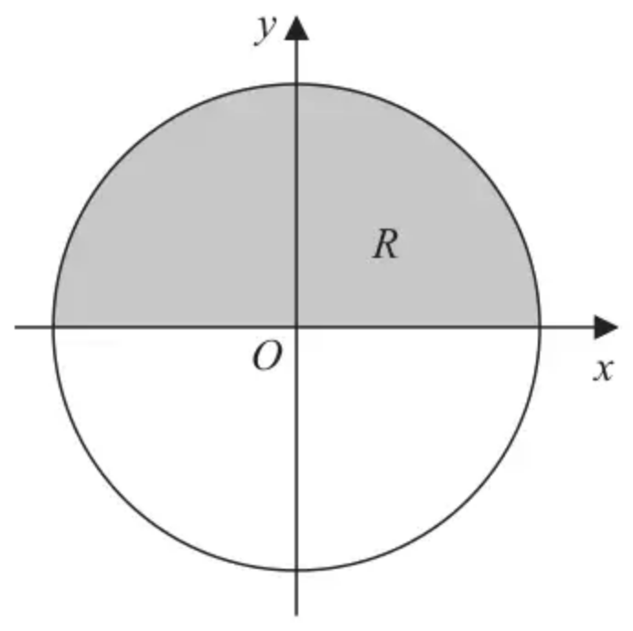
Figure 1
Figure 1 shows a circle with radius $r$ and centre at the origin.
The region $R$, shown shaded in Figure 1, is bounded by the $x$-axis and the part of the circle for which $y>0$
The region $R$ is rotated through 360° about the $x$-axis to create a sphere with volume $V$
Use integration to show that $V=\frac{4}{3}πr^{3}$ (5)
(Total 5 marks)
Edexcel AS October 2020 Paper 1 Q3
2.
(a) Find
$$∫(2x−1)^{\frac{3}{2}}\text{d}x$$
giving your answer in its simplest form. (2)
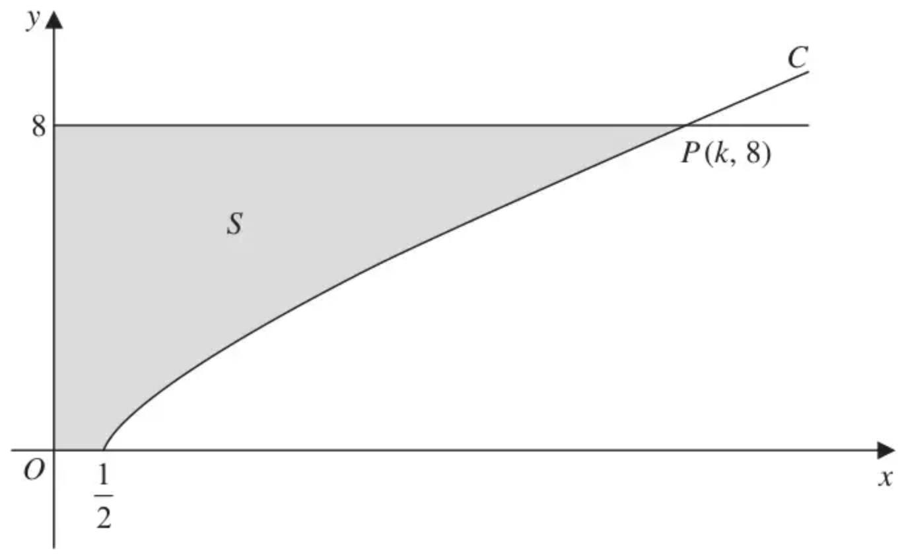
Figure 3
Figure 3 shows a sketch of part of the curve $C$ with equation
$$y=(2x−1)^{\frac{3}{4}}, x⩾\frac{1}{2}$$
The curve $C$ cuts the line $y=8$ at the point $P$ with coordinates $(k,8)$, where $k$ is a constant.
(b) Find the value of $k$. (2)
The finite region $S$, shown shaded in Figure 3, is bounded by the curve $C$, the $x$-axis, the $y$-axis and the line $y=8$. This region is rotated through $2π$ radians about the $x$-axis to form a solid of revolution.
(c) Find the exact value of the volume of the solid generated. (4)
(Total 8 marks)
Edexcel C4 June 2016 Q7
3.
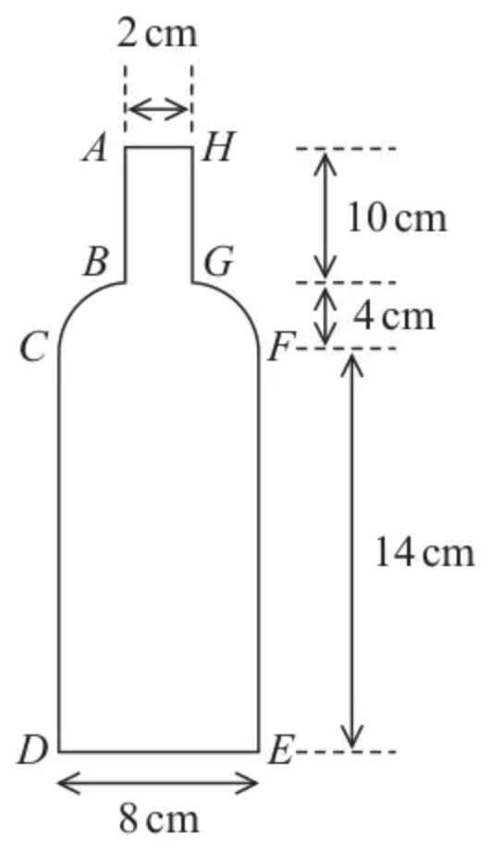
Figure 1
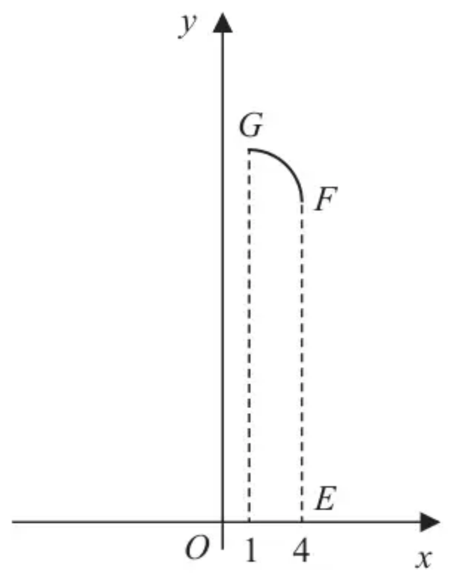
Figure 2
A mathematics student is modelling the profile of a glass bottle of water. Figure 1 shows a sketch of a central vertical cross-section $ABCDEFGHA$ of the bottle with the measurements taken by the student.
The horizontal cross-section between $CF$ and $DE$ is a circle of diameter 8 cm and the horizontal cross-section between $BG$ and $AH$ is a circle of diameter 2 cm.
The student thinks that the curve $GF$ could be modelled as a curve with equation
$$y=ax^{2}+b 1⩽x⩽4$$
where $a$ and $b$ are constants and $O$ is the fixed origin, as shown in Figure 2.
(a) Find the value of $a$ and the value of $b$ according to the model. (2)
(b) Use the model to find the volume of water that the bottle can contain. (7)
(c) State a limitation of the model. (1)
The label on the bottle states that the bottle holds approximately 750 cm³ of water.
(d) Use this information and your answer to part (b) to evaluate the model, explaining your reasoning. (1)
(Total 11 marks)
Edexcel AS June 2018 Paper 1 Q9
Solutions
1.
Scheme | Marks | AO
$x^{2}+y^{2}=r^{2}$ | B1 | 1.2
$\{V\}=π\int_{−r}^{r}{}r^{2}−x^{2}\text{d}x$ or $\{V\}=2π\int_{0}^{r}{}r^{2}−x^{2}\text{d}x$ | B1 | 2.1
Integrates to the form $αx±βx^{3}$  [note: the correct integration gives $r^{2}x−\frac{1}{3}x^{3}$] | M1 | 1.1b
Substitutes limits of $−r$ and $r$ and subtracts the correct way round  $$(r^{2}(r)−\frac{1}{3}(r)^{3})−(r^{2}(−r)−\frac{1}{3}(−r)^{3})$$  or  Substitutes limits of 0 and $r$ and subtracts the correct way round with twice the volume. Note the limit of 0 can be implied if gives and answer of 0  $$(r^{2}(r)−\frac{1}{3}(r)^{3})−(0)$$ | dM1 | 1.1b
$V=\frac{4}{3}πr^{3}$ * cso | A1* | 1.1b
 | (5)
 | (5 marks)

Notes
B1: Correct equation of the circle, may be implied by correct integral
B1: Correct expression for the volume, including limits, d$x$ may be implied and if using limits $r$ and 0 the 2 could appear later with reasoning
M1: Integrates to the form $αx±βx^{3}$. Do not award if $r^{2}→λr^{3}$
dM1: Dependent on previous method mark. Correct use of limits $−r$ and $r$ or limits of 0 and $r$ with twice the volume.
A1*: $V=\frac{4}{3}πr^{3}$ * cso
Note: rotation about the $y$-axis all marks are available, however for the final accuracy mark must refer to symmetry
2.
Mark scheme (a)
Scheme | Marks
$y=(2x−1)^{\frac{3}{4}}, x⩾\frac{1}{2}$ passes though $P(k,8)$
$\{∫(2x−1)^{\frac{3}{2}}\text{d}x\}=\frac{1}{5}(2x−1)^{\frac{5}{2}}\{+c\}$  $(2x±1)^{\frac{3}{2}}→±λ(2x±1)^{\frac{5}{2}}$ or $±λu^{\frac{5}{2}}$ where $u=2x±1$; $λ\text{≠}0$  $\frac{1}{5}(2x−1)^{\frac{5}{2}}$ with or without $+c$. Must be simplified. | M1 A1
 | (2)

Mark scheme (b)
Scheme | Marks
$\{P(k,8)⇒\}8=(2k−1)^{\frac{3}{4}}⇒k=\frac{8^{\frac{4}{3}}+1}{2}$  Sets $8=(2k−1)^{\frac{3}{4}}$ or $8=(2x−1)^{\frac{3}{4}}$ and rearranges to give $k=$ (or $x=$) a numerical value. | M1
So, $k=\frac{17}{2}$  $k$ (or $x$) $=\frac{17}{2}$ or 8.5 | A1
 | (2)

Notes
SC: Allow Special Case SC M1 for a candidate who sets $8=(2k−1)^{\frac{3}{2}}$ or $8=(2x−1)^{\frac{3}{2}}$ and rearranges to give $k=$ (or $x=$) a numerical value.
Mark scheme (c)
Scheme | Marks
$π∫{((2x−1)^{\frac{3}{4}})}^{2}\text{d}x$  For $π∫{((2x−1)^{\frac{3}{4}})}^{2}$ or $π∫(2x−1)^{\frac{3}{2}}$. Ignore limits and $\text{d}x$. Can be implied. | B1
$\{\int_{\frac{1}{2}}^{\frac{17}{2}}{}y^{2}\text{d}x\}={[\frac{(2x−1)^{\frac{5}{2}}}{5}]}_{\frac{1}{2}}^{\frac{17}{2}}=((\frac{16^{\frac{5}{2}}}{5})−(0))\{=\frac{1024}{5}\}$  Note: It is not necessary to write the "$−0$"  Applies $x$-limits of “8.5” (their answer to part (b)) and 0.5 to an expression of the form $±β(2x−1)^{\frac{5}{2}};β\text{≠}0$ and subtracts the correct way round. | M1
$\{V_{\text{cylinder}}\}=π(8)^{2}(\frac{17}{2})\{=544π\}$  $π(8)^{2}(\text{their answer to part}(b))$. $V_{\text{cylinder}}=544π$ implies this mark | B1 ft
$\{\text{Vol}(S)=544π−\frac{1024π}{5}\}⇒\text{Vol}(S)=\frac{1696}{5}π$  An exact correct answer in the form $kπ$. E.g. $\frac{1696}{5}π$, $\frac{3392}{10}π$ or $339.2π$ | A1
 | (4)
 | (8 marks)

Notes
M1: Can also be given for applying $u$-limits of “16” (2("part (b)") $−$ 1) and 0 to an expression of the form $±βu^{\frac{5}{2}};β\text{≠}0$ and subtracts the correct way round.
Note: You can give M1 for ${[\frac{(2x−1)^{\frac{5}{2}}}{5}]}_{\frac{1}{2}}^{\frac{17}{2}}=\frac{1024}{5}$
Note: Give M0 for ${[\frac{(2x−1)^{\frac{5}{2}}}{5}]}_{0}^{\frac{17}{2}}=((\frac{16^{\frac{5}{2}}}{5})−(0))$
B1ft: Correct expression for the volume of a cylinder with radius 8 and their (part (b)) height $k$.
Note: If a candidate uses integration to find the volume of this cylinder they need to apply their limits to give a correct expression for its volume.
So $π\int_{0}^{8.5}{}8^{2}\text{d}x=π[64x]_{0}^{8.5}$ is not sufficient for B1 but $π(64(8.5)−0)$ is sufficient for B1.
Alt. (c)
Scheme | Marks
$\text{Vol}(S)=π(8)^{2}(\frac{1}{2})+\overset{‾}{\overset{‾}{π}}\int_{0.5}^{8.5}{(8^{2}−\overset{‾}{\overset{‾}{(2x−1)^{\frac{3}{2}}}})}\text{d}x$  For $\overset{‾}{\overset{‾}{π}}∫……\overset{‾}{\overset{‾}{(2x−1)^{\frac{3}{2}}}}$. Ignore limits and $\text{d}x$. | B1
$=π(8)^{2}(\frac{1}{2})+π{[64x−\frac{1}{5}(2x−1)^{\frac{5}{2}}]}_{0.5}^{8.5}$
$=\overset{‾}{\overset{‾}{π(8)^{2}(\frac{1}{2})}}+\overset{‾}{\overset{‾}{π}}((\overset{‾}{\overset{‾}{64(\text{"}8.5\text{"})}}−\frac{1}{5}(2(8.5)−1)^{\frac{5}{2}})−(\overset{‾}{\overset{‾}{64(0.5)}}−\frac{1}{5}(2(0.5)−1)^{\frac{5}{2}}))$  as above | M1 B1
$\{=32π+π((544−\frac{1024}{5})−(32−0))\}⇒\text{Vol}(S)=\frac{1696}{5}π$ | A1
 | (4)

MISREADING IN BOTH PARTS (B) AND (C)
Apply the misread rule (MR) for candidates who apply $y=(2x−1)^{\frac{3}{2}}$ to both parts (b) and (c)
(b)
Scheme | Marks
$\{P(k,8)⇒\}8=(2k−1)^{\frac{3}{2}}⇒k=\frac{8^{\frac{2}{3}}+1}{2}$  Sets $8=(2k−1)^{\frac{3}{2}}$ or $8=(2x−1)^{\frac{3}{2}}$ and rearranges to give $k=$ (or $x=$) a numerical value. | M1
So, $k=\frac{5}{2}$  $k$ (or $x$) $=\frac{5}{2}$ or 2.5 | A1
 | (2)

(c)
Scheme | Marks
$π∫{((2x−1)^{\frac{3}{2}})}^{2}\text{d}x$  For $π∫{((2x−1)^{\frac{3}{2}})}^{2}$ or $π∫(2x−1)^{3}$. Ignore limits and $\text{d}x$. Can be implied. | B1
$\{\int_{\frac{1}{2}}^{\frac{5}{2}}{}y^{2}\text{d}x\}={[\frac{(2x−1)^{4}}{8}]}_{\frac{1}{2}}^{\frac{5}{2}}=((\frac{4^{4}}{8})−(0))\{=32\}$  Applies $x$-limits of “2.5” (their answer to part (b)) and 0.5 to an expression of the form $±β(2x−1)^{4};β\text{≠}0$ and subtracts the correct way round. | M1
$V_{\text{cylinder}}=π(8)^{2}(\frac{5}{2})\{=160π\}$  $π(8)^{2}(\text{their answer to part}(b))$. Sight of $160π$ implies this mark | B1 ft
$\{\text{Vol}(S)=160π−32π\}⇒\text{Vol}(S)=128π$  An exact correct answer in the form $kπ$. E.g. $128π$ | A1
 | (4)

(corrected from the printed mark scheme: the upper limit on the integral in the misread (c) scheme is printed as $\frac{17}{2}$; it is $\frac{5}{2}$, as used in the rest of that line.)
Note: Mark parts (b) and (c) using the mark scheme above and then working forwards from part (b) deduct two from any A or B marks gained.
E.g. (b) M1A1 (c) B1M1B1A1 would score (b) M1A0 (c) B0M1B1A1
E.g. (b) M1A1 (c) B1M1B0A0 would score (b) M1A0 (c) B0M1B0A0
Note: If a candidate uses $y=(2x−1)^{\frac{3}{4}}$ in part (b) and then uses $y=(2x−1)^{\frac{3}{2}}$ in part (c) do not apply a misread in part (c).
3.
Mark scheme (a)
Scheme | Marks | AO
$(4,14),(1,18)⇒14=a(4)^{2}+b,18=a(1)^{2}+b⇒a=…,b=…$ | M1 | 3.3
$a=−\frac{4}{15},b=\frac{274}{15}$ | A1 | 1.1b
 | (2)

Notes
M1: Chooses (4, 14) and (1, 18) and substitutes into the equation modelling the curve to obtain at least one correct equation and attempts to find the values of $a$ and $b$.
A1: Infers from the data in the model, the values of $a$ and $b$
Mark scheme (b)
Scheme | Marks | AO
$π×4^{2}×14$ and $π×1^{2}×10$ | B1 | 1.1b
$π∫x^{2}\text{d}y=\frac{π}{4}∫(274−15y)\text{d}y$ | B1ft | 1.1a
$=\frac{π}{4}\int_{14}^{18}{(}\text{d}y$ | M1 | 3.3
$=\frac{π}{4}{[274y−\frac{15y^{2}}{2}]}_{14}^{18}$ | M1  A1 | 1.1b  1.1b
$V=234π+\frac{π}{4}[274(18)−\frac{15(18)^{2}}{2}−(274(14)−\frac{15(14)^{2}}{2})]$ | ddM1 | 3.4
$V=268π≈842{\text{cm}}^{3}$ | A1 | 2.2b
 | (7)

Notes
B1: Correct expressions for the 2 cylindrical parts. May be seen as a sum or as separate cylinders.
B1ft: Uses the model to obtain $π∫(\frac{y−\text{their}b}{\text{their}a})\text{d}y$ (Note that the $π$ may be recovered later)
M1: Chooses limits appropriate to the model i.e. 14 and 18
M1: Integrates to obtain an expression of the form $αy+βy^{2}$
A1: Uses their model correctly to give $274y−\frac{15y^{2}}{2}$
ddM1: Uses the model to find the sum of their cylinders + their integrated volume. Must be a fully correct method here and is dependent on both previous method marks. So must have attempted the volumes of the cylinders “AHBG” and “CFED” and adds these to the magnitude of their integrated volume.
A1: $268π$ or awrt 842
Mark scheme (c)
Scheme | Marks | AO
Any one of e.g.  The measurements may not be accurate  The equation of the curve may not be a suitable model  The bottom of the bottle may not be flat  The thickness of the glass may not have been considered  The glass may not be smooth  This part asks for a limitation of the model so their answer must refer to e.g. :  • The measuring of the dimensions  • The model used for the curve  • The simplified model (the thickness of glass, the simplified shape, smoothness of the glass etc.) | B1 | 3.5b
 | (1)

Notes
B1: States an acceptable limitation of the model with no contradictory statements. (This is independent of part (b))
Mark scheme (d)
Scheme | Marks | AO
There are 2 criteria for this mark:  • A comparison of their value to 750 e.g. larger, smaller, about the same or a difference demonstrated e.g. 810 – 750 = … but not just a percentage error or just a difference with no calculation  • A conclusion that is consistent with their values e.g. this is not a good model, this is a good model etc.  If they reach an answer that is less than 750, they need to conclude that it is not a good model  If they reach an answer that is greater than 750 then look for a sensible comment that is consistent with their value | B1ft | 3.5a
 | (1)
 | (11 marks)

Notes
B1ft: Compares the actual volume to their answer to part (b) and makes an assessment of the model with a reason with no contradictory statements.

