QQQ – Core Pure 1 – Chapter 5 – Volumes of Revolution (Version 1)
Total Marks: 24
(24 = Platinum, 22 = Gold, 19 = Silver, 16 = Bronze)
1. The function f is defined by
$$\text{f}(x)=2x+3 0⩽x⩽5$$
The region $R$ is enclosed by $y=\text{f}(x)$, $x=5$, the $x$-axis and the $y$-axis.
The region $R$ is rotated through $2π$ radians about the $x$-axis.
Give an expression for the volume of the solid formed.
Tick (✓) one box. [1 mark]
• $π\int_{0}^{5}{(}\text{d}x$
• $π\int_{0}^{5}{(})^{2}\text{d}x$
• $2π\int_{0}^{5}{(}\text{d}x$
• $2π\int_{0}^{5}{(})^{2}\text{d}x$
(Total 1 marks)
AQA AS June 2024 Paper 1 Q2
2. $O$ is the origin of a coordinate system whose units are cm.
The points $A$, $B$, $C$ and $D$ have coordinates $(1,0)$, $(1,4)$, $(6,9)$ and $(0,9)$ respectively.
The arc $BC$ is part of the curve with equation $x^{2}+(y−10)^{2}=37$.
The closed shape $OABCD$ is formed, in turn, from the line segments $OA$ and $AB$, the arc $BC$ and the line segments $CD$ and $DO$ (see diagram).
A funnel can be modelled by rotating $OABCD$ by $2π$ radians about the $y$-axis.
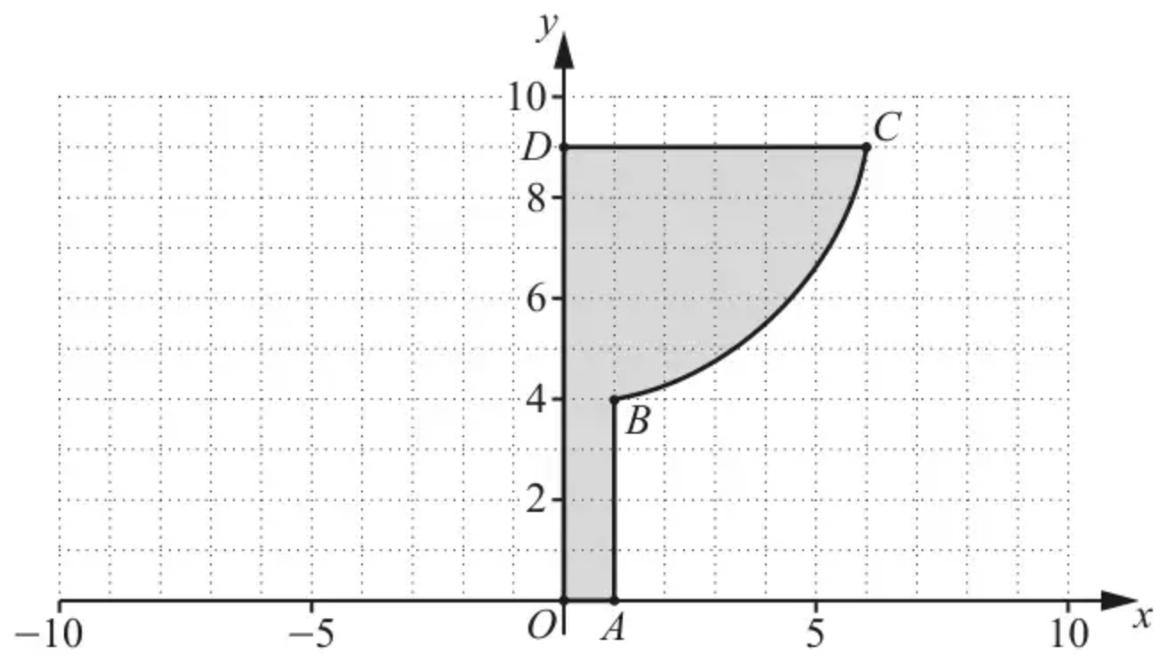
Find the volume of the funnel according to the model. [3]
(Total 3 marks)
OCR A A2 October 2021 Paper 1 Q6
3. A segment of the line $y=kx$ is rotated about the $x$-axis to generate a cone with vertex $O$.
The distance of $O$ from the centre of the base of the cone is $h$.
The radius of the base of the cone is $r$.
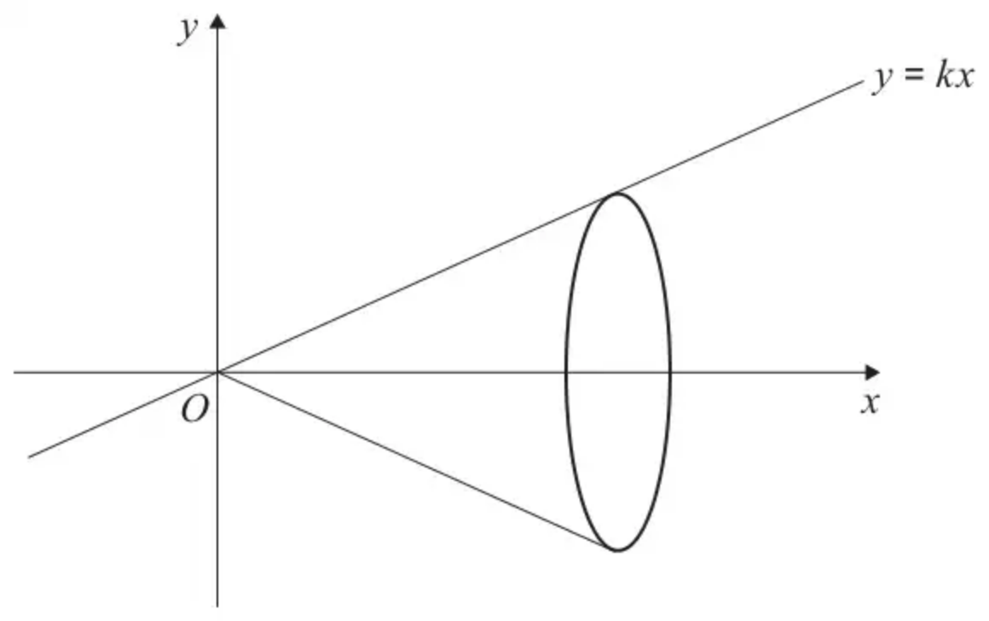
(a) Find $k$ in terms of $r$ and $h$. [1 mark]
(b) Use calculus to prove that the volume of the cone is
$$\frac{1}{3}πr^{2}h$$
[3 marks]
(Total 4 marks)
AQA AS June 2020 Paper 1 Q15
4. The curve $C_{1}$ is given by the equation
$$xy=m$$
where $m$ is a positive constant.
The region $R_{1}$ is enclosed by curve $C_{1}$, the $x$-axis and the lines $x=1$ and $x=4$
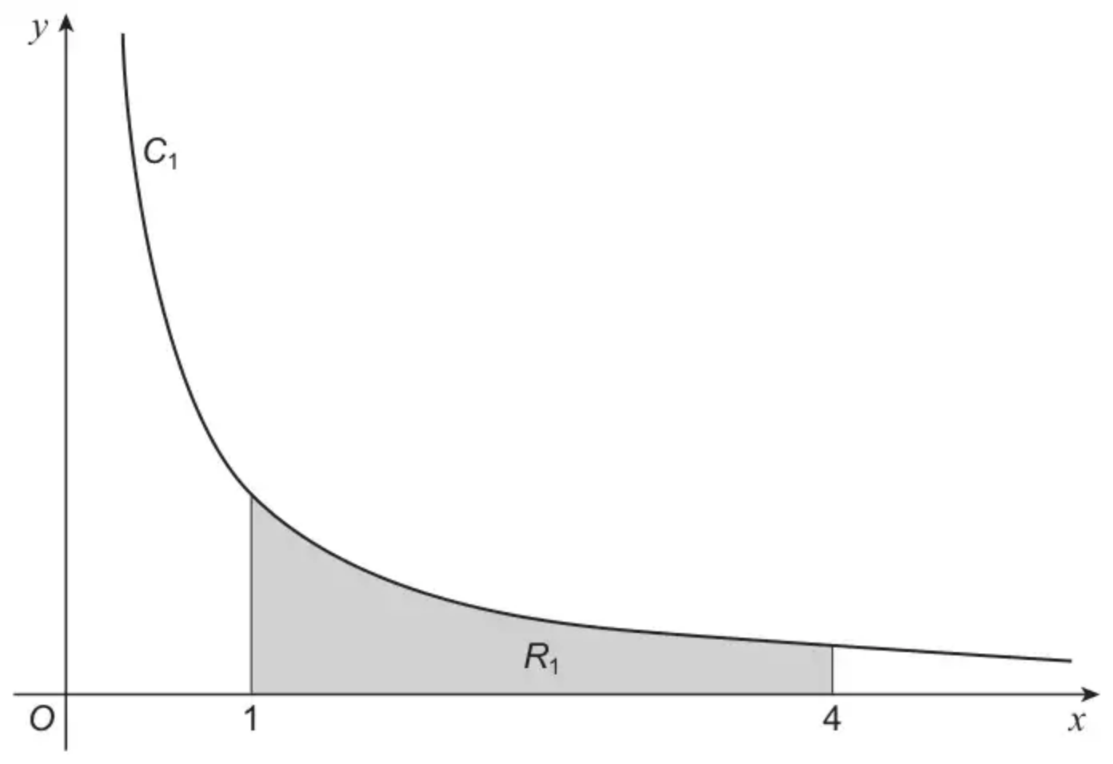
The region $R_{1}$ is rotated through $2π$ radians about the $x$-axis.
The volume of the solid generated is $V$
(a) Find a simplified expression for $V$ in terms of $m$ [2 marks]
(b) The curve $C_{2}$ is a stretch of $C_{1}$ by a factor 5 in the $y$-direction.
The region $R_{2}$ is enclosed by $C_{2}$, the $x$-axis and the lines $x=1$ and $x=4$
The region $R_{2}$ is rotated through $2π$ radians about the $x$-axis.
The volume of the solid generated by rotating $R_{2}$ is $6π$
Calculate the value of $m$ [3 marks]
(Total 5 marks)
AQA AS June 2025 Paper 1 Q13
5.
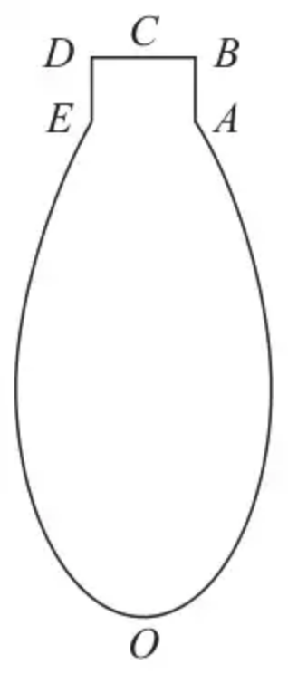
Figure 1
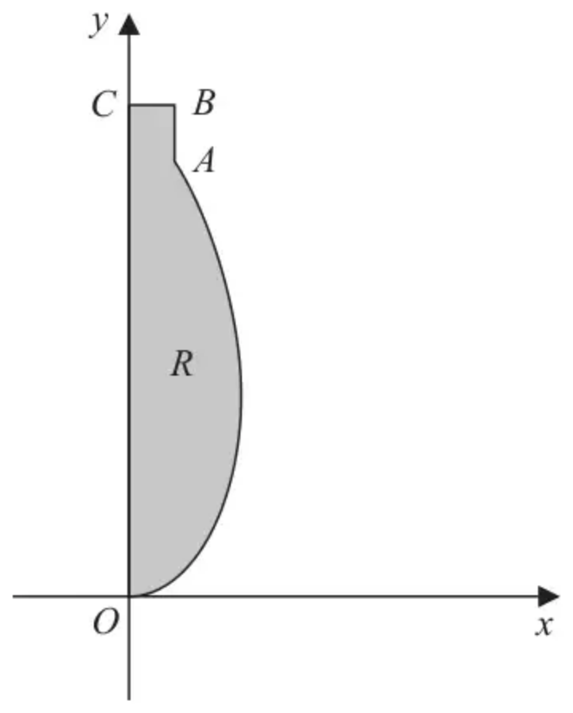
Figure 2
Figure 1 shows the central vertical cross-section, $OABCDEO$, of the design for a solid glass ornament.
Figure 2 shows the finite region, $R$, which is bounded by the $y$-axis, the horizontal line $CB$, the vertical line $BA$, and the curve $AO$.
The ornament is formed by rotating the region $R$ through 360° about the $y$-axis.
The curve $AO$ is modelled by the equation
$$x=ky^{2}+\sqrt{y} 0⩽y⩽4$$
where $k$ is a constant.
The point $A$ has coordinates (0.4, 4) and the point $B$ has coordinates (0.4, 4.5)
The units are centimetres.
(a) Determine the value of $k$ according to this model. (2)
(b) Use algebraic integration to determine the exact volume of glass that would be required to make the ornament, according to the model. (7)
(c) State a limitation of the model. (1)
When the ornament was manufactured, 9 cm³ of glass was required.
(d) Use this information and your answer to part (b) to evaluate the model, explaining your reasoning. (1)
(Total 11 marks)
Edexcel AS June 2024 Paper 1 Q8
Solutions
1.
Scheme | Marks | AO
Ticks the 2nd box. | B1 | 1.1b
 | (1 mark)

Typical solution
$$π\int_{0}^{5}{(})^{2}\text{d}x$$
2.
Scheme | Marks | AO
For $AB$, $V=π×1^{2}×4=12.566…$
For $BC$, $V=\int_{a}^{b}{π}x^{2}\text{d}y=π\int_{4}^{9}{(37−(y−10)^{2})}\text{d}y$ | M1 | 3.3
$=356.05…$ | A1 | 1.1
$⇒$ Total $V=356.05…+12.566…=368.61…$  $=369({\text{cm}}^{3})$ to 3 sf | A1 | 3.4
 | [3]

Notes
For $AB$: $4π$
M1: Split into two parts and use formulae
An integral and an attempt at the volume of a cylinder must be seen
A1: Integration – ignore limits BC
$\frac{340}{3}π$
A1: Units are not required
$\frac{352}{3}π$
3.
Mark scheme (a)
Scheme | Marks | AO
Obtains the correct expression $k=\frac{r}{h}$. | B1 | 1.1b

Typical solution
$$\frac{r}{h}$$
Mark scheme (b)
Scheme | Marks | AO
Uses the formula for volume of revolution $V=π∫mx^{2}dx$.  Condone missing $π$, $dx$ and missing or incorrect limits. | M1 | 1.1a
Correctly integrates their $(kx)^{2}$, with an expression for $k$ in terms of $r$ and $h$. | M1 | 1.1a
Completes a rigorous proof to show that $V=\frac{1}{3}πr^{2}h$. | R1 | 2.1
 | (4 marks)

Typical solution
$$\begin{matrix}\text{Volume} & =π\int_{0}^{h}{}{(\frac{rx}{h})}^{2}dx \\ & =π\int_{0}^{h}{}\frac{r^{2}x^{2}}{h^{2}}dx \\ & =π{[\frac{r^{2}x^{3}}{3h^{2}}]}_{0}^{h} \\ & =π(\frac{r^{2}h^{3}}{3h^{2}}−0)=\frac{1}{3}πr^{2}h\end{matrix}$$
4.
Mark scheme (a)
Scheme | Marks | AO
Writes a correct expression for $V$ in terms of $x$  Condone missing $\text{d}x$ | M1 | 1.2
Obtains $\frac{3}{4}m^{2}π$ | A1 | 1.1b
 | (2)

Typical solution
$$\begin{matrix}V & =π\int_{1}^{4}{}{(\frac{m}{x})}^{2}\text{d}x \\ & =πm^{2}{[−\frac{1}{x}]}_{1}^{4} \\ & =\frac{3πm^{2}}{4}\end{matrix}$$
Mark scheme (b)
Scheme | Marks | AO
Writes a correct expression for the stretched volume in terms of $m$ (and $x$)  eg $π\int_{1}^{4}{}{(\frac{5m}{x})}^{2}\text{d}x$  or  Writes their part (a) $×5^{2}$ | M1 | 3.1a
Forms a correct equation in terms of $m$ only  or  Forms the equation  their part (a) $×5^{n}=6π$  where $n=1,2$ or 3  PI by $m^{2}=\frac{8}{5}$ or $m^{2}=\frac{8}{125}$ oe | M1 | 1.1a
Obtains $\frac{2}{5}\sqrt{2}$ oe eg $\frac{\sqrt{8}}{5}$  Negative root does not have to be considered. | A1 | 1.1b
 | (3)
 | (5 marks)

Typical solution
$$\frac{3πm^{2}}{4}×5^{2}=6π$$
$$m^{2}=\frac{8}{25}$$
$$m>0\text{so}m=\frac{2}{5}\sqrt{2}$$
5.
Mark scheme (a)
Scheme | Marks | AO
$(0.4,4)⇒0.4=k×4^{2}+\sqrt{4}⇒k=…$ | M1 | 3.3
$k=−0.1$ | A1 | 1.1b
 | (2)

Notes
M1: Substitutes (0.4, 4) into the equation modelling the curve in an attempt to find the value of $k$
A1: Infers from the data in the model, the value of $k$
Mark scheme (b)
Scheme | Marks | AO
Cylinder volume = $π×0.4^{2}×0.5=0.08π=\frac{2}{25}π$ | B1 | 3.4
Volume generated by curve = $π∫x^{2}\text{d}y$  $π∫{(\sqrt{y}+ky^{2})}^{2}\{\text{d}y\}=π∫{(\sqrt{y}−0.1y^{2})}^{2}\{\text{d}y\}$ | M1 | 3.1b
$=\{π\}∫(y+2ky^{\frac{5}{2}}+k^{2}y^{4})\{\text{d}y\}$  $=\{π\}∫(y−0.2y^{\frac{5}{2}}+0.01y^{4})\{\text{d}y\}$ | A1ft | 1.1b
$=\{π\}\int_{0}{(y−0.2y^{\frac{5}{2}}+0.01y^{4})}\{\text{d}y\}$  $⇒\{π\}[Ay^{2}+By^{\frac{7}{2}}+Cy^{5}]$  at least one of their terms with the correct power | M1 | 3.4
$=\{π\}[\frac{y^{2}}{2}+\frac{4k}{7}y^{\frac{7}{2}}+\frac{k^{2}}{5}y^{5}]$  $=\{π\}[\frac{y^{2}}{2}−\frac{2}{35}y^{\frac{7}{2}}+\frac{1}{500}y^{5}]$ | A1ft | 1.1b
$V=π(8−\frac{256}{35}+\frac{256}{125})−(0)+\frac{2}{25}π$  $V=\frac{2392}{875}π+\frac{2}{25}π$ | M1 | 3.4
$V=\frac{2462π}{875}{\text{cm}}^{3}$ | A1 | 2.2b
 | (7)

Notes
B1: Uses the information given in the model to establish the correct volume of the cylinder
M1: Uses the model and applies $π∫x^{2}\{\text{d}y\}$, d$y$ not required and $π$ may appear later in their solution. If they find an expression for $x^{2}$ first and then substitutes into the formula score M1 even if an incorrect expansion.
A1ft: Correct expression for the volume generated by the curve with the bracket expanded (follow through their $k$ value), d$y$ not required and $π$ may appear later in their solution. Indices need to be processed for this mark, may be seen later in the solution.
M1: Attempts to integrate with at least one power raised by 1
A1ft: Correct integration (follow through on their expression for $x^{2}$ as long as there are 3 terms). Need not be simplified.
M1: Uses the correct limits and finds the sum of the 2 volumes. Must come from an attempt at $π\int_{0}^{4}{}x^{2}\{\text{d}y\}$ and an attempt at the volume of the cylinder, condone incorrect formula used as long as it is 3 dimensional not an area.
A1: $\frac{2462π}{875}$
Use of calculator scores a maximum of B1M1A0M0A0M1A0 volume = $\text{π}$2.7337…
Mark scheme (c)
Scheme | Marks | AO
E.g.  • The equation of the curve may not be a suitable model  • The sides of the ornament will not be perfectly smooth  • There may be flaws/bubbles within the glass  • The corner (ABC) may not be a perfect right angle | B1 | 3.5b
 | (1)

Notes
B1: States an acceptable limitation of the model, which is the curve but accept flaws/bubbles in the glass. Measurements may not be accurate, or anything related to thickness is B0
Mark scheme (d)
Scheme | Marks | AO
Makes an appropriate comment that is consistent with their value for the volume and 9 cm³.  Some evidence of making a comparison and draws a conclusion  E.g. a good estimate as 8.84 cm³ is only 0.16 cm³ less than 9 cm³  • A volume between 8.5 and 9.5 is a good model  • A volume between 8 and 10 can be either a good or bad model  • A volume less than 8 or more than 10 is a bad model, over estimate or underestimate  • model volume is less, not enough glass would be ordered so it is a bad model, following a correct answer to (b) | B1ft | 3.5a
 | (1)
 | (11 marks)

Notes
B1ft: Compares the actual volume to their answer to part (b) and makes an assessment of the model with a reason. If using a percentage error then they must use 9 as the true volume.

