QQQ – Core Pure 1 – Chapter 3 – Series (Version 2)
Total Marks: 24
(24 = Platinum, 22 = Gold, 19 = Silver, 16 = Bronze)
1. Using the formulae for $\sum_{r=1}^{n}{r}$ and $\sum_{r=1}^{n}{}r^{2}$, show that $\sum_{r=1}^{10}{r}$. [3]
(Total 3 marks)
OCR A A2 June 2019 Paper 1 Q4
2. Find $\sum_{r=1}^{n}{(}r^{2}−1)$, expressing your answer in fully factorised form. [4]
(Total 4 marks)
OCR MEI A2 June 2019 Paper 1 Q1
3. In this question you must show detailed reasoning.
Determine the sum of all cube numbers from 216 to 512 000 inclusive. [4]
(Total 4 marks)
OCR A A2 June 2025 Paper 2 Q4
4. You are given that $\sum_{r=1}^{n}{(}n^{2}$ for all $n$, where $a$ and $b$ are constants.
By finding $\sum_{r=1}^{n}{(}$ in terms of $a$, $b$ and $n$, determine the values of $a$ and $b$. [6]
(Total 6 marks)
OCR MEI AS June 2023 Paper 1 Q4
5.
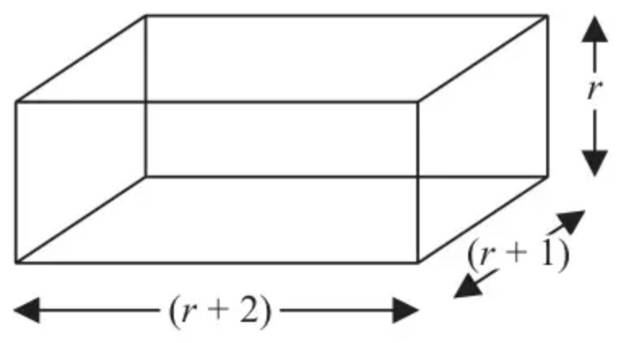
Figure 2
A block has length $(r+2)$ cm, width $(r+1)$ cm and height $r$ cm, as shown in Figure 2.
In a set of $n$ such blocks, the first block has a height of 1 cm, the second block has a height of 2 cm, the third block has a height of 3 cm and so on.
(a) Use the standard results for $\sum_{r=1}^{n}{}r^{3},\sum_{r=1}^{n}{}r^{2}$ and $\sum_{r=1}^{n}{r}$ to show that the total volume, $V$, of all $n$ blocks in the set is given by
$$V=\frac{n}{4}(n+1)(n+2)(n+3) n⩾1$$
(5)
Given that the total volume of all $n$ blocks is
$$(n^{4}+6n^{3}−11710){\text{cm}}^{3}$$
(b) determine how many blocks make up the set. (2)
(Total 7 marks)
Edexcel AS October 2020 Paper 1 Q5
Solutions
1.
Scheme | Marks | AO
$\sum_{r=1}^{10}{r}\sum_{r=1}^{10}{(}r^{2}−2r)=3\sum_{r=1}^{10}{}r^{2}−2\sum_{r=1}^{10}{r}$ | M1 | 1.1
$=3(\frac{1}{6}10.11.21)−2(\frac{1}{2}10.11)$ | M1 | 2.1
$(=55(21−2)=55×19)$  $=1045$ | A1 | 1.1
 | [3]

Notes
M1: Separate soi
M1: Use both formulae with $n=10$
A1: AG. oe 1155 − 110
Alternative method (leaving substitution to the end)
Scheme | Marks
$\sum_{r=1}^{10}{r}\sum_{r=1}^{10}{(}r^{2}−2r)=3\sum_{r=1}^{10}{}r^{2}−2\sum_{r=1}^{10}{r}$ | M1
$=\frac{3}{6}n(n+1)(2n+1)−\frac{2}{2}n(n+1)$  $=\frac{1}{2}n(n+1)(2n+1−2)=\frac{1}{2}n(n+1)(2n−1)$  $n=10⇒\frac{1}{2}10.11.19$ | M1
$=1045$ | A1
 | [3]

2.
Scheme | Marks | AO
$\sum_{r=1}^{n}{(}r^{2}−1)=\frac{1}{3}n(n+1)(2n+1)−n$ | B1  B1 | 2.5  1.1b
$=\frac{1}{3}n(2n^{2}+3n−2)$ | B1 | 1.1b
$=\frac{1}{3}n(2n−1)(n+2)$ | B1cao | 1.1b
 | [4]

Notes
B1: $\frac{1}{3}n(n+1)(2n+1)…$
B1: $…−n$
B1: factoring out $n$ correctly
B1cao: allow $\frac{2}{6}n(2n−1)(n+2)$, etc
3.
Scheme | Marks | AO
DR  $(\sqrt[3]{512000}=)80$ | B1 | 3.1a
$\sum_{r=1}^{80}{}r^{3}=\frac{1}{4}×80^{2}×(80+1)^{2}$ | M1 | 1.1
$=10497600$ OR $−\frac{1}{4}×5^{2}×6^{2}$ OR $−225$ | A1 | 1.1
Required sum $=10497375$ | A1 | 2.2a
 | [4]

Notes
B1: May be seen embedded in a sum
M1: Using the correct formula for sum of cubes with an upper limit (between 26-720 but not 216) substituted
A1: Any one of these seen correct
May see $1+8+27+64+125=225$
A1: Correct answer with no working is 0/4
Alternative method
Scheme | Marks
DR  $(\sqrt[3]{512000}=80\text{and}80−5=)75$ | B1
Sum is $(\sum_{r=6}^{80}{}r^{3})=\sum_{R=1}^{75}{(})^{3}=\sum_{R=1}^{75}{}R^{3}+15R^{2}+75R+125$ | M1
$=\frac{1}{4}×75^{2}×(75+1)^{2}$  $+15×\frac{75(75+1)(2×75+1)}{6}+75×\frac{75(75+1)}{2}$  $+125×75$ | A1
$=8122500+2151750+213750+9375$  $=10497375$ | A1

B1: May be seen embedded in a sum (e.g. 75 as upper limit)
M1: Expressing the required sum as a single sum and multiplying out so that standard formulae can be applied (allow one slip in coefficients). Ignore limits for this mark.
A1: 3 out of 4 terms correct (must include $125×75$)
A1: Correct answer with no working is 0/4
4.
Scheme | Marks | AO
$\sum_{r=1}^{n}{(}\sum_{r=1}^{n}{r}\sum_{r=1}^{n}{1}$ | M1 | 1.1a
$\frac{1}{2}an(n+1)+bn$ | A1 A1 | 1.2 1.1
$\frac{1}{2}an(n+1)+bn=n^{2}$  $\frac{1}{2}a=1,\frac{1}{2}a+b=0$ | M1 | 3.1a
So $a=2$ | A1 | 1.1
$b=−1$ | A1 | 1.1
 | [6]

Notes
M1: (1st) splitting sum
A1 A1: $\frac{1}{2}an(n+1)…$
$…+bn$
M1: (2nd) equating coefficients (or substituting two values for $n$)
Alternative solution
Scheme | Marks
$\sum_{r=1}^{n}{(}$ is an AP with 1st term $a+b$, common diff $a$ | M1
so $\sum_{r=1}^{n}{(}\frac{n}{2}[2(a+b)+(n−1)a]$ | M1A1
$=\frac{n}{2}[2a+2b+na−a]=\frac{1}{2}na+nb+\frac{1}{2}n^{2}a$  $\frac{1}{2}a=1,\frac{1}{2}a+b=0$ | M1
So $a=2$ | A1
$b=−1$ | A1

M1A1: use of sum formula (need not be simplified)
M1: (3rd) equating coeffs or substituting two values for $n$
Alternative solution
Scheme | Marks
substitute $n=1$: $a+b=1$  substitute $n=2$: $3a+2b=4$  solving simultaneously: $2a+2b=2$ | M1
so $a=2$ | A1
$b=−1$ | A1

As the question requires finding $\sum_{r=1}^{n}{(}$ in terms of $a$, $b$ and $n$, allow a maximum of 3 marks for this method
5.
Mark scheme (a)
Scheme | Marks | AO
Volume = $r×(r+1)×(r+2)$ | B1 | 1.1b
A complete method for finding the total volume of $n$ blocks and expressing it in sigma notation. This can be implied by later work.  $\sum_{r=1}^{n}{(r^{3}+3r^{2}+2r)}$ | M1 | 3.1b
$V=\frac{1}{4}n^{2}(n+1)^{2}+3×\frac{1}{6}n(n+1)(2n+1)+2×\frac{n}{2}(n+1)$ | M1 | 2.1
$V=\frac{1}{4}n(n+1)[n(n+1)+2(2n+1)+4]$ | dM1 | 1.1b
$V=\frac{1}{4}n(n+1)[n^{2}+5n+6]$  $⇒V=\frac{1}{4}n(n+1)(n+2)(n+3)$* | A1* | 1.1b
 | (5)

Notes
B1: Correct volume of a block
M1: Expressing the total volume of all $n$ blocks as a series in terms of $r$, $r^{2}$ and $r^{3}$
M1: Substitutes at least one of the standard formulae into their volume.
dM1: Attempts to factorise $\frac{1}{4}n(n+1)$ having used at least one standard formula correctly. Each term must contain a factor of $n(n+1)$
A1*: Obtains the printed result with no errors seen, no bracketing errors and following from $V=\frac{1}{4}n(n+1)[n^{2}+5n+6]$ o.e.
Note: Going from $\frac{1}{4}n(n^{3}+6n^{2}+11n+6)$ to $\frac{1}{4}n(n+1)(n+2)(n+3)$ with no reasoning shown scores dM0 A0
Mark scheme (b)
Scheme | Marks | AO
Sets $\frac{1}{4}n(n+1)(n+2)(n+3)=n^{4}+6n^{3}−11710$  $\frac{1}{4}n^{4}+\frac{3}{2}n^{3}+\frac{11}{4}n^{2}+\frac{3}{2}n=n^{4}+6n^{3}−11710$  simplifies $(3n^{4}+18n^{3}−11n^{2}−6n−46840=0)$ and solves $n=…$ | M1 | 1.1b
There are 10 blocks or $n=10$ | A1 | 3.2a
 | (2)
 | (7 marks)

Notes
M1: Sets the printed answer $=n^{4}+6n^{3}−11710$, simplifies, collects terms and uses their calculator to solve a quartic equation to find a value for $n$.
A1: Selects $n=10$ or states that there are 10 blocks from a correct equation

