3A Continuous Random Variables
Continuous random variable:

For a continuous random variable X, P(X = x) = for any single value x, because

Probability density function (p.d.f.):

If X is a continuous random variable with p.d.f. f(x), then:
• f(x) for all x ∈ ℝ

• P(a < X < b) =

• the total area under the p.d.f. is

1. In each case, state whether the function could be a probability density function, where k is a positive constant.
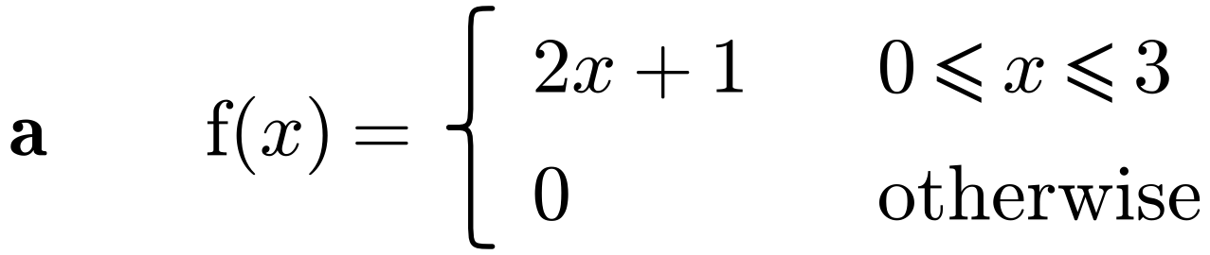

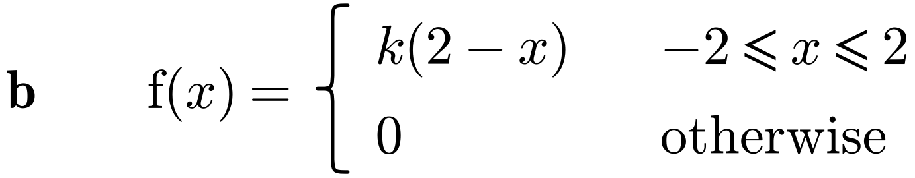

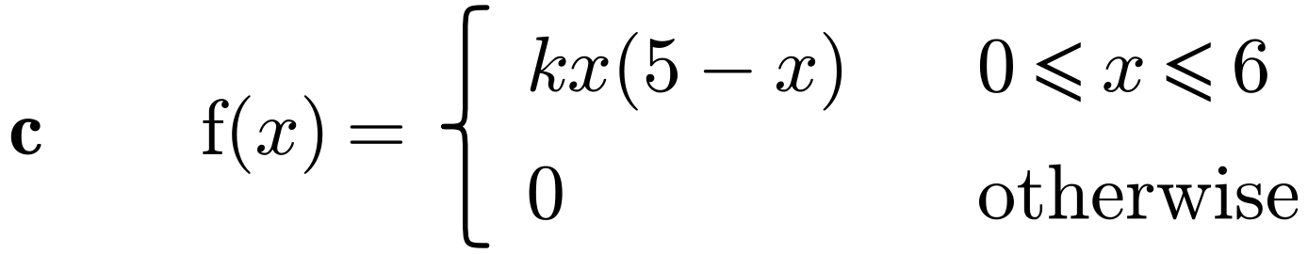

2. The random variable X has probability density function
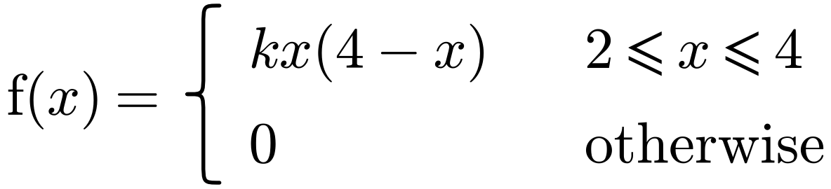
Find:
a) the value of k and sketch the p.d.f.

b) P(2.5 < X < 3), giving your answer to 3 decimal places.

3. The random variable X has probability density function
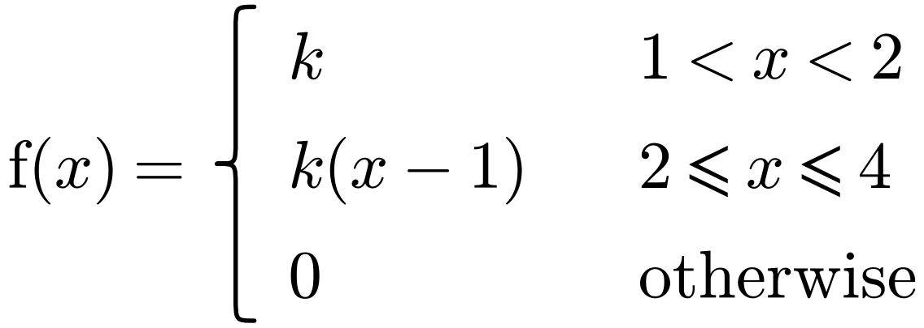
a) Sketch f(x).

b) Find the value of k.

c) Find P(X > 3).

3B The Cumulative Distribution Function
Cumulative distribution function (c.d.f.), F(x):

F(x) = P(X ≤ x) =

In terms of area under the p.d.f., F(x) is

Going between the p.d.f. and the c.d.f.:
f(x) = F(x) =

To specify F(x) fully you must

1. The random variable X has probability density function
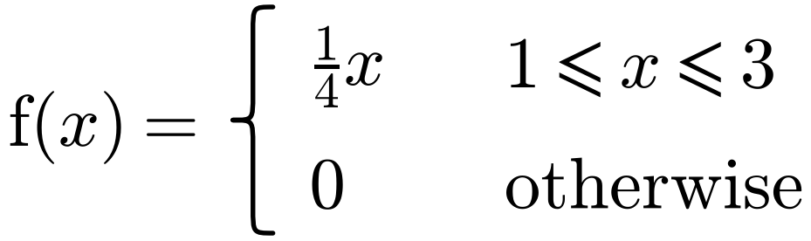
Find F(x).

2. The random variable X has probability density function
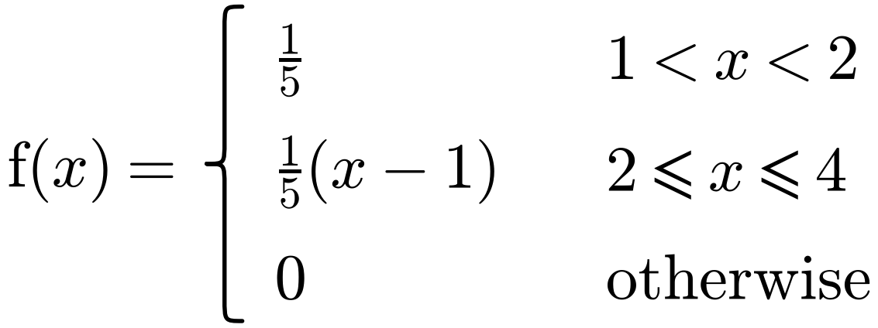
Specify fully the cumulative distribution function of X.

3. The random variable X has cumulative distribution function
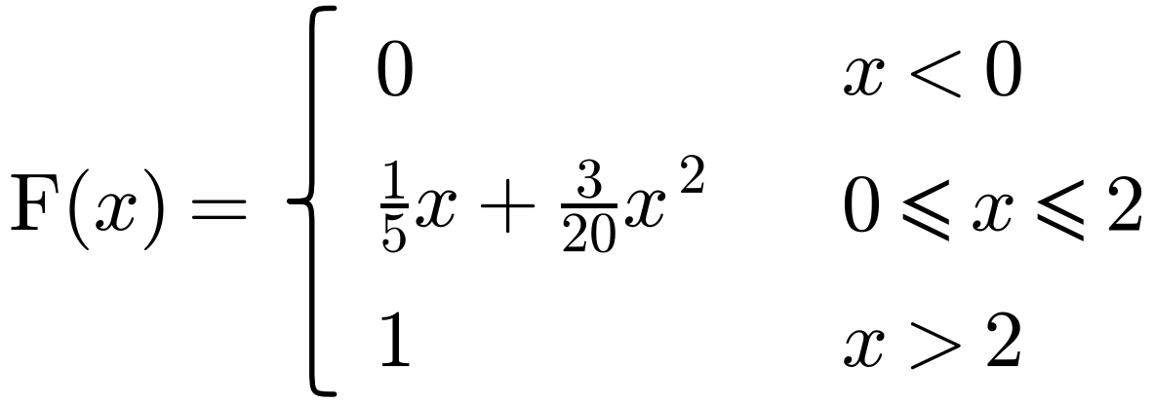
Find:
a) P(X ≤ 1.5)

b) P(0.5 ≤ X ≤ 1.5)

c) P(X = 1)

d) the probability density function, f(x).

3C Mean and Variance of a Continuous Distribution
If X is a continuous random variable with p.d.f. f(x):
Mean or expected value: E(X) = µ =

Variance: Var(X) = σ² =

Expected value of a function of X: E(g(X)) =

A convenient way to calculate the variance: Var(X) =

E(aX + b) = Var(aX + b) =

If the p.d.f. is symmetric about x = a, then

1. A random variable Y has probability density function
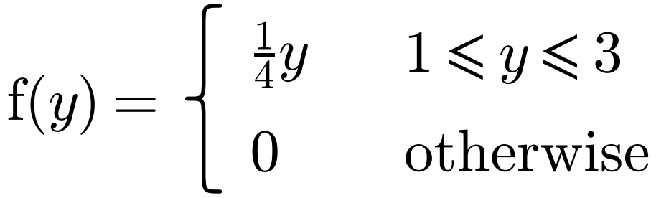
Find:
a) E(Y)

b) Var(Y)

c) E(2Y − 3)

d) Var(2Y − 3)

2. A random variable X has probability density function
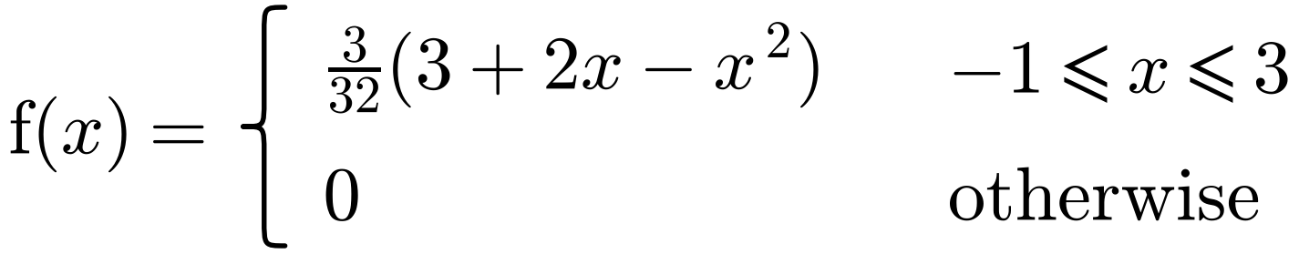
a) Sketch the probability density function.

b) Find E(X).

3. The random variable X has probability density function
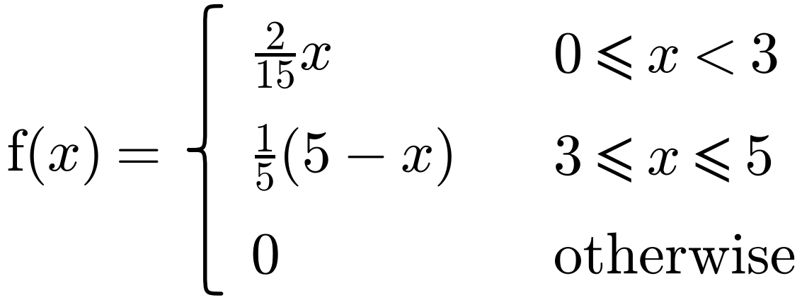
Find:
a) E(X)

b) Var(X)

4. In a block-building video game, a cube of side length X pixels is randomly generated. X is a continuous random variable with probability density function
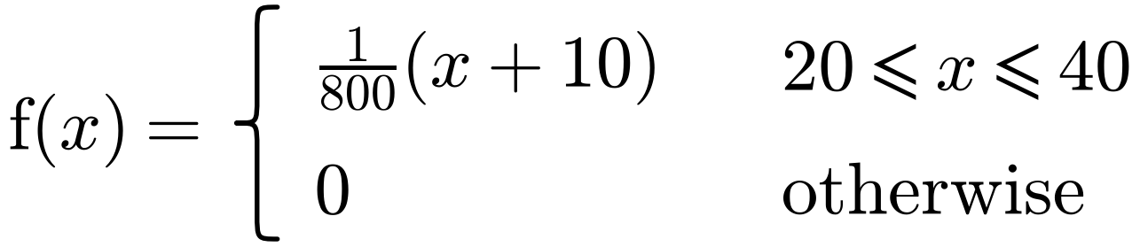
a) Find:
i) E(X)

ii) E(X²)

iii) Var(X)

b) Find the expected volume of the cube.

3D Mode, Median, Percentiles and Skewness
The mode of a continuous random variable is

How to find the mode:

1. The random variables X and Y have probability density functions f(x) and g(y) respectively.
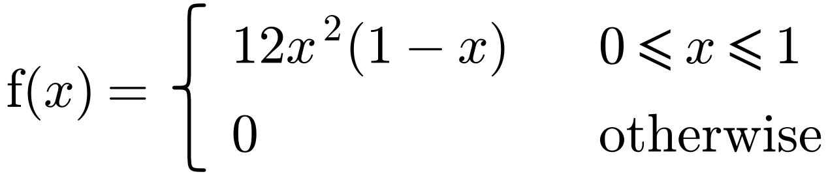
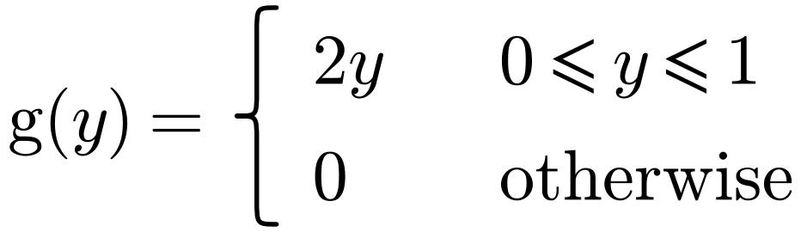
Find the mode of:
a) X

b) Y

If X is a continuous random variable with c.d.f. F(x):
the median m satisfies

the lower quartile Q₁ satisfies

the upper quartile Q₃ satisfies

the nth percentile Pₙ satisfies

2. A continuous random variable X has probability density function
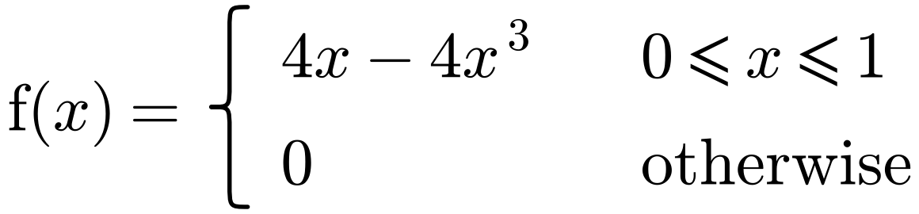
Find:
a) the c.d.f. of X

b) the median value of X.

3. A continuous random variable X has the cumulative distribution function
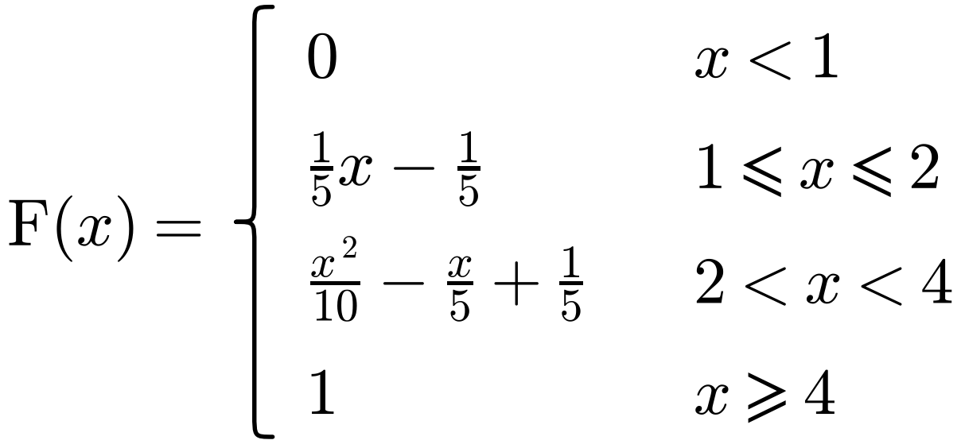
Find:
a) the interquartile range

b) the 10th percentile.

Skewness: sketch and label each p.d.f.
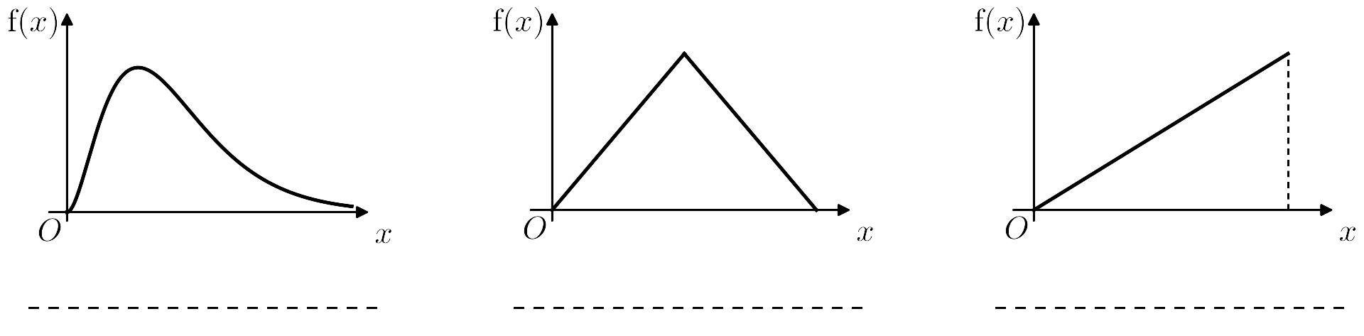
Positive skew: < <

Negative skew: < <

4. A continuous random variable X has probability density function
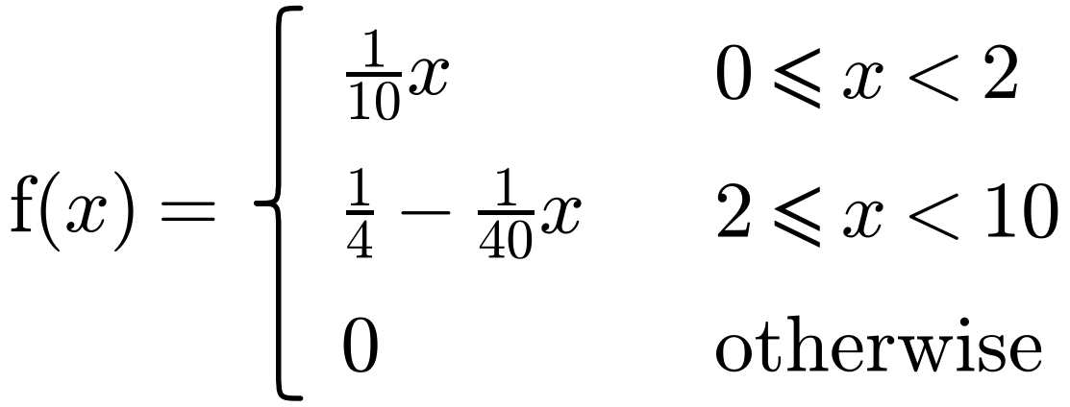
a) Find:
i) the mean of X

ii) the mode of X.

b) Comment on the skewness of the distribution.

3E The Continuous Uniform Distribution
A continuous uniform distribution over the interval [a, b] has p.d.f.
f(x) =

Notation:

Sketch of the p.d.f.:

1. The continuous random variable X is uniformly distributed on [3, 5]. Find:
a) P(3.2 < X < 4.3)

b) k such that P(2X < k − X) = 0.2.

2. The continuous random variable X has p.d.f. as shown in the diagram.
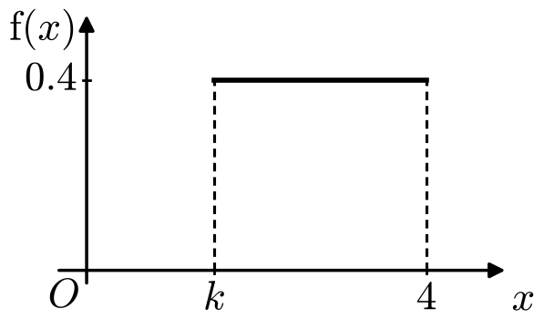
Find:
a) the value of k

b) P(3 < X < 3.5)

c) P(X > 3 | X > 2)

3. The continuous random variable X has probability density function
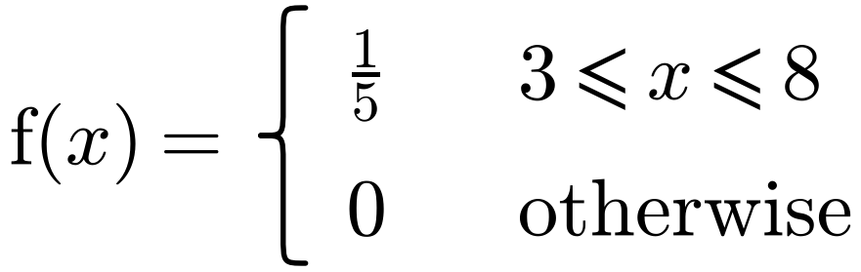
a) Write down the name of this distribution.

The continuous random variable Y = 12 − 3X. Find:
b) E(Y)

c) P(Y > 0)

d) P(X < 7 | Y < 0)

4. The continuous random variable X has probability density function
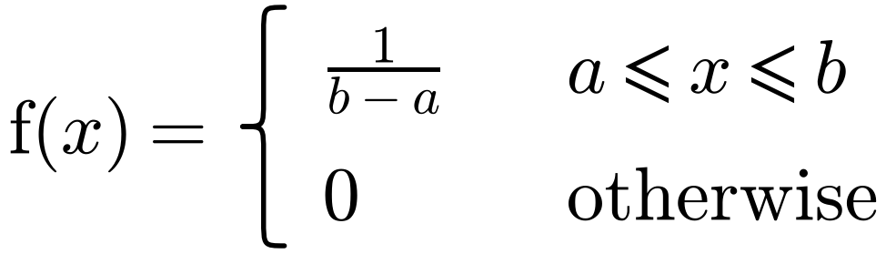
Find:
a) E(X)

b) Var(X)

c) F(x)

For a continuous uniform distribution U[a, b]:
E(X) = Var(X) =

F(x) =

5. The continuous random variable X is uniformly distributed over the interval [4, 7]. Find:
a) E(X)

b) Var(X)

c) the cumulative distribution function of X, for all x.

6. The continuous random variable Y is uniformly distributed over the interval [a, b]. Given that E(Y) = 1 and Var(Y) = 16/3, find the value of a and the value of b.

7. The continuous random variable X is uniformly distributed over the interval [−3, 5].
a) Write down E(X).

b) Use integration to find the variance of X.

3F Modelling with the Continuous Uniform Distribution
Real-life situations that can be modelled by a continuous uniform distribution:

Remember: E(X²) is not the same as (E(X))². E(X²) =

1. The trunk of a small tree varies in diameter from 10 cm at the bottom to 2 cm at the top. The tree is cut horizontally at a randomly chosen point, and the radius R cm of the cross-section is modelled as R ~ U[1, 5].
Find the expected value of the area, A, of the cross-section of the tree.

2. The length of a pencil is measured to the nearest cm. Write down the distribution of the rounding errors R.

3. Write down the name of the distribution you would recommend as a suitable model for each of the following situations.
a) The masses of 200 g tins of tomatoes produced on a production line.

b) The difference between the true length and the length of metal rods measured to the nearest centimetre.

