3D Mode, Median, Percentiles and Skewness
The mode of a continuous random variable is

How to find the mode:

1. The random variables X and Y have probability density functions f(x) and g(y) respectively.
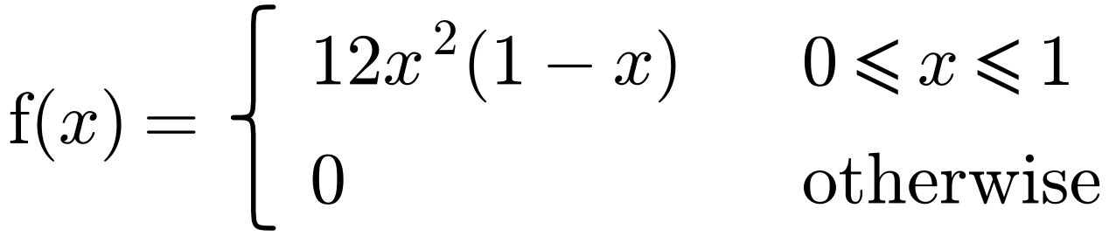
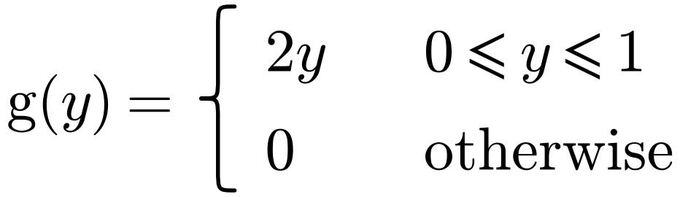
Find the mode of:
a) X

b) Y

If X is a continuous random variable with c.d.f. F(x):
the median m satisfies

the lower quartile Q₁ satisfies

the upper quartile Q₃ satisfies

the nth percentile Pₙ satisfies

2. A continuous random variable X has probability density function
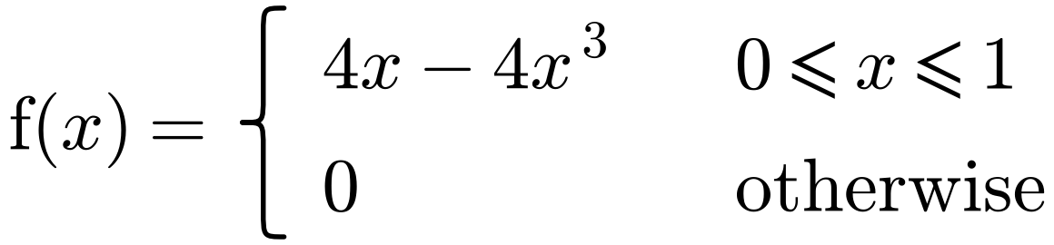
Find:
a) the c.d.f. of X

b) the median value of X.

3. A continuous random variable X has the cumulative distribution function
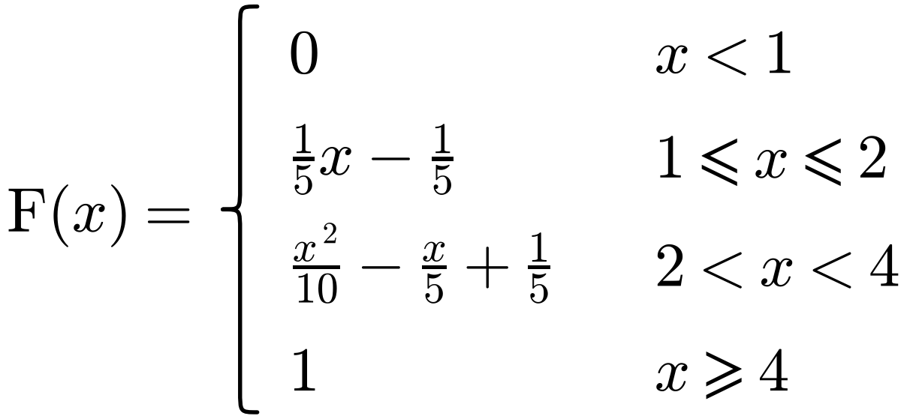
Find:
a) the interquartile range

b) the 10th percentile.

Skewness: sketch and label each p.d.f.
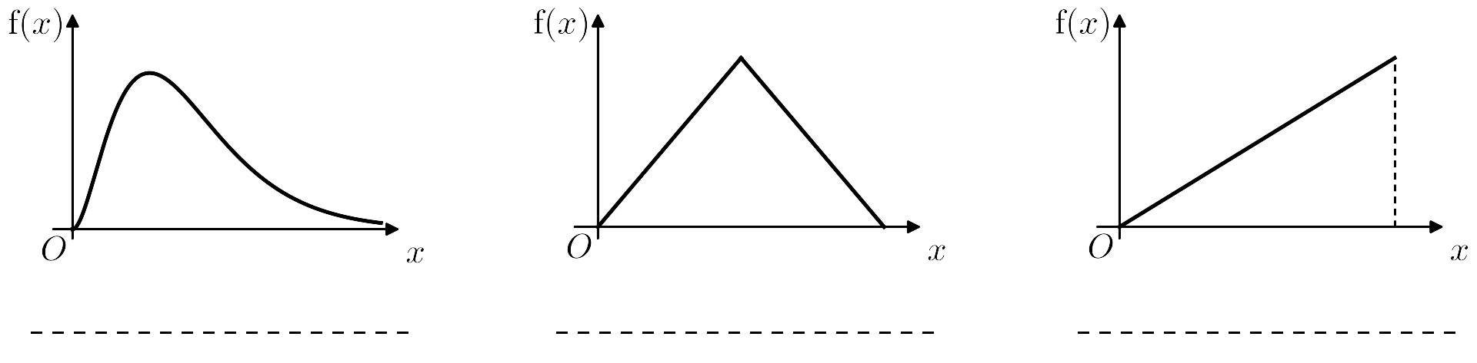
Positive skew: < <

Negative skew: < <

4. A continuous random variable X has probability density function
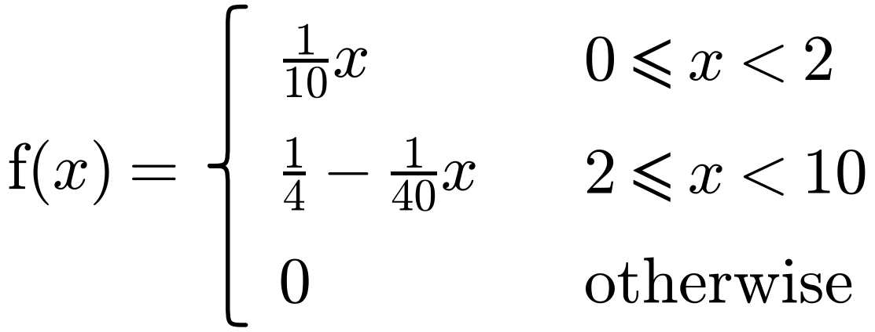
a) Find:
i) the mean of X

ii) the mode of X.

b) Comment on the skewness of the distribution.

