3C Mean and Variance of a Continuous Distribution
If X is a continuous random variable with p.d.f. f(x):
Mean or expected value: E(X) = µ =

Variance: Var(X) = σ² =

Expected value of a function of X: E(g(X)) =

A convenient way to calculate the variance: Var(X) =

E(aX + b) = Var(aX + b) =

If the p.d.f. is symmetric about x = a, then

1. A random variable Y has probability density function
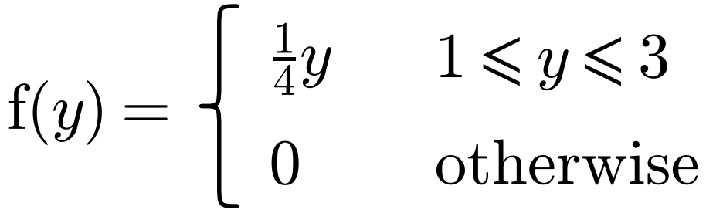
Find:
a) E(Y)

b) Var(Y)

c) E(2Y − 3)

d) Var(2Y − 3)

2. A random variable X has probability density function
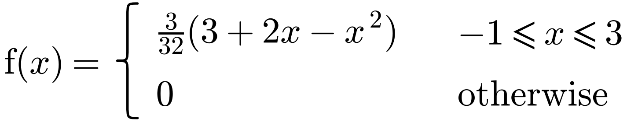
a) Sketch the probability density function.

b) Find E(X).

3. The random variable X has probability density function
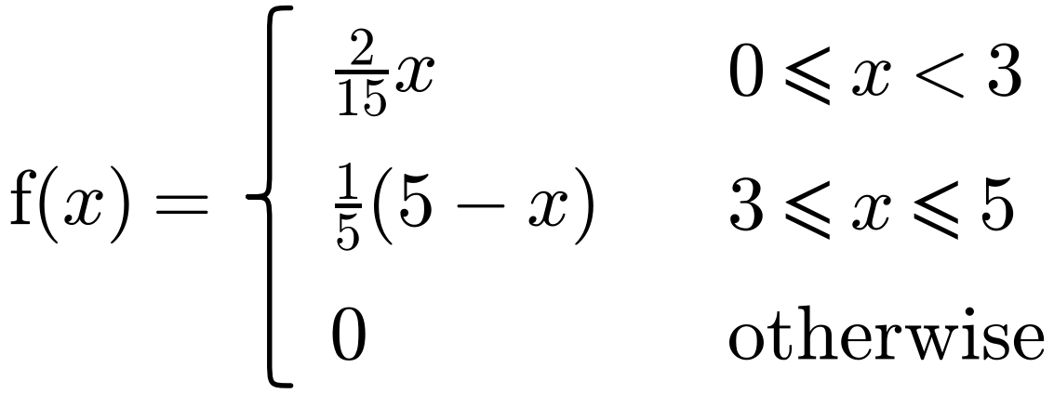
Find:
a) E(X)

b) Var(X)

4. In a block-building video game, a cube of side length X pixels is randomly generated. X is a continuous random variable with probability density function
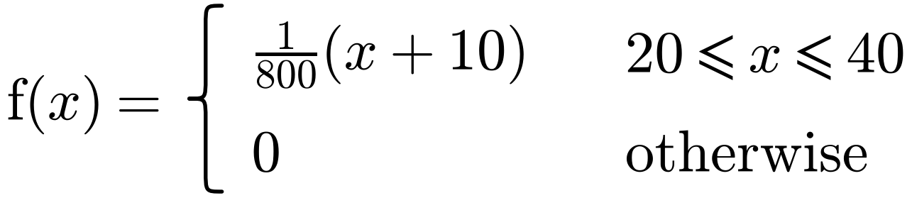
a) Find:
i) E(X)

ii) E(X²)

iii) Var(X)

b) Find the expected volume of the cube.

