3B The Cumulative Distribution Function
Cumulative distribution function (c.d.f.), F(x):

F(x) = P(X ≤ x) =

In terms of area under the p.d.f., F(x) is

Going between the p.d.f. and the c.d.f.:
f(x) = F(x) =

To specify F(x) fully you must

1. The random variable X has probability density function
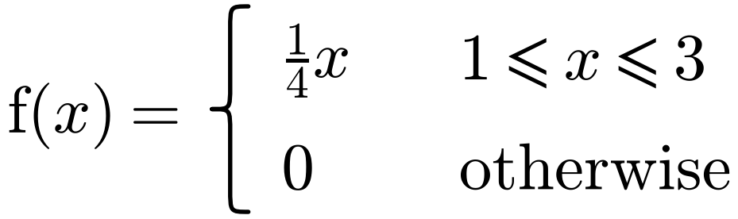
Find F(x).

2. The random variable X has probability density function
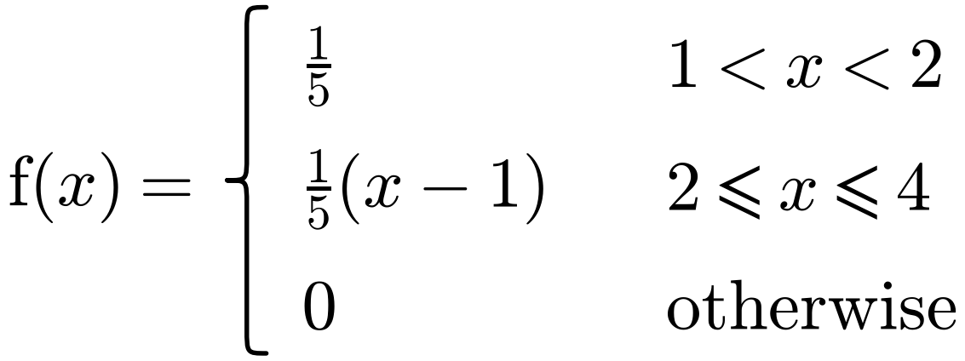
Specify fully the cumulative distribution function of X.

3. The random variable X has cumulative distribution function
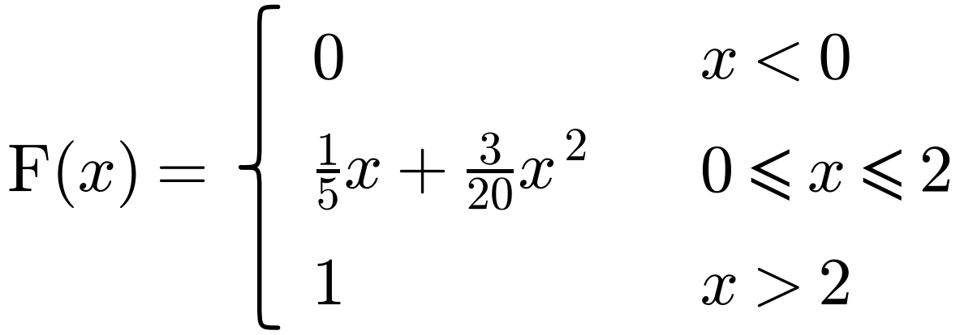
Find:
a) P(X ≤ 1.5)

b) P(0.5 ≤ X ≤ 1.5)

c) P(X = 1)

d) the probability density function, f(x).

