3A Continuous Random Variables
Continuous random variable:

For a continuous random variable X, P(X = x) = for any single value x, because

Probability density function (p.d.f.):

If X is a continuous random variable with p.d.f. f(x), then:
• f(x) for all x ∈ ℝ

• P(a < X < b) =

• the total area under the p.d.f. is

1. In each case, state whether the function could be a probability density function, where k is a positive constant.
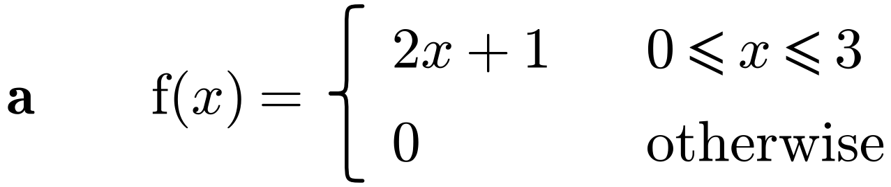

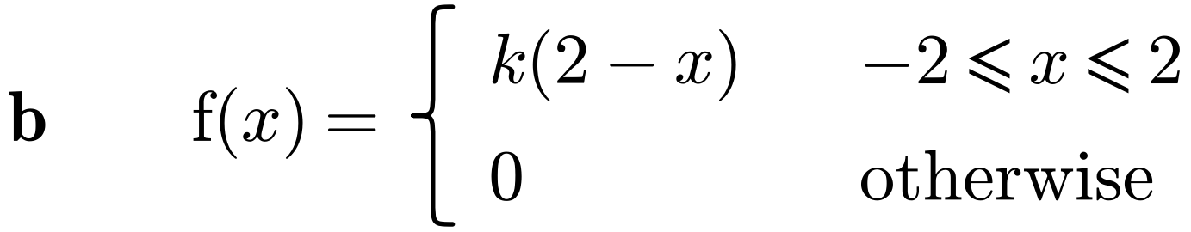

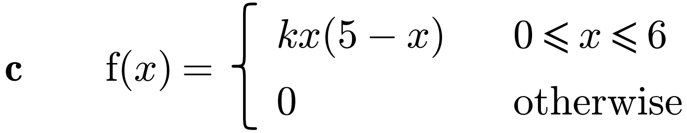

2. The random variable X has probability density function
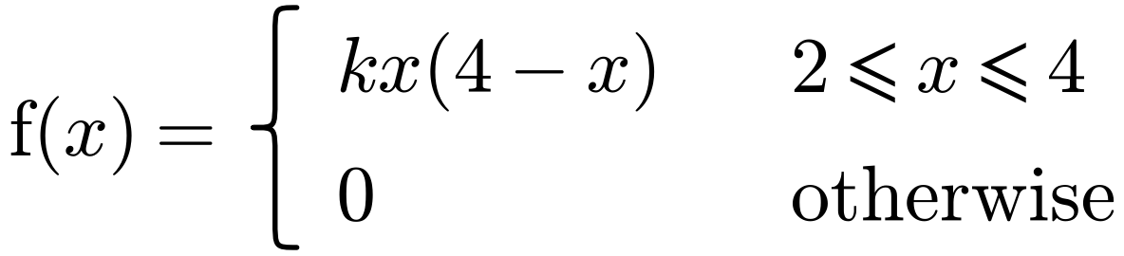
Find:
a) the value of k and sketch the p.d.f.

b) P(2.5 < X < 3), giving your answer to 3 decimal places.

3. The random variable X has probability density function
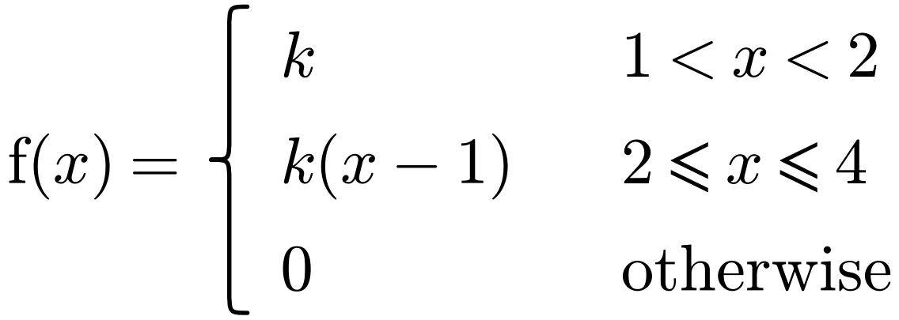
a) Sketch f(x).

b) Find the value of k.

c) Find P(X > 3).

