2A The Product Moment Correlation Coefficient
The product moment correlation coefficient (PMCC) measures:

The PMCC can take values between:
r = 1 means

r = −1 means

The PMCC was designed for data that is:

The product moment correlation coefficient, r, is given by:
r =

Effect of linear coding on the PMCC, for example
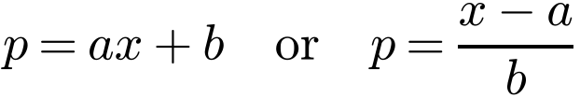

Why:

1. The number of vehicles, x millions, and the number of accidents, y thousands, in 15 different countries were recorded. The following summary statistics were calculated and a scatter graph of the data is given below:
Σx = 176.9, Σy = 679, Σx² = 2576.47, Σy² = 39 771, Σxy = 9915.3
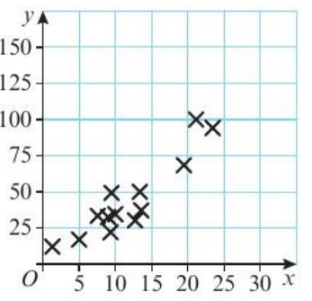
a) Calculate the product moment correlation coefficient between x and y.

b) With reference to your answer to part a and the scatter graph, comment on the suitability of a linear regression model for these data.

2. Data are collected on the amount of dietary supplement, d grams, given to a sample of 8 cows and their milk yield, m litres. The data were coded using
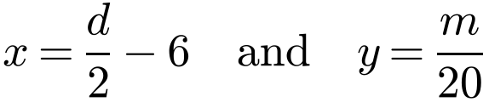
The following summary statistics were obtained:
Σd² = 4592, S_{dm} = 90.6, Σx = 44, S_{yy} = 0.05915
a) Use the formula for S_{yy} to show that S_{mm} = 23.66.

b) Find the value of the product moment correlation coefficient between d and m.

