8A Type I and Type II Errors
Critical region (discrete distributions):

Actual significance level:

1. One rainy day during the summer holidays, a family of four were playing a simple game of cards. The game was one of chance so the probability of any particular person winning should have been ¼. After playing a number of games, Robert complained that his younger sister Sarah must have been cheating as she kept winning. Their parents quickly intervened and decided to carry out a proper investigation and carefully watched the next 20 games.
Find the critical region for a one-tailed test using a 5% level of significance.

Type I error:

Type II error:

Complete the table to show the types of error that can occur in a hypothesis test.

Test result | H₀ is true | H₀ is false
Accept H₀
Reject H₀

2. Use the situation in question 1.
a) Find the probability of a Type I error.

b) If in fact Sarah was cheating and p = 0.35, find the probability of a Type II error.

3. Accidents occurred on a stretch of motorway at an average rate of 6 per month. Many of the accidents that occurred involved vehicles skidding into the back of other vehicles. By way of a trial, a new type of road surface that is said to reduce the risk of vehicles skidding is laid on this stretch of road, and during the first month of operation 4 accidents occurred.
a) Test this result to see if it gives evidence that there has been an improvement at the 5% level of significance.

b) Calculate P(Type I error) for this test.

c) If the true average rate of accidents occurring with the new type of road surface was 3.5, calculate the probability of a Type II error.

4. A coin is spun 20 times and a head is obtained on 7 occasions.
a) Test to see whether or not the coin is biased.

b) Calculate the probability of a Type I error for this test.

c) Given that the coin is biased and that this bias causes the tail to appear 3 times for each head that appears, calculate the probability of a Type II error for the test.

For X ~ Geo(p): P(X ≤ n) = P(X ≥ n) =

5. Jane knows from experience that 10% of the emails she receives are spam. After her email service upgraded the spam filters, she recorded the number of emails sent up to and including the first spam email. She wants to test, at the 5% significance level, whether this upgrade improved the spam filter.
a) Find the critical region for her test.

b) Calculate the probability of a Type I error for this test.

c) Given that after the upgrade the probability of an email she receives being spam is now 1 in a 100, calculate the probability of a Type II error for the test.

8B Finding Type I and Type II Errors Using the Normal Distribution
Distribution of the sample mean X̄ for a sample of size n from N(μ, σ²):

P(Type I error) when a continuous distribution is used:

1. Bags of sugar having a nominal weight of 1 kg are filled by a machine. From past experience it is known that the weight, X kg, of sugar in the bags is normally distributed with a standard deviation of 0.04 kg. At the beginning of each week a random sample of 10 bags is taken in order to see if the machine needs to be reset. A test is then done at the 5% significance level with H₀: μ = 1.00 kg and H₁: μ ≠ 1.00 kg. Find:
a) the critical region for this test
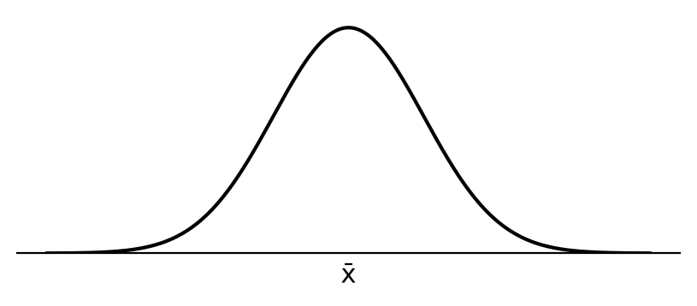

b) P(Type I error) for this test.

Assuming that the mean weight has in fact changed to 1.02 kg,
c) find P(Type II error) for this test.
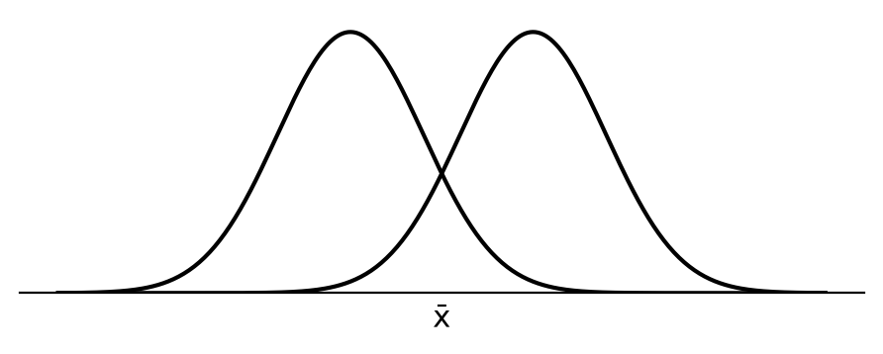

2. The weight of jam in a jar, measured in grams, is distributed normally with a mean of 150 g and a standard deviation of 6 g. The production process occasionally leads to a change in the mean weight of jam per jar but the standard deviation remains unaltered.
The manager monitors the production process and for every new batch takes a random sample of 25 jars and weighs their contents to see if there has been any reduction in the mean weight of jam per jar.
Find the critical values for the test statistic X̄, the mean weight of jam in a sample of 25 jars, using:
a) a 5% level of significance

b) a 1% level of significance.

Given that the true value of μ for the new batch is in fact 147,
c) find the probability of a Type II error for each of the above critical regions.

Relationship between P(Type I error) and P(Type II error):

How to reduce both P(Type I error) and P(Type II error):

8C Calculate the Size and Power of a Test
Size of a test:

Power of a test:

Complete the table using size, power and P(Type II error).

Test result | H₀ is true | H₀ is false
Accept H₀
Reject H₀

Ways to increase the power of a test:

1. The random variable X has a binomial distribution. A random sample of size 25 was taken to test H₀: p = 0.30 against H₁: p < 0.30 using a 10% level of significance.
a) Find the critical region for this test.

b) Find the size of this test.

Given that p = 0.20,
c) calculate the power of this test.

2. Jam is sold in jars. The amount of jam, in grams, in a jar is normally distributed with mean μ and standard deviation 5. The manufacturer claims that μ is 106 and quality control officers will take action against the manufacturer if μ < 106. A random sample of 30 jars is examined and a 5% level of significance is used.
a) Find the critical region for the sample mean using this test.

Given that in fact μ = 102,
b) find the power of this test.

3. A particular mobile-phone provider fails to deliver text messages with probability p. Brooke wants to investigate whether p > 0.02.
Using H₀: p = 0.02 and H₁: p > 0.02, Brooke notes the number of text messages she is able to send successfully up until the first failure. If this value is less than or equal to 5 she rejects H₀. If it is more than 100 she accepts H₀. If it is more than 5 but less than or equal to 100 she notes the number of additional text messages she is able to send successfully up until the next failure. She rejects H₀ if this is less than or equal to 5 and accepts it otherwise.
a) Find the size of this test.

b) Calculate the power of this test when p = 0.015.

8D The Power Function
Power function:

1. Past experience has shown that the number of accidents that take place at a road junction has a Poisson distribution with an average of 3.5 accidents per month. A trading estate is built along one of the roads leading away from the junction and the local council is anxious that this may have increased the accident rate. To see if the number of accidents had increased, a test was set up with the null hypothesis H₀: λ = 3.5 and with the alternative hypothesis being accepted if the number of accidents X within the first month after the alteration was ≥ 7.
a) Find the size of the test.

b) Find the power function for the test and sketch the graph of the power function.

λ | 4 | 5 | 6 | 7 | 8 | 9 | 10
Power | 0.1107 | 0.2378

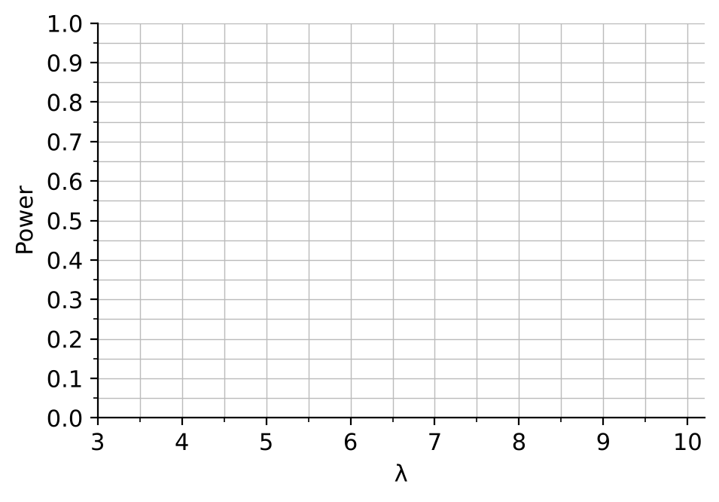

Comparing two tests:

2. A manufacturer of sweets supplies a mixed assortment of chocolates in a jar. He claims that 40% of the chocolates have a ‘hard centre’, the remainder being ‘soft centred’.
A shopkeeper does not believe the manufacturer’s claim and proposes to test it using the hypotheses H₀: p = 0.4, H₁: p < 0.4, where p is the proportion of ‘hard centres’ in the jar. Two tests are proposed.
In test A he takes a random sample of 10 chocolates from the jar and rejects H₀ if the number of ‘hard centres’ is less than 2.
a) Find the size of test A.

b) Show that the power function of test A is given by (1 − p)¹⁰ + 10p(1 − p)⁹.

In test B he takes a random sample of 5 chocolates from the jar and if there are no ‘hard centres’ he rejects H₀, otherwise he takes a second sample of 5 chocolates and H₀ is rejected if there are no further ‘hard centres’ on this second occasion.
c) Find the size of test B.

d) Find an expression for the power function of test B.

The powers for test A and test B for various values of p are given in the table.
p | 0.1 | 0.2 | 0.25 | 0.3 | 0.35
Power for test A | 0.74 | r | 0.24 | s | 0.09
Power for test B | 0.83 | 0.54 | 0.42 | 0.31 | 0.22

e) Calculate values for r and s.

f) State, giving a reason, which of the two tests the shopkeeper should use.

3. A local park believes the fox population in the area has decreased. They want to test for the probability, p, that a fox will be observed on any given day. They count the number of days, X, that pass until the first observation of a fox. They test H₀: p = 0.1 against H₁: p < 0.1 and reject H₀ if X > 30.
a) Find the size of this test.

b) Find the power function for the test.

