7A Probability Generating Functions
A probability generating function (p.g.f.) is:

A p.g.f. can only be used with:

If a discrete random variable X has probability mass function P(X = x), then the probability generating function of X is
G_{X}(t) =

where t is:

For example, find the p.g.f. of X:
x | 0 | 1 | 2 | 3
P(X = x) | 0.2 | 0.3 | 0.3 | 0.2

G_{X}(t) =

The coefficient of t^{x} is:

For any probability generating function, G_{X}(1) = because

The p.g.f. in terms of expectation (given in the formulae booklet):
G_{X}(t) =

1. X is the discrete random variable that denotes the absolute difference of the scores when two fair dice are thrown. Construct the probability distribution of X and write down the probability generating function.

Complete the sample space diagram:
 | 1 | 2 | 3 | 4 | 5 | 6
1 | 0 | 1 | 2 | 3 | 4 | 5
2 | 1 | 0
3 | 2 |  | 0
4 |  |  |  | 0
5 |  |  |  |  | 0
6 |  |  |  |  |  | 0

x | 0 | 1 | 2 | 3 | 4 | 5
P(X = x)

2. The probability generating function of the discrete random variable X is given by G_{X}(t) = k(1 + t)²
a) Find the value of k.

b) Write down the probability distribution of X.

x
P(X = x)

7B Probability Generating Functions of Standard Distributions
The probability generating functions of the standard distributions (given in the formulae booklet):

If X ~ B(n, p): G_{X}(t) =

If X ~ Po(λ): G_{X}(t) =

If X ~ Geo(p): G_{X}(t) =

If X ~ Negative B(r, p): G_{X}(t) =

‘Write down’ or ‘find’ the p.g.f. of a standard distribution means:

‘Show from first principles’ means:

Useful results: Maclaurin series e^{x} =

Sum to infinity of a geometric series S∞ =

3. An archer hits the bullseye with probability 0.6. She fires three shots at a target. The random variable X represents the number of times she hits the bullseye. Find the probability generating function of X.

x | 0 | 1 | 2 | 3
P(X = x)

4. X is a discrete random variable such that X ~ Po(1.1). Show, from first principles, that the probability generating function of X is given by G_{X}(t) = e^{1.1(t−1)}

5. A fair tetrahedral dice is rolled until the dice shows a four. The discrete random variable X represents the number of rolls up to and including the first instance of a four. Show, from first principles, that the probability generating function for X is given by
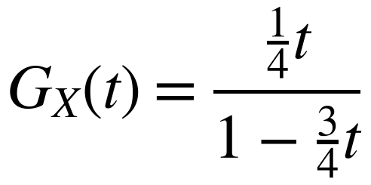

6. The discrete random variable X ~ Negative B(r, p). Prove, from first principles, that the probability generating function of X can be written as
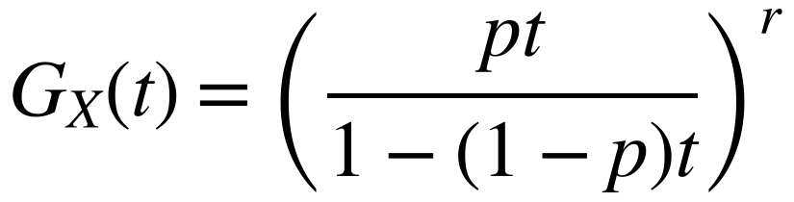
You may quote the following result without proof:
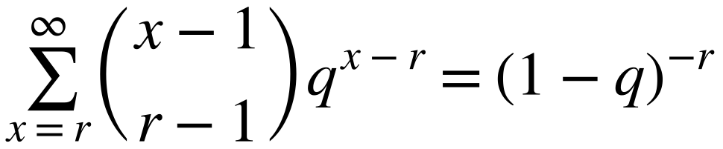 where q = 1 − p

7C Mean and Variance of a Distribution
If X is a discrete random variable with probability generating function G_{X}(t):
E(X) = Var(X) =

Proof of the result for E(X): G_{X}(t) = E(t^{X}) = Σ t^{x}P(X = x)

Proof of the result for Var(X):

Differentiating term by term: if G_{X}(t) = P(X = 0) + P(X = 1)t + P(X = 2)t² + P(X = 3)t³ + …
then G′_{X}(t) =

and G″_{X}(t) =

So G_{X}(0) = G′_{X}(0) = G″_{X}(0) = and in general P(X = n) =

1. The discrete random variable X has a probability generating function given by
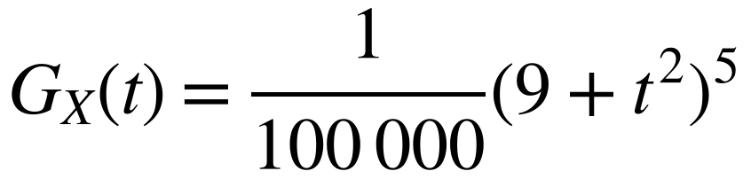
Find:
a) E(X)

b) Var(X)

2. A discrete random variable X has a probability generating function given by G_{X}(t) = a + bt + ct², where a, b and c are constants. Given that the expected value of X is ⁷⁄₆ and the variance of X is ²⁹⁄₃₆, find the values of a, b and c.

7D Sums of Independent Random Variables
Dice A has three faces showing 1 and three faces showing 2. Dice B has two faces showing 0 and four faces showing 1. X and Y are the scores on dice A and dice B.
x | 1 | 2
P(X = x) | ¹⁄₂ | ¹⁄₂

y | 0 | 1
P(Y = y) | ¹⁄₃ | ²⁄₃

Write down G_{X}(t) and G_{Y}(t):

Complete the distribution of Z = X + Y and write down G_{Z}(t):
z | 1 | 2 | 3
P(Z = z)

Find G_{X}(t) × G_{Y}(t). What do you notice?

If X and Y are independent random variables with p.g.f.s G_{X}(t) and G_{Y}(t), the p.g.f. of Z = X + Y is given by
G_{Z}(t) =

1. Two independent discrete random variables X and Y have probability generating functions
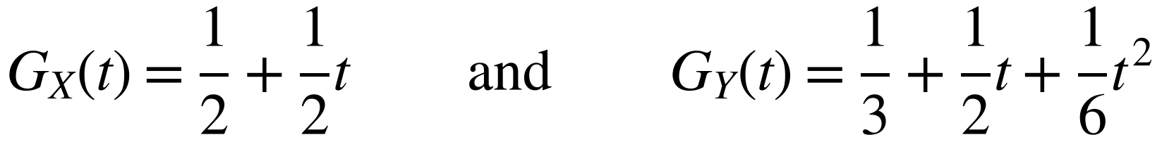
a) Find the probability generating function of the random variable Z = X + Y.

b) Use probability generating functions to show that E(Z) = E(X) + E(Y).

2. A random variable X has a probability generating function G_{X}(t) = ²⁄₃ + ¹⁄₃t
a) Write down the probability distribution of X.
x
P(X = x)

b) Y = 2X + 1. Write down the probability distribution of Y and hence find the probability generating function of Y.
y
P(Y = y)

c) Verify that G_{Y}(t) = tG_{X}(t²).

Linear transformations: if X has p.g.f. G_{X}(t), then the p.g.f. of Y = aX + b (where a and b are positive integers) is
G_{Y}(t) =

This result is not in the formulae booklet, so

