2A/B The Poisson Distribution
The Poisson distribution is used to model:

If X has a Poisson distribution with parameter λ, we write:

Probability function:
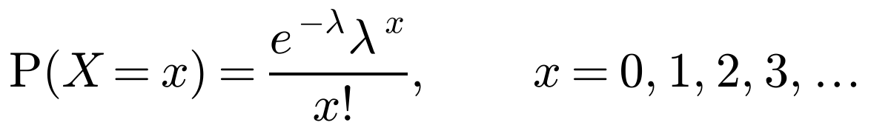

The values that X can take:

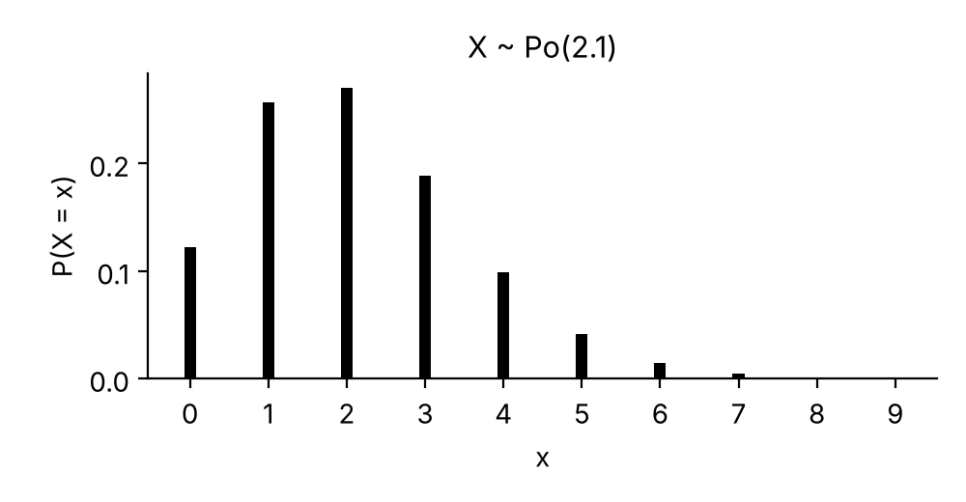
Why the probabilities add up to 1 (use the series expansion below):
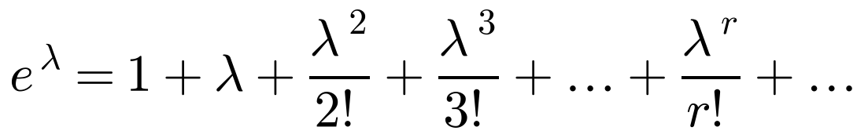

1. The random variable X ~ Po(2.1). Find:
a) P(X = 3)

b) P(X ≥ 1)

c) P(1 < X ≤ 4)
 | 2 | 3 | 4
P(X = x)

Cumulative Poisson tables give:

Writing probabilities in terms of P(X ≤ x) so you can use the tables:
In terms of P(X ≤ x)
P(X < a)
P(X ≥ a)
P(X > a)
P(a ≤ X ≤ b)

2. The random variable X ~ Po(5). Find, using tables:
a) P(X ≤ 3)
b) P(X ≥ 2)
c) P(1 ≤ X ≤ 4)
Extract from the cumulative Poisson tables, P(X ≤ x):
 | λ = 4.5 | λ = 5.0
x = 0 | 0.0111 | 0.0067
1 | 0.0611 | 0.0404
2 | 0.1736 | 0.1247
3 | 0.3423 | 0.2650
4 | 0.5321 | 0.4405

3. The random variable X ~ Po(7.5). Find the values of a, b and c such that:
a) P(X ≤ a) = 0.2414
b) P(X < b) = 0.5246
c) P(X ≥ c) = 0.3380
Extract from the cumulative Poisson tables, λ = 7.5:
 | 4 | 5 | 6 | 7 | 8 | 9
P(X ≤ x) | 0.1321 | 0.2414 | 0.3782 | 0.5246 | 0.6620 | 0.7764

2C Modelling with the Poisson Distribution
The Poisson distribution models the number of times, X, that:

For a Poisson distribution to be a good model, events must occur:
•

•

•

The parameter λ represents:

Changing the length of the interval:

Examples of situations that could be modelled by a Poisson distribution:

1. An internet service provider has a large number of users regularly connecting to the internet. On average, 4 users every hour fail to connect to the internet at their first attempt.
a) Give two reasons why a Poisson distribution might be a suitable model for the number of failed connections every hour.

b) Find the probability that in a randomly chosen hour:
i) 2 users fail to connect at their first attempt

ii) more than 6 users fail to connect at their first attempt.

c) Find the probability that in a randomly chosen 90-minute period:
i) 5 users fail to connect at their first attempt

ii) fewer than 7 users fail to connect at their first attempt.

2D Adding Poisson Distributions
If X ~ Po(λ) and Y ~ Po(µ) are independent, then:

Watch out: before you add the parameters, the two random variables must:

1. If X ~ Po(3.6) and Y ~ Po(4.4), find:
a) P(X + Y = 7)

b) P(X + Y ≤ 5)

2. The number of cars passing an observation point in a 5-minute interval is modelled by a Poisson distribution with mean 2. The number of other vehicles passing the observation point in a 15-minute interval is modelled by a Poisson distribution with mean 3. Find the probability that:
a) exactly 5 vehicles, of any type, pass the observation point in a 10-minute interval
 | 5-minute interval | 10-minute interval | 15-minute interval
Cars, X | Po(2)
Other vehicles, Y |  |  | Po(3)
All vehicles, X + Y

b) more than 8 vehicles, of any type, pass the observation point in a 15-minute interval.

2E Mean and Variance of a Poisson Distribution
If X ~ Po(λ), then:
E(X) =

Var(X) =

Why this property is useful:

Calculating the mean and variance from summary data (Σx and Σx²) for n observations:
x̄ =

σ² =

1. A botanist counts the number of daisies, x, in each of 80 randomly selected squares within a field. The results are summarised below.
Σx = 295, Σx² = 1386
a) Calculate the mean and the variance of the number of daisies per square for the 80 squares. Give your answers to 2 decimal places.

b) Explain how the answers from part a support the choice of a Poisson distribution as a model.

c) Using a suitable value for λ, estimate the probability that exactly 3 daisies will be found in a randomly selected square.

2F Mean and Variance of the Binomial Distribution
Reminder: the probability function for X ~ B(n, p) is

If X ~ B(n, p), then:
E(X) = µ =

Var(X) = σ² =

1. A fair, five-sided spinner is spun 20 times. The random variable X represents the number of 5s obtained.
a) Find the mean and variance of X.

b) Find P(X < µ − σ).

2. A company produces a certain type of delicate component. The probability of any one component being defective is p. The probability of obtaining at least one defective component in a sample of 4 is 0.3439. The company produces 600 components in a day. Find the mean and variance of the number of defective components produced per day.

2G Using the Poisson Distribution to Approximate the Binomial Distribution
If X ~ B(n, p), then X can be approximated by a Poisson distribution when:
•

•

The approximating distribution is X ≈ Po( ), where λ =

Why the approximation works (compare the mean and variance of B(n, p)):

1. The random variable X ~ B(200, 0.03).
a) Find P(X = 4).

A Poisson variable Y ~ Po(λ) is used to approximate X.
b) Write down the value of λ and justify the use of a Poisson approximation in this context.

c) Find P(Y = 4) and comment on the accuracy of the approximation.
 | Exact: X ~ B(200, 0.03) | Approximation: Y ~ Po( )
P(… = 4)

2. The probability of a component produced by a certain machine being faulty is 0.007. The number of faulty components in a batch of 1000 components is noted.
a) Find the probability that exactly 6 components are faulty.

b) Use a Poisson approximation to find the probability that more than 7 components are faulty.

c) Explain why the approximation in part b is valid.

