6A Reduction Formulae
A reduction formula is:

The formula for integration by parts:

How you use a reduction formula to find an integral:

1. Given that Iₙ = ∫xⁿeˣ dx, where n is a positive integer,

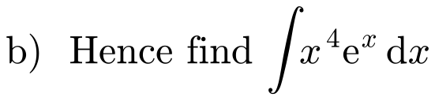

2.

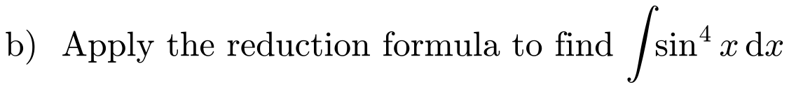

Why you may need an identity after integrating by parts:

3.
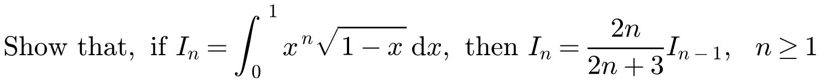

4. Iₙ = ∫tanⁿx dx, where n is a positive integer. By writing tanⁿx as tanⁿ⁻²x tan²x, and using 1 + tan²x ≡ sec²x, establish the reduction formula
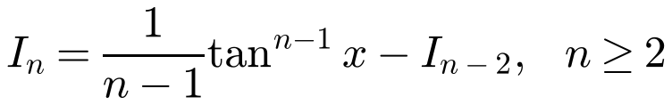

5.
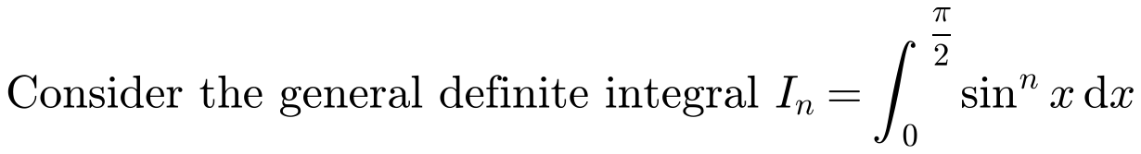
a) Prove that, for n ≥ 2, nIₙ = (n − 1)Iₙ₋₂

b) Find the values of
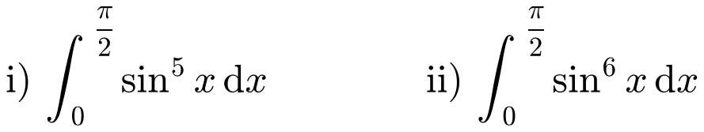

6.
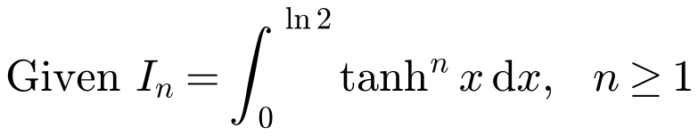
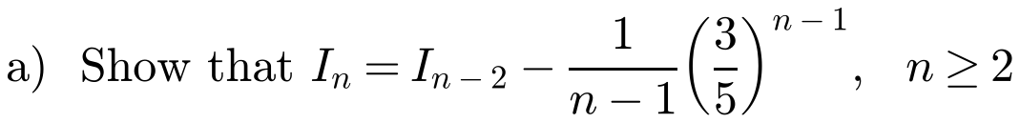

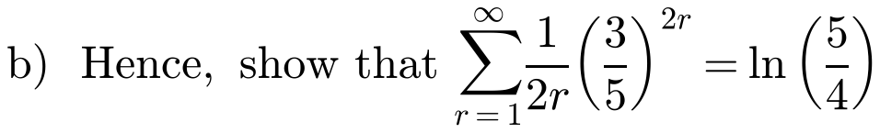
You may assume that the limit of Iₙ as n → ∞ is 0.

7.

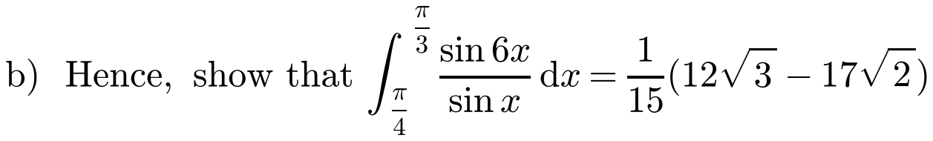

6B Arc Length
Arc length means:

Using Pythagoras on a small arc δs:

Arc length for y = f(x), integrating with respect to x:

Arc length for y = f(x), integrating with respect to y:

Arc length for a curve given parametrically, x = f(t), y = g(t):

Arc length for a curve with polar equation r = f(θ), between θ = α and θ = β:

1. Find the length of the arc PQ on the curve with equation y = ⅔x^(3/2), where the x-coordinates of P and Q are 8 and 15 respectively.
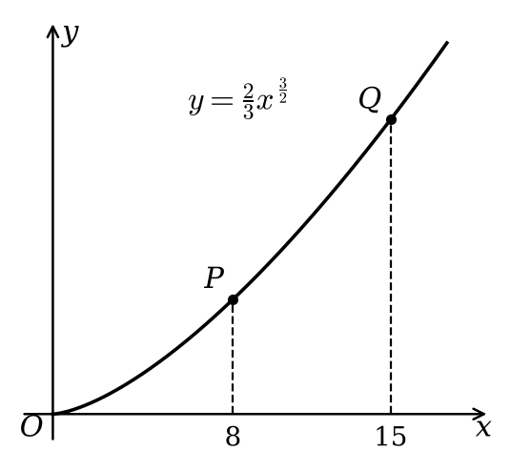

2. A curve is defined by the parametric equations x = 3 + 2cos t, y = 2t + 2sin t, t ∈ ℝ.
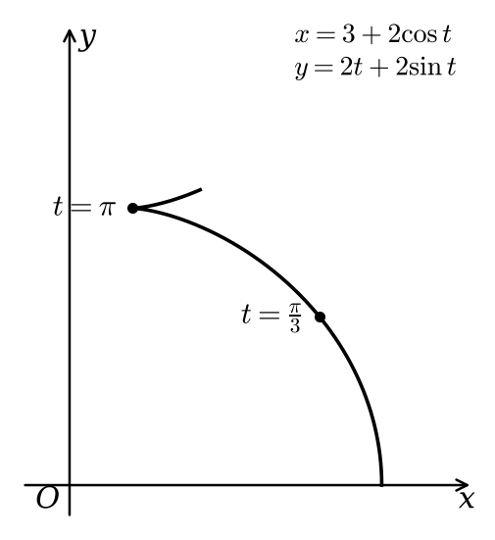
a)
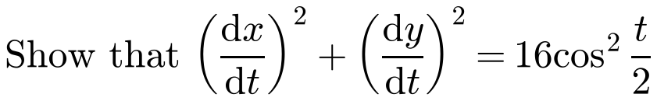

b) Find the exact length of this curve between the points where t = π/3 and t = π.

3. The curve C shown in the diagram has polar equation r = 5e²ᶿ. Find the length of the arc of C between the points on the curve with θ = 0 and θ = π/2.
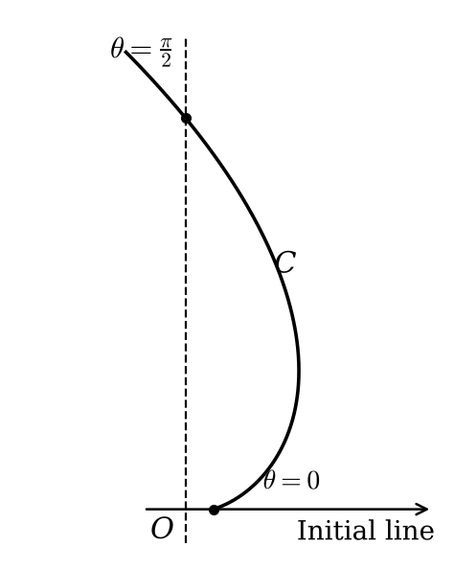

A useful substitution for ∫√(1 + x²) dx:

4. Find the exact length of the arc on the parabola with equation y = ½x², from the origin to the point P(4, 8).

6C Area of a Surface of Revolution
A surface of revolution is:

Area of the thin band made by rotating a small arc δs, a distance y from the x-axis:

Surface area for y = f(x) rotated through 2π about the x-axis:

Surface area for a Cartesian curve rotated through 2π about the y-axis (two forms):

Surface area for a parametric curve x = f(t), y = g(t), rotated about the x-axis and about the y-axis:

Surface area for a polar curve r = f(θ), rotated about the initial line and about the line θ = π/2:

1. The curve C has equation y = ⅓√x (3 − x). The arc of the curve between the points with x-coordinates 1 and 3 is completely rotated about the x-axis. Find the area of the surface generated.
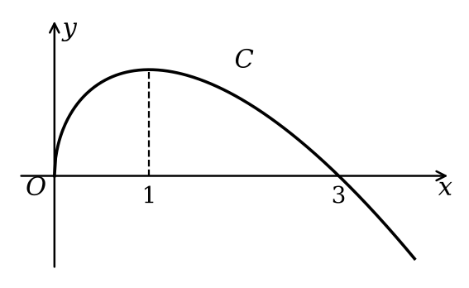

2. The curve with parametric equations x = t − sin t, y = 1 − cos t, from t = 0 to t = 2π, is rotated through 360° about the x-axis. Find the area of the surface generated.
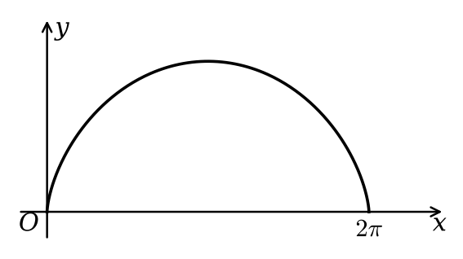

3. The graph of the polar equation r = 4 + 4sin θ from θ = −π/2 to θ = π/2 is shown below. The curve is rotated through 2π radians about the vertical line θ = π/2, forming a surface of revolution. Find the exact area of the surface.
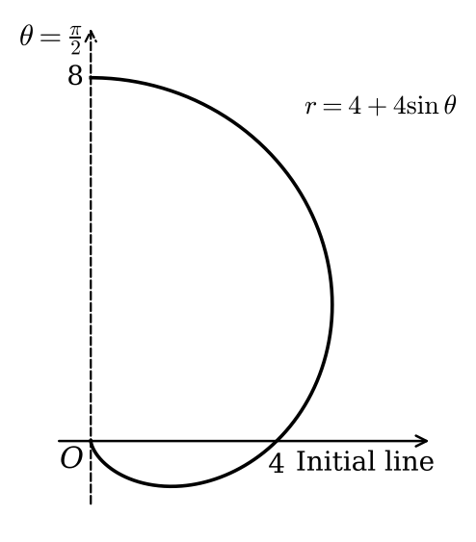

4. The arc of the curve with equation y = cosh x, from the point (0, 1) to (ln 2, 5/4), is rotated completely about the y-axis. Find the area of the surface generated.
