5A/B Eigenvalues and Eigenvectors
An eigenvector of a matrix A is:

The eigenvalue corresponding to the eigenvector x is:

Under the transformation represented by A, what happens to an eigenvector? What does the eigenvalue tell you?

Eigenvectors and invariant lines:

If the corresponding eigenvalue is 1:

Why det(A − λI) = 0 gives the eigenvalues:

The characteristic equation of A:

1. Find the eigenvalues and corresponding eigenvectors of the matrix
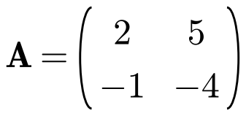

A normalised eigenvector:
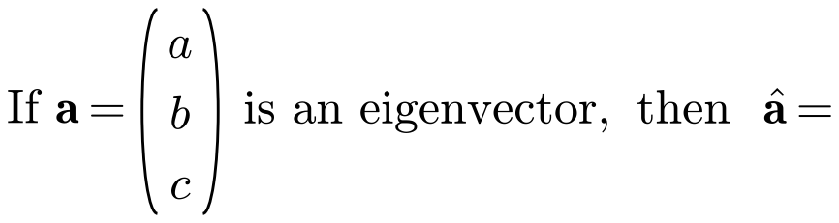

Normalised eigenvectors for question 1:

Repeated eigenvalues and complex eigenvalues:

Linearly independent vectors:

2. Find the eigenvalues and corresponding eigenvectors for these matrices:
a)
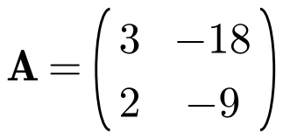

b)
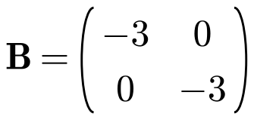

c)
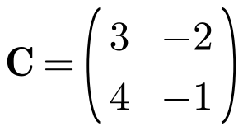

3. A transformation T: ℝ² → ℝ² is represented by the matrix
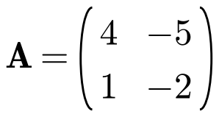
a) Find the eigenvalues of A.

b) Find Cartesian equations of the two lines passing through the origin which are invariant under T.

Eigenvalues and eigenvectors of a 3 × 3 matrix (what kind of equation? how do you factorise it?):

Why a 3 × 3 matrix always has at least one real eigenvalue:

4. Find the eigenvalues and corresponding eigenvectors of the matrix
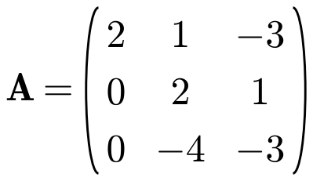

5. The matrix
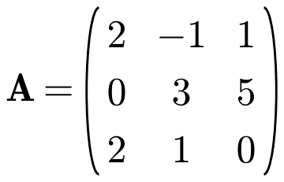
a) Show that −2 is the only real eigenvalue of A.

b) Find a normalised eigenvector of A corresponding to the eigenvalue −2.

6. The matrix
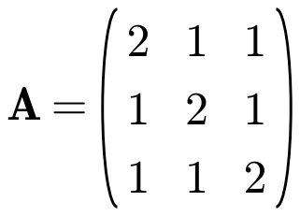
a) Show that 1 is a repeated eigenvalue of A and find the other distinct eigenvalue.

b) Find two linearly independent eigenvectors corresponding to the eigenvalue 1.

5C Reducing Matrices to Diagonal Form
A diagonal matrix:

The leading diagonal:

The general 2 × 2 diagonal matrix:

To reduce a given matrix A to diagonal form:
1.

2.

3.

4.

1. For the matrix below:
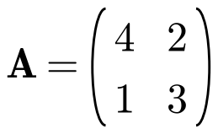
a) Find a matrix P such that D = P⁻¹AP is diagonal.

b) Write down the diagonal matrix D.

The elements on the leading diagonal of D:

A symmetric matrix:

An orthogonal matrix:

The procedure for orthogonal diagonalisation of a symmetric matrix A:
1.

2.

3.

4.

2. Reduce the matrix A to a diagonal matrix.
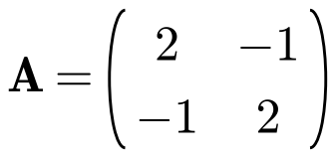

3. Find a matrix P and a diagonal matrix D such that D = P⁻¹AP.
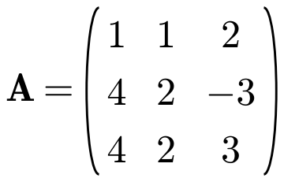

4. The matrix
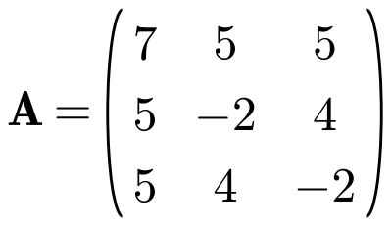
a) Verify that (2, 1, 1)ᵀ is an eigenvector of A and find the corresponding eigenvalue.

b) Show that −6 is another eigenvalue of A and find the corresponding eigenvector.

c) Given that the third eigenvector of A is (1, −1, −1)ᵀ, find a matrix P and a diagonal matrix D such that PᵀAP = D.

5. The two sequences xₙ and yₙ satisfy the recurrence relations
These recurrence relations can be written in matrix form as
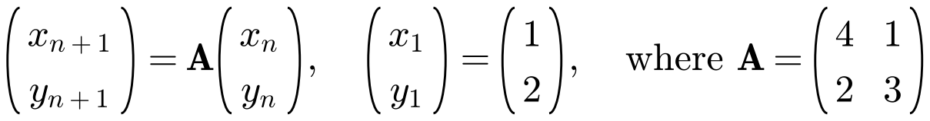
a) Find the eigenvalues and corresponding eigenvectors of A.

b) Hence write down matrices P and D such that P⁻¹AP = D where D is a diagonal matrix.

New sequences uₙ and vₙ can be formed from xₙ and yₙ using the transformation
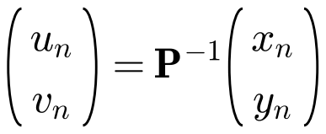
c)
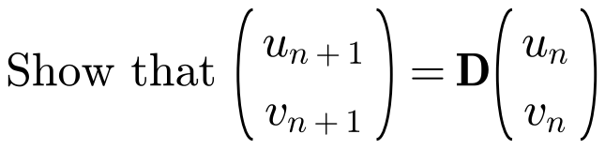

d) Hence find closed form expressions for the original sequences xₙ and yₙ.

Powers of a diagonal matrix:
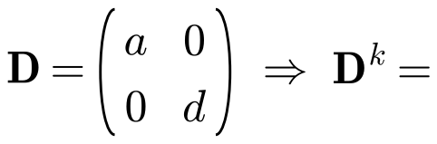

If P⁻¹AP = D, then Aᵏ =

6. For the matrix below:
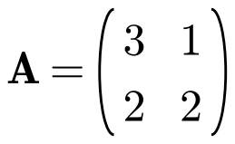
a) Find a matrix P and a diagonal matrix D such that P⁻¹AP = D.

b) Hence find A⁶.

5D The Cayley–Hamilton Theorem
The Cayley–Hamilton theorem:

If the characteristic equation of M is λ² + aλ + b = 0, then:

1. Demonstrate that the matrix A satisfies its own characteristic equation.
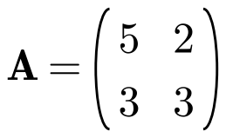

Using the Cayley–Hamilton theorem to find higher powers of a matrix:

2. Given that
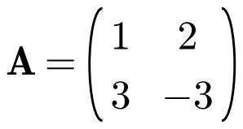
a) find the characteristic equation of A.

b) Hence show that A³ = 13A − 18I.

Using the Cayley–Hamilton theorem to find the inverse of a matrix:

3. Given that
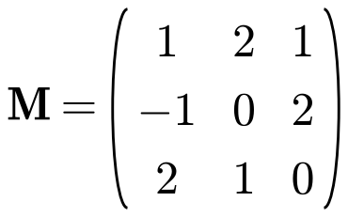
a) find the characteristic equation of M.

b) Hence, by using the Cayley–Hamilton theorem, find M⁻¹.

