3A Loci in an Argand Diagram
The locus of z where |z − z₁| = r is:

The locus of z where |z − z₁| = |z − z₂| is:

The locus of z where |z − a| = k|z − b|, with k > 0 and k ≠ 1, is:

How to find its centre and radius:

1. Given that |z − 6| = 2|z + 6 − 9i|,
a) use algebra to show that the locus of z is a circle, stating its centre and its radius

b) sketch the locus of z on an Argand diagram.
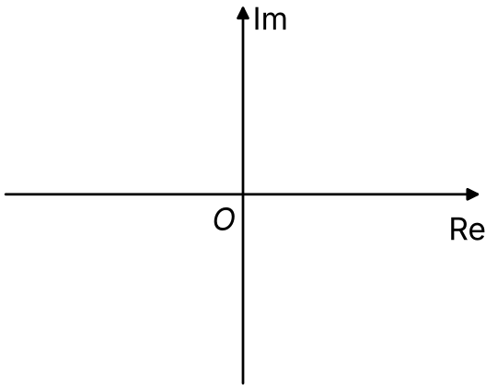

The locus of z where arg(z − z₁) = θ is:

Three circle theorems that help with arg loci:
•

•

•

The locus of z where 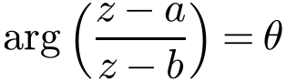, θ > 0, is:

Why (use arg z₁ − arg z₂ = arg(z₁/z₂)):

Shape of the locus
θ < π/2
θ = π/2
θ > π/2

Which way round the arc goes, and what happens at the endpoints A and B:

2. Given that 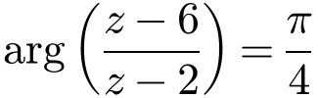,
a) sketch the locus of P(x, y) which is represented by z on an Argand diagram

b) find the Cartesian equation of this locus.
Method 1 (geometric):

Method 2 (algebraic):

3. Given the equation 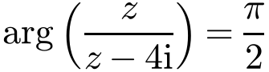,
a) sketch the locus of points z that satisfy the equation on an Argand diagram

b) Hence write down the range of possible values of Re(z).

3B Regions in an Argand Diagram
The region θ₁ ≤ arg(z − z₁) ≤ θ₂ is:

Solid and dashed boundary lines (≤ and <):

The region |z − z₁| ≤ r is:

The symbols ∩ and ∪ mean:

1. Describe algebraically, in terms of z, the region shown in each Argand diagram.
a)
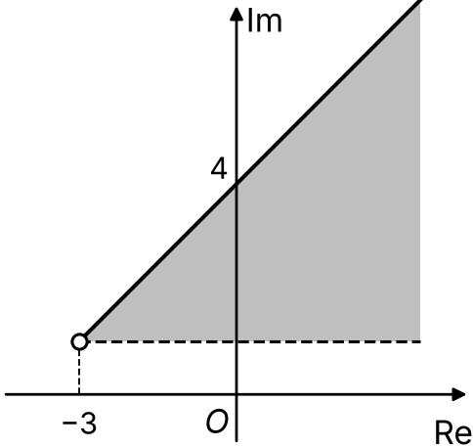

b)
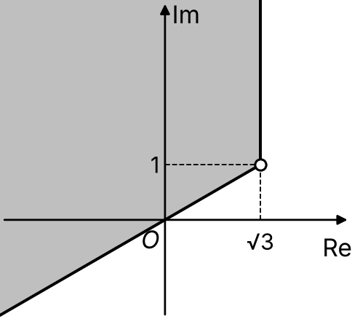

c)
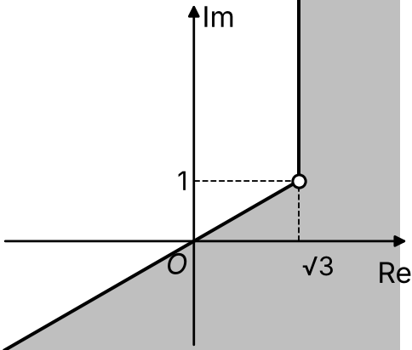

d)
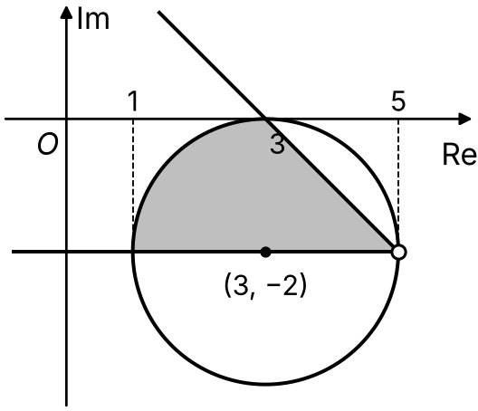

Tip for sketching an intersection of regions:

2. On separate Argand diagrams, shade the region satisfied by each set of points:
a) {z ∈ ℂ : 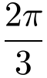 ≤ arg z ≤ π} ∩ {z ∈ ℂ : |z + 3 − 4i| ≤ 5}

b) {z ∈ ℂ : 2|z − 4| ≤ |z|} ∩ {z ∈ ℂ : 4 ≤ Re(z) ≤ 6}

3C Transformations of the Complex Plane
A transformation maps the z-plane (z = x + iy) to the w-plane (w = u + iv). Method for finding the image of a locus:

Transformation it represents
w = z + a + ib
w = kz (k real)
w = iz
w = kz + a + ib

1. The point P represents the complex number z on an Argand diagram, where |z| = 2. T₁, T₂ and T₃ represent transformations from the z-plane, where z = x + iy, to the w-plane, where w = u + iv. Describe the locus of the image of P under the transformations:
a) T₁: w = z − 2 + 4i

b) T₂: w = 3z

c) T₃: w = ½z + i

2. For the transformation w = iz − 1, find the locus of w when z lies on the half-line 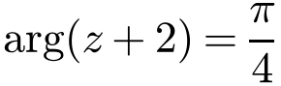.
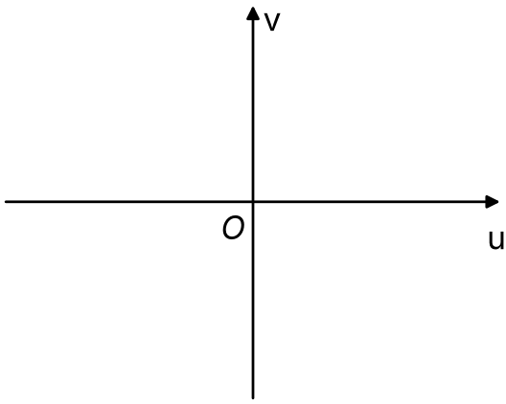

3. A transformation from the z-plane to the w-plane is given by w = z², where z = x + iy and w = u + iv. Describe the locus of w and give its Cartesian equation when z lies on:
a) a circle with equation x² + y² = 16

b) the line with equation x = 1

Transformations of the form 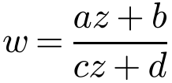, a, b, c, d ∈ ℂ, are called:

Method:

4. The transformation T from the z-plane, where z = x + iy, to the w-plane, where w = u + iv, is given by 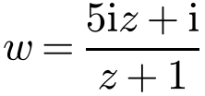, z ≠ −1.
a) Show that the image, under T, of the circle |z| = 1 in the z-plane is a line l in the w-plane.

b) Sketch l on an Argand diagram.

5. The transformation T from the z-plane, where z = x + iy, to the w-plane, where w = u + iv, is given by 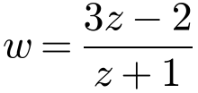, z ≠ −1. Show that the image, under T, of the circle with equation x² + y² = 4 in the z-plane is a circle C in the w-plane. State the centre and radius of C.

6. A transformation T of the z-plane to the w-plane is given by 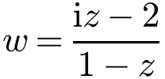, z ≠ 1. Show that as z lies on the real axis in the z-plane, then w lies on a line l in the w-plane. Sketch l on an Argand diagram.

