2A The Axioms for a Group
Binary operation:

A set S is closed under a binary operation ∗ if:

1. S = {x + y√3 : x, y ∈ ℤ}. Show that addition is a binary operation on S.

2. Show that the set of natural numbers, ℕ = {1, 2, 3, 4, ...}, is not closed under subtraction.

Identity element of a set S under a binary operation ∗:

3. Prove that an identity element of a set S under a binary operation must be unique.

Inverse elements (a and b are inverses of each other if...):

4. The binary operation ∗ on the set of real numbers is defined as a ∗ b = a + b + ab.
a) Find a real number e that satisfies the property a ∗ e = a.

The real number m has inverse m⁻¹ that satisfies the property m ∗ m⁻¹ = e.
b) Express m⁻¹ in terms of m.

A binary operation ∗ on a set S is associative if:

5. A binary operation on ℝ is defined by a ∘ b = ab + 1. Show that ∘ is not associative.

If G is a set and ∗ is a binary operation defined on G, then (G, ∗) is a group if these four axioms hold:
• Closure:

• Identity:

• Inverses:

• Associativity:

6. Show that:
a) the set of integers forms a group under addition

b) the set of integers does not form a group under multiplication.

7. The operation ∗ is defined by a ∗ b = a + b − 1, where a and b are real numbers. Determine whether the set of real numbers under the operation ∗ forms a group.

8. Prove that, for all elements a, b in a group (G, ∗), there exists a unique element c such that a ∗ c = b.

The latin square property:

2B Cayley Tables and Finite Groups
Finite group:

Cayley table:

Which element comes first in a Cayley table?

1. The set {1, −1, i, −i}, where i² = −1, forms a group under multiplication.
a) Draw a Cayley table for this group.
× | 1 | −1 | i | −i
1
−1
i
−i

b) Write down: i) the identity element ii) the inverse of i iii) the inverse of −1

When a group’s elements are displayed in a Cayley table, then:
•

•

•

•

Multiplication modulo n, ×ₙ:

Addition modulo n, +ₙ:

The Cayley tables below show the set {0, 1, 2, 3, 4} under addition and multiplication modulo 5.
+₅ | 0 | 1 | 2 | 3 | 4
0 | 0 | 1 | 2 | 3 | 4
1 | 1 | 2 | 3 | 4 | 0
2 | 2 | 3 | 4 | 0 | 1
3 | 3 | 4 | 0 | 1 | 2
4 | 4 | 0 | 1 | 2 | 3

×₅ | 0 | 1 | 2 | 3 | 4
0 | 0 | 0 | 0 | 0 | 0
1 | 0 | 1 | 2 | 3 | 4
2 | 0 | 2 | 4 | 1 | 3
3 | 0 | 3 | 1 | 4 | 2
4 | 0 | 4 | 3 | 2 | 1

2. The set S = {0, 1, 2, 3, 4}. Use the Cayley tables above to determine whether S forms a group under:
a) addition modulo 5

b) multiplication modulo 5

3. S = {1, 3, 7, 9}. Determine whether each of the following are groups. You may assume that the associative law holds in each case.
a) (S, ×₁₀)
×₁₀ | 1 | 3 | 7 | 9
1
3
7
9

b) (S, ×₁₂)

Permutation:

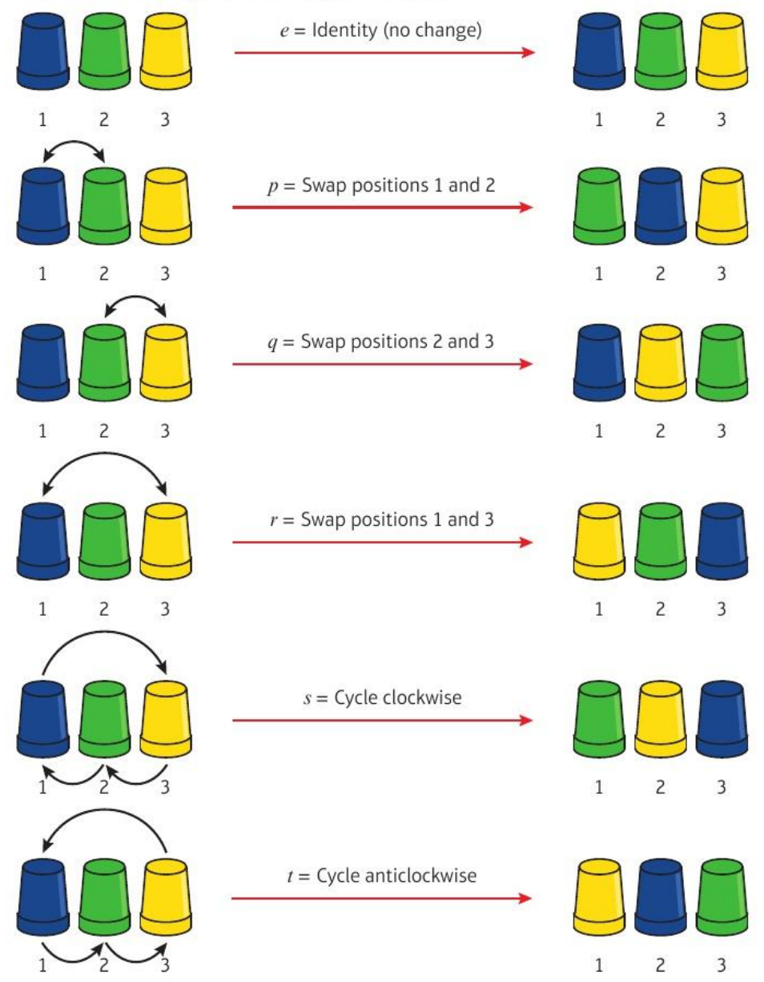
Composition: p ∘ q means

4. For the set of permutations of 3 cups, {e, p, q, r, s, t} as defined above, find:
a) q ∘ p

b) r ∘ r

The symmetric group on n elements, Sₙ:

Two-row notation. The six permutations of 3 cups are:
Composition and inverses in two-row notation. Find α ∘ β, β ∘ α and α⁻¹ for:
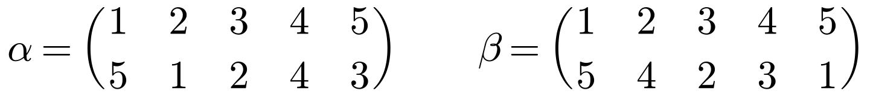

5. Show that the permutations below form a group under composition. You may assume the associativity axiom is satisfied.
∘ | e | p | q | r
e
p
q
r

Groups of symmetries. The symmetries of an equilateral triangle are:
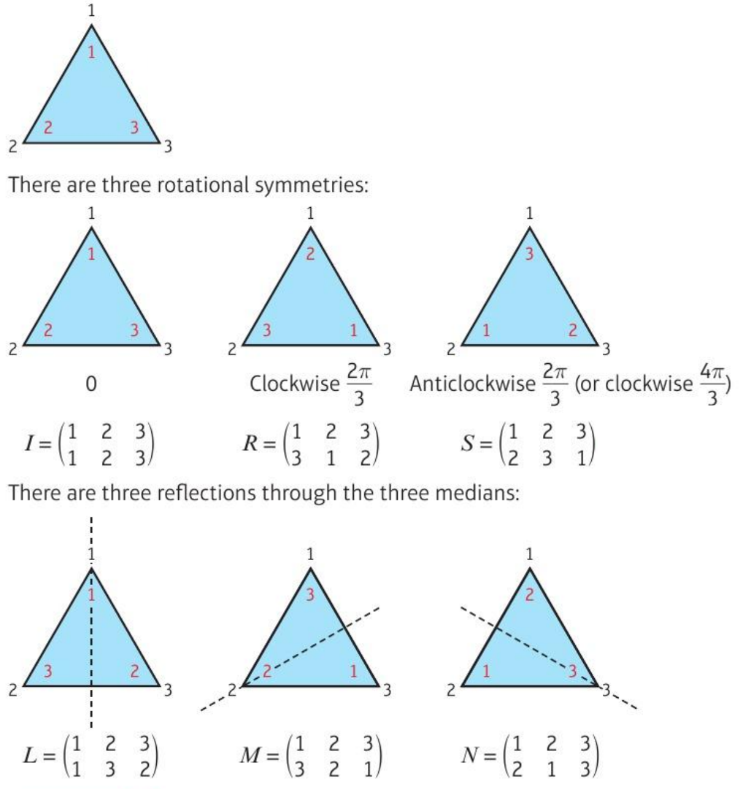
6. Show that G = {I, R, S, L, M, N} forms a group under composition of transformations. You may assume that the associative law holds.
∘ | I | R | S | L | M | N
I
R
S
L
M
N

Dihedral group D₂ₙ:

7. Show that the symmetries of a rectangle form a group under composition of transformations. You may assume that the associativity axiom holds.
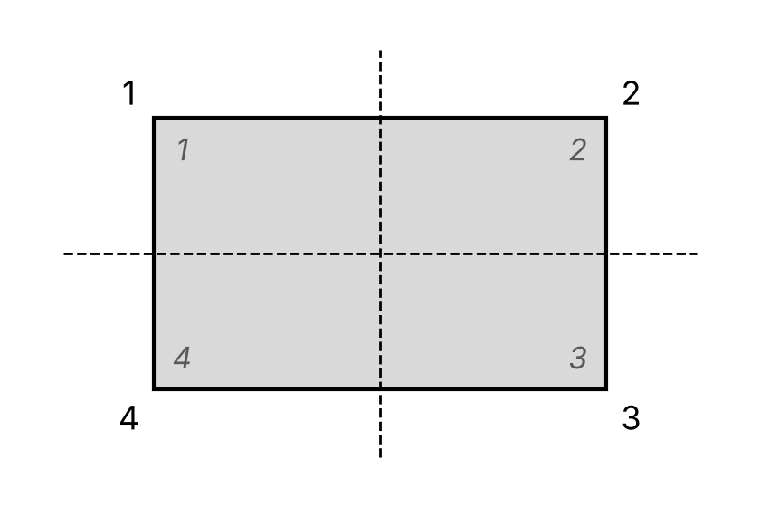

Cyclic group:

Generator:

8. The set S = {0, 1, 2, 3, 4, 5, 6, 7} is a group under addition modulo 8. Show that 3 is a generator of this group and write each element in terms of this generator.

9. The set {1, 3, 5, 7} forms a group under multiplication modulo 8. Show that this group is not cyclic.

2C Order and Subgroups
The order of a finite group G, |G|:

The order of an element a, |a|:

If (G, ∗) is finite with a ∈ G, then:

(G, ∗) is cyclic if and only if:

1. Let (G, ∘) be a finite group. Prove that every element in G must have finite order.

2. For each of the following groups, write down the order of the group, and the order of each element in the group.
a) {1, −1, i, −i} under complex multiplication

b) {1, 3, 7, 9} under multiplication modulo 10

3. G has elements {e, p, p², p³, q, pq, p²q, p³q} under multiplication, where e is the identity. You can assume the associativity axiom is satisfied. A partially completed Cayley table is shown below.
× | e | p | p² | p³ | q | pq | p²q | p³q
e | e | p | p² | p³ | q | pq | p²q | p³q
p | p | p² | p³ | e | pq | p²q | p³q | q
p² | p² | p³ | e | p | p²q | p³q | q | pq
p³ | p³ | e | p | p² | p³q
q | q | p³q | p²q | pq | e
pq | pq | q | p³q | p²q | p
p²q | p²q | pq | q | p³q | p²
p³q | p³q | p²q | pq | q | p³

a) State the order of the group.

b) State the order of p and q.

c) Complete the Cayley table and verify that G forms a group.

d) Find the order of pq, p²q and p³q.

4. The set {0, 1, 2, 3, 4} forms a group under addition modulo 5. Explain why no element of this group, other than the identity, can be self-inverse.

Let a be an element in a group (G, ∗). Then:
• if a has finite order n, then aᵐ = e if and only if

• if a has infinite order, then

• if aˣ = aʸ with x ≠ y, then

Subgroup:

Proper subgroup:

Trivial subgroup:

5.
a) Show that the set S = {5ⁿ : n ∈ ℤ} forms a group under multiplication.

b) Determine, with reasons, whether each of the following subsets of S forms a subgroup of (S, ×).
i) T = {5²ⁿ : n ∈ ℤ}

ii) U = {5ⁿ : n ∈ ℤ⁺}

Let G be a group and H a finite non-empty subset of G. Then H is a subgroup of G if:

6. The set S = {0, 1, 2, 3, 4, 5, 6, 7} forms a group under addition modulo 8. Find two nontrivial proper subgroups of (S, +₈).
+₈ | 0 | 1 | 2 | 3 | 4 | 5 | 6 | 7
0
1
2
3
4
5
6
7

If G is a finite group, then any element a ∈ G generates:

Lagrange’s theorem:

7. The set G = {1, 2, 4, 5, 8, 10, 11, 13, 16, 17, 19, 20} forms a group under multiplication modulo 21.
a) Find the elements in the subgroup of (G, ×₂₁) generated by the element 5, and state its order.

b) Explain why (G, ×₂₁) has no subgroup of order 5.

2D Isomorphism
Isomorphic groups:

Compare these two groups: the permutations below under composition, and {0, 1, 2} under addition modulo 3.
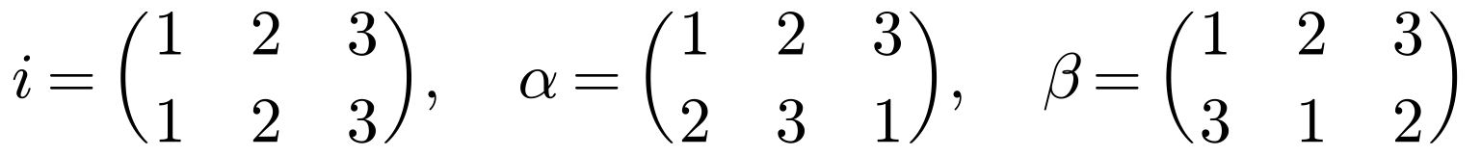
∘ | i | α | β
i | i | α | β
α | α | β | i
β | β | i | α

+₃ | 0 | 1 | 2
0 | 0 | 1 | 2
1 | 1 | 2 | 0
2 | 2 | 0 | 1

One-to-one function that maps one group onto the other:

Two groups (G, ∗) and (H, ∘) are isomorphic if there exists a mapping f: G → H such that:
•

•

•

Notation:

1. Let (G, ∗) and (H, ∘) be isomorphic groups with identity elements e_{G} and e_{H} respectively, and let f: G → H be an isomorphism from G to H. Prove that f(e_{G}) = e_{H}.

If f: G → H is an isomorphism then, for all a ∈ G and n ∈ ℤ:

Group isomorphisms also preserve order and subgroups:

2. The Cayley tables for two isomorphic groups G and H are shown below.
(G, ∗) | a | b | c | d
a | b | a | d | c
b | a | b | c | d
c | d | c | b | a
d | c | d | a | b

(H, ∘) | 1 | 3 | 5 | 7
1 | 1 | 3 | 5 | 7
3 | 3 | 1 | 7 | 5
5 | 5 | 7 | 1 | 3
7 | 7 | 5 | 3 | 1

a) State the identity element of each group.

b) Describe an isomorphism from G onto H.

3. G and H are cyclic groups with |G| = |H|. Prove that G ≅ H.

Groups of order 8 or less (only these are needed in the exam):
Order | Name | Properties
1 | ℤ₁
2 | ℤ₂
3 | ℤ₃
4 | ℤ₄
4 | Klein four-group, K₄
5 | ℤ₅
6 | ℤ₆
6 | S₃, D₆
7 | ℤ₇
8 | ℤ₈
8 | D₈
8 | ℤ₄ × ℤ₂
8 | ℤ₂ × ℤ₂ × ℤ₂
8 | Quaternion group

Groups of order 8 or less can be classified entirely by:

4. The group G consists of the elements below under the operation of matrix multiplication.
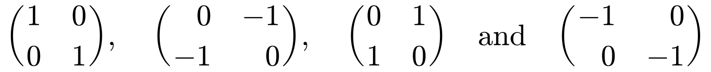
The set H = {1, 3, 5, 7, 9, 11, 13, 15} forms a group under multiplication modulo 16.
a) Show that H contains a subgroup that is isomorphic to G.

b) Determine whether H is isomorphic to the symmetry group of a square, giving reasons for your answer.

