6B Arc Length
Arc length means:

Using Pythagoras on a small arc δs:

Arc length for y = f(x), integrating with respect to x:

Arc length for y = f(x), integrating with respect to y:

Arc length for a curve given parametrically, x = f(t), y = g(t):

Arc length for a curve with polar equation r = f(θ), between θ = α and θ = β:

1. Find the length of the arc PQ on the curve with equation y = ⅔x^(3/2), where the x-coordinates of P and Q are 8 and 15 respectively.
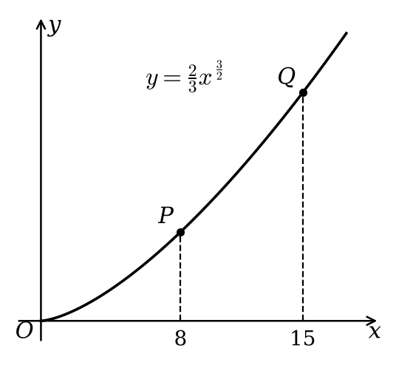

2. A curve is defined by the parametric equations x = 3 + 2cos t, y = 2t + 2sin t, t ∈ ℝ.
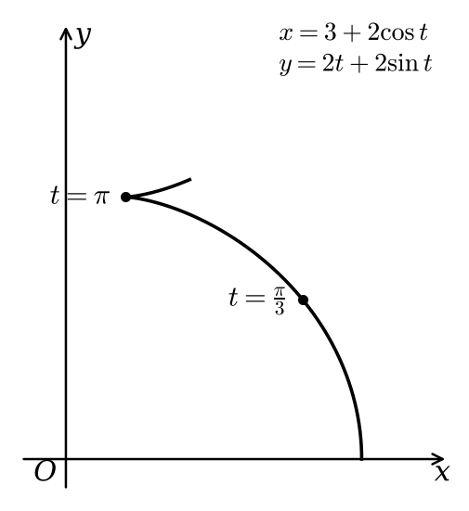
a)
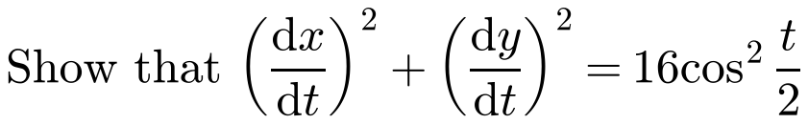

b) Find the exact length of this curve between the points where t = π/3 and t = π.

3. The curve C shown in the diagram has polar equation r = 5e²ᶿ. Find the length of the arc of C between the points on the curve with θ = 0 and θ = π/2.
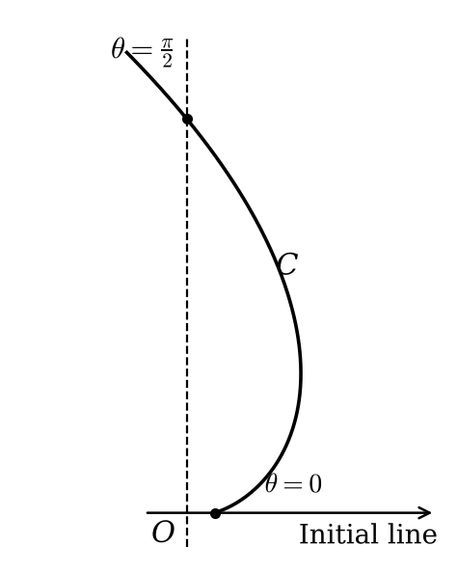

A useful substitution for ∫√(1 + x²) dx:

4. Find the exact length of the arc on the parabola with equation y = ½x², from the origin to the point P(4, 8).

