6A Reduction Formulae
A reduction formula is:

The formula for integration by parts:

How you use a reduction formula to find an integral:

1. Given that Iₙ = ∫xⁿeˣ dx, where n is a positive integer,

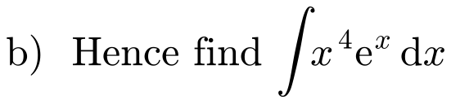

2.

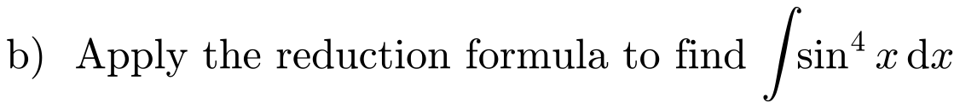

Why you may need an identity after integrating by parts:

3.
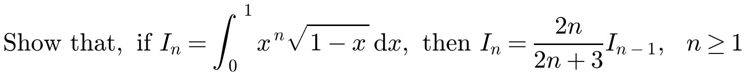

4. Iₙ = ∫tanⁿx dx, where n is a positive integer. By writing tanⁿx as tanⁿ⁻²x tan²x, and using 1 + tan²x ≡ sec²x, establish the reduction formula
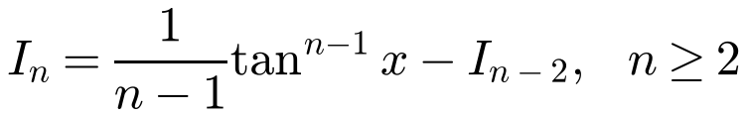

5.
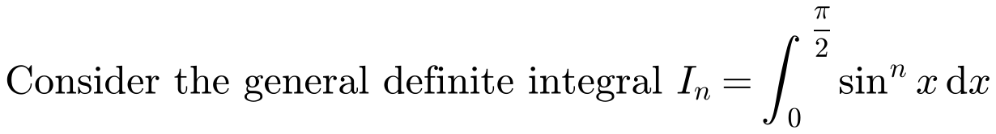
a) Prove that, for n ≥ 2, nIₙ = (n − 1)Iₙ₋₂

b) Find the values of
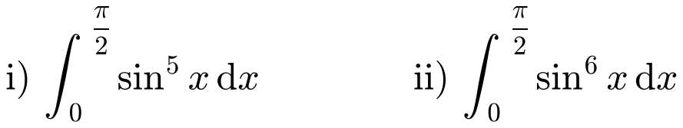

6.
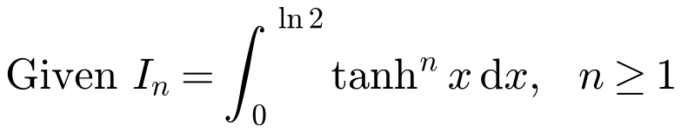
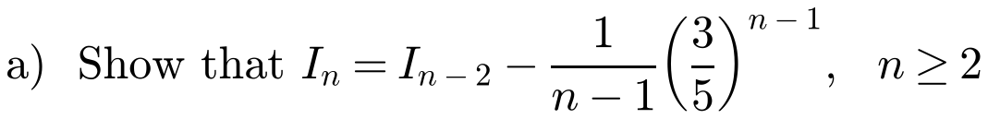

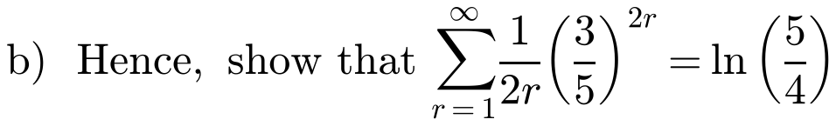
You may assume that the limit of Iₙ as n → ∞ is 0.

7.

