5C Reducing Matrices to Diagonal Form
A diagonal matrix:

The leading diagonal:

The general 2 × 2 diagonal matrix:

To reduce a given matrix A to diagonal form:
1.

2.

3.

4.

1. For the matrix below:
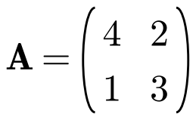
a) Find a matrix P such that D = P⁻¹AP is diagonal.

b) Write down the diagonal matrix D.

The elements on the leading diagonal of D:

A symmetric matrix:

An orthogonal matrix:

The procedure for orthogonal diagonalisation of a symmetric matrix A:
1.

2.

3.

4.

2. Reduce the matrix A to a diagonal matrix.
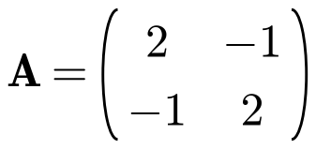

3. Find a matrix P and a diagonal matrix D such that D = P⁻¹AP.
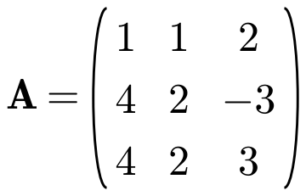

4. The matrix
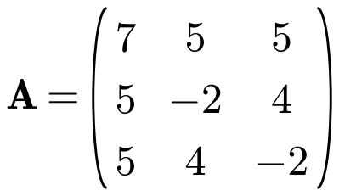
a) Verify that (2, 1, 1)ᵀ is an eigenvector of A and find the corresponding eigenvalue.

b) Show that −6 is another eigenvalue of A and find the corresponding eigenvector.

c) Given that the third eigenvector of A is (1, −1, −1)ᵀ, find a matrix P and a diagonal matrix D such that PᵀAP = D.

5. The two sequences xₙ and yₙ satisfy the recurrence relations
These recurrence relations can be written in matrix form as
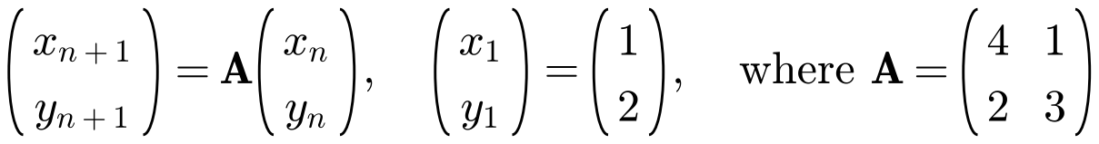
a) Find the eigenvalues and corresponding eigenvectors of A.

b) Hence write down matrices P and D such that P⁻¹AP = D where D is a diagonal matrix.

New sequences uₙ and vₙ can be formed from xₙ and yₙ using the transformation
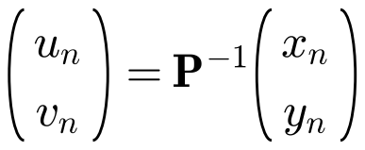
c)
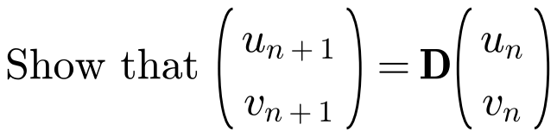

d) Hence find closed form expressions for the original sequences xₙ and yₙ.

Powers of a diagonal matrix:
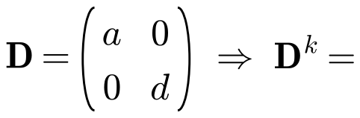

If P⁻¹AP = D, then Aᵏ =

6. For the matrix below:
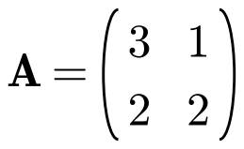
a) Find a matrix P and a diagonal matrix D such that P⁻¹AP = D.

b) Hence find A⁶.

