5A/B Eigenvalues and Eigenvectors
An eigenvector of a matrix A is:

The eigenvalue corresponding to the eigenvector x is:

Under the transformation represented by A, what happens to an eigenvector? What does the eigenvalue tell you?

Eigenvectors and invariant lines:

If the corresponding eigenvalue is 1:

Why det(A − λI) = 0 gives the eigenvalues:

The characteristic equation of A:

1. Find the eigenvalues and corresponding eigenvectors of the matrix
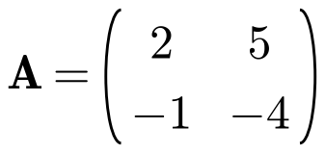

A normalised eigenvector:
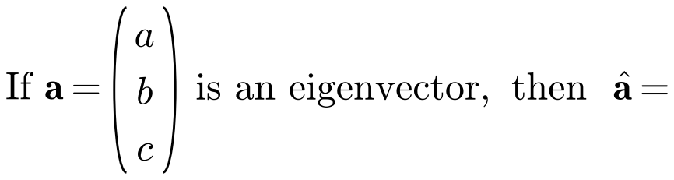

Normalised eigenvectors for question 1:

Repeated eigenvalues and complex eigenvalues:

Linearly independent vectors:

2. Find the eigenvalues and corresponding eigenvectors for these matrices:
a)
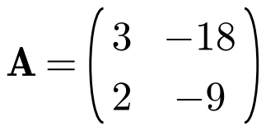

b)
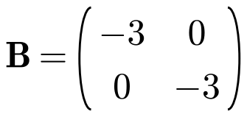

c)
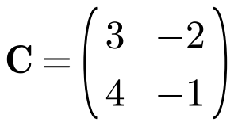

3. A transformation T: ℝ² → ℝ² is represented by the matrix
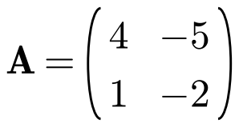
a) Find the eigenvalues of A.

b) Find Cartesian equations of the two lines passing through the origin which are invariant under T.

Eigenvalues and eigenvectors of a 3 × 3 matrix (what kind of equation? how do you factorise it?):

Why a 3 × 3 matrix always has at least one real eigenvalue:

4. Find the eigenvalues and corresponding eigenvectors of the matrix
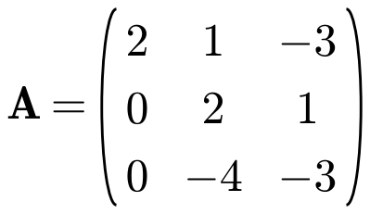

5. The matrix
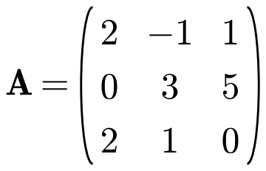
a) Show that −2 is the only real eigenvalue of A.

b) Find a normalised eigenvector of A corresponding to the eigenvalue −2.

6. The matrix
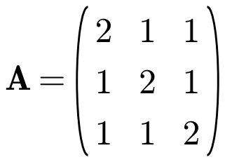
a) Show that 1 is a repeated eigenvalue of A and find the other distinct eigenvalue.

b) Find two linearly independent eigenvectors corresponding to the eigenvalue 1.

