2B Cayley Tables and Finite Groups
Finite group:

Cayley table:

Which element comes first in a Cayley table?

1. The set {1, −1, i, −i}, where i² = −1, forms a group under multiplication.
a) Draw a Cayley table for this group.
× | 1 | −1 | i | −i
1
−1
i
−i

b) Write down: i) the identity element ii) the inverse of i iii) the inverse of −1

When a group’s elements are displayed in a Cayley table, then:
•

•

•

•

Multiplication modulo n, ×ₙ:

Addition modulo n, +ₙ:

The Cayley tables below show the set {0, 1, 2, 3, 4} under addition and multiplication modulo 5.
+₅ | 0 | 1 | 2 | 3 | 4
0 | 0 | 1 | 2 | 3 | 4
1 | 1 | 2 | 3 | 4 | 0
2 | 2 | 3 | 4 | 0 | 1
3 | 3 | 4 | 0 | 1 | 2
4 | 4 | 0 | 1 | 2 | 3

×₅ | 0 | 1 | 2 | 3 | 4
0 | 0 | 0 | 0 | 0 | 0
1 | 0 | 1 | 2 | 3 | 4
2 | 0 | 2 | 4 | 1 | 3
3 | 0 | 3 | 1 | 4 | 2
4 | 0 | 4 | 3 | 2 | 1

2. The set S = {0, 1, 2, 3, 4}. Use the Cayley tables above to determine whether S forms a group under:
a) addition modulo 5

b) multiplication modulo 5

3. S = {1, 3, 7, 9}. Determine whether each of the following are groups. You may assume that the associative law holds in each case.
a) (S, ×₁₀)
×₁₀ | 1 | 3 | 7 | 9
1
3
7
9

b) (S, ×₁₂)

Permutation:

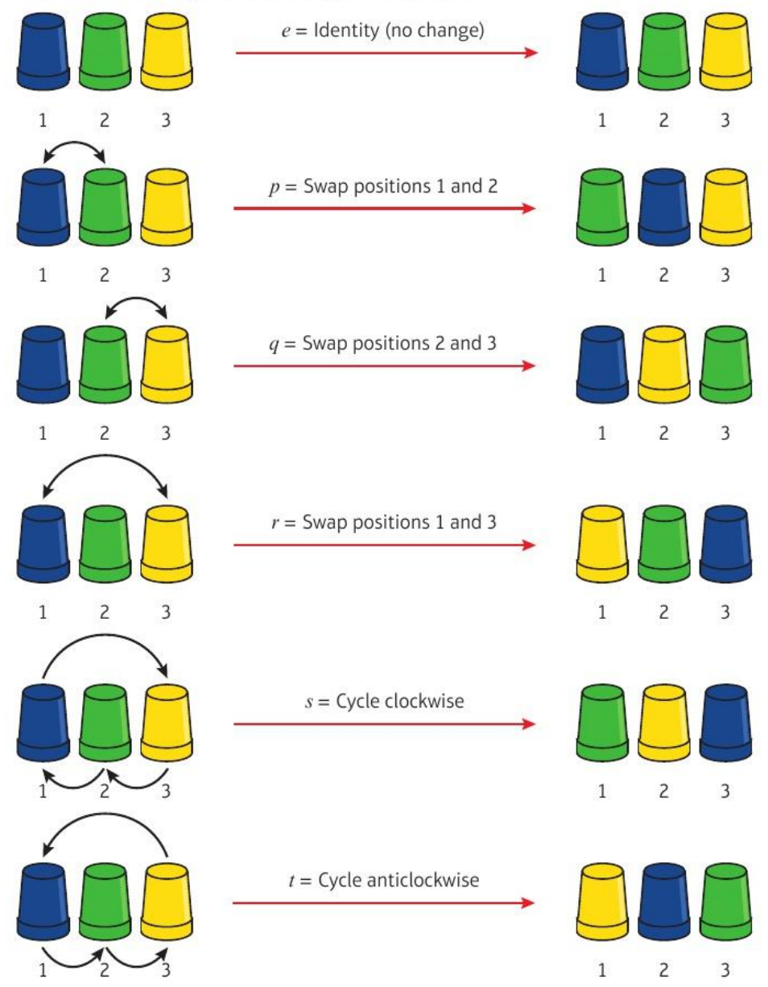
Composition: p ∘ q means

4. For the set of permutations of 3 cups, {e, p, q, r, s, t} as defined above, find:
a) q ∘ p

b) r ∘ r

The symmetric group on n elements, Sₙ:

Two-row notation. The six permutations of 3 cups are:
Composition and inverses in two-row notation. Find α ∘ β, β ∘ α and α⁻¹ for:
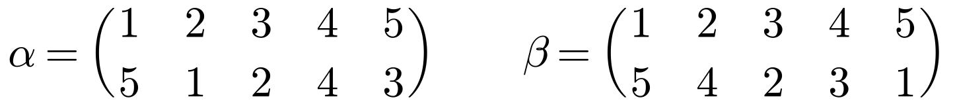

5. Show that the permutations below form a group under composition. You may assume the associativity axiom is satisfied.
∘ | e | p | q | r
e
p
q
r

Groups of symmetries. The symmetries of an equilateral triangle are:
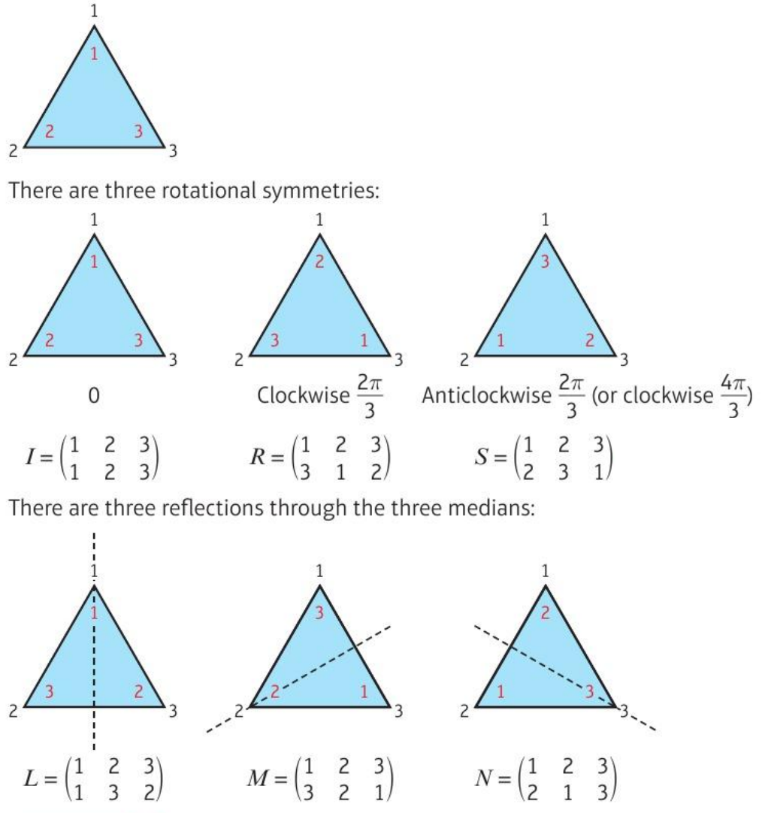
6. Show that G = {I, R, S, L, M, N} forms a group under composition of transformations. You may assume that the associative law holds.
∘ | I | R | S | L | M | N
I
R
S
L
M
N

Dihedral group D₂ₙ:

7. Show that the symmetries of a rectangle form a group under composition of transformations. You may assume that the associativity axiom holds.
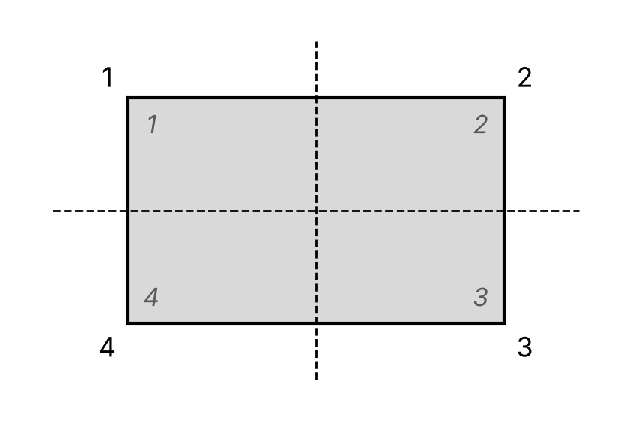

Cyclic group:

Generator:

8. The set S = {0, 1, 2, 3, 4, 5, 6, 7} is a group under addition modulo 8. Show that 3 is a generator of this group and write each element in terms of this generator.

9. The set {1, 3, 5, 7} forms a group under multiplication modulo 8. Show that this group is not cyclic.

