1G Combinatorics
The product rule of counting: if you can choose one item in m different ways, and a second item in n different ways, then:

If you need to choose k items, and the kth item can be chosen in n_{k} different ways, then:

1. A number plate consists of two letters, followed by two digits, followed by three more letters. The letters can be chosen from the entire alphabet except the letters I, O, Q or Z, and the digits can be chosen from 0 up to 9.

a) Find the total number of different number plates that can be generated in this way.

All number plates registered in one particular region must start with the letter combinations CW or CX.
b) Find the total number of different number plates that can be generated in this way.

2. Find the total number of 3-digit even numbers.

3. Find the total number of positive integers less than 1000 that contain the digit 5
a) exactly once

b) at least once

If a set S contains n elements, then the total number of possible subsets of S is:

4. A set S = {1, 2, 3, 4, 5, 6}. Find the total number of possible subsets of S.

5. A group of 10 students are being selected to clean up a local park. Given that at least one student must be selected, how many different groups of students could be selected to clean up the park?

The number of different ways of placing n items in order (permutations of n items):

6. Consider the letters ABCDEF.
a) Find the number of different strings of length 6 that can be written using these letters exactly once each.

b) Find the number of these strings that contain:
i) the substring DEF

ii) the letters DEF together in any order.

The number of possible permutations of r items taken from a set of n items, where n ≥ r:

7. 15 runners compete in a cross-country race. Find the number of different ways the top 6 positions can be filled.

The number of permutations of n items, of which r are identical:

The number of permutations of n items, of which r₁ are identical, r₂ are identical, and so on:

8. Find the number of possible different permutations of the letters in the word WINNINGS.

The number of possible combinations of r items (in any order) taken from a set of n items, where n ≥ r:

9. In a lottery game you choose 6 numbers from a choice of 45 by shading in a grid. 6 numbers are selected at random and if you match all six you win a jackpot prize. Find the probability of winning a jackpot prize.
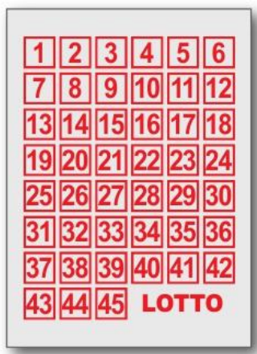

10. In poker, a deck of 52 different cards is used. There are 13 cards in each of four suits. A hand is made up of five cards, arranged in any order.
a) Work out the total number of different hands that are possible.

A flush is a hand containing five cards of the same suit.
b) Work out the number of hands containing five cards of the same suit.

Four-of-a-kind is a hand containing four cards of the same value, such as four 7s, or four queens.
c) Work out the number of four-of-a-kind hands.

11. The set S = {1, 2, 3, 4, 5, 6, 7, 8}. Find:
a) the number of subsets of S containing exactly 4 elements

b) the number of different 4-digit numbers that can be made using the elements of S. (Each element can be used only once.)

