3A Using Calculus to Find Centres of Mass
For a system of particles m₁, m₂, … at (x₁, y₁), (x₂, y₂), …:

Elemental strip:

ρ (rho) can mean:

Centre of mass of a uniform lamina bounded by y = f(x), the x-axis and the lines x = a and x = b:
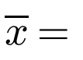

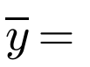

Why is the strip’s centre of mass at height ½y?

1. Use calculus to find the position of the centre of mass of a right-angled triangular lamina OPQ with base d and height h, as shown in the diagram.
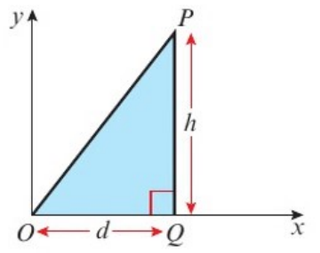

2. Find the coordinates of the centre of mass of the uniform lamina bounded by the curve with equation y = 4 − x², the x-axis and the y-axis, as shown.
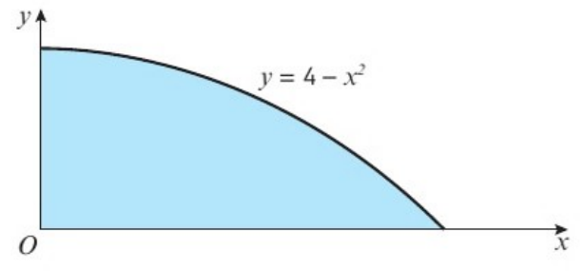

3. A uniform semicircular lamina has radius r cm. Find the position of its centre of mass.
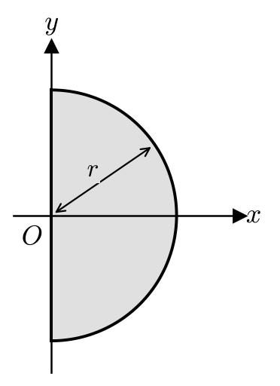

Centre of mass of a uniform semicircular lamina:

4. The diagram shows a uniform lamina occupying the shaded region bounded by the curve with equation y = √x and the straight line with equation y = ½x. Find the coordinates of the centre of mass of the lamina.
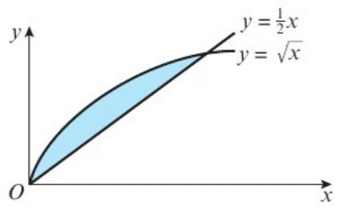

Lamina between two curves y₁ (upper) and y₂ (lower): mass of strip and centre of mass of strip

5. Find the centre of mass of a uniform lamina in the form of a sector of a circle, radius r and centre O, which subtends an angle 2α at O.
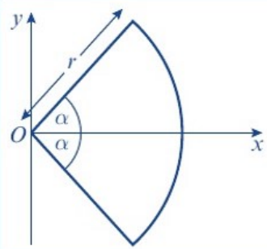

6. Find the centre of mass of a uniform wire in the form of an arc of a circle, radius r and centre O, which subtends an angle 2α at O.
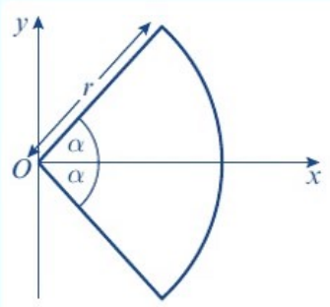

Standard results (in the formula booklet), distance from O along the axis of symmetry:
Distance of centre of mass from O
Sector of a circle, angle 2α
Arc of a circle, angle 2α
Semicircular lamina

3B Centre of Mass of a Uniform Body
For a uniform solid body, the centre of mass lies:

Uniform solid sphere:

Uniform solid right circular cylinder:

Solid of revolution about the x-axis: divide into thin discs of radius y and thickness δx. Mass of one disc:

Solid of revolution about the y-axis:

1. Find the centre of mass of the uniform solid right circular cone with radius R and height h.
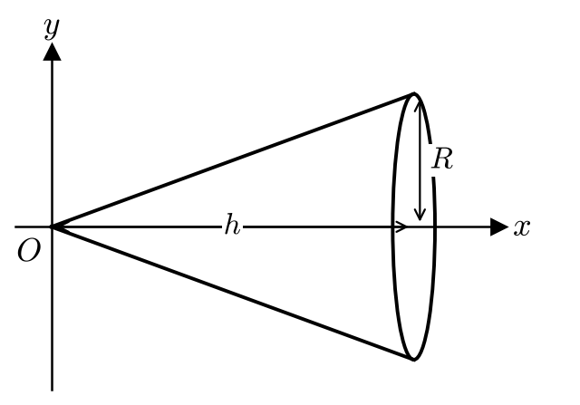

Centre of mass of a uniform solid cone:

2. Find the centre of mass of the uniform solid hemisphere with radius R.
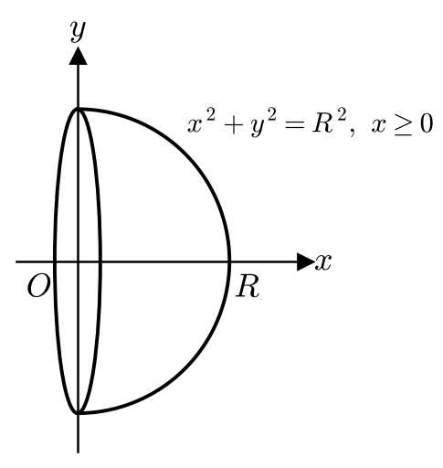

Centre of mass of a uniform solid hemisphere:

3. Find the centre of mass of the uniform solid of revolution formed by rotating the finite region enclosed by the curve y = x² + 1, the x-axis and the lines x = 0 and x = 3 through 360° about the x-axis as shown in the diagram below.
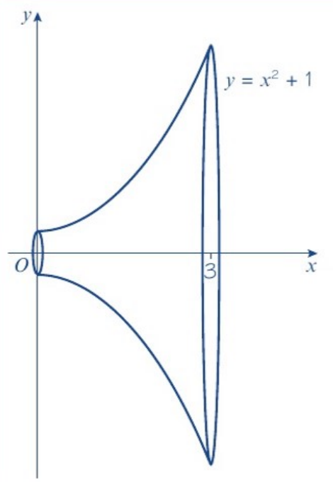

4. Find the centre of mass of the uniform hemispherical shell with radius R.
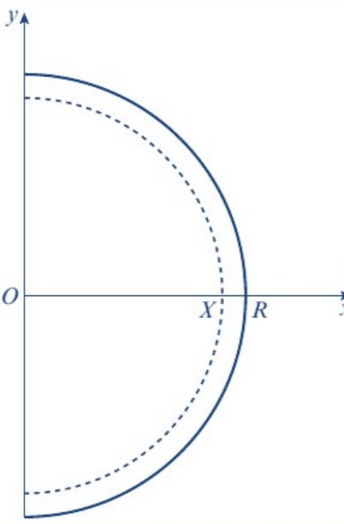
Hint: remove a solid hemisphere of radius X from a solid hemisphere of radius R, then let X → R.
 | Mass | Centre of mass
Solid hemisphere, radius R
Solid hemisphere, radius X
Hollow shell

Centre of mass of a uniform hemispherical shell:

5. Show that the centre of mass of the uniform hollow right circular cone with radius R and height h is at a distance ⅓h from the base along the axis of symmetry.

Centre of mass of a conical shell:

Frustum:

6. Find the position of the centre of mass of the frustum of a right circular uniform cone, of end radii 1 cm and 4 cm, and of height 7 cm.
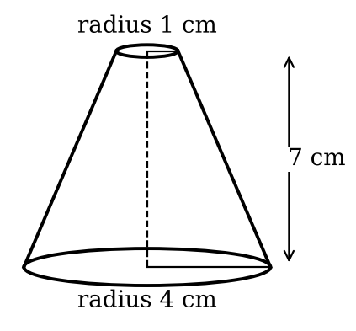
 | Mass | Distance of centre of mass from base
Large cone
Small cone
Frustum

3C Non-Uniform Bodies
Composite bodies made from materials of different densities:

1. A uniform solid right circular cone of height 2R and base radius R is joined at its base to the base of a uniform solid hemisphere. The centres of their bases coincide at O and their axes are collinear. The radius of the hemisphere is 2R. Find the position of the centre of mass of the composite body if the cone has four times the density of the hemisphere.
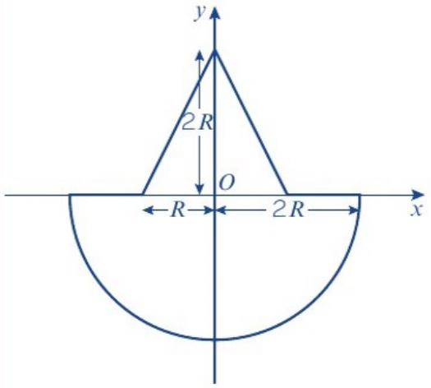
 | Mass | Ratio of masses | Distance from O to centre of mass
Cone
Hemisphere
Composite body

Non-uniform rod: the mass per unit length is ρ = f(x). The mass of a small section of length δx is:

Distance of the centre of mass from the end of the rod (length l):

2. A non-uniform telegraph pole is 10 m long. At any distance x metres from its base, the mass per unit length of the telegraph pole is given by m = 20 − ⅕x kg m⁻¹. By modelling the telegraph pole as a rod, find:
a) the mass of the telegraph pole

b) the distance of the centre of mass of the telegraph pole from its top.

3D Rigid Bodies in Equilibrium
If a body is in equilibrium:

When a rigid body is suspended freely from a fixed point and rests in equilibrium:

1. A uniform solid hemisphere has radius r. It is suspended by a string attached to a point A on the rim of its base. Find the angle between the axis of the hemisphere and the downward vertical when the hemisphere is in equilibrium.

2. A non-uniform cylinder has height 20 cm and radius 2 cm. At any height h cm above its base, the density of the cylinder is given by ρ = 3(2 − h⁄50) g cm⁻³. The cylinder is freely suspended from a point P that lies on the circumference of its top face. Find the angle between the downward vertical and the top face of the cylinder.
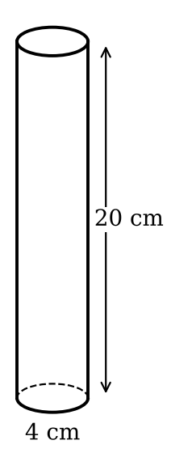

3. The diagram shows a uniform solid right circular cone, of mass M with radius r and height 3r. P and Q are points at opposite ends of a diameter on the circular plane face of the cone. The cone is suspended from a horizontal beam by two vertical inelastic strings fastened at P and Q. Given that the cone is in equilibrium with its axis at an angle of 45° to the horizontal, find the values of the tensions in the strings, giving your answers in terms of M and g.
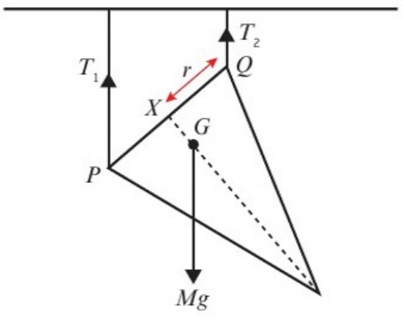

4. Two smooth uniform spheres of radius 4 cm and mass 5 kg are suspended from the same point A by identical light inextensible strings of length 8 cm attached to their surfaces. The spheres hang in equilibrium, touching each other. What is the reaction between them?

3E Toppling and Sliding
If a body rests in equilibrium on a rough inclined plane, the line of action of the weight:

What happens if the line of action of the weight passes outside the face in contact with the plane?

1. A solid uniform cylinder of radius 3 cm and height 5 cm has a solid uniform hemisphere made from the same material, of radius 3 cm, joined to it so that the base of the hemisphere coincides with one circular end of the cylinder.
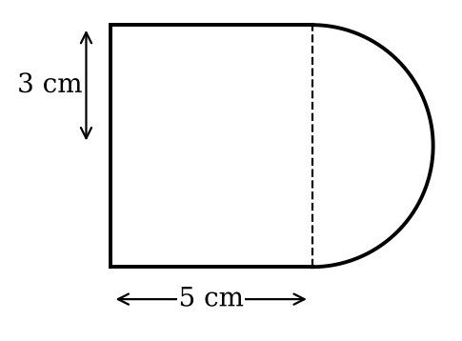
a) Find the position of the centre of mass of the composite body.
 | Mass | Ratio of masses | Height of centre of mass above base (cm)
Cylinder
Hemisphere
Composite body

The composite body is placed with the circular face of the cylinder on a rough inclined plane, which is inclined at an angle α to the horizontal. Given that the plane is sufficiently rough to prevent sliding,
b) show that equilibrium is maintained provided that tan α < 28⁄33.

2. A uniform solid cube of mass M and side 2a rests on a rough horizontal plane. The coefficient of friction is μ. A horizontal force of magnitude P is applied at the midpoint of an upper edge, perpendicular to that edge, as shown in the diagram. The reaction between the plane and the cube comprises a normal reaction force R and a friction force F and acts at a distance h from a lower edge of the cube as shown in the diagram.
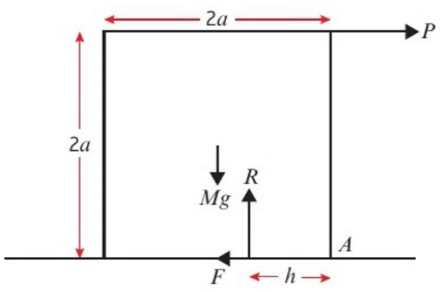
Find whether the cube remains in equilibrium, or whether the equilibrium is broken by sliding or toppling, in each of the following cases. Also determine the value of F and the value of h in each case, giving your answers in terms of M, g and a as appropriate:

a) P = 0

b) P = ½Mg and μ = ¾

c) P = ¼Mg and μ = ⅕

A body is on the point of sliding when:

A body is on the point of toppling when:

3. A uniform solid cube of mass M and side 2a is placed on a rough inclined plane which is at an angle α to the horizontal, where tan α = ½. The coefficient of friction is μ. Show that if μ < ½ the cube will slide down the slope.

4. The cube in the previous example is now replaced by a cylinder of mass M with base radius a and height 6a. The cylinder is placed on the rough inclined plane, which is inclined at an angle α to the horizontal, where tan α = ½. The coefficient of friction is μ. Show that if μ > ½ the cylinder will topple about the lower edge.

