2A Centre of Mass of a Set of Particles on a Straight Line
Centre of mass:

Finding the centre of mass of particles on a line (what you take moments about, and why g cancels):

1. A system of 3 particles, with masses 2 kg, 5 kg and 3 kg are placed along the x-axis at the points (3, 0), (4, 0) and (6, 0) respectively. Find the centre of mass of the system.

2. A system of n particles, with masses m₁, m₂, …, mₙ are placed along the x-axis at the points (x₁, 0), (x₂, 0), …, (xₙ, 0) respectively. Find the centre of mass of the system.

Key result (particles on the x-axis):

The same result for particles on the y-axis:

2B Centre of Mass of a Set of Particles Arranged in a Plane
For particles arranged in a plane, consider the x- and y-coordinates separately:

1. Find the coordinates of the centre of mass of the following system of particles:
2 kg at (1, 2); 3 kg at (3, 1); 5 kg at (4, 3)
Method 1 (taking moments about each axis):

Method 2 (using position vectors):

Key result using position vectors (masses m₁, …, mₙ with position vectors r₁, …, rₙ):

2. Find the coordinates of the centre of mass of the following system of particles:
4 kg at (−1, 3); 2 kg at (−2, −4); 8 kg at (4, 0); 6 kg at (1, −3)

If a question does not specify axes or coordinates:

3. A light rectangular plate ABCD has AB = 20 cm and AD = 50 cm. Particles of masses 2 kg, 3 kg, 5 kg and 5 kg are attached to the plate at the points A, B, C and D respectively. Find the distance of the centre of mass of the loaded plate from:
a) AD
b) AB

4. Particles of masses 4 kg, 3 kg, 2 kg and 1 kg are placed at the points (x, y), (3, 2), (1, −5) and (6, 0) respectively. Given that the centre of mass of the four particles is at the point (2.5, −2), find the values of x and y.

5. Three particles of masses 2 kg, 1 kg and m kg are situated at the points (−1, 3), (2, 9) and (2, −1) respectively. Given that the centre of mass of the three particles is at the point (1, ȳ), find:
a) the value of m
b) the value of ȳ.

2C Centres of Mass of Standard Uniform Plane Laminas
Lamina:

Uniform lamina:

Axes of symmetry and the centre of mass:

Centre of mass of a uniform circular disc:

Centre of mass of a uniform rectangular lamina:

Medians and centroid of a triangle:

Centre of mass of a uniform triangular lamina with vertices (x₁, y₁), (x₂, y₂) and (x₃, y₃):

Uniform sector of a circle, radius r and centre angle 2α (α in radians):
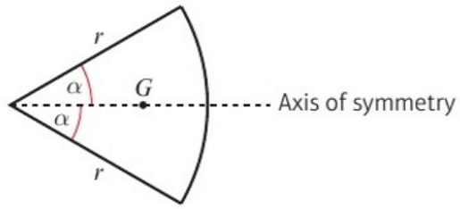
Distance of the centre of mass from the centre =

1. A uniform triangular lamina has vertices A(1, 4), B(3, 2) and C(5, 3). Find the coordinates of its centre of mass.

2. Find the centre of mass of the uniform triangular lamina shown:
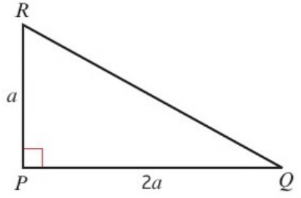

3. The diagram shows a uniform semicircular lamina of radius 6 cm with centre O. Find the centre of mass of the lamina.
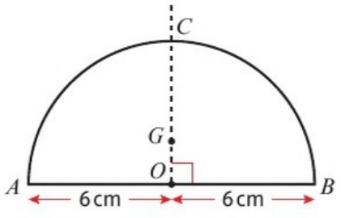

2D Centre of Mass of a Composite Lamina
Composite uniform lamina:

Method (treat each part as a particle at its own centre of mass, with mass proportional to):

1. A uniform lamina consists of a rectangle PQRS joined to an isosceles triangle QRT, as shown in the diagram. Find the distance of the centre of mass of the lamina from:
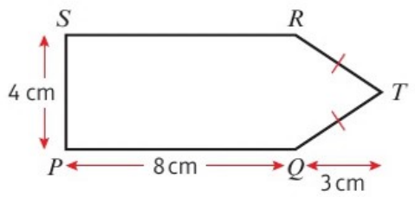
a) PQ
b) PS
 | Rectangle PQRS | Triangle QRT | Lamina
Area
x
y

The centre of mass of a uniform lamina or framework will always lie on:

2. The diagram shows a uniform lamina. Find the distance of the centre of mass of the lamina from:
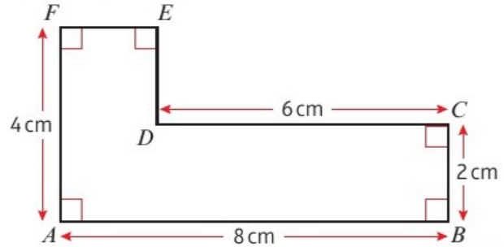
a) AF
b) AB
 | Part 1 | Part 2 | Lamina
Area
x
y

Two other ways of splitting this lamina:

Removing part of a lamina:

3. A uniform circular disc, centre O, of radius 5 cm has two circular holes cut in it, as shown in the diagram.
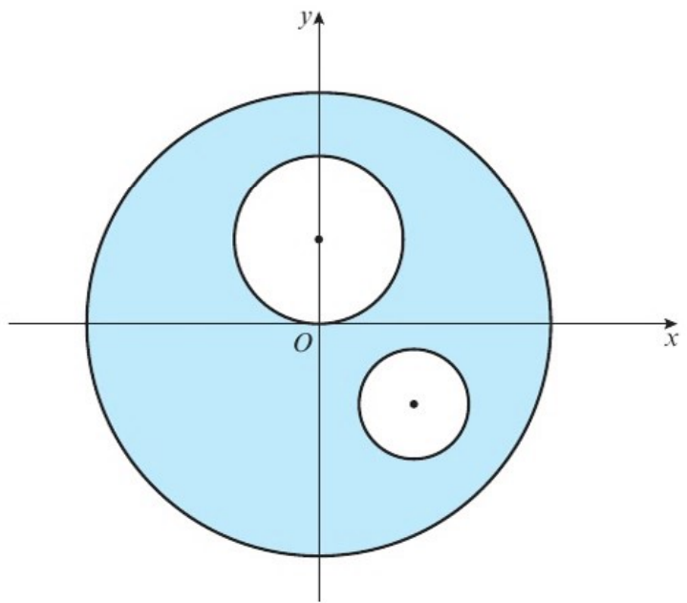
The larger hole has radius 2 cm and the smaller hole has radius 1 cm. The coordinates of the centres of the holes are (0, 2) and (2, −2) respectively. Find the coordinates of the centre of mass of the remaining lamina.
 | Disc | Large hole | Small hole | Remaining lamina
Area
x
y

2E Centre of Mass of a Framework
Framework:

Centre of mass of a uniform straight rod:

For a framework made from uniform wire, the mass of each piece is proportional to:

Uniform circular arc of radius r and centre angle 2α (α in radians):
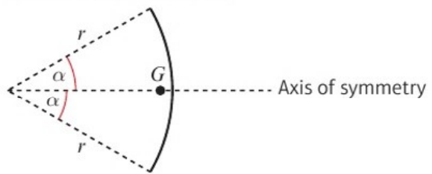
Distance of the centre of mass from the centre =

1. A framework consists of a uniform length of wire which has been bent into the shape of a letter L, as shown. Find the distance of the centre of mass of the framework from AB and AF.
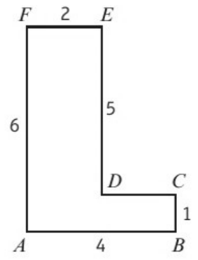
 | AB | BC | CD | DE | EF | FA | Frame
Length
x
y

2. Find the position of the centre of mass of a framework constructed from a uniform piece of wire bent into the shape shown:
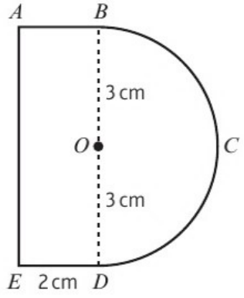
where the wire BCD is a semicircle, centre O, of radius 3 cm and wire BAED forms three sides of a rectangle ABDE.
 | Arc BCD | AB | AE | ED | Framework
Length
x
y

2F Lamina in Equilibrium
When a lamina or framework is freely suspended from a fixed point, or pivots freely about a horizontal axis, it rests in equilibrium with:

Why (the forces acting and their moments):

Method for finding the angle a line makes with the vertical:

1. Find the angle that the line AB makes with the vertical if this L-shaped uniform lamina is freely suspended from:
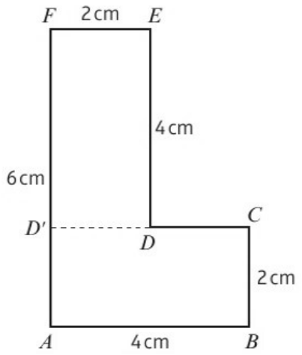
a) A

b) B

c) E

Attaching a particle to a lamina:

2. The L-shaped lamina in question 1 has mass M kg. Find the angle that FE makes with the vertical when a mass of 1/10 M kg is attached to B and the lamina is freely suspended from F.

2G Frameworks in Equilibrium
Frameworks in equilibrium are solved:

A framework suspended by two vertical strings (resolving and taking moments):

1. The inverted T-shaped uniform framework of weight W shown in the diagram is freely suspended from D and G by two vertical strings, so that AH is horizontal. The strings and the framework lie in the same plane.
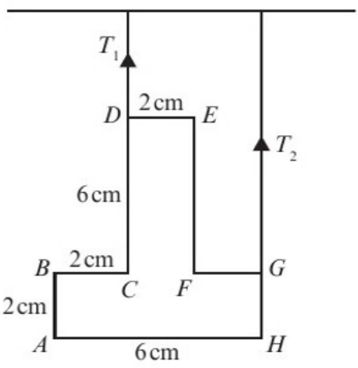
a) Find, in terms of W, the tensions T₁ and T₂.

The string at G breaks and the framework hangs freely in equilibrium from D.
b) Find the angle that DE makes with the vertical when the framework comes to rest in equilibrium.

2. The inverted T-shaped uniform framework used in question 1 has mass W kg.
a) Find the location of the centre of mass when a mass of ¼W kg is fixed at point H.

b) Find the angle that DE makes with the vertical when the system is freely suspended from E.

2H Non-uniform Composite Laminas and Frameworks
Modelling folded card:

Framework made from wires of different masses:

1. The lamina shown is made from a square piece of cardboard ABCD that has had the corner C folded to the centre of the square. Find the position of the centre of mass of the lamina.
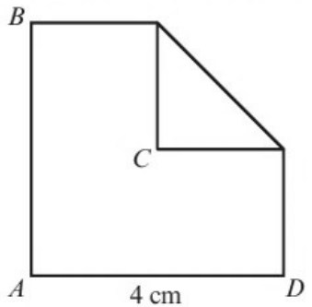
 | Rectangle | Square | Triangle | Lamina
Mass
x
y

2. The triangular framework shown is made from three pieces of uniform wire, AB, AC and BC of mass 2M, 3M and 5M respectively. Find the coordinates of the centre of mass of the framework.
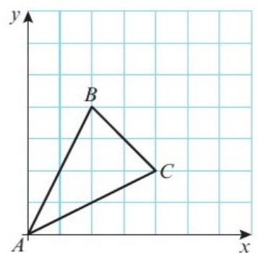
 | AB | AC | BC | Framework
Mass
x
y

