1A Angular Speed
Angular speed (what it measures, its symbol and its units):

The link between linear speed v and angular speed ω for a circle of radius r:

Converting revolutions to radians:

1. A particle moves in a circle of radius 4 m with speed 2 m s⁻¹. Calculate the angular speed.

2. Express an angular speed of 200 revolutions per minute in radians per second.

3. A particle moves round a circle in 10 seconds at a constant speed of 15 m s⁻¹. Calculate the angular speed of the particle and the radius of the circle.

1B Acceleration of an Object Moving on a Horizontal Circular Path
Why an object moving in a circle at constant speed is accelerating:

The acceleration of an object moving on a circular path with constant linear speed v and constant angular speed ω (magnitude and direction):

Units to check before substituting:

1. A particle is moving on a horizontal circular path of radius 20 cm with constant angular speed 2 rad s⁻¹. Calculate the acceleration of the particle.

2. A particle of mass 150 g moves in a horizontal circle of radius 50 cm at a constant speed of 4 m s⁻¹. Find the force towards the centre of the circle that must act on the particle.

3. One end of a light inextensible string of length 20 cm is attached to a particle P of mass 250 g. The other end of the string is attached to a fixed point O on a smooth horizontal table. P moves in a horizontal circle centre O at constant angular speed 3 rad s⁻¹. Find the tension in the string.
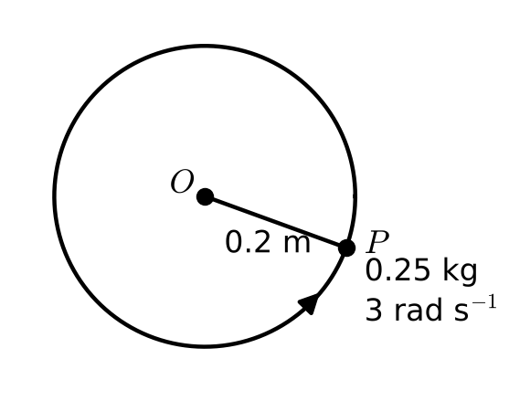

4. A smooth wire is formed into a circle of radius 15 cm. A bead of mass 50 g is threaded onto the wire. The wire is horizontal and the bead is made to move along it with a constant speed of 20 cm s⁻¹. Find the horizontal component of the force on the bead due to the wire.

5. A particle P of mass 10 g rests on a rough horizontal disc at a distance 15 cm from the centre. The disc rotates at constant angular speed of 1.2 rad s⁻¹, and the particle does not slip. Calculate the force due to the friction acting on the particle.

6. A car of mass M kg is travelling on a flat road round a bend which is an arc of a circle of radius 140 m. The greatest speed at which the car can travel round the bend without slipping is 45 km h⁻¹. Find the coefficient of friction between the tyres of the car and the road.

1C Three-Dimensional Problems with Objects Moving in Horizontal Circles
Method: which directions to resolve in, and what each equation says:

Conical pendulum:

1. A particle of mass 2 kg is attached to one end of a light inextensible string of length 50 cm. The other end of the string is attached to a fixed point A. The particle moves with constant angular speed in a horizontal circle of radius 40 cm. The centre of the circle is vertically below A. Calculate the tension in the string and the angular speed of the particle.
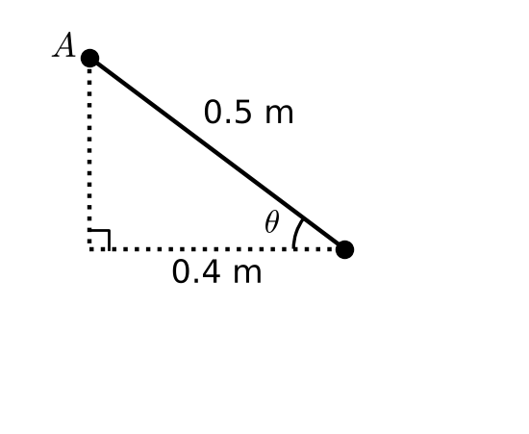

2. A particle of mass m is attached to one end of a light inextensible string of length l. The other end of the string is attached to a fixed point A. The particle moves with constant angular speed in a horizontal circle. The string is taut and the angle between the string and the vertical is θ. The centre of the circle is vertically below A. Find the angular speed of the particle.

Banked tracks: if there is no friction (no tendency to slip), the force towards the centre comes from:

3. A car travels round a bend of radius 500 m on a road which is banked at an angle θ to the horizontal. The car is assumed to be moving at constant speed in a horizontal circle and there is no tendency to slip. If there is no frictional force acting on the car when it is travelling at 90 km h⁻¹, find the value of θ.

4. The diagram shows a particle P of mass m attached by two strings to fixed points A and B, where A is vertically above B. The strings are both taut and P is moving in a horizontal circle with constant angular speed 2√(3g) rad s⁻¹. Both strings are 0.5 m in length and inclined at 60° to the vertical.
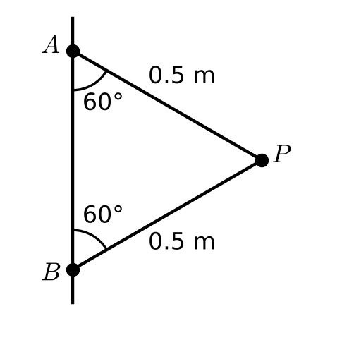
a) Calculate the tensions in the two strings.

The strings will break if the tension in them exceeds 8mg N. The angular speed of the particle is increased until the strings break.
b) State which string will break first.

c) Find the maximum angular speed of the particle before the string breaks.

A banked aircraft: the lift force acts perpendicular to the wings, so its components do two jobs:

5. An aircraft of mass 2 tonnes flies at 500 km h⁻¹ on a path which follows a horizontal circular arc in order to change course from due north to due east. The aircraft turns in the clockwise direction from due north to due east. It takes 40 seconds to change course, with the aircraft banked at an angle α to the horizontal. Calculate the value of α and the magnitude of the lift force perpendicular to the surface of the aircraft’s wings.

Rough surfaces: finding the greatest (or least) possible speed, and which way friction acts:

6. In this question use g = 9.81 m s⁻². A hollow right circular cone is fixed with its axis of symmetry vertical and its vertex V pointing downwards. A particle P of mass 25 g moves in a horizontal circle with centre C, and radius 0.27 m, on the rough inner surface of the cone. P remains in contact as it moves with constant angular speed, ω, and does not slip. The angle between VP and the vertical is θ, such that tan θ = 0.45. The coefficient of friction between the particle and the cone is 0.15. Find the greatest possible value of ω.
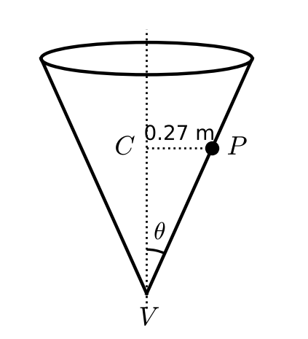

1D Objects Moving in Vertical Circles
Why the speed of an object moving in a vertical circle is not constant:

The two components of the acceleration for motion in a vertical circle of radius r:

Why the sum of kinetic and potential energy stays constant:

1. A particle of mass 0.4 kg is attached to one end A of a light rod AB of length 0.3 m. The rod is free to rotate in a vertical plane about B. The particle is held at rest with AB horizontal. The particle is released. Calculate:
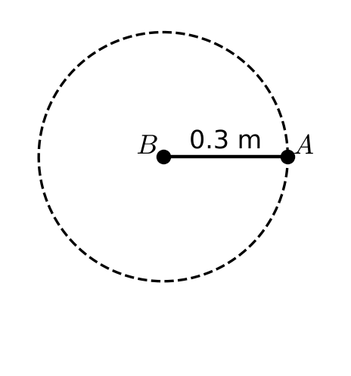
a) the speed of the particle as it passes through the lowest point of the path

b) the tension in the rod at this point.

2. A particle of mass 0.4 kg is attached to one end A of a light rod AB of length 0.3 m. The rod is free to rotate in a vertical plane about B. The rod is hanging vertically with A below B when the particle is set in motion with a horizontal speed of u m s⁻¹. Find:
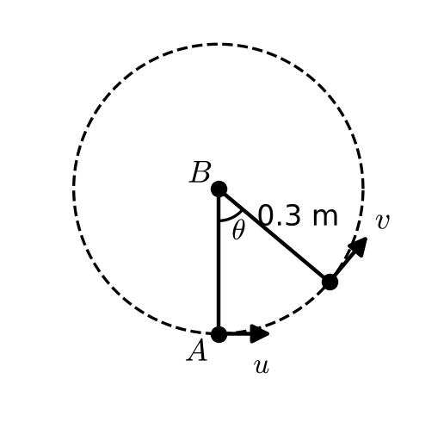
a) an expression for the speed of the particle when the rod is at an angle θ to the downward vertical through B

b) the minimum value of u for which the particle will perform a complete circle.

3. A particle A of mass 0.4 kg is attached to one end of a light inextensible string of length 0.3 m. The other end of the string is attached to a fixed point B. The particle is hanging in equilibrium when it is set in motion with a horizontal speed of u m s⁻¹. Find:
a) an expression for the tension in the string, in terms of u, when it is at an angle θ to the downward vertical through B

b) the minimum value of u for which the particle will perform a complete circle.

Conditions for performing complete vertical circles:
• a particle on the end of a light rod:

• a small bead threaded on a smooth circular wire:

• a particle on the end of a light inextensible string:

1E Objects Not Constrained on a Circular Path
Examples of objects that are constrained / not constrained to stay on a circular path:

What happens when the contact force (tension or normal reaction) becomes zero:

1. A particle P of mass m is attached to one end of a light inextensible string of length l. The other end of the string is attached to a fixed point O. The particle is hanging in equilibrium at point A, directly below O, when it is set in motion with a horizontal speed 2√(gl). When OP has turned through an angle θ and the string is still taut, the tension in the string is T. Find:
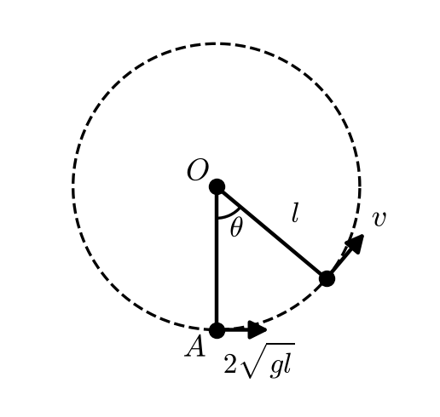
a) an expression for T

b) the height of P above A at the instant when the string goes slack

c) the maximum height above A reached by P before it starts to fall to the ground again.

2. A smooth hemisphere with radius 5 m and centre O is resting in a fixed position on a horizontal plane with its flat face in contact with the plane. A particle P of mass 4 kg is slightly disturbed from rest at the highest point of the hemisphere. When OP has turned through an angle θ and the particle is still on the surface of the hemisphere the normal reaction of the sphere on the particle is R. Find:
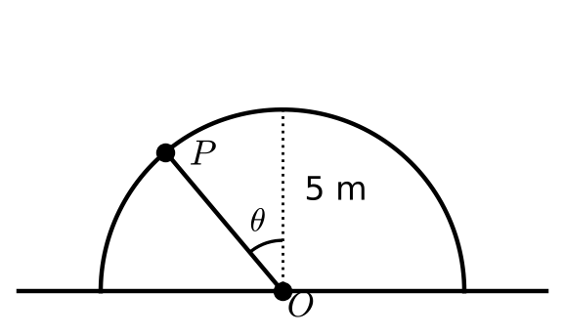
a) an expression for R

b) the angle between OP and the upward vertical when the particle leaves the surface of the hemisphere

c) the distance of the particle from the centre of the hemisphere when it hits the ground.

