3C Non-Uniform Bodies
Composite bodies made from materials of different densities:

1. A uniform solid right circular cone of height 2R and base radius R is joined at its base to the base of a uniform solid hemisphere. The centres of their bases coincide at O and their axes are collinear. The radius of the hemisphere is 2R. Find the position of the centre of mass of the composite body if the cone has four times the density of the hemisphere.
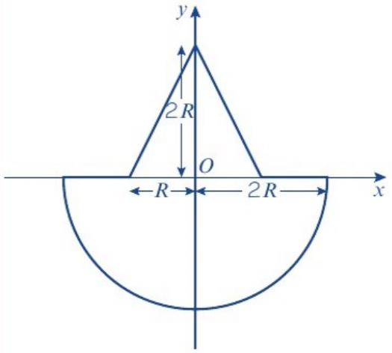
 | Mass | Ratio of masses | Distance from O to centre of mass
Cone
Hemisphere
Composite body

Non-uniform rod: the mass per unit length is ρ = f(x). The mass of a small section of length δx is:

Distance of the centre of mass from the end of the rod (length l):
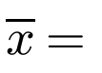

2. A non-uniform telegraph pole is 10 m long. At any distance x metres from its base, the mass per unit length of the telegraph pole is given by m = 20 − ⅕x kg m⁻¹. By modelling the telegraph pole as a rod, find:
a) the mass of the telegraph pole

b) the distance of the centre of mass of the telegraph pole from its top.

