3B Centre of Mass of a Uniform Body
For a uniform solid body, the centre of mass lies:

Uniform solid sphere:

Uniform solid right circular cylinder:

Solid of revolution about the x-axis: divide into thin discs of radius y and thickness δx. Mass of one disc:

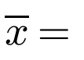

Solid of revolution about the y-axis:
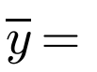

1. Find the centre of mass of the uniform solid right circular cone with radius R and height h.
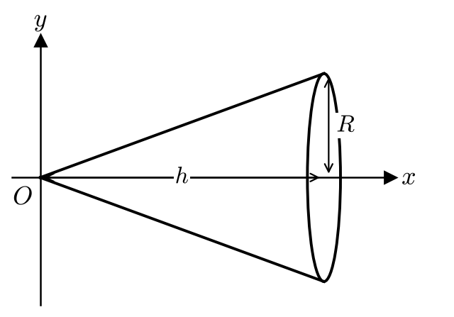

Centre of mass of a uniform solid cone:

2. Find the centre of mass of the uniform solid hemisphere with radius R.
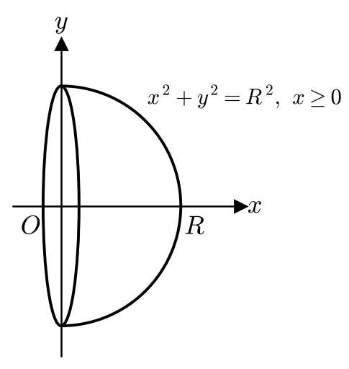

Centre of mass of a uniform solid hemisphere:

3. Find the centre of mass of the uniform solid of revolution formed by rotating the finite region enclosed by the curve y = x² + 1, the x-axis and the lines x = 0 and x = 3 through 360° about the x-axis as shown in the diagram below.
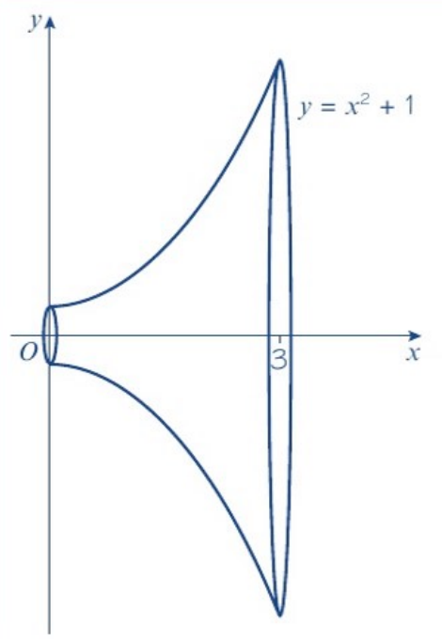

4. Find the centre of mass of the uniform hemispherical shell with radius R.
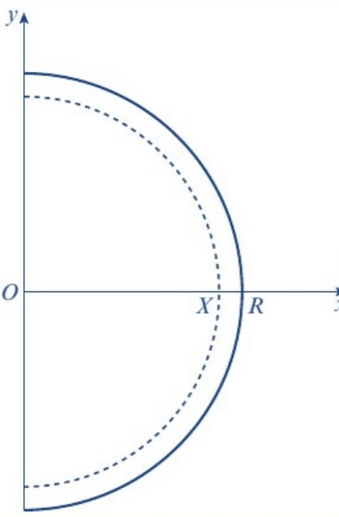
Hint: remove a solid hemisphere of radius X from a solid hemisphere of radius R, then let X → R.
 | Mass | Centre of mass
Solid hemisphere, radius R
Solid hemisphere, radius X
Hollow shell

Centre of mass of a uniform hemispherical shell:

5. Show that the centre of mass of the uniform hollow right circular cone with radius R and height h is at a distance ⅓h from the base along the axis of symmetry.

Centre of mass of a conical shell:

Frustum:

6. Find the position of the centre of mass of the frustum of a right circular uniform cone, of end radii 1 cm and 4 cm, and of height 7 cm.
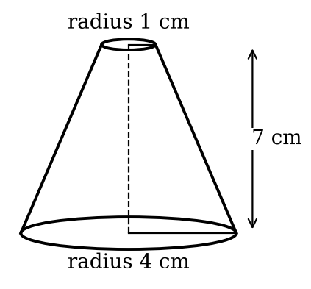
 | Mass | Distance of centre of mass from base
Large cone
Small cone
Frustum

