3A Using Calculus to Find Centres of Mass
For a system of particles m₁, m₂, … at (x₁, y₁), (x₂, y₂), …:

Elemental strip:

ρ (rho) can mean:

Centre of mass of a uniform lamina bounded by y = f(x), the x-axis and the lines x = a and x = b:
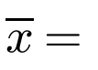

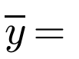

Why is the strip’s centre of mass at height ½y?

1. Use calculus to find the position of the centre of mass of a right-angled triangular lamina OPQ with base d and height h, as shown in the diagram.
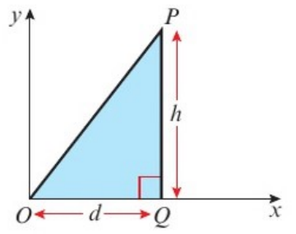

2. Find the coordinates of the centre of mass of the uniform lamina bounded by the curve with equation y = 4 − x², the x-axis and the y-axis, as shown.
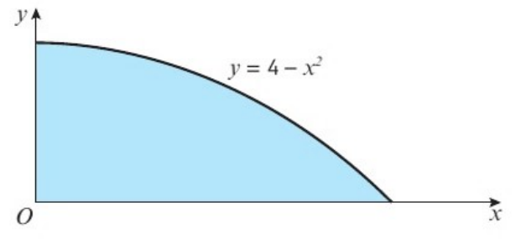

3. A uniform semicircular lamina has radius r cm. Find the position of its centre of mass.
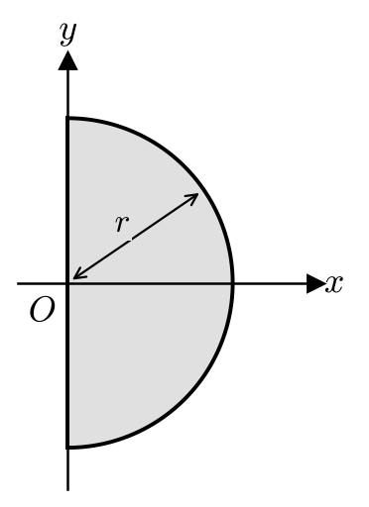

Centre of mass of a uniform semicircular lamina:

4. The diagram shows a uniform lamina occupying the shaded region bounded by the curve with equation y = √x and the straight line with equation y = ½x. Find the coordinates of the centre of mass of the lamina.
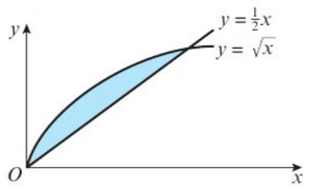

Lamina between two curves y₁ (upper) and y₂ (lower): mass of strip and centre of mass of strip

5. Find the centre of mass of a uniform lamina in the form of a sector of a circle, radius r and centre O, which subtends an angle 2α at O.
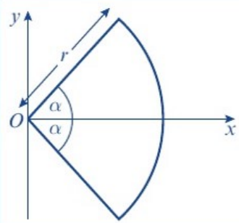

6. Find the centre of mass of a uniform wire in the form of an arc of a circle, radius r and centre O, which subtends an angle 2α at O.
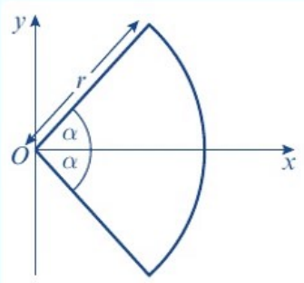

Standard results (in the formula booklet), distance from O along the axis of symmetry:
Distance of centre of mass from O
Sector of a circle, angle 2α
Arc of a circle, angle 2α
Semicircular lamina

