2H Non-uniform Composite Laminas and Frameworks
Modelling folded card:

Framework made from wires of different masses:

1. The lamina shown is made from a square piece of cardboard ABCD that has had the corner C folded to the centre of the square. Find the position of the centre of mass of the lamina.
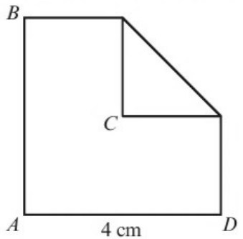
 | Rectangle | Square | Triangle | Lamina
Mass
x
y

2. The triangular framework shown is made from three pieces of uniform wire, AB, AC and BC of mass 2M, 3M and 5M respectively. Find the coordinates of the centre of mass of the framework.
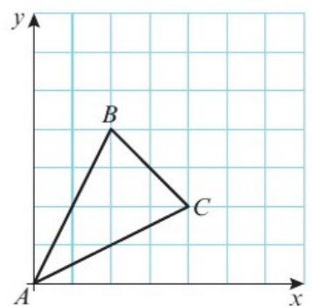
 | AB | AC | BC | Framework
Mass
x
y

