2E Centre of Mass of a Framework
Framework:

Centre of mass of a uniform straight rod:

For a framework made from uniform wire, the mass of each piece is proportional to:

Uniform circular arc of radius r and centre angle 2α (α in radians):
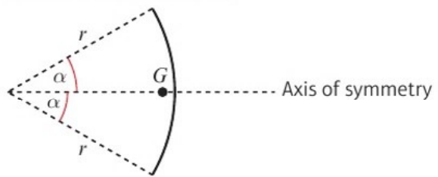
Distance of the centre of mass from the centre =

1. A framework consists of a uniform length of wire which has been bent into the shape of a letter L, as shown. Find the distance of the centre of mass of the framework from AB and AF.
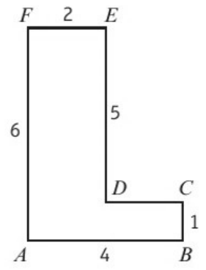
 | AB | BC | CD | DE | EF | FA | Frame
Length
x
y

2. Find the position of the centre of mass of a framework constructed from a uniform piece of wire bent into the shape shown:
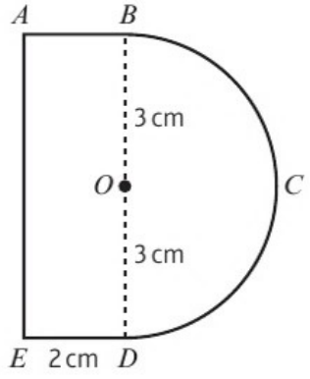
where the wire BCD is a semicircle, centre O, of radius 3 cm and wire BAED forms three sides of a rectangle ABDE.
 | Arc BCD | AB | AE | ED | Framework
Length
x
y

