2D Centre of Mass of a Composite Lamina
Composite uniform lamina:

Method (treat each part as a particle at its own centre of mass, with mass proportional to):

1. A uniform lamina consists of a rectangle PQRS joined to an isosceles triangle QRT, as shown in the diagram. Find the distance of the centre of mass of the lamina from:
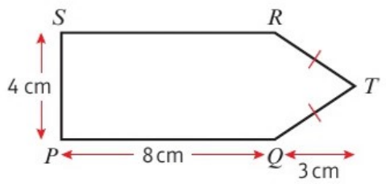
a) PQ
b) PS
 | Rectangle PQRS | Triangle QRT | Lamina
Area
x
y

The centre of mass of a uniform lamina or framework will always lie on:

2. The diagram shows a uniform lamina. Find the distance of the centre of mass of the lamina from:
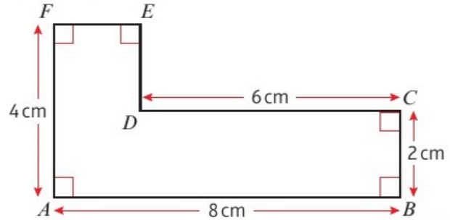
a) AF
b) AB
 | Part 1 | Part 2 | Lamina
Area
x
y

Two other ways of splitting this lamina:

Removing part of a lamina:

3. A uniform circular disc, centre O, of radius 5 cm has two circular holes cut in it, as shown in the diagram.
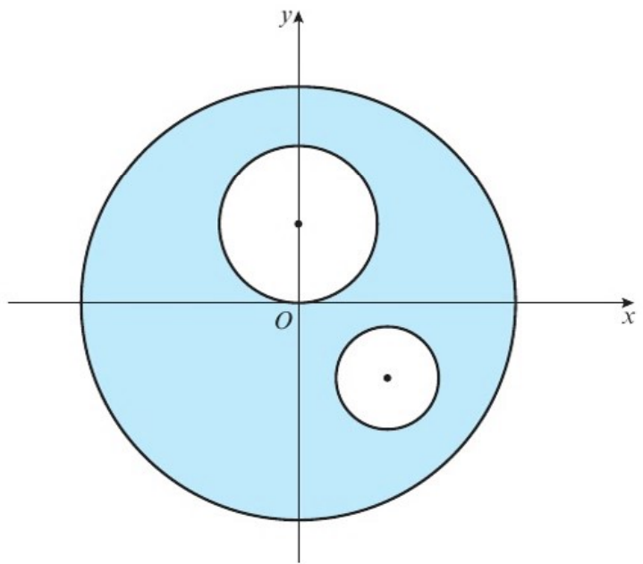
The larger hole has radius 2 cm and the smaller hole has radius 1 cm. The coordinates of the centres of the holes are (0, 2) and (2, −2) respectively. Find the coordinates of the centre of mass of the remaining lamina.
 | Disc | Large hole | Small hole | Remaining lamina
Area
x
y

