2C Centres of Mass of Standard Uniform Plane Laminas
Lamina:

Uniform lamina:

Axes of symmetry and the centre of mass:

Centre of mass of a uniform circular disc:

Centre of mass of a uniform rectangular lamina:

Medians and centroid of a triangle:

Centre of mass of a uniform triangular lamina with vertices (x₁, y₁), (x₂, y₂) and (x₃, y₃):

Uniform sector of a circle, radius r and centre angle 2α (α in radians):
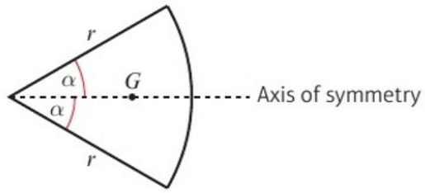
Distance of the centre of mass from the centre =

1. A uniform triangular lamina has vertices A(1, 4), B(3, 2) and C(5, 3). Find the coordinates of its centre of mass.

2. Find the centre of mass of the uniform triangular lamina shown:
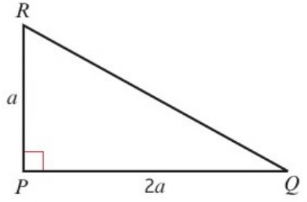

3. The diagram shows a uniform semicircular lamina of radius 6 cm with centre O. Find the centre of mass of the lamina.
