8A Decision Trees
In a decision tree:
boxes represent ____________________ nodes
triangles represent ____________________ nodes
circles represent ____________________ nodes

Annotating a decision tree (probabilities, pay-offs and expected values):

Expected monetary value (EMV):

A player tosses a coin and wins £5 for heads, or loses £2 for tails. Complete the decision tree.
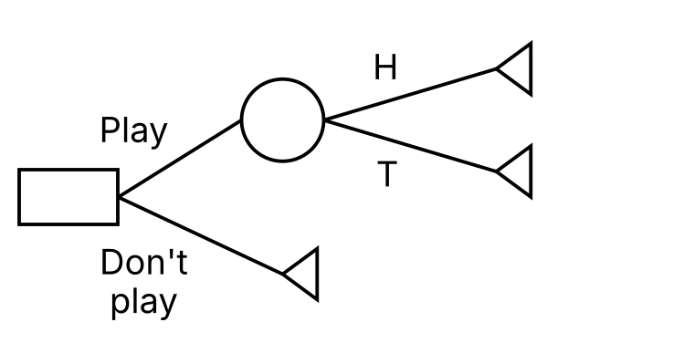

1. Carol plans to travel from Cannock to Derby by car. One option is to take the A460 to Uttoxeter and then take the A50. This is a distance of 38 miles and will take around 1 hour 20 minutes. A second option is to set off on the A5 to the M6 Toll road then continue on the A38. This is a distance of 36 miles and will take around 55 minutes. A final option is to combine the routes by taking the A460 to Rugeley, then the A515, then take the A38 at Alrewas. This is a distance of 34 miles and will take around 1 hour and 5 minutes.
a) Use a decision tree to choose the best option for Carol based purely on:
i) the distance to travel
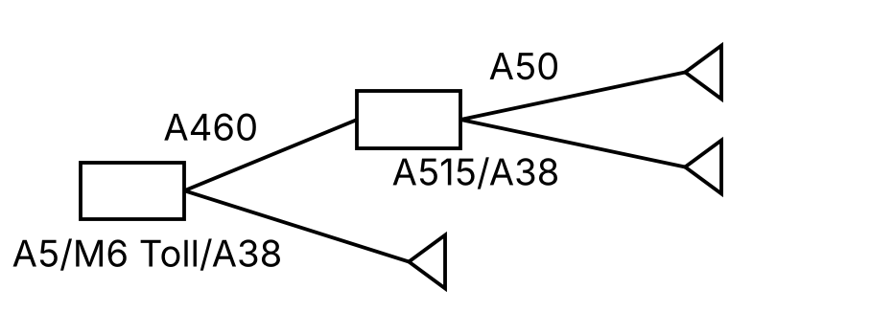

ii) the time needed to complete the journey.

The cost of driving is estimated at 40p per mile. There is an additional cost of £10 for using the M6 Toll road.
b) Comment on the best option overall.

An optimal strategy based on the EMV criterion:

Showing the optimal strategy on a decision tree:

2. James is trying to decide whether or not to play a game using two fair tetrahedral dice. The sides of the dice are numbered from 1 to 4. If he scores a total of 6 or more then he wins £4; otherwise he loses £2.
a) Draw a decision tree to model James’s possible decisions and outcomes.

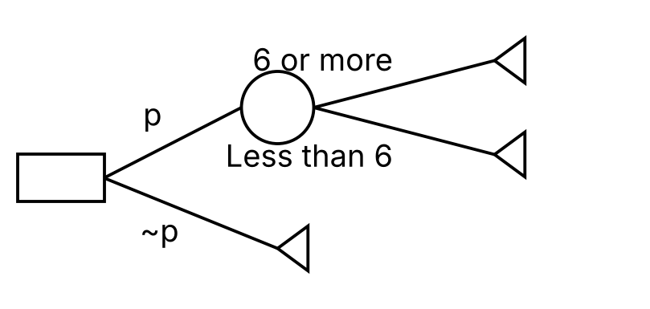
b) Determine whether James should play the game and state his EMV.

3. Jess pays £2 to play a game. She rolls two dice and if they both show the same score, she wins £5; otherwise she loses. If she loses, she can pay a further £1 to roll a third dice. If the score on the third dice matches the score on either of the first two dice, then she wins £6; otherwise she loses.
a) Draw a decision tree to model the decisions and possible outcomes.

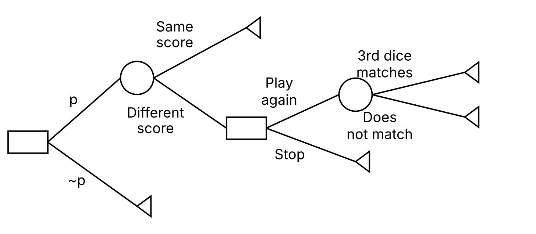

b) Find the best strategy for Jess as indicated by the decision tree.

4. Jack has time for one revision session before he takes an exam in Mechanics and Statistics. He will devote this time either to Mechanics or Statistics. These are worth 50 marks each. Jack estimates that if the Mechanics questions go in his favour then he would expect to achieve 45 marks, but if they don’t then this reduces to 30 marks. Similarly, if the Statistics questions go in his favour then he would expect to achieve 35 marks, but if they don’t then this reduces to 25 marks.
If Jack devotes his revision time to Mechanics then he has a 70% chance of finding the Mechanics questions favourable and a 20% chance of finding the Statistics questions favourable.
If Jack devotes his revision time to Statistics then he has a 60% chance of finding the Statistics questions favourable and a 60% chance of finding the Mechanics questions favourable.
Use a decision tree to determine how Jack should devote his revision time.

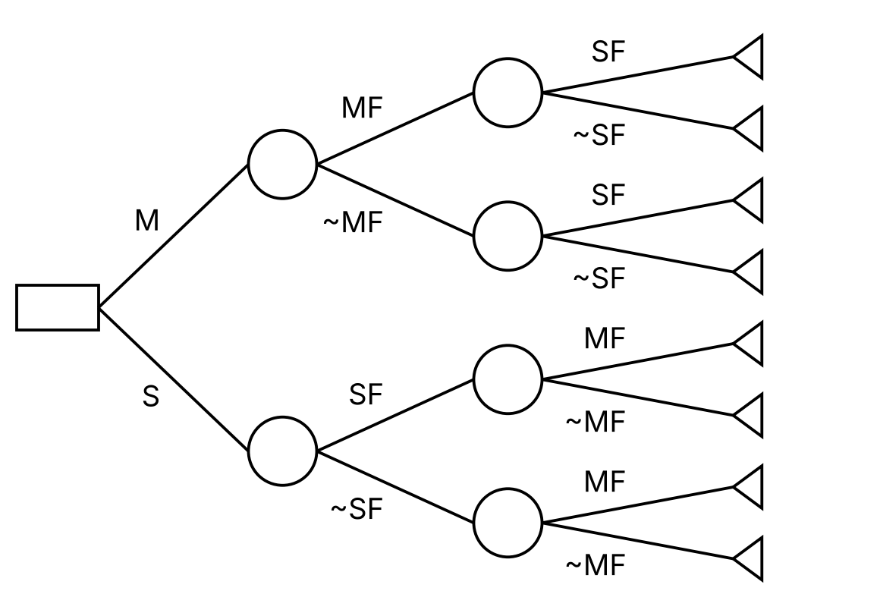

8B Utility
A school fete runs a dice game in which six dice are thrown. The charge is £1 for each attempt and the prize is £2000 for obtaining six sixes in a single throw. There are expected to be 400 attempts during the day, and at most one prize is awarded.

P(Win) on each throw =

P(Someone wins) =

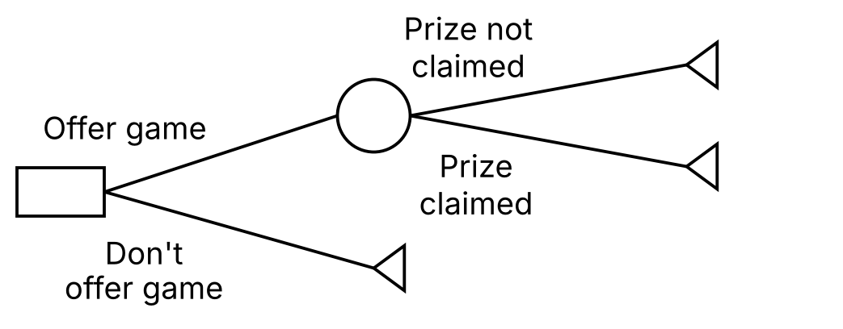

Why the EMV may not be the best criterion here:

Utility function:

Expected utility, E(U), and utils:

The utility function u(x) = 1 − e^{−x/R}, and the effect of R:

1. A school has to decide whether to offer the dice game described above. For a pay-off of £x, the school determines that its utility function is 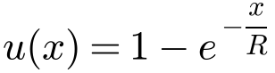.
Calculate the school’s expected utility, given that:
a) R = 400

b) R = 200

In each case, interpret the results.

2. A company can choose one of three business options A, B or C. The profits in pounds associated with each outcome are shown on the decision tree below.
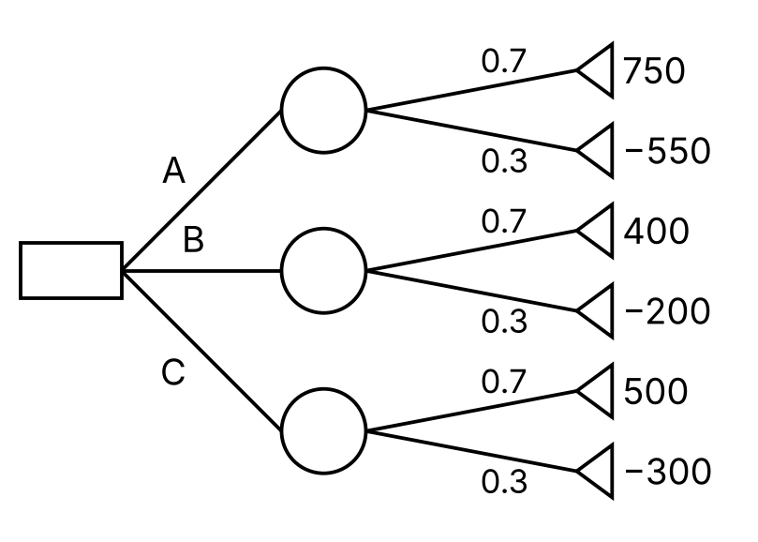
a) Using the decision tree, calculate the optimal EMV to determine the best choice.

For a profit of £x, the company’s utility is given by 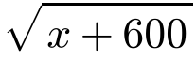.
b) Using expected utility as the criterion, determine the optimal choice.

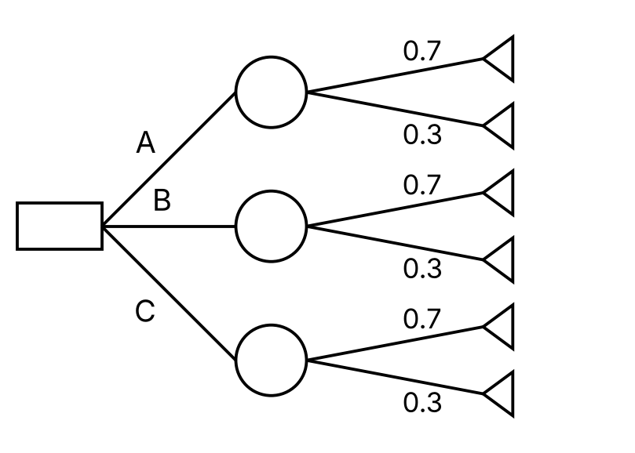

3. Tim is considering whether to play a card game. If he picks a Jack, Queen or King, at random from a standard pack of playing cards, then he wins a prize. If he picks any other card, then he loses £5.
a) Draw a decision tree and state Tim’s best course of action using the EMV criterion, given that the prize on offer is £12.
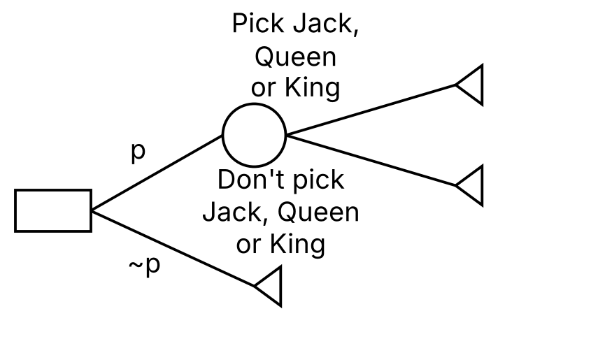

Tim only has £5. He uses utility = 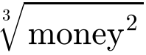 to reflect his risk aversion.
b) Calculate the minimum prize amount that would make it worthwhile for Tim to play the game.

