5A Shortest and Longest Path Problems
Dynamic programming:

Bellman's principle of optimality:

If the shortest/longest path from S to T is SABCT, then the shortest/longest path from S to C is

and the shortest/longest path from A to C is

Stage:

State:

Action:

Destination:

Value:

Which way do you work through the network in dynamic programming?

1. a Use dynamic programming to find the minimum cost route from S to T in the network below.
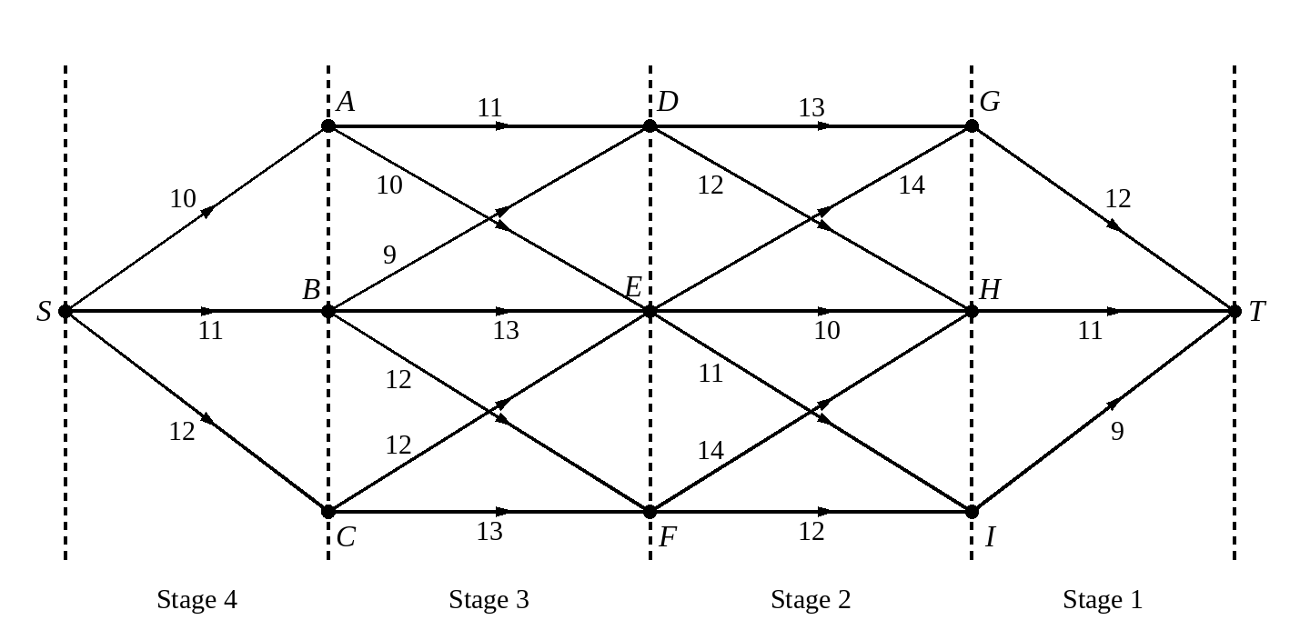
b Hence write down the minimum cost route from S to I.

Stage | State | Action | Destination | Value
1 | G | GT | T | 12*
 | H | HT | T | 11*
 | I | IT | T | 9*
2 | D | DG | G
 |  | DH | H
 | E | EG | G
 |  | EH | H
 |  | EI | I
 | F | FH | H
 |  | FI | I
3 | A | AD | D
 |  | AE | E
 | B | BD | D
 |  | BE | E
 |  | BF | F
 | C | CE | E
 |  | CF | F
4 | S | SA | A
 |  | SB | B
 |  | SC | C

2. Use dynamic programming to find the maximum cost route from S to T in the network below.
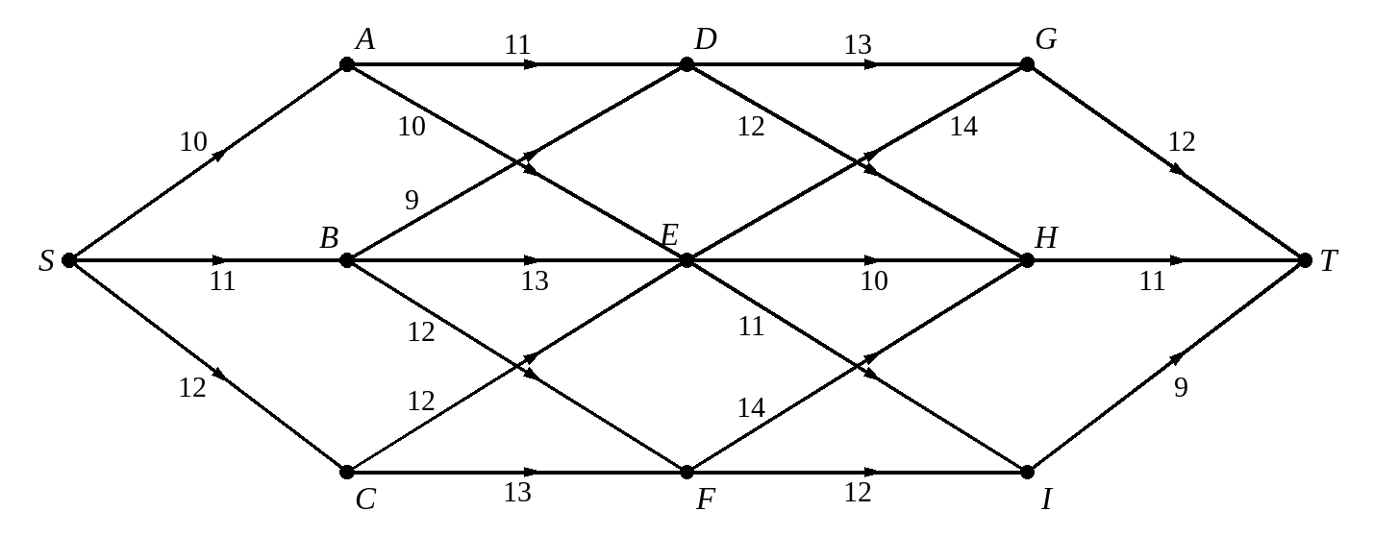
Stage | State | Action | Destination | Value
1 | G | GT | T
 | H | HT | T
 | I | IT | T
2 | D | DG | G
 |  | DH | H
 | E | EG | G
 |  | EH | H
 |  | EI | I
 | F | FH | H
 |  | FI | I
3 | A | AD | D
 |  | AE | E
 | B | BD | D
 |  | BE | E
 |  | BF | F
 | C | CE | E
 |  | CF | F
4 | S | SA | A
 |  | SB | B
 |  | SC | C

What do you do when two actions from the same state give the same optimal value?

3. Use dynamic programming to find: a the shortest b the longest route between S and T. State the route and its length in each case.
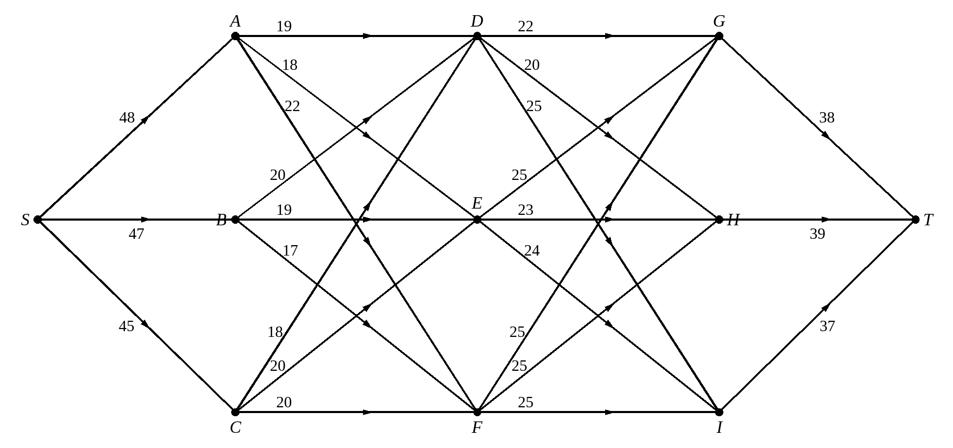
a The shortest route
Stage | State | Action | Destination | Value
1 | G | GT | T
 | H | HT | T
 | I | IT | T
2 | D | DG | G
 |  | DH | H
 |  | DI | I
 | E | EG | G
 |  | EH | H
 |  | EI | I
 | F | FG | G
 |  | FH | H
 |  | FI | I
3 | A | AD | D
 |  | AE | E
 |  | AF | F
 | B | BD | D
 |  | BE | E
 |  | BF | F
 | C | CD | D
 |  | CE | E
 |  | CF | F
4 | S | SA | A
 |  | SB | B
 |  | SC | C

b The longest route
Stage | State | Action | Destination | Value
1 | G | GT | T
 | H | HT | T
 | I | IT | T
2 | D | DG | G
 |  | DH | H
 |  | DI | I
 | E | EG | G
 |  | EH | H
 |  | EI | I
 | F | FG | G
 |  | FH | H
 |  | FI | I
3 | A | AD | D
 |  | AE | E
 |  | AF | F
 | B | BD | D
 |  | BE | E
 |  | BF | F
 | C | CD | D
 |  | CE | E
 |  | CF | F
4 | S | SA | A
 |  | SB | B
 |  | SC | C

4. A firm is creating a three-year plan, and considering a possible expansion. If the firm expands there will be costs, due to purchasing new premises and equipment, but also increased revenue. To establish the effect of the decisions, the firm will then calculate the effect on selling all of its assets at the end of the three-year period. The firm can only expand a maximum of two times due to plant restrictions. The results of the decisions are shown in the network below, with negative numbers indicating costs and positive numbers indicating revenues, in £100 000s.
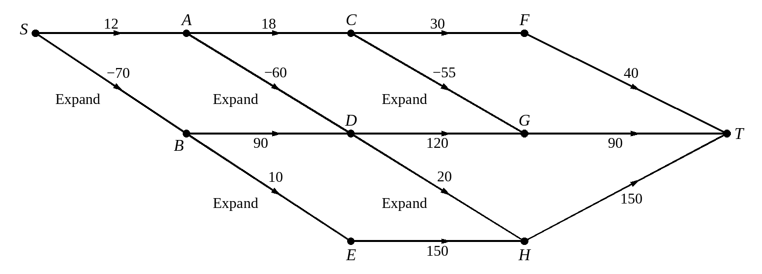
Determine the strategy that maximises the profit over the three-year period.
Stage | State | Action | Destination | Value
1 | F | FT | T
 | G | GT | T
 | H | HT | T
2 | C | CF | F
 |  | CG | G
 | D | DG | G
 |  | DH | H
 | E | EH | H
3 | A | AC | C
 |  | AD | D
 | B | BD | D
 |  | BE | E
4 | S | SA | A
 |  | SB | B

5B Minimax and Maximin Problems
A minimax route:

A maximin route:

An example of a minimax problem:

An example of a maximin problem:

Does Bellman's principle apply in the same way to minimax and maximin problems?

1. Use dynamic programming to find a minimax route from S to T.
Stage | State | Action | Destination | Value
1 | G | GT | T
 | H | HT | T
 | I | IT | T
2 | D | DG | G
 |  | DH | H
 | E | EG | G
 |  | EH | H
 |  | EI | I
 | F | FH | H
 |  | FI | I
3 | A | AD | D
 |  | AE | E
 | B | BD | D
 |  | BE | E
 |  | BF | F
 | C | CE | E
 |  | CF | F
4 | S | SA | A
 |  | SB | B
 |  | SC | C

2. Use dynamic programming to find a maximin route from S to T.
Stage | State | Action | Destination | Value
1 | G | GT | T
 | H | HT | T
 | I | IT | T
2 | D | DG | G
 |  | DH | H
 | E | EG | G
 |  | EH | H
 |  | EI | I
 | F | FH | H
 |  | FI | I
3 | A | AD | D
 |  | AE | E
 | B | BD | D
 |  | BE | E
 |  | BF | F
 | C | CE | E
 |  | CF | F
4 | S | SA | A
 |  | SB | B
 |  | SC | C

5C Dynamic Programming Problems in Table Form
Terminology for problems in table form
Stage:

State:

Action:

Destination:

Value:

1. A fruit grower can use his surplus crop to make into jam, pie filling or dried fruit. He can process up to five units of fruit and the expected profits, in hundreds of pounds, from making the various products are shown in the table. He will use all five units to make these products and wishes to maximise his income. Dynamic programming will be used to solve this problem.
Number of units of fruit | 1 | 2 | 3 | 4 | 5
Jam | 12 | 27 | 33 | 36 | 38
Pie filling | 16 | 18 | 20 | 22 | 24
Dried fruit | 8 | 16 | 24 | 32 | 40

a) Define the terms Stage, State, Action, Destination and Value in this context.

b) Determine the number of units he should allocate to each product in order to maximise his income.
Stage | State | Action | Destination | Value
1 Dried fruit | 0 | 0 | 0
 | 1 | 1 | 0
 | 2 | 2 | 0
 | 3 | 3 | 0
 | 4 | 4 | 0
 | 5 | 5 | 0
2 Pie filling | 0 | 0 | 0
 | 1 | 1 | 0
 |  | 0 | 1
 | 2 | 2 | 0
 |  | 1 | 1
 |  | 0 | 2
 | 3 | 3 | 0
 |  | 2 | 1
 |  | 1 | 2
 |  | 0 | 3
 | 4 | 4 | 0
 |  | 3 | 1
 |  | 2 | 2
 |  | 1 | 3
 |  | 0 | 4
 | 5 | 5 | 0
 |  | 4 | 1
 |  | 3 | 2
 |  | 2 | 3
 |  | 1 | 4
 |  | 0 | 5
3 Jam | 5 | 5 | 0
 |  | 4 | 1
 |  | 3 | 2
 |  | 2 | 3
 |  | 1 | 4
 |  | 0 | 5

2. A clockmaker makes grandfather clocks during the winter. The order book for clocks over the next five months is shown in the table below.
Month | October | November | December | January | February
Number of clocks ordered | 2 | 3 | 5 | 3 | 1

The clocks are delivered to customers at the end of each month. He can make up to four clocks in any month, but if he needs to make more than two in any one month he will need to hire additional help at £500 per month. The overhead costs are £300 in any month in which work is done. He can put up to two clocks into storage at a cost of £100 per clock per month. There are no clocks in storage at the beginning of October and there should be no clocks in storage after the February delivery.
a) Use dynamic programming to determine the production schedule that minimises the costs.
Stage: State:
Action: Destination: Value:

Stage | State | Action | Destination | Value
Feb | 1 | 0 | 0
 | 0 | 1 | 0
Jan | 2 | 2 | 1
 |  | 1 | 0
 | 1 | 3 | 1
 |  | 2 | 0
 | 0 | 4 | 1
 |  | 3 | 0
Dec | 2 | 4 | 1
 |  | 3 | 0
 | 1 | 4 | 0
Nov | 2 | 3 | 2
 |  | 2 | 1
 | 1 | 4 | 2
 |  | 3 | 1
 | 0 | 4 | 1
Oct | 0 | 4 | 2
 |  | 3 | 1
 |  | 2 | 0

Month | October | November | December | January | February
Number of clocks made

The clockmaker's helper needs some extra income in October, so the clockmaker decides he will definitely make four clocks this month.
b) Given this information, use your table to determine the optimum production schedule for the remaining months, and write down the total production costs.
Month | October | November | December | January | February
Number of clocks made

3. A builder has purchased a site and will build three houses A, B and C on it at the rate of one a year. The profit made on each house will depend on site accessibility, interest rates and cost of materials and labour. The builder's estimates of potential profits are shown in the table below, in thousands of pounds.
Already built | A | B | C
None | 50 | 70 | 65
A | − | 65 | 60
B | 65 | − | 70
C | 60 | 70 | −
A and B | − | − | 80
A and C | − | 60 | −
B and C | 70 | − | −

Dynamic programming is to be used to determine the order in which the houses are to be built so that the minimum profit in each year is to be maximised.
a) Explain the meaning of Stage, State and Action in this context.

b) Find the order in which the houses should be built and the value of the minimum estimated annual profit.
Stage | State | Action | Destination | Value
1 | AB | C | ABC
 | AC | B | ABC
 | BC | A | ABC
2 | A | B | AB
 |  | C | AC
 | B | A | AB
 |  | C | BC
 | C | A | AC
 |  | B | BC
3 | None | A | A
 |  | B | B
 |  | C | C

4. Toby has a fairground ride and will take it to three county fairs over the next three weeks. He will leave home at the start of week 1 and travel to the first fair, then go to the second fair for the second week and then go to the third fair for the final week before returning home. There are seven fairs during the next three weeks so there is a choice of fair each week. Toby must decide which one of the fairs he should go to. Table 1 gives the week in which each fair is held. Table 2 gives the expected profits, in hundreds of pounds, in going to each fair. Table 3 gives the travel costs in hundreds of pounds.
Table 1: Week | 1 | 2 | 3
Fair | A, B | C, D, E | F, G

Table 2: Fair | A | B | C | D | E | F | G
Profit (£100s) | 6 | 5 | 8 | 10 | 11 | 14 | 12

Table 3: Travel costs (£100s) | A | B | C | D | E | F | G
Home | 3 | 2 |  |  |  | 8 | 7
A |  |  | 3 | 2 | 5
B |  |  | 1 | 3 | 3
C |  |  |  |  |  | 5 | 5
D |  |  |  |  |  | 4 | 2
E |  |  |  |  |  | 4 | 1

Toby wishes to maximise his income. Use dynamic programming to determine the fairs he should go to and his total income.

Stage: State:
Action: Destination:

Stage | State | Action | Destination | Value
1 | F | F–Home | Home
 | G | G–Home | Home
2 | C | CF | F
 |  | CG | G
 | D | DF | F
 |  | DG | G
 | E | EF | F
 |  | EG | G
3 | A | AC | C
 |  | AD | D
 |  | AE | E
 | B | BC | C
 |  | BD | D
 |  | BE | E
4 | Home | Home–A | A
 |  | Home–B | B

