4A Lower Capacities
Lower capacity and upper capacity:

An arc labelled (3, 7) means

The conservation condition:

1. In the diagram, arcs AB, BC and BD represent part of a directed capacitated network. Deduce the value of the flow in each arc.
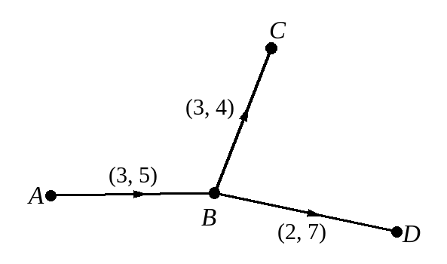

If the maximum total flow into a vertex is equal to the minimum total flow out of that vertex, then:

If the minimum total flow into a vertex is equal to the maximum total flow out of that vertex, then:

2. The diagram shows a directed capacitated network. The numbers on each arc represent the lower and upper capacities of that arc.
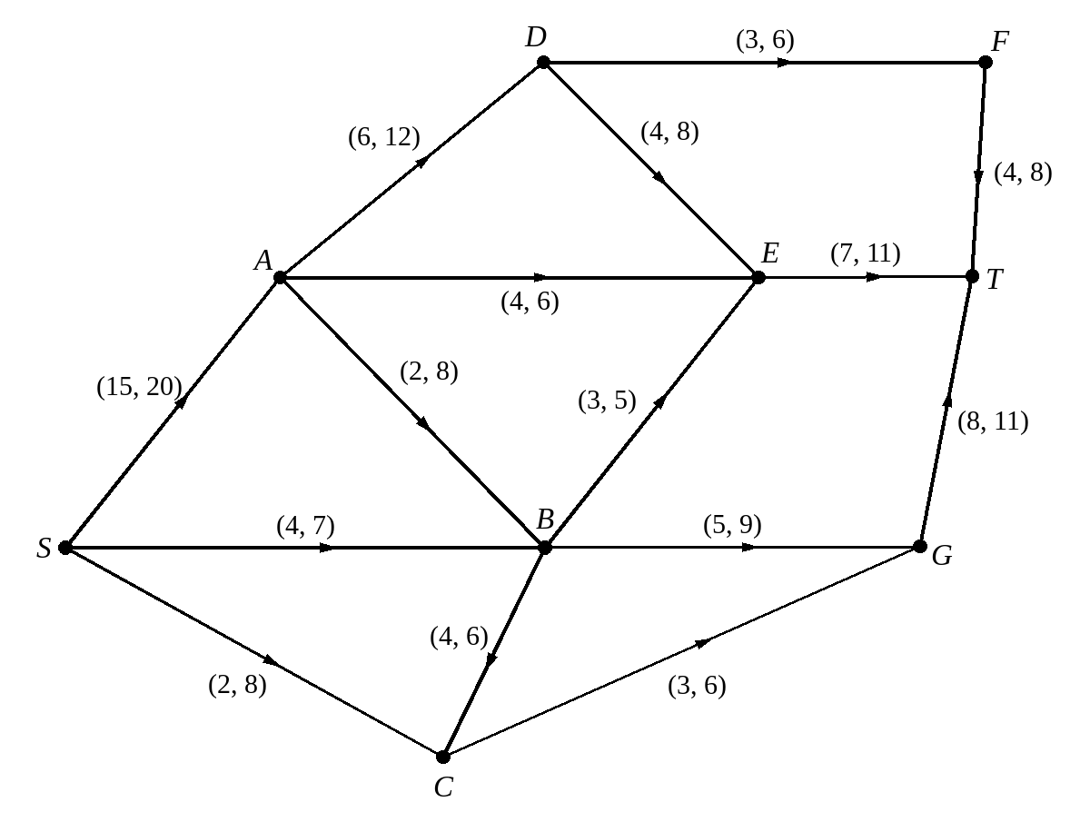
a) By considering vertex C, calculate the flow in: i SC ii BC iii CG

b) Explain why arcs DE, AE and BE must all be at their lower capacities.

c) Calculate the flow in GT.

Flow augmentation with lower capacities (excess capacity and potential backflow):

3. The diagram shows a feasible flow for the network given in question 2.
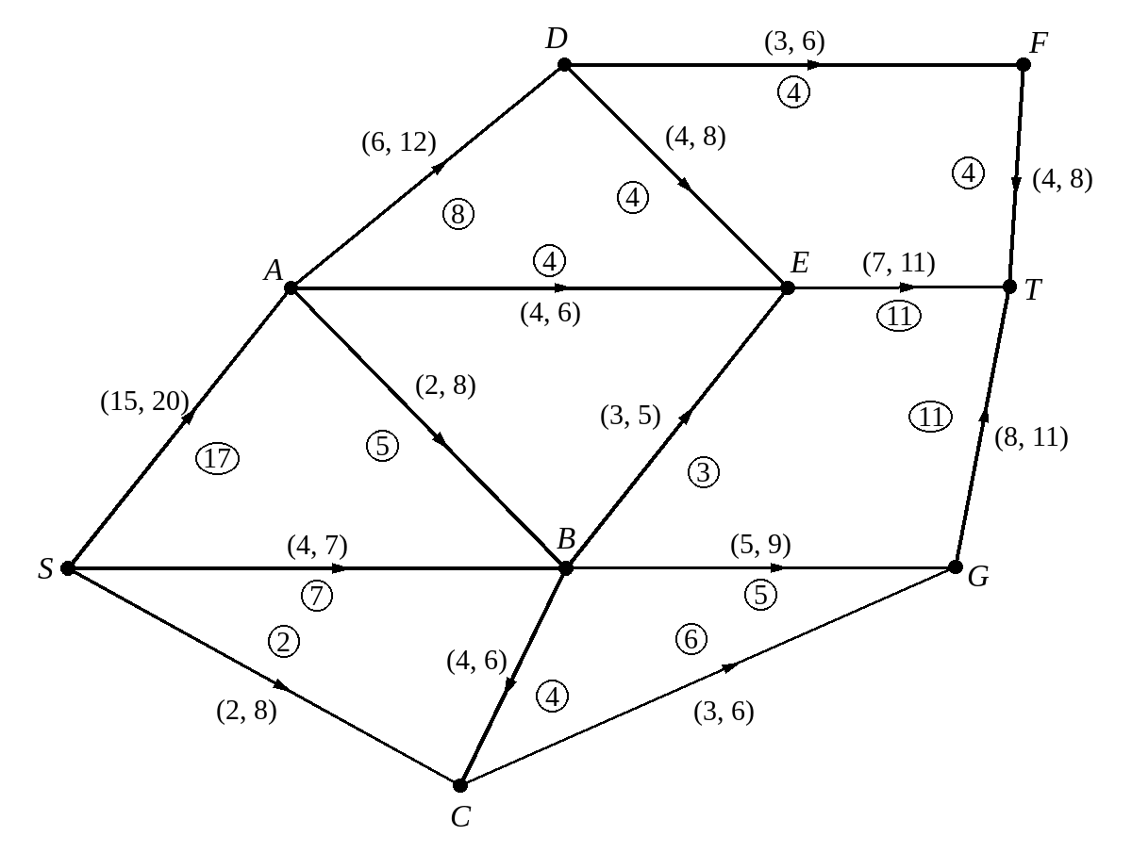
a) Use flow augmentation to find the maximum flow through the network.

b) Show the maximum flow on a diagram.

The capacity (value) of a cut in a network with lower capacities:

4. Here is the network used in questions 2 and 3.
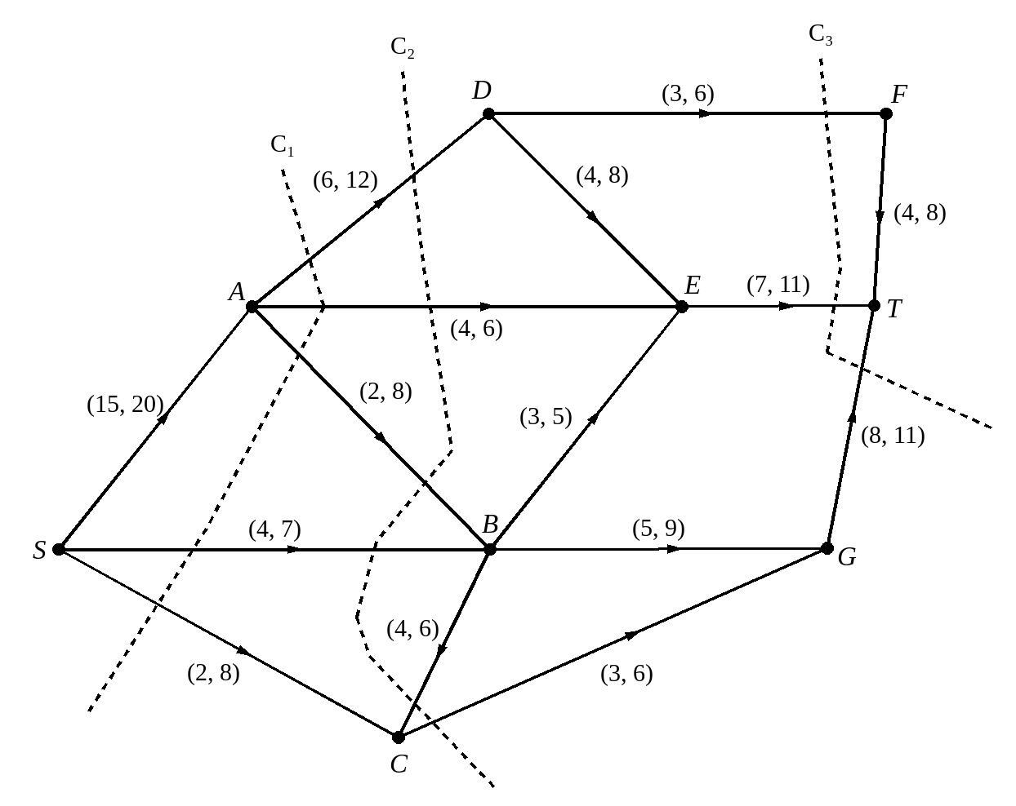
a) Find the capacity of the cuts C₁, C₂ and C₃.

b) Explain what this shows about the maximal flow.

4B Sources and Sinks
Supersource:

Supersink:

Capacity and flow of the arcs from the supersource and to the supersink:

How do you recognise a source or a sink?

1. The diagram shows a capacitated directed network. The capacity of each arc is shown on each arc. The numbers in circles represent an initial flow.
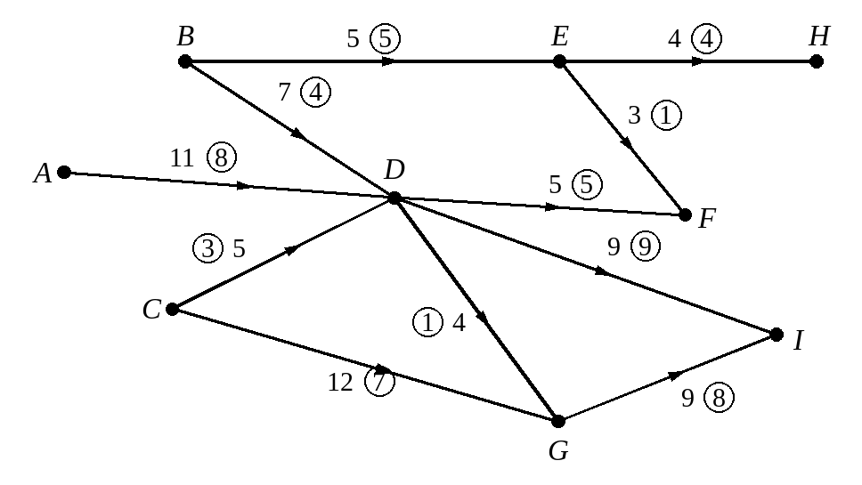
a) List the source vertices.

b) List the sink vertices.

c) Add a supersource, S, a supersink, T, and appropriate arcs and flows to the diagram.
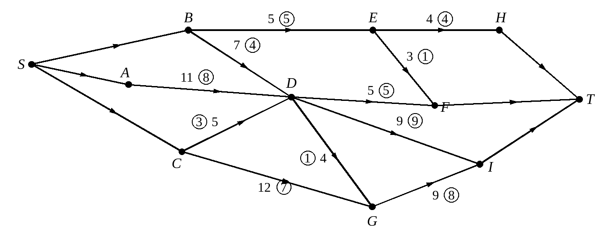

2. Water from three reservoirs, S₁, S₂ and S₃, is used to supply two towns T₁ and T₂, using a network of pipes. The capacity of each pipe is given by the number on each arc. The numbers in circles represent an initial flow.
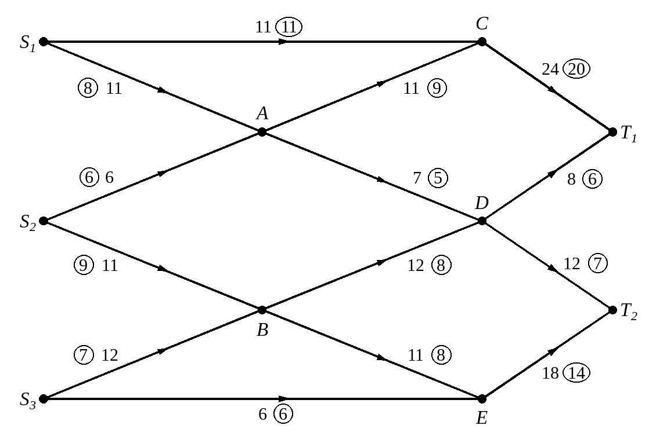
a) Add a supersource, supersink and appropriate arcs to the diagram.
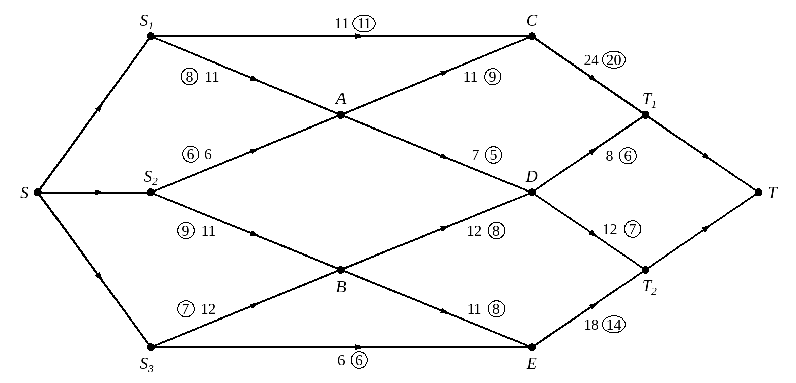
b) Use the initial flow and the labelling procedure to find the maximum flow through the network. List each flow-augmenting route you use, together with its flow.

c) Draw your maximal flow pattern.
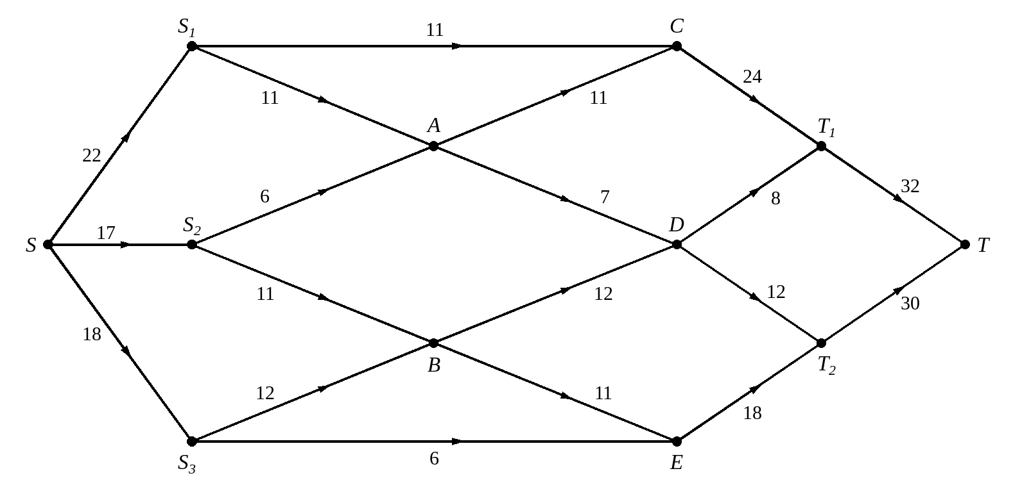
d) State the value of your flow.

e) Show that there are two minimum cuts.
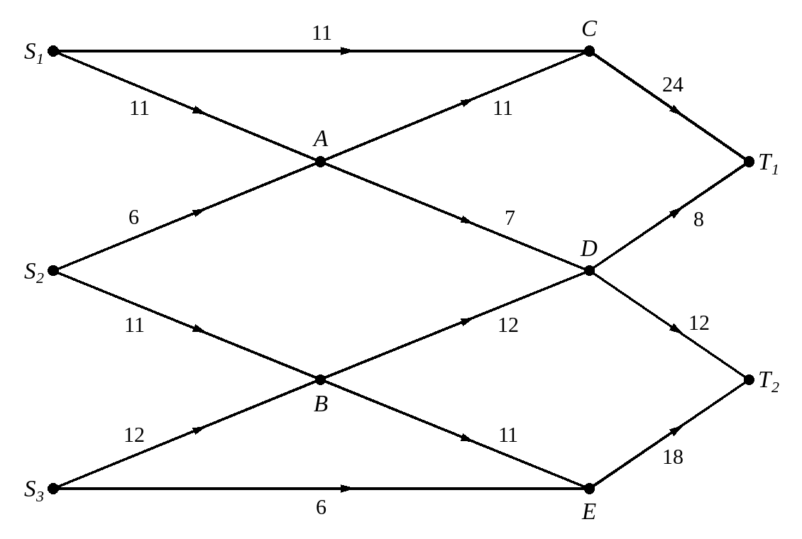

Supersource and supersink arcs when there are lower capacities:

3. The diagram shows a network of oil pipes with separate sources S₁ and S₂, and separate sinks T₁ and T₂. The numbers on the arcs represent the lower and upper capacities through the pipes.
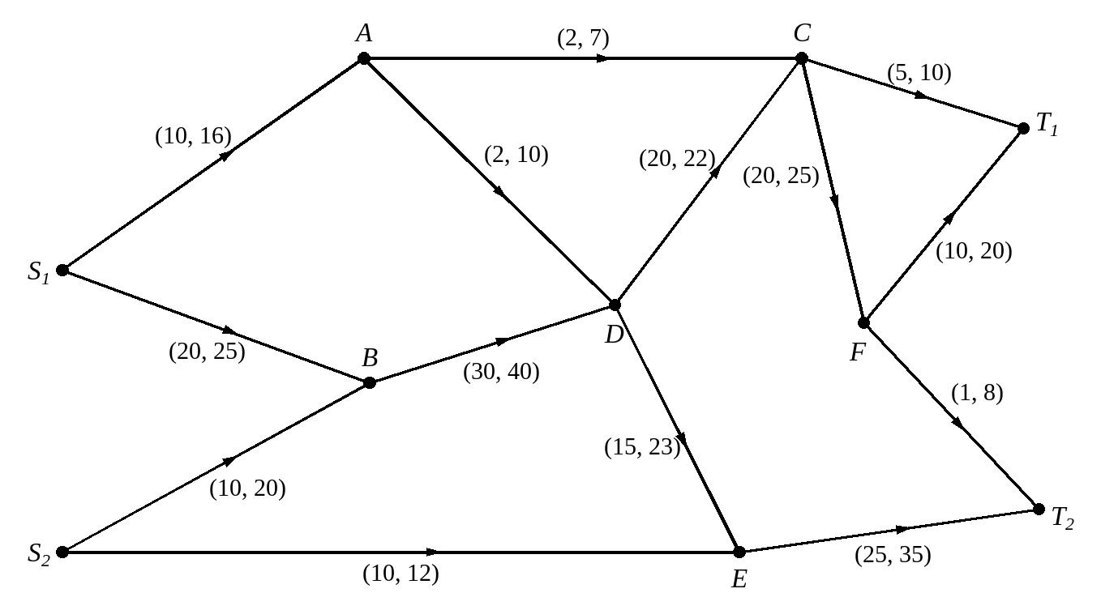
a) Add a supersource and supersink to the network with appropriate arcs. Label the new arcs with their lower and upper capacities.
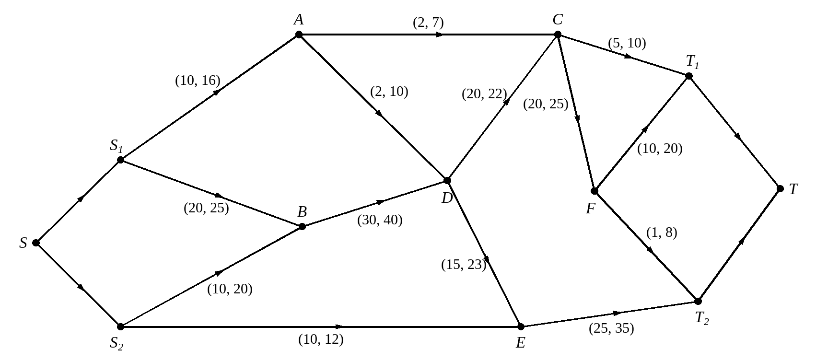

The diagram shows a partly completed feasible flow for the network.
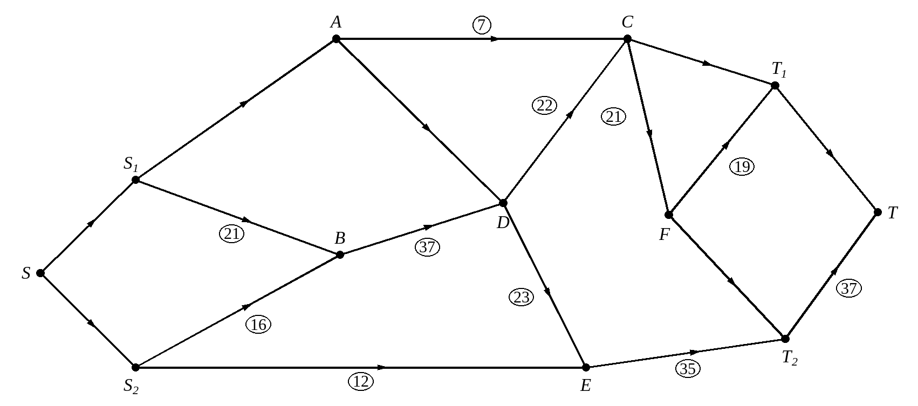
b) Complete the diagram to show a feasible flow of 64.

c) Prove that 64 is the maximum flow for the network.
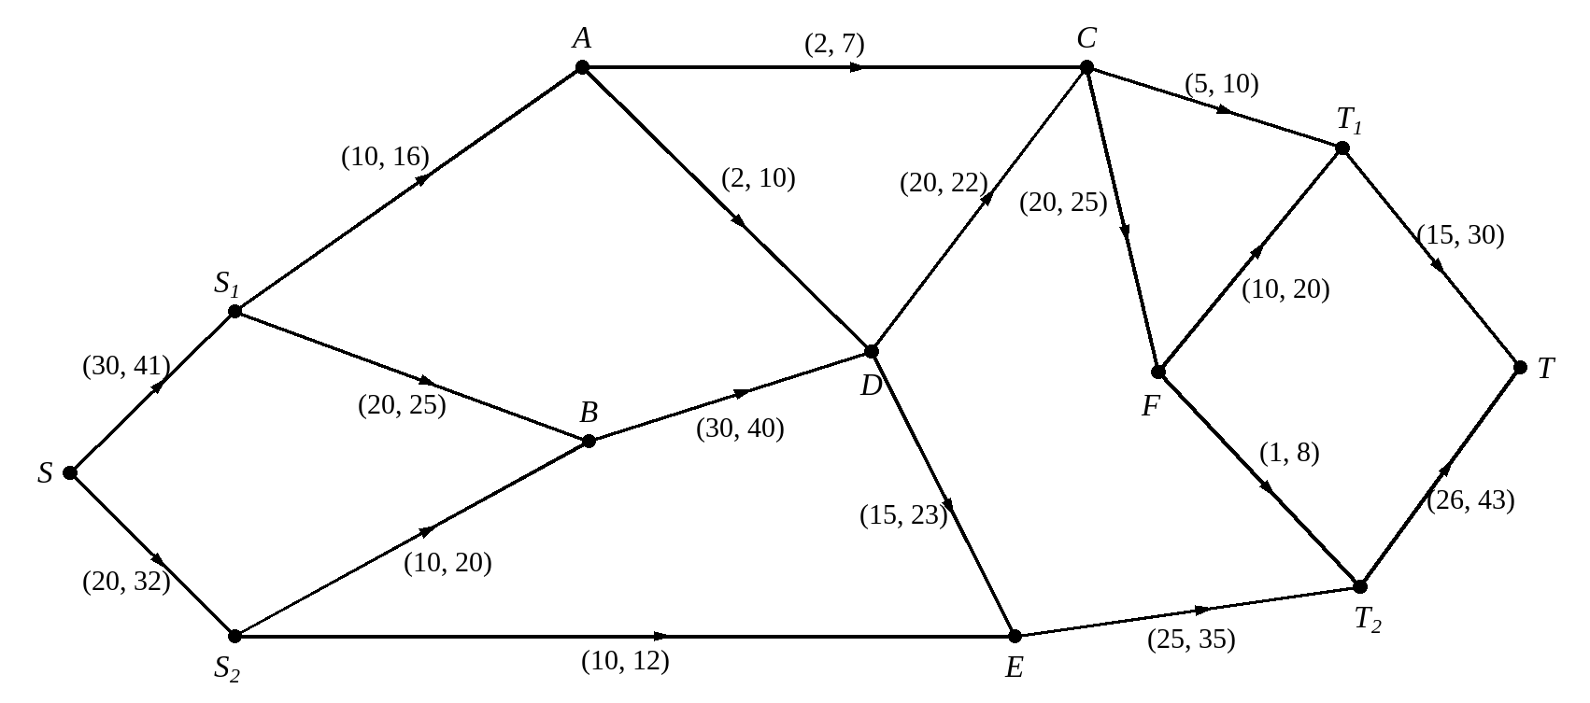

4C Restricted Capacity Nodes
Restricted capacity node:

1. The diagram shows part of a capacitated directed network. The node, C, has a restricted capacity of 41. Show this information on the diagram.
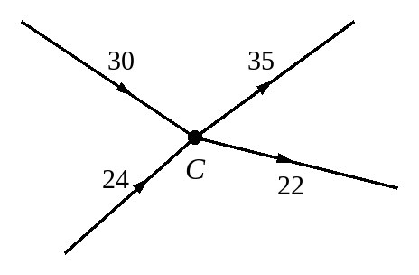

2. The diagram shows part of a capacitated directed network. The node, C, has a restricted capacity of 15. Show this information on the diagram.
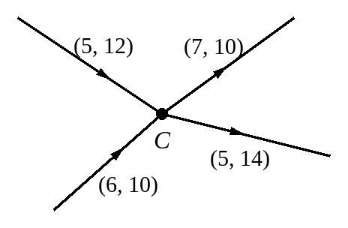

3. Here is the diagram used in 4B question 3.
The maximum flow through the network is 64, as shown in this diagram.
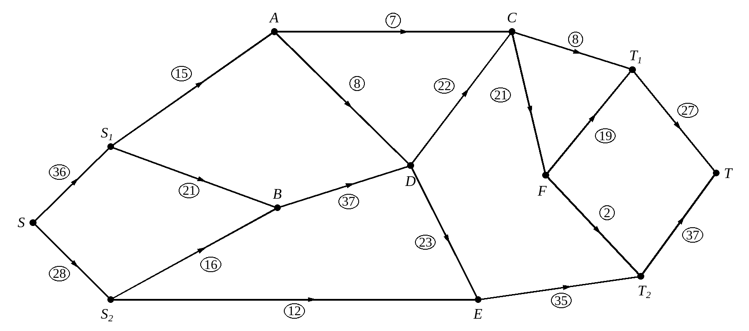
The node at B now has a restricted capacity of 30.
a) Explain why the maximum flow in the network cannot now exceed 58.

b) Show a feasible flow of 58 for the new network.
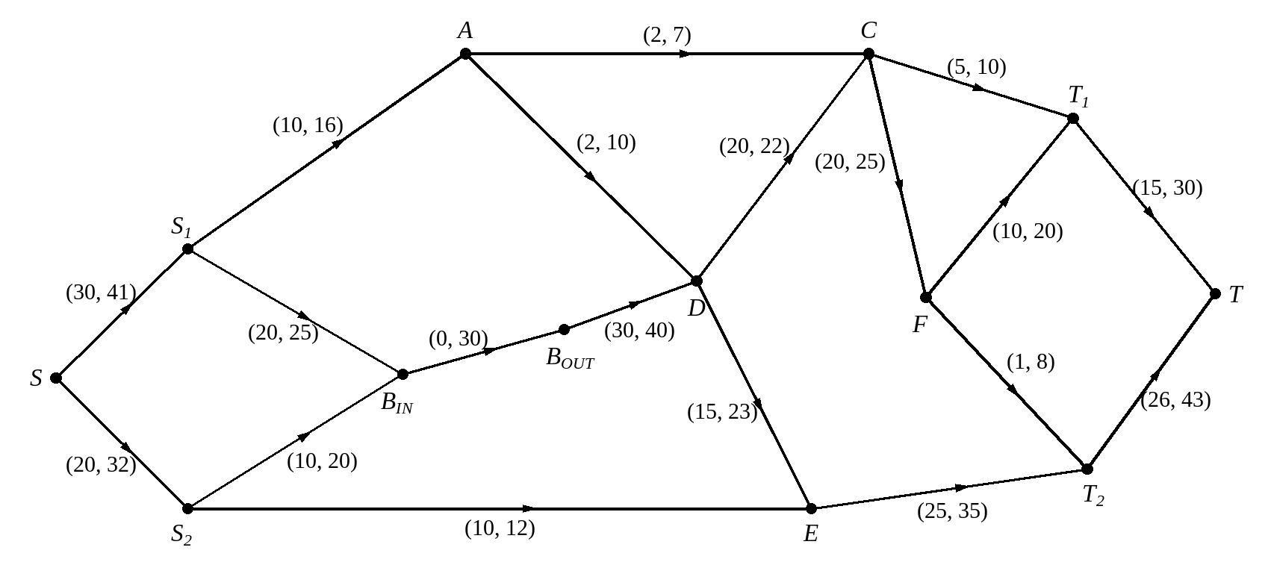

A node that is completely blocked:

